

**American International University- Bangladesh**

**CSC 3215: Web Technologies**

**CO1 and CO3 Evaluation**

**Project Report**

**Spring 2019-2020**

**Project Title: School Management System**

**Section: D**

|  |  |
| --- | --- |
| Student Name | Student Id |
| Md. Asiqur Rahman Khan | **17-34907-2** |
| Abedin,Mohammad Joynul | **17-34845-2** |
| Rafin Maidul Islam | **17-34874-2** |
| Alif Rifat | **17-34916-2** |

**Introduction:**

This project is about to build a school management system to do management more faster and easier.

**Background Study:**

To build this system we have studied some website and management system to get ideas and features. We also googled some school management system to get ideas like what kind of features we want to add.

**Requirement Analysis:**

1. **User Category**

There are 4-types of users are in our system.

* Super Admin
* Admin
* Teacher
* Student

1. Feature List:

In this project User type **Super Admin** has the below features,

* Adding new Techer
* Adding new Courses
* Adding new Admin

In this project User type **Admin** has the below features,

* Adding New Class
* Assigning Course Techer
* Adding Student
* Assigning Student Class

In this project User type **Teacher** has the below features,

* Giving marks to student
* Adding Attendance of student

In this project User type **Student** has the below features,

* Can See marks

**Design:**

**Entity, ER** diagram is given below:

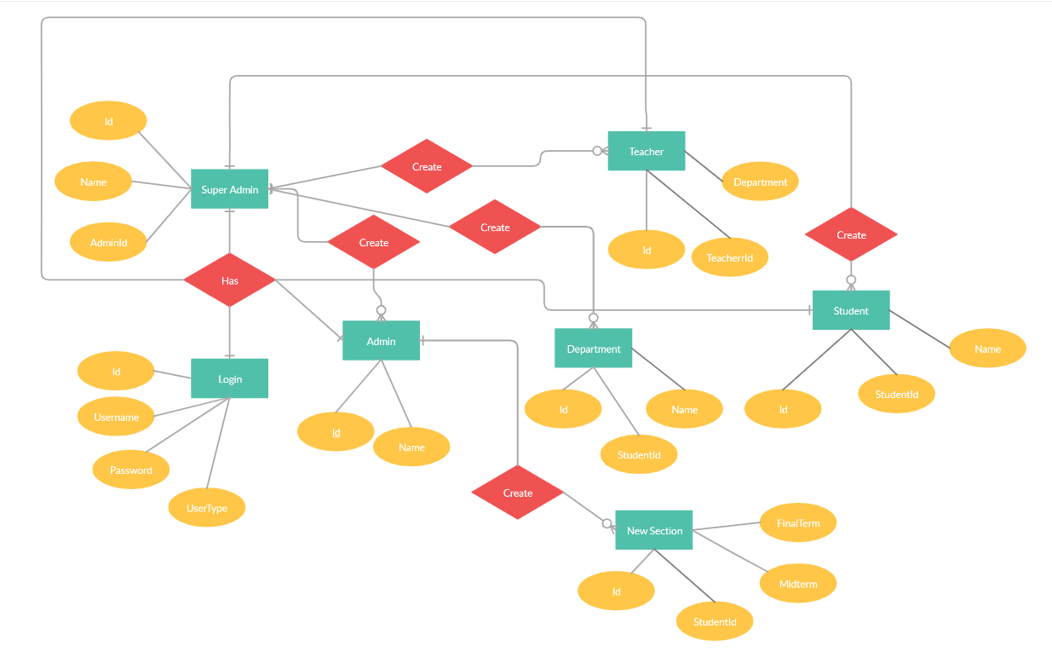

**Description: This is the ER class Diagram For our Project.**

**Tools Used:**

To develop this project we have used the following tools,

* VS Code (Editing Software)
* Atom (Editing Software)
* PHP (for back-end)
* HTML & CSS (form Front-end)
* Microsoft Word
* Xampp (for Database

**System Images against the Specifications:**

**Below some GUIs related to project are given:**

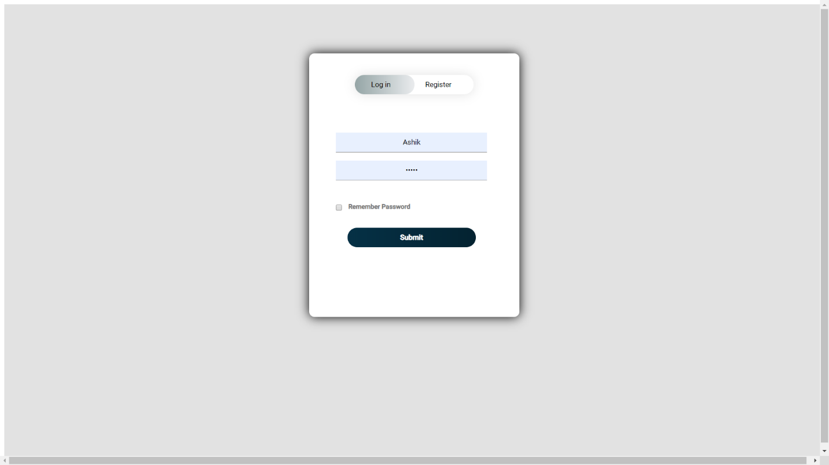

**Description: This is the log in Page.**

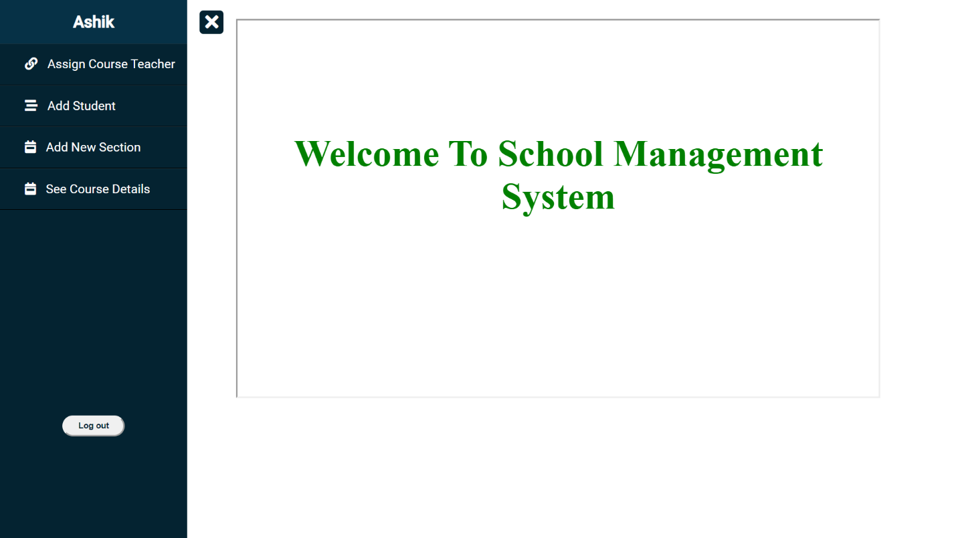

**Description: This is the Admin Home Page.**

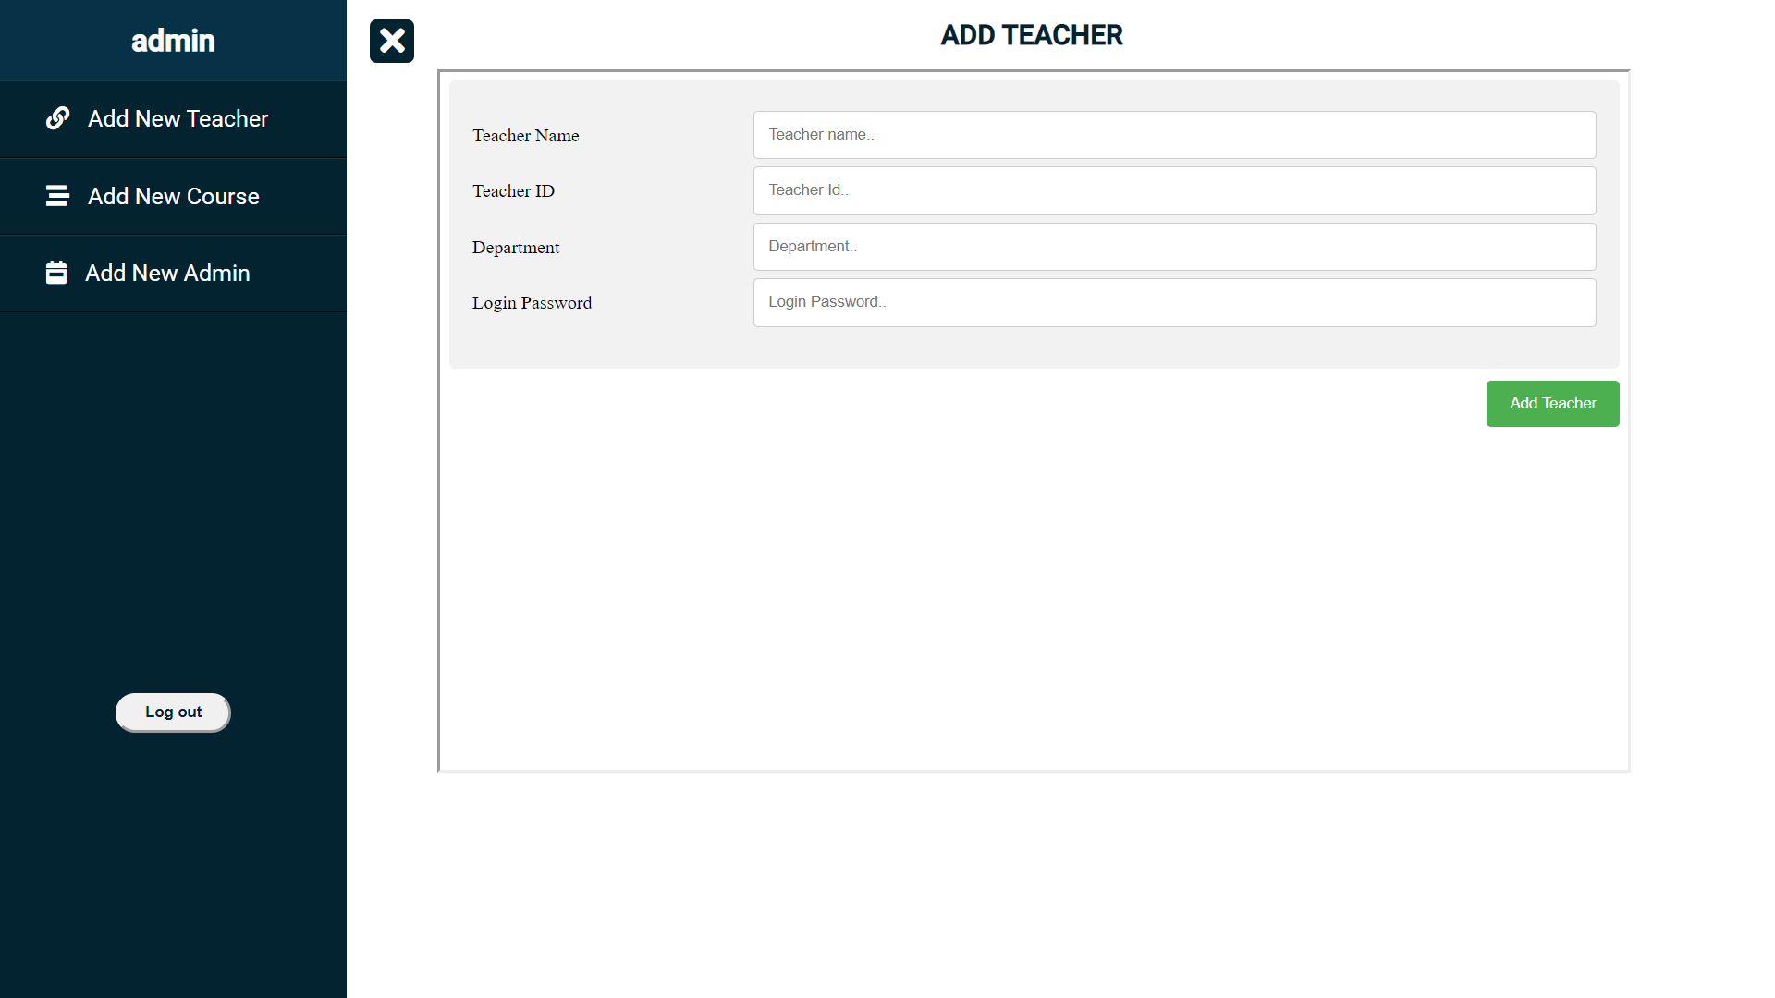

**Description: This is the Super Admin Home Page.**

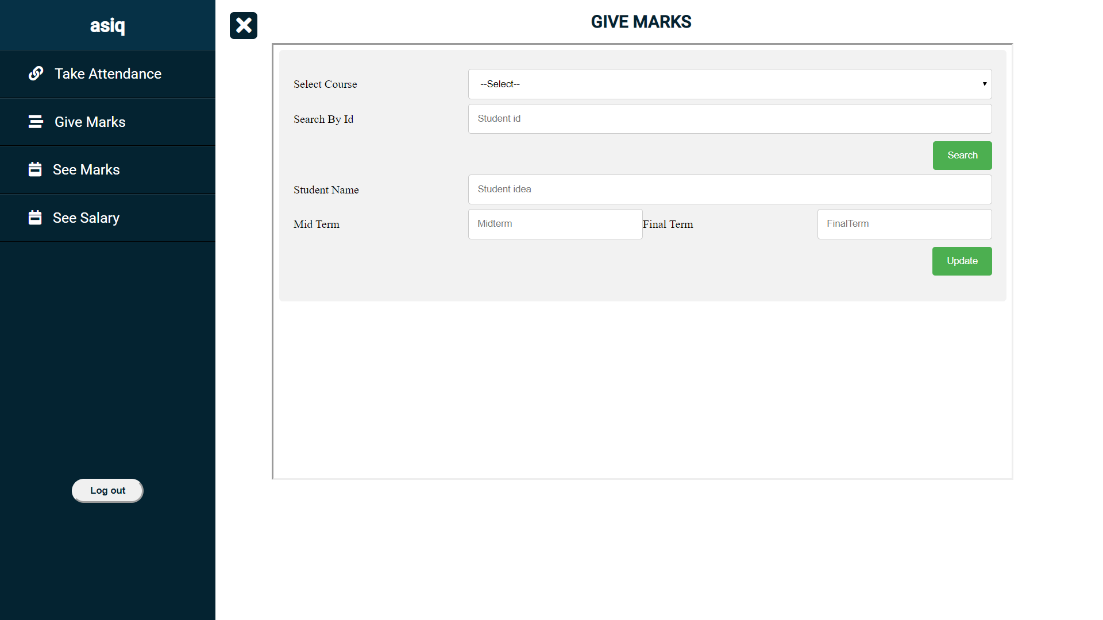

**Description: This is the Teacher Home Page.**

**Imapact of this Project:**

This sytem will help the school to manage the management very easily.It will turn the school management very faster and easier than before. Now the era of internet and this system is online based so this system will same sime and money and efforts.

**Limitation and Drawbacks:**

Like most other Systems this system has some limitation for this reason some features cannot be implemented. It will be more beautiful if we add the rest of the features in future.

***[Note: Make sure that your report is maximum 8 pages (including cover page). Print (Colored) the report and submit it with spiral bind.]***

|  |  |  |  |  |  |
| --- | --- | --- | --- | --- | --- |
| **CO1 and CO3 Evaluation: Project Report Evaluation** | | | | | |
| **Project Proposal**  **(5)** | **Background**  **Study**  **(5)** | **Requirement Analysis**  **(5)** | **Entity**  **Diagram**  **(5)** | **System Images**  **against the**  **Specification (5)** | **Total (25)** |
|  |  |  |  |  |  |
|  | | | | | |