**TASK LIST APPLICATION**

**By Ananda Kishore Sirivella**

1. **Introduction**

Time management strategies are often associated with the recommendation towards particular goals. The literature stresses themes such as - "Work in Priority Order" - set goals and prioritize "Set gravitational goals" - that attract actions automatically. There are various methods to maintain list of task. We have a simple java console application for the purpose.

The standalone console application that is developed using Java swing framework.

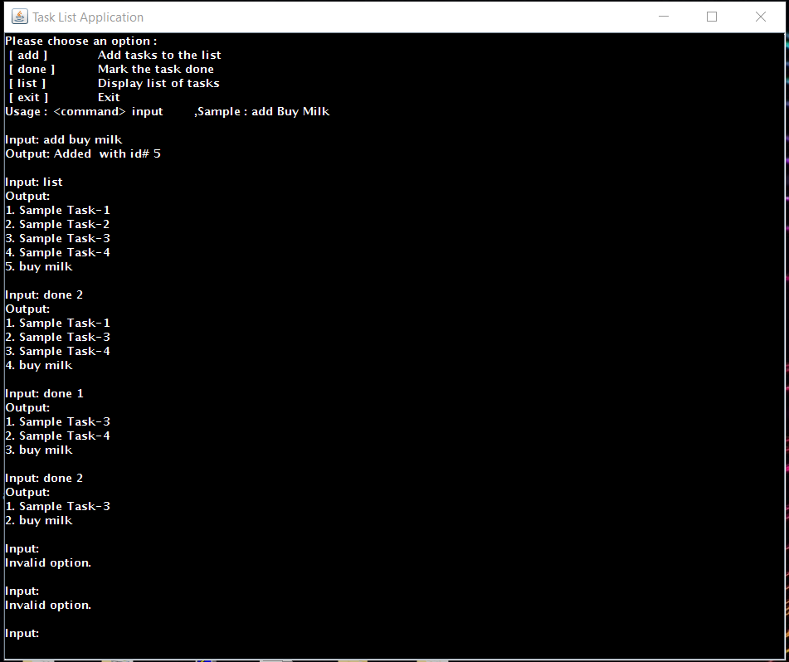

1. **Usage**

* Support the following commands <add>, <done> taskId, <list>.
* Sample interaction follows:

Input: <add> Buy Milk

Output: Added with id# 1

Input: <add> Pick up Dry Cleaners

Output: Added with id #2

Input: <add> Send email to Bob

Output: Added with id #3

Input: <list>

Output:

1. Buy Milk

2. Pick up Dry Cleaners

3. Send email to Bob

Input: <done> 1

Output:

1. Pick up Dry Cleaners

2. Send email to Bob

Input: <done> 2

Output:

1. Pick up Dry Cleaners
2. **Requirements**

* Oracle JDK 7 and JRE 7 installed
* Execution rights to the program.
* Celeron 300 CPU expandable or more.
* 64 MB or more RAM.

1. **References**

* https://docs.oracle.com/javase/tutorial/uiswing/
* <http://www.java2s.com/Code/Java/Swing-Components/CatalogSwing-Components.htm>

1. **Contact**

Ananda Kishore Sirivella

Graduate Student at University of Florida, Gainesville, FL-32601

Linkedin: <https://www.linkedin.com/in/siaki>

Bitbucket: <https://bitbucket.org/siaki/>