**THIS THE FIRST VIEW OF THE PAGE:-**

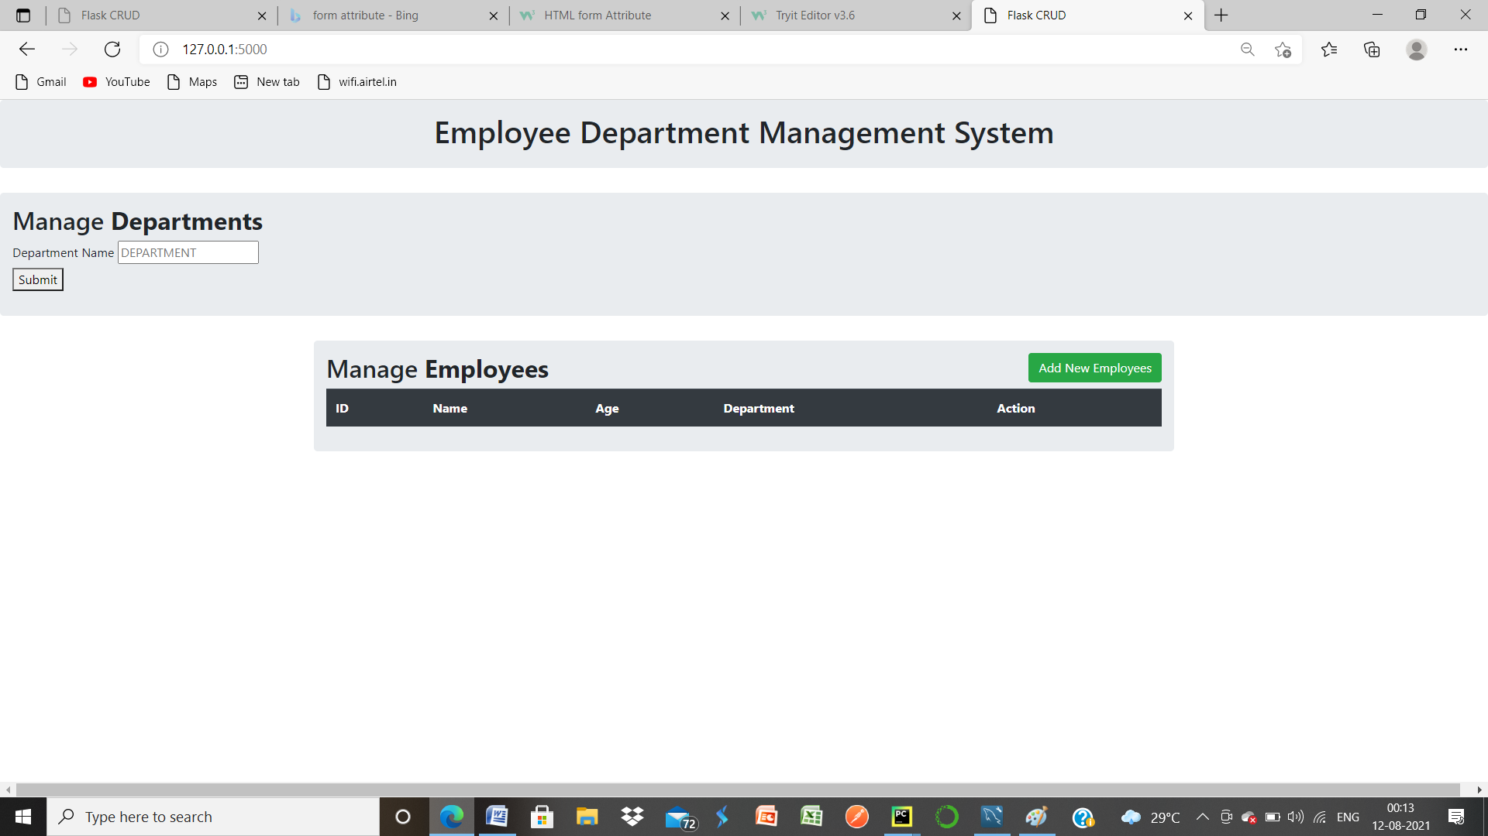

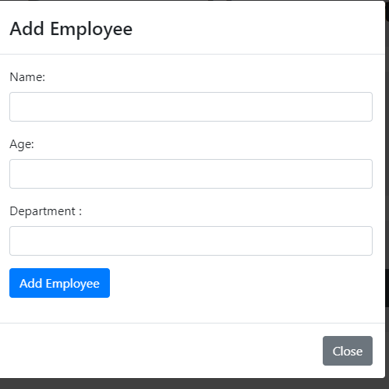

After Successful Insertion operation our webpage look like this

**ADD EMPLOYEE** : After Clicking on this , this window box open

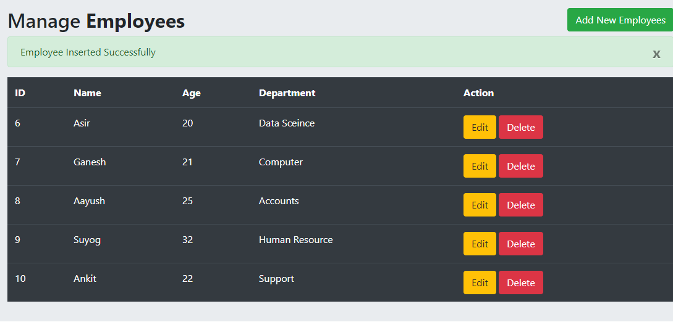

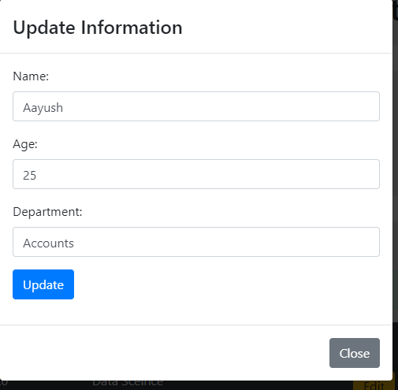

**EDIT** : after you clicking on particular employess edit button then this window open.

**DELETE** : After Click on Delete button the conformation pop up arrives.

