**Introduction**

In the missionaries and cannibals problem, three missionaries and three cannibals must cross a river using a boat which can carry at most two people, under the constraint that, for both banks, if there are missionaries present on the bank, they cannot be outnumbered by cannibals (if they were, the cannibals would eat the missionaries). The boat cannot cross the river by itself with no people on board. And, in some variations, one of the cannibals has only one arm and cannot row.

**About Traverse(Search):**

Graph traversal means visiting every vertex and edge exactly once in a well-defined order. While using certain graph algorithms, we must ensure that each vertex of the graph is visited exactly once. The order in which the vertices are visited are important and may depend upon the algorithm or question that we are solving.

For the mentioned assignment we have used Breadth First Search.

BFS is a traversing algorithm where we start traversing from a selected node and traverse the graph layer wise thus exploring the neighbor nodes. You must then move towards the next-level neighbor nodes.

Example of BFS.

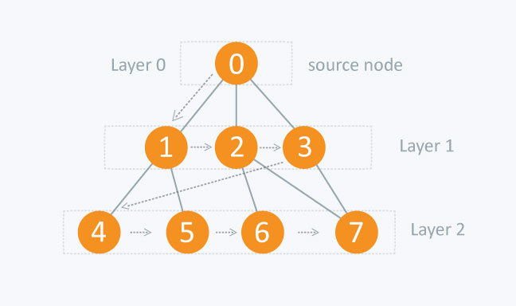

Here node from Layer0 is root node or source node. Now, we find the available nodes for Layer1 in Breadth wise i.e. at first node 1 than 2 and 3. After finding all the nodes we find all the children’s of first node and traverse similarly unit the final state is not reached.

**Language used:**

Python

**Library used:**

Pydot and Graphviz:

They are used to create nodes and edges.

Pygame:

Pygame is a Graphics library used to develop GUI based contents.

**Platform used:**

Atom:

**Atom** is a [free and open-source](https://en.wikipedia.org/wiki/Free_and_open-source_software) [text](https://en.wikipedia.org/wiki/Text_editor) and [source code editor](https://en.wikipedia.org/wiki/Source_code_editor) for [macOS](https://en.wikipedia.org/wiki/MacOS), [Linux](https://en.wikipedia.org/wiki/Linux), and [Microsoft Windows](https://en.wikipedia.org/wiki/Microsoft_Windows) with support for different [plugins](https://en.wikipedia.org/wiki/Plug-in_(computing)).

**Methodology**

​We denote the position of the missionaries, cannibals and boat by (cannibal Left, missionary Left, boat, cannibal Right, missionary Right, game) respectively. If the value of Boat is left then the boat is on the left side of the river. Similarly if the value of Boat is Right then the boat is on the right side of the river.

We consider that at the beginning all the missionaries and cannibals are on the left side of the river. Our initial state is (3,3,'left',0,0, None) which signifies that all 3 missionaries and 3 cannibals are on the same side and the boat is on the left side of the river. And there our goal state is (0,0,'right',3,3, None) which signifies that there are no missionaries and cannibals left on the left side of river and the boat is also on the right side of the river and game isn’t over.

To reach the goal state we take the missionaries and cannibals from the left bank to the right bank according to the conditions of the game. Breadth First Search is applied to search for the first possible solution in the state space tree.

**Result**

* We considered the initial state as : (3,3,left) (cannibals, missionaries)
* Next state : (1,3,right) [2 cannibals are taken to the right side of river ]
* Next state : (2,3,left) [The boat brings back 1 cannibals to the left side of river]
* Next state : (0,3,right)[The boat takes both the cannibals to the right side of river
* Next state : (1,3,left)[The boat bring back 1 cannibal to the left side of river ]
* Next state : (1,1,right)[The boat takes 2 missionaries to the right side of river ]

Next state : (2,2,left)[The boat bring 1 missionary and 1 cannibal to the left side of river ]

* Next state : (2,0,right)[The boat takes both missionaries to the right side of river ]
* Next state : (3,0,left)[The boat brings back 1 cannibal to the left side of river ]
* Next state : (1,0,right)[The boat takes 2 cannibals to the right side of river ]
* Next state : (1,1,left)[The boat brings back 1 missionaries to the left side of river ]

Goal state : (0,0,right)[The boat takes 1 missionaries and 1 cannibal to the right side of river and the final state is obtained]

**State Space Tree for Missionaries and Cannibals Problem:**

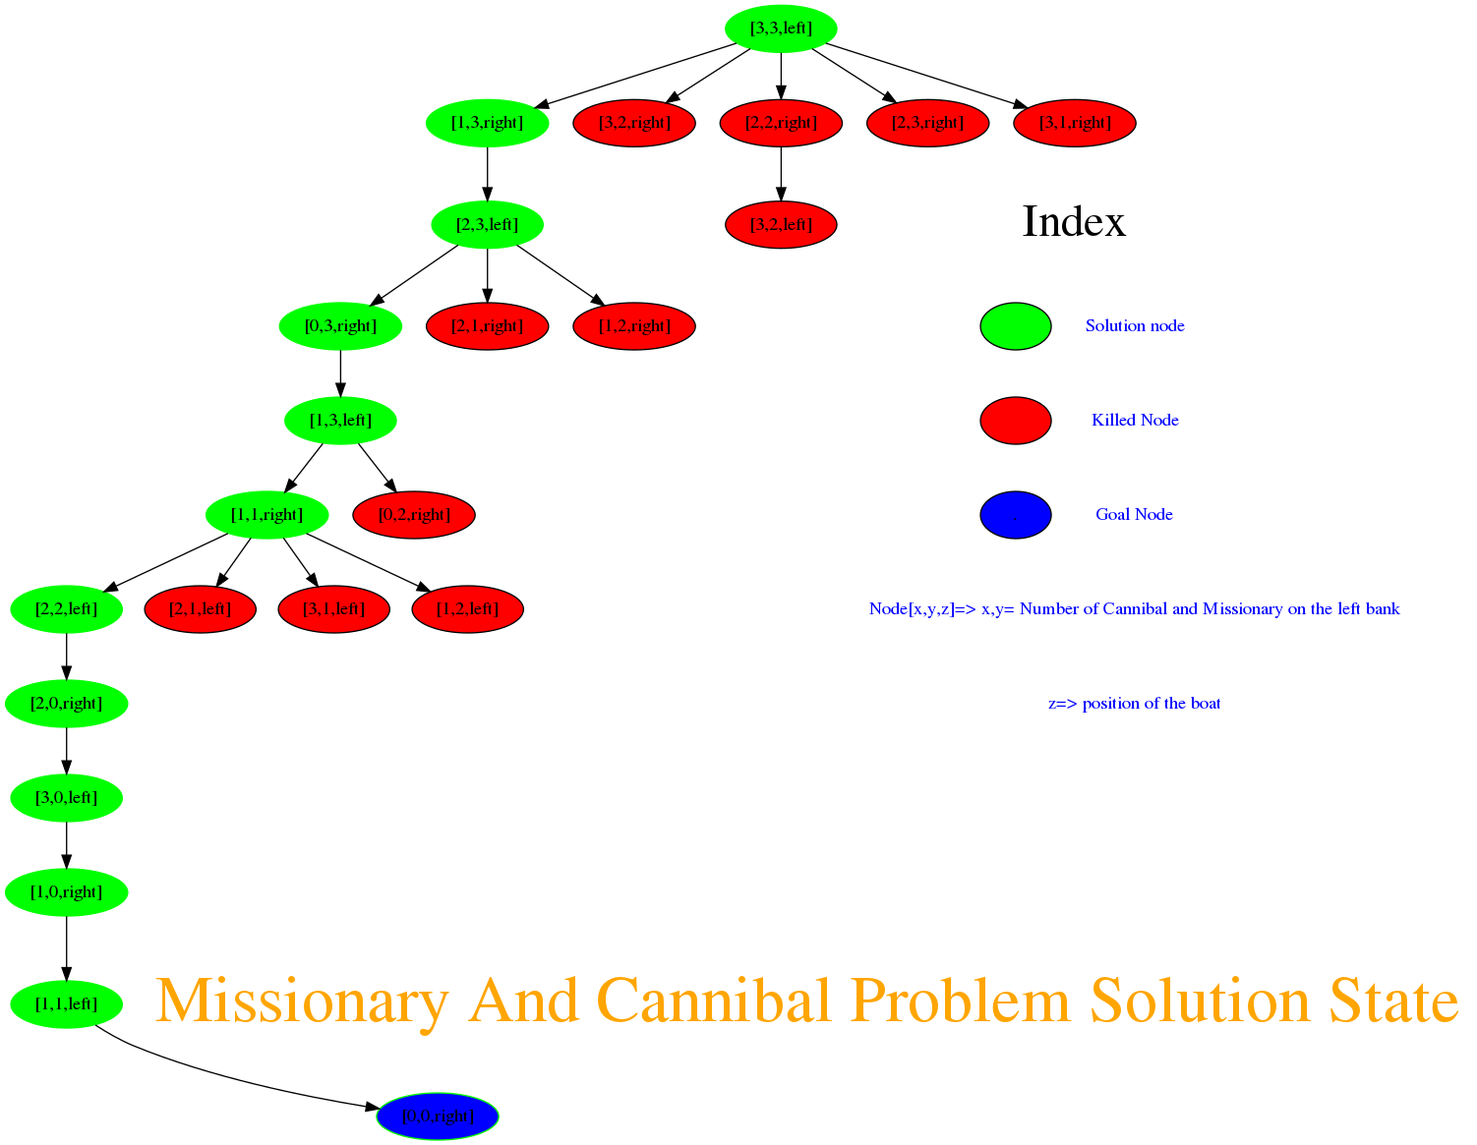

Code for generating state space tree of Missionaries and Cannibals Problem using Breadth First Search:

Algorithm for BFS:

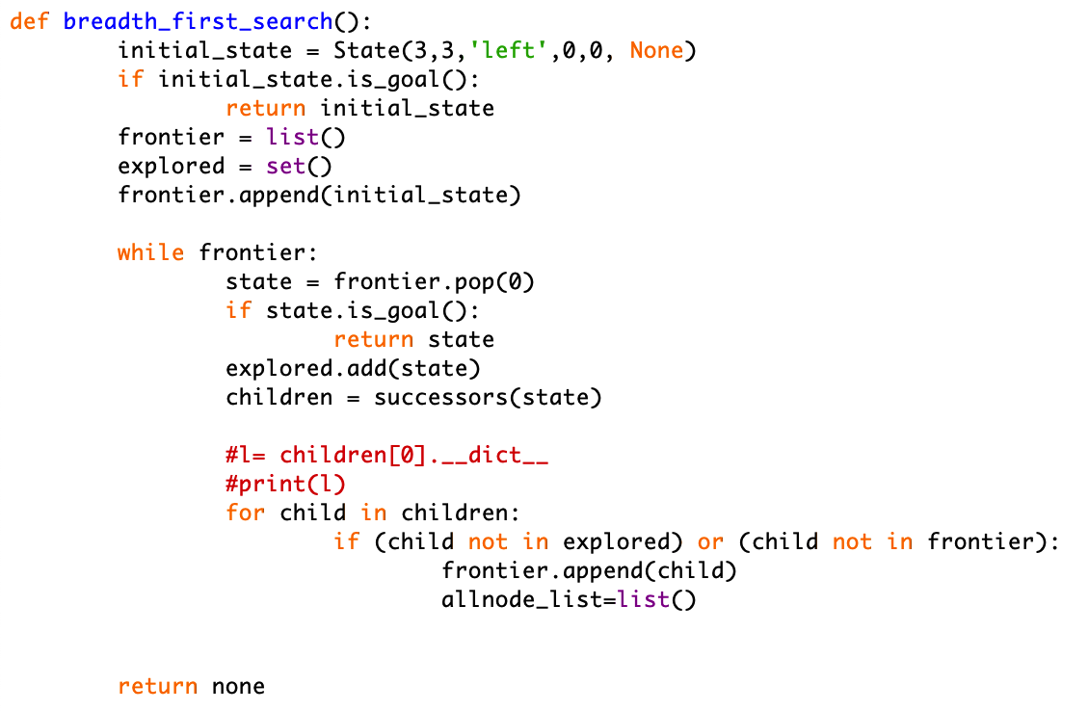

Algorithm to generate children nodes.

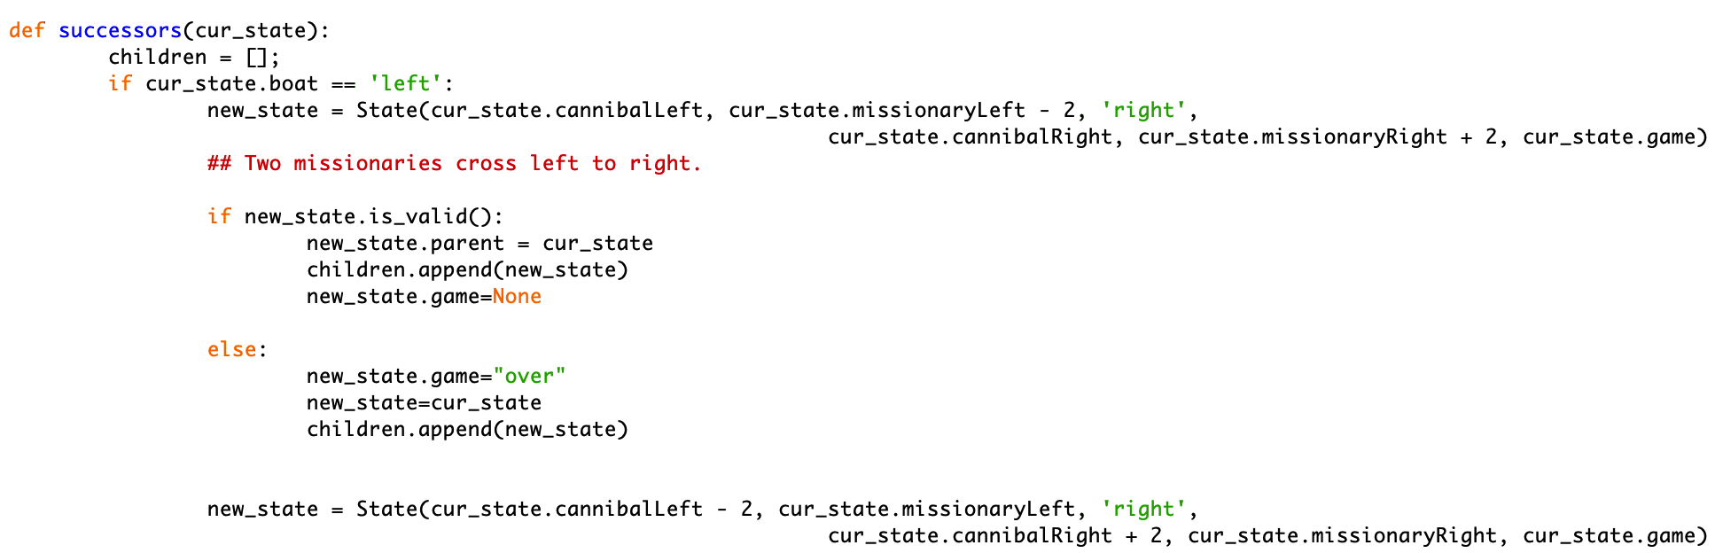

Initial State of Cannibals and Missionaries

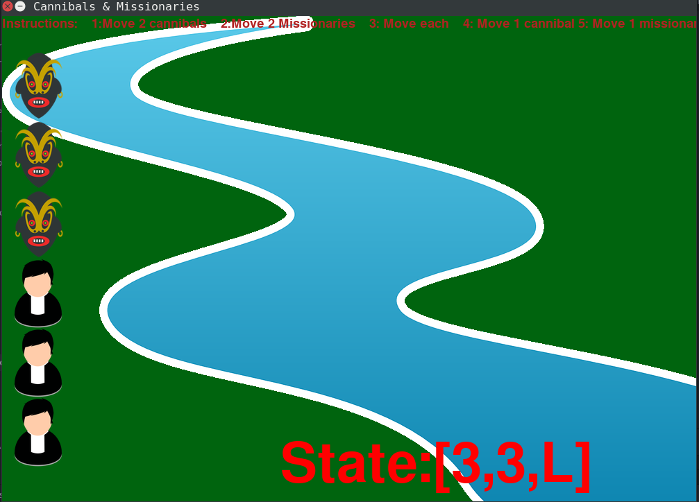

Submitted By :

Ashish Gyawali(15)

Pratik Poudel(34)

Batch 2015,Computer Engineering

Department of Computer Science and Engineering