Flask & MongoDB – DevOps Assignment
Implementation documentation and testing evidence

1. Objective
The objective is to build a Flask application that exposes a JSON API backed by a local JSON file and provides a frontend form that stores submitted data in MongoDB Atlas. The application handles successful submissions with a redirect and displays errors on the form page without redirecting.

2. Project structure
The project contains app.py, data.json, requirements.txt, .env.example, .gitignore, README.md, two Jinja2 templates (index.html and success.html), and this documentation file.

3. Task 1 – JSON API route
The GET /api route opens data.json using Python's json module, parses its contents, verifies that the top-level value is a list, and returns it using Flask's jsonify(). File-not-found, invalid JSON, and file-read errors are handled with a JSON error response and an appropriate HTTP status.
Test command: curl http://127.0.0.1:5000/api
Expected result: an HTTP 200 response containing the three sample records from data.json.

[INSERT SCREENSHOT 1: Terminal showing the Flask development server running.]
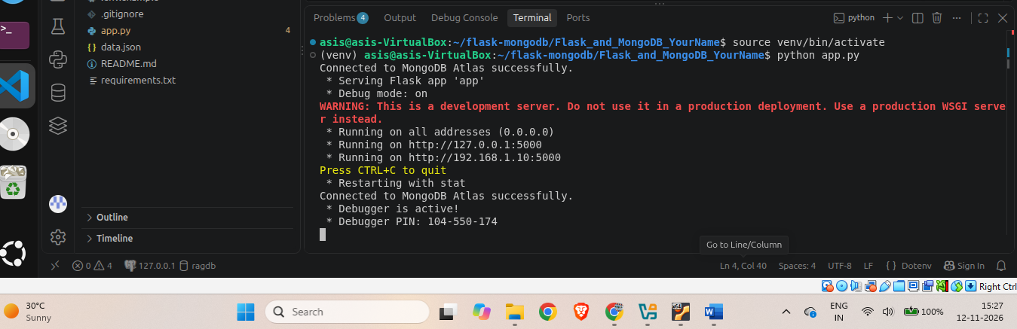
[INSERT SCREENSHOT 2: Browser or terminal showing the JSON response from /api.]
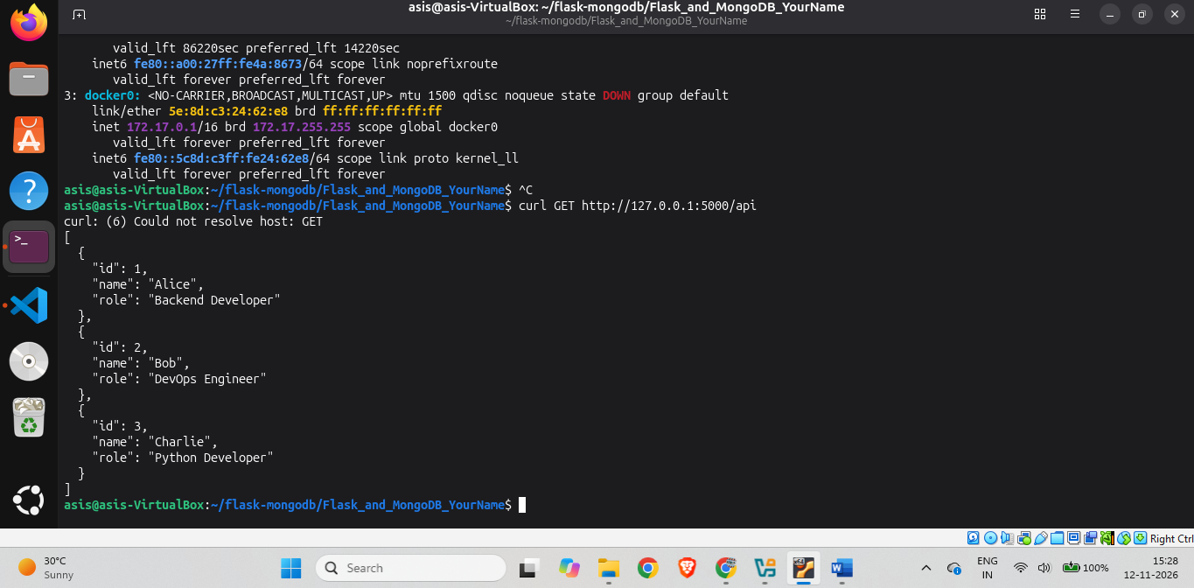

4. Task 2 – Frontend form and MongoDB Atlas
The home route renders templates/index.html. The form sends a POST request to /submit with name, email, and message fields. The route trims and validates the fields before attempting a MongoDB insert.
PyMongo connects to MongoDB Atlas using MONGODB_URI from the local .env file. Database and collection names are configurable through MONGODB_DATABASE and MONGODB_COLLECTION. Credentials are not hard-coded.
On a successful insert, the application responds with a 303 redirect to /success. The success page displays the exact message: “Data submitted successfully”. On validation, connection, or insert errors, the index page is rendered again with an error message and previously entered values.

[INSERT SCREENSHOT 3: MongoDB Atlas cluster/database/collection visible. Do not show credentials.]
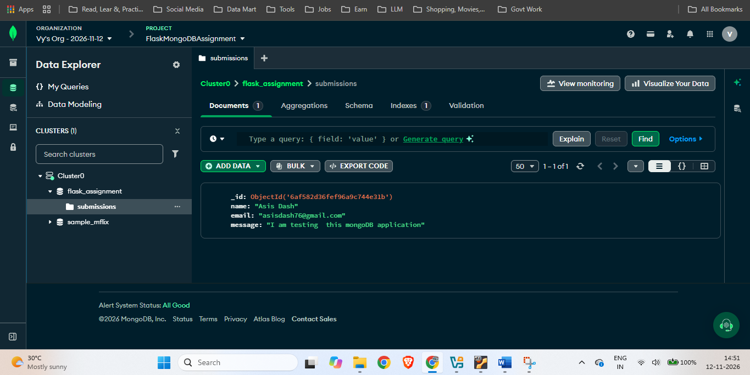

[INSERT SCREENSHOT 4: Frontend form filled in before submission.]
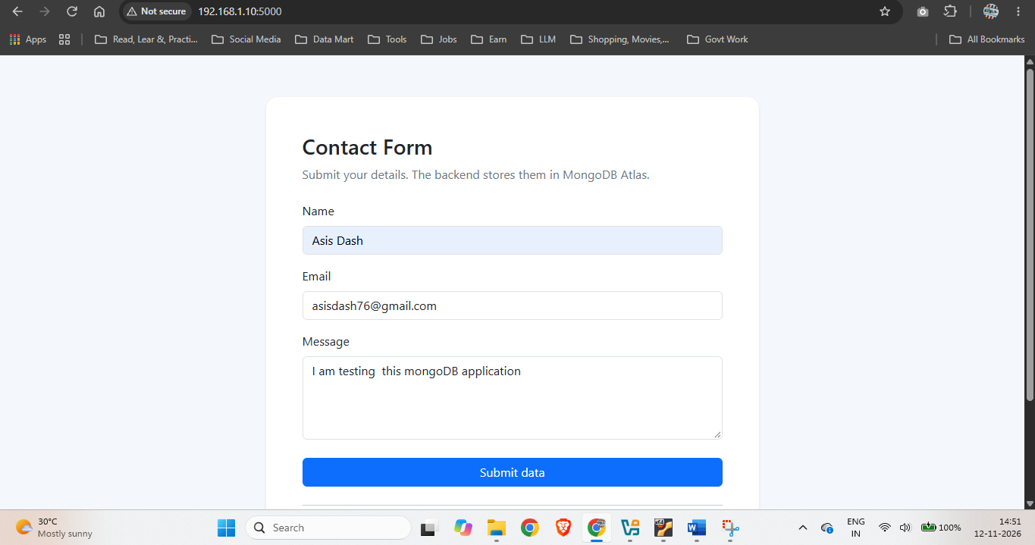

[INSERT SCREENSHOT 5: Success page displaying “Data submitted successfully”.]
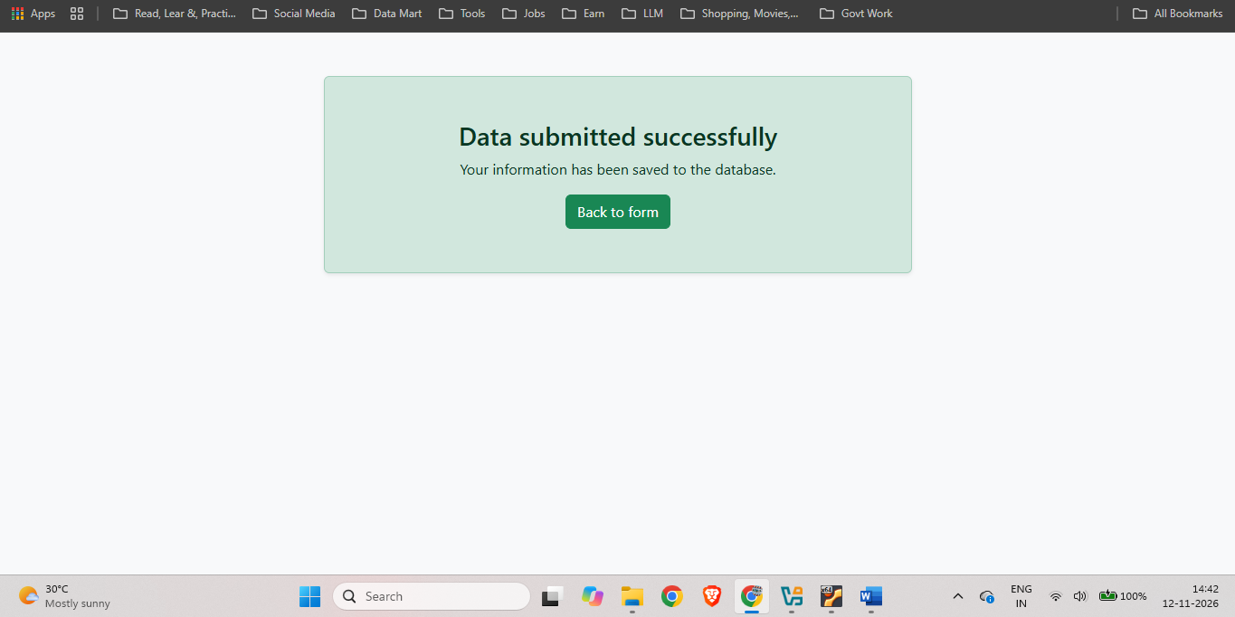

[INSERT SCREENSHOT 6: MongoDB Atlas document showing the submitted fields.]
[INSERT SCREENSHOT 7: Error message displayed on the same form page without redirect.]
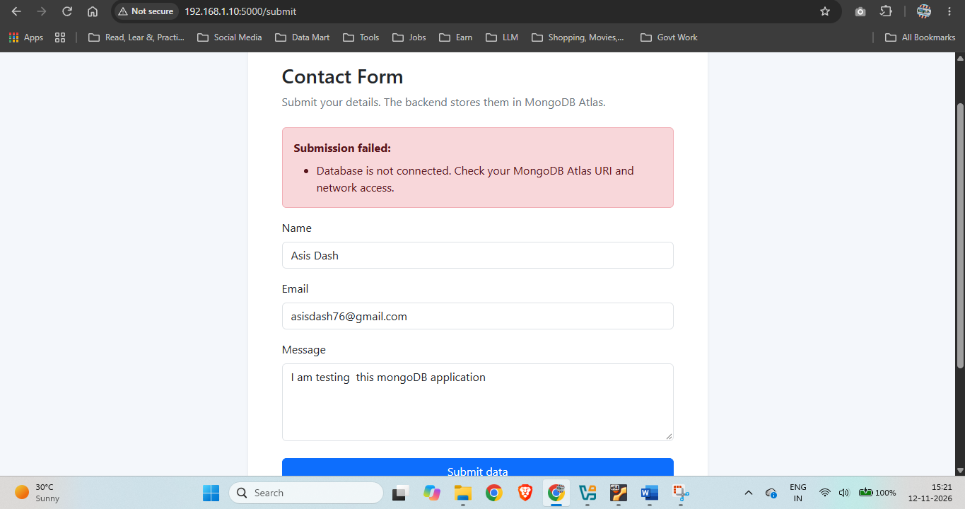

5. Commands used
- python -m venv .venv
- .venv\\Scripts\\Activate.ps1 (Windows PowerShell)
- source .venv/bin/activate (macOS/Linux)
- pip install -r requirements.txt
- Copy .env.example to .env and configure the MongoDB Atlas URI
- python app.py
- curl http://127.0.0.1:5000/api

6. Error handling and security
The application validates required fields and basic email format, catches PyMongo errors, and avoids exposing database exception details to the browser. The MongoDB URI is loaded from an environment file. The .env file is excluded from Git using .gitignore. Atlas Network Access should be restricted to the developer's current IP rather than left open to all addresses.

7. GitHub repository
Repository URL: [PASTE YOUR GITHUB REPOSITORY URL HERE]
Before pushing, confirm that .env is not staged or committed. Push the source code, templates, data.json, README, requirements file and documentation.

8. Final submission checklist
☐ Project runs locally and /api returns a JSON list.
☐ Successful form submission creates a document in MongoDB Atlas.
☐ Successful submission redirects to the success page.
☐ An error is displayed on the same form page without redirect.
☐ All seven genuine screenshots have been inserted above.
☐ GitHub repository URL has been added.
☐ The project folder has been renamed Flask_and_MongoDB_AsisDash.
☐ The folder has been compressed into Flask_and_MongoDB_YourName.zip.

