Linux Basics Assignment, Asis Dash, 1-Oct-2026
Task-1
Create a directory named test_dir using mkdir
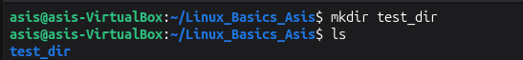
Task-2
Inside test_dir, create an empty file called example.txt
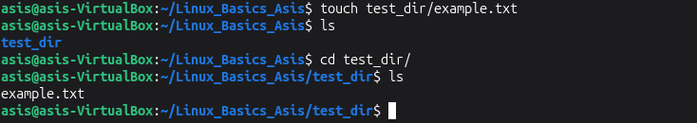
Task-3
Rename example.txt to renamed_example.txt using mv
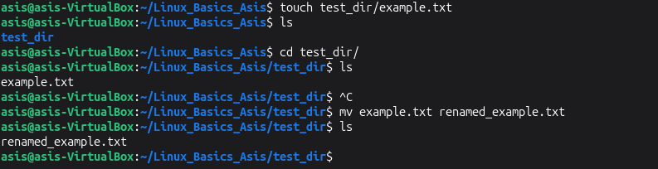
Task-4
Use cat to display the contents of /etc/passwd
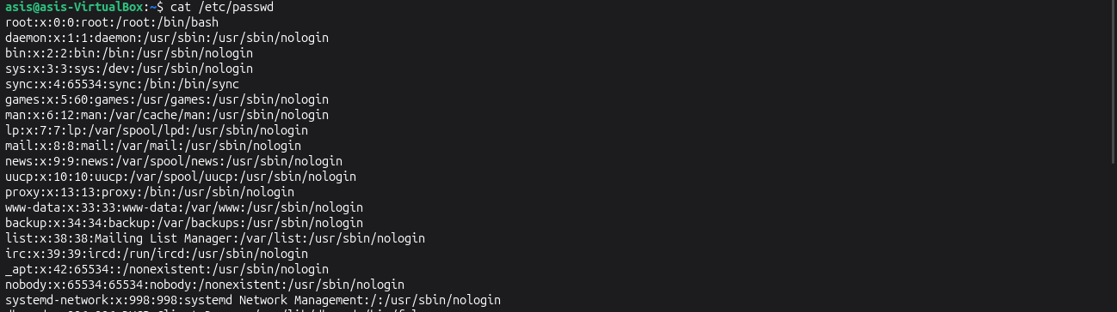

Task-5
Display only the first 5 lines of /etc/passwd using head
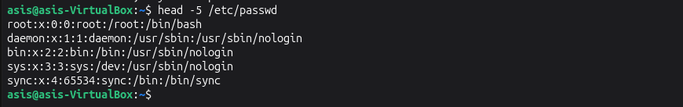
Task-6
Display only the first 5 lines of /etc/passwd using tail
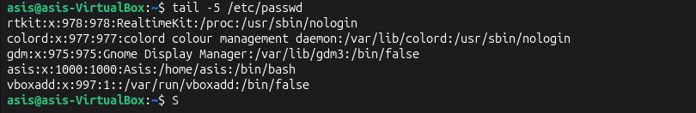
Task-7
Use grep to find all lines containing the word "root" in /etc/passwd
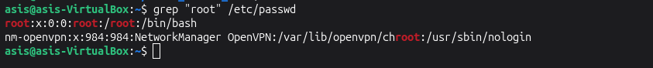
Task-8
Compress test_dir into test_dir.zip using zip
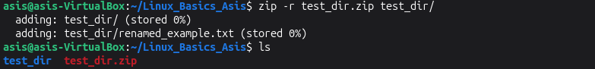
Task-9
Unzip test_dir.zip into a new directory named unzipped_dir
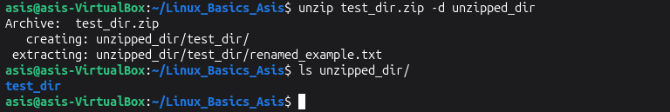

Task-10
Use wget to download a file from a URL
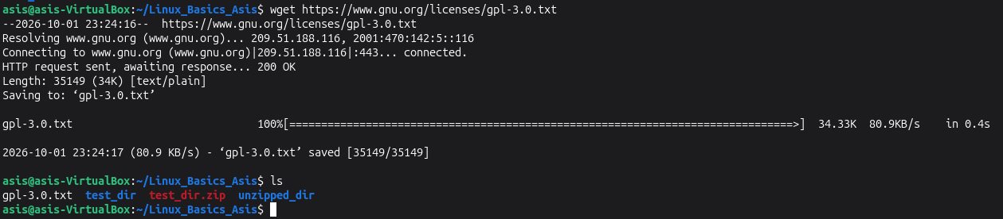
Task-11
Create secure.txt and make it read-only for everyone using chmod
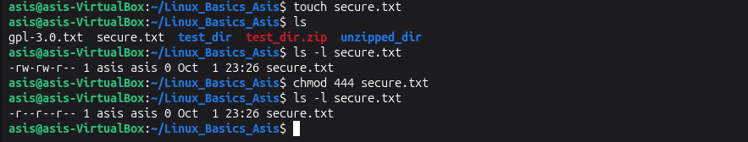
Task-12
Use export to set MY_VAR with the value "Hello, Linux!"
