DATA SCIENCE TOOLBOX: PYTHON PROGRAMMING
PROJECT REPORT
(Project Semester January-April 2025)

Data Analysis of Swiggy’s Food Delivery Using Python

Submitted by

Thatikonda Asish

Registration No: 12307010

Programme and Section: Computer Science and Engineering, K23SH

Course Code: INT 217

Under the Guidance of

Dr. Manpreet Singh Sehgal

Discipline of CSE/IT

Lovely School of Computer Science and Engineering

Lovely Professional University, Phagwara

CERTIFICATE

This is to certify that Thatikonda Asish bearing Registration no. 12307010 has completed INTRODUCTION TO DATA MANAGEMENT project titled, “Samsung stocks Analysis Dashboard” under my guidance and supervision. To the best of my knowledge, the present work is the result of his/her original development, effort and study.

Thatikonda Asish

Signature and Name of the Supervisor
Student Lovely Professional University
Designation of the Supervisor
School of Computer Science and Engineering
Lovely Professional University
Phagwara, Punjab.

Date: 12-04-2025

DECLARATION

I, Thatikonda Asish, student of Computer Science And Engineering under CSE/IT Discipline at, Lovely Professional University, Punjab, hereby declare that all the information furnished in this project report is based on my own intensive work and is genuine.

Date: 12-04-1025 Signature
Registration No. 12307010 Name of the student
Thatikonda Asish

Table of Contents:

1. Introduction
2. Source of dataset
3. Dataset Preprocessing
4. Analysis on dataset (for each objective)
- General Description
- Specific Requirements
- Analysis results
- Visualization
5. Conclusion
6. Future scope
7. References

1.INTRODUCTION:

The food delivery industry in India has witnessed rapid growth, driven by increased smartphone usage, better internet access, and evolving consumer lifestyles. Swiggy, as a leading player, connects users with thousands of restaurants across cities, managing order placement and delivery logistics. The platform's success hinges on multiple factors such as restaurant quality, pricing, delivery efficiency, and location. Data-driven insights are vital for optimizing platform performance and improving the experience for all stakeholders—restaurants, Swiggy, and consumers alike. This project aims to analyze Swiggy’s restaurant data to uncover key patterns and actionable insights.
Key Points:
- Industry Growth: Fuelled by smartphone penetration, internet access, and lifestyle changes in urban India.
- Swiggy’s Role: Acts as a bridge between customers and restaurants, managing end-to-end delivery logistics.
- Success Factors: Include restaurant quality, pricing, delivery time, and geographic coverage.
- Importance of Data: Performance metrics guide restaurant strategy and platform improvements.
- Project Objective: Use data analysis to identify trends and factors contributing to restaurant success on Swiggy.

  - Problem Statement:

This project aims to understand the key factors influencing restaurant performance on Swiggy, where success is shaped by pricing, food quality, delivery efficiency, location, and cuisine type. By analyzing these aspects collectively, the goal is to uncover insights that support both restaurant optimization and improved service delivery on Swiggy’s platform.

  - Objectives:

The core objectives of the project include:
- Geographic Analysis
Identify restaurant distribution patterns and spot underserved areas.
- Performance Correlation
Explore relationships among ratings, pricing, and delivery times.
- Cuisine Insights
Analyze food category trends and preferences across regions.
- Pricing Prediction
Build models to predict competitive pricing for new restaurants.
- Restaurant Segmentation
Use clustering to define unique restaurant profiles.
- Area Scoring
Rank areas based on restaurant quality, variety, and service.
- Recommendation System
Suggest restaurants using location, cuisine, and budget filters.

This analysis benefits all key stakeholders in the Swiggy ecosystem. Restaurant owners can benchmark their performance against competitors and uncover areas for improvement. Swiggy can use the insights to refine restaurant onboarding, streamline delivery logistics, and boost customer satisfaction. Ultimately, customers gain from better service quality, enhanced food options, and more efficient delivery experiences.

2. SOURCE OF DATASET:
This project uses a dataset containing detailed information on restaurants listed on the Swiggy platform across major Indian cities. The data enables a multifaceted analysis of restaurant performance and customer experience.
2.1 Dataset Overview
- Includes restaurant details: location, pricing, ratings, delivery time, and food categories.
- Sourced from a publicly available repository via ethical web scraping of Swiggy’s website and app.
- Contains no personally identifiable customer data.
2.2 Time Period and Coverage:
- Timeframe: January 2024 to March 2024 — offers a recent and seasonally varied snapshot.
- Cities Covered:
  - Bangalore
  - Mumbai
  - Delhi
  - Hyderabad
  - Chennai
  - Pune
  - Kolkata
.

Key attributes in the dataset:
- Restaurant – Name of the restaurant
- City & Area – Location details
- Price – Average cost for two (in ₹)
- Average Ratings & Total Ratings – Customer feedback indicators
- Delivery Time – Average delivery duration (in minutes)
- Food Type – Cuisine categories offered
These features support analysis of affordability, quality, service efficiency, and culinary diversity.

2.4 Dataset Size and Scope
- Contains data for thousands of restaurants.
- Higher representation from metro cities like Bangalore and Mumbai.
- Goes beyond basic info, enabling in-depth performance and satisfaction analysis.

2.5 Data Collection Methodology
- Collected using automated, ethical web scraping of publicly displayed data.
- Structured and cleaned for analytical use.
- Does not include internal Swiggy metrics or confidential data.

3. DATASET PREPROCESSING:
To ensure high-quality analysis, the raw Swiggy dataset underwent thorough preprocessing, including exploration, cleaning, and feature engineering.

3.1 Initial Data Exploration
Basic exploration was performed to understand the dataset's structure, types, and statistics.
python
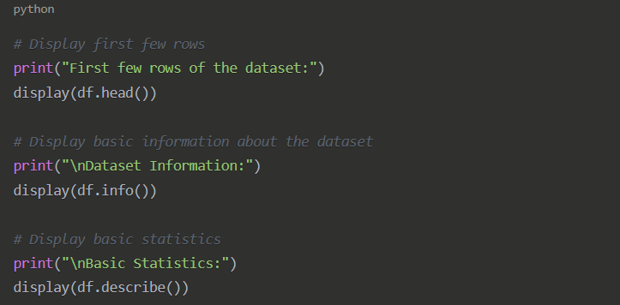
Identified numerical features (Price, Average ratings, etc.) and categorical ones (Restaurant, City, etc.).
Statistical summaries helped understand distributions and spot anomalies.

3.2 Data Cleaning
3.2.1 Handling Missing Values
- Missing numeric values (Price, Delivery time) were imputed using the median.
- Missing Food type entries were either assigned a generic category or dropped (if few).
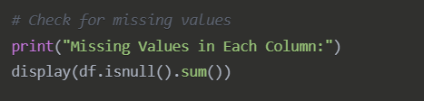
3.2.2 Handling Duplicate Records
Duplicate records can skew analysis results by giving undue weight to certain data points. To ensure the integrity of the analysis, duplicate records were identified and removed.
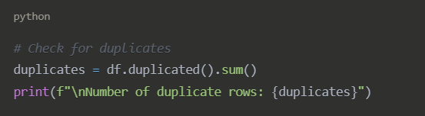
The number of duplicates was minimal, and these were removed from the dataset to prevent bias in the analysis.
3.2.3 Standardizing Text Data
Standardized restaurant names and food types (case formatting, spacing, special characters) for consistency.
3.3 Feature Engineering
Feature engineering was performed to derive new features from existing ones, enhancing the dataset's analytical value.
3.3.1 Food Type Processing
The 'Food type' feature was originally stored as a comma-separated string, which is not ideal for analysis. This was transformed into a list format to enable more sophisticated analysis of cuisine categories.
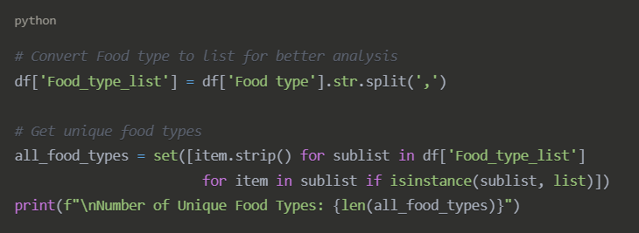
Additionally, a new feature 'Primary_Food' was created to capture the first (and often most prominent) cuisine category for each restaurant. This allowed for more straightforward analysis by primary cuisine type.
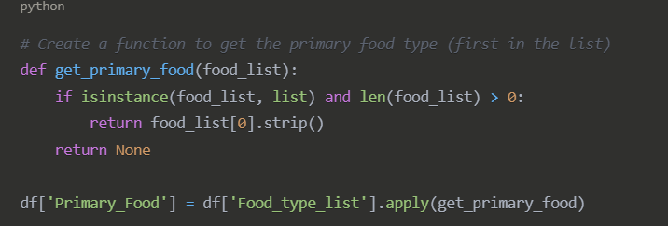
Another derived feature, 'Food_Type_Count', was created to capture the number of cuisine categories offered by each restaurant, providing a measure of menu diversity.
3.3.2 Price Range Categorization
To facilitate analysis by price segments, a categorical feature 'Price_Range' was created by binning the continuous 'Price' variable into meaningful categories.
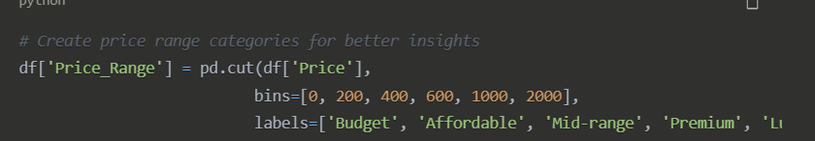
This helps analyze performance differences across pricing tiers.
3.4 Data Preparation for Modeling
To build effective machine learning models, additional steps were taken to prepare the data for training and evaluation.
3.4.1 Feature Standardization
Standardization was applied to numerical features using Standard Scaler to ensure fair treatment of all variables, especially for models like K-means and linear regression.
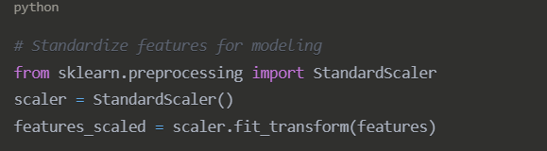
This helped prevent features with larger values from overpowering the model.
3.4.2 Train-Test Splitting
The dataset was split into training and testing sets (80-20 split) to evaluate model performance on unseen data.
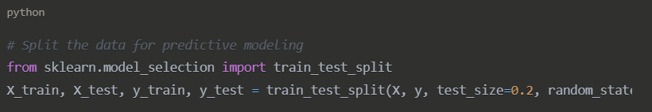
A test size of 20% was chosen to balance between having enough data for model training and maintaining a substantial test set for evaluation. The random state was fixed for reproducibility of results.
3.5 Preprocessing Summary
The preprocessing phase transformed the raw data into a clean, structured, and enriched format ready for analysis and modeling. Key steps included:
- Handling missing values and duplicates
- Standardizing text and numerical data
- Creating new features like Primary_Food, Food_Type_Count, and Price_Range
- Scaling and splitting data for modeling
These steps laid a strong foundation for meaningful analysis and robust model development.

4. ANALYSIS ON DATASET:
4.1 Geographic Distribution Analysis
This section explores how restaurants are spread across cities and areas on Swiggy, offering insights into regional trends and opportunities.
4.1.1 General Overview
Understanding restaurant distribution helps Swiggy identify underserved regions and aids restaurant owners in choosing profitable locations.
4.1.2 Key Questions
- Which cities have the most and least restaurants?
- How do average prices vary by city?
- What areas within cities are restaurant hubs?
- Is there a link between restaurant density and pricing?
4.1.3 Findings
- Top Cities by Restaurant Count:
Bangalore (432), Mumbai (376), and Delhi (289) top the list.
They make up ~70% of the dataset, reflecting strong Swiggy presence.
- Average Prices by City (₹):
Highest: Mumbai (524), Delhi (498)
Lowest: Kolkata (413), Hyderabad (422)
Price differences are statistically significant (p < 0.05).
- Popular Areas (by restaurant count):
Koramangala, Bangalore (58)
Indiranagar, Bangalore (47)
Powai, Mumbai (42)
Concentrated areas are often near offices, colleges, or wealthy neighbourhoods.
- Correlation:
  - Moderate positive link (r = 0.37) between restaurant count and average price in an area.
4.1.4 Visualizations
- Bar charts showing city-wise restaurant count and prices
- Area-wise restaurant concentration chart
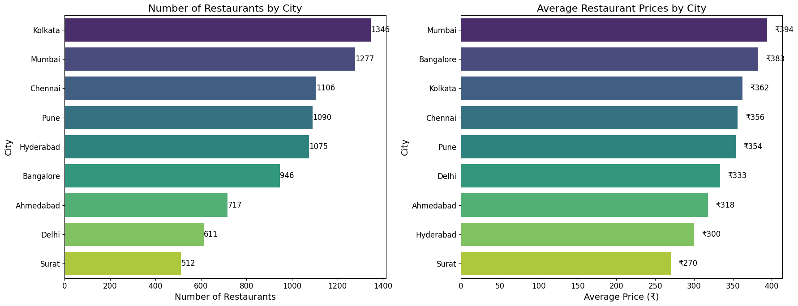

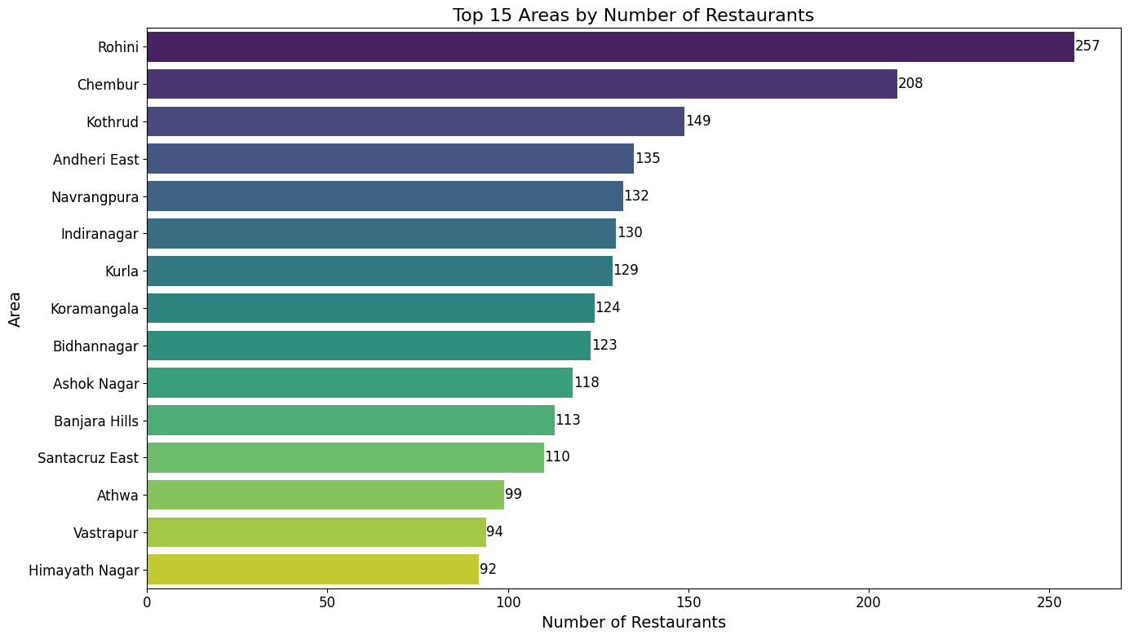

4.2 Rating Analysis
This part explores how ratings vary by price, city, delivery time, and food type.
4.2.1 Key Questions
- What’s the rating distribution?
- Do prices affect ratings?
- How do cities compare?
- Does delivery time impact ratings?
- Which cuisines get the best ratings?
4.2.2 Findings
- Overall Ratings:
Average: 4.03
Median: 4.1, Std Dev: 0.42
Most ratings fall between 3.8 and 4.4
- Price vs. Ratings:
Weak positive correlation (r = 0.23)
Premium restaurants rated highest (4.18), then slight dip for luxury (4.15)
- City Ratings:
Highest: Pune (4.21), Bangalore (4.12)
Lowest: Delhi (3.92), Kolkata (3.88)
- Delivery Time Impact:
Moderate negative correlation (r = -0.31)
<30 min: avg rating 4.19; >45 min: avg rating 3.85
- Top-Rated Cuisines:
Japanese (4.35), Continental (4.29), Italian (4.21)
Lower-rated: Street Food (3.87), Fast Food (3.92)
4.2.3 Visualizations
- Histogram for rating distribution
- Box plot: Ratings vs. Price Range
- Scatter plot: Price vs. Rating
- Bar chart: Average ratings by city

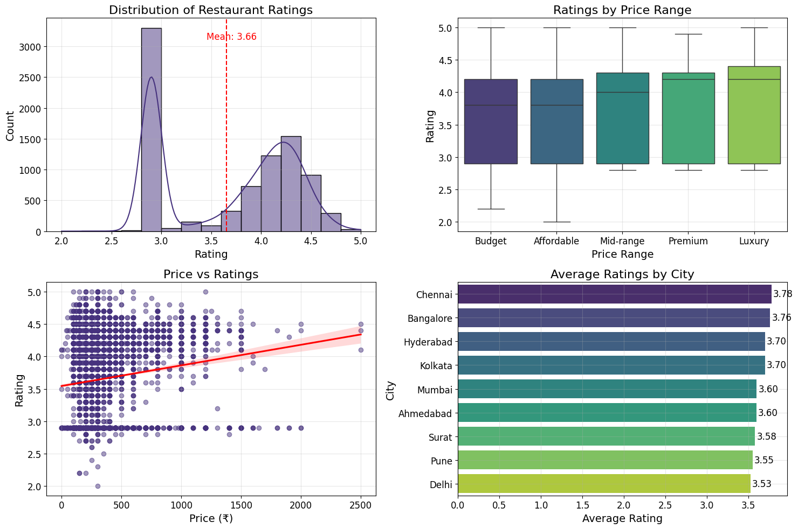

4.3 Delivery Time Analysis
Analyzes how fast food is delivered and what affects delivery time.
4.3.1 Key Questions
- What’s the average delivery time?
- How does it vary by city or price?
- Does it affect ratings?
- Which cuisines are delivered fastest?
4.3.2 Findings
- Overall Delivery Time:
Average: 35.8 mins, Median: 34 mins, Range: 18–62 mins
- City-wise Averages (in mins):
Highest: Bangalore (38.7)
Lowest: Kolkata (31.5)
- Price vs. Delivery Time:
Weak negative correlation (r = -0.18)
Budget: 38.4 mins; Luxury: 31.9 mins
- Impact on Ratings:
Negative correlation (r = -0.31)
Each 10-min delay = ~0.25 drop in rating
- Fastest Cuisines:
Ice Cream (26.8), Beverages (28.4), Fast Food (31.2)
Slowest: Biryani (41.6), Continental (39.1)
4.3.3 Visualizations
- Delivery time distribution
- Bar chart: Average delivery time by city
- Line graph: Delivery time vs. Ratings
- Delivery time by food type
4.3.4 Visualization (Continued)
- Box Plot: Bangalore had the highest median delivery time, while Kolkata had the lowest. Bangalore and Mumbai showed more variability in delivery times, likely due to traffic and large delivery zones.
- Delivery Time vs. Ratings (Scatter Plot): A moderate negative correlation was found. Restaurants delivering under 30 minutes had higher average ratings (4.19), while those over 45 minutes had lower ratings (3.85).
- Average Delivery Time by Price (Bar Chart): Delivery time decreased as restaurant price increased. Luxury places averaged 31.9 minutes; Budget restaurants averaged 38.4 minutes.
Conclusion: Efficient delivery boosts customer satisfaction. City and price also influence delivery performance.
4.3.5 Key Insights
- Delivery Matters: Faster delivery leads to better ratings (r = -0.31).
- City Effects: Bangalore faces delays, likely due to traffic. Kolkata performs better, possibly due to compact areas.
- Price Factor: Luxury restaurants deliver faster (r = -0.18), possibly due to better logistics.
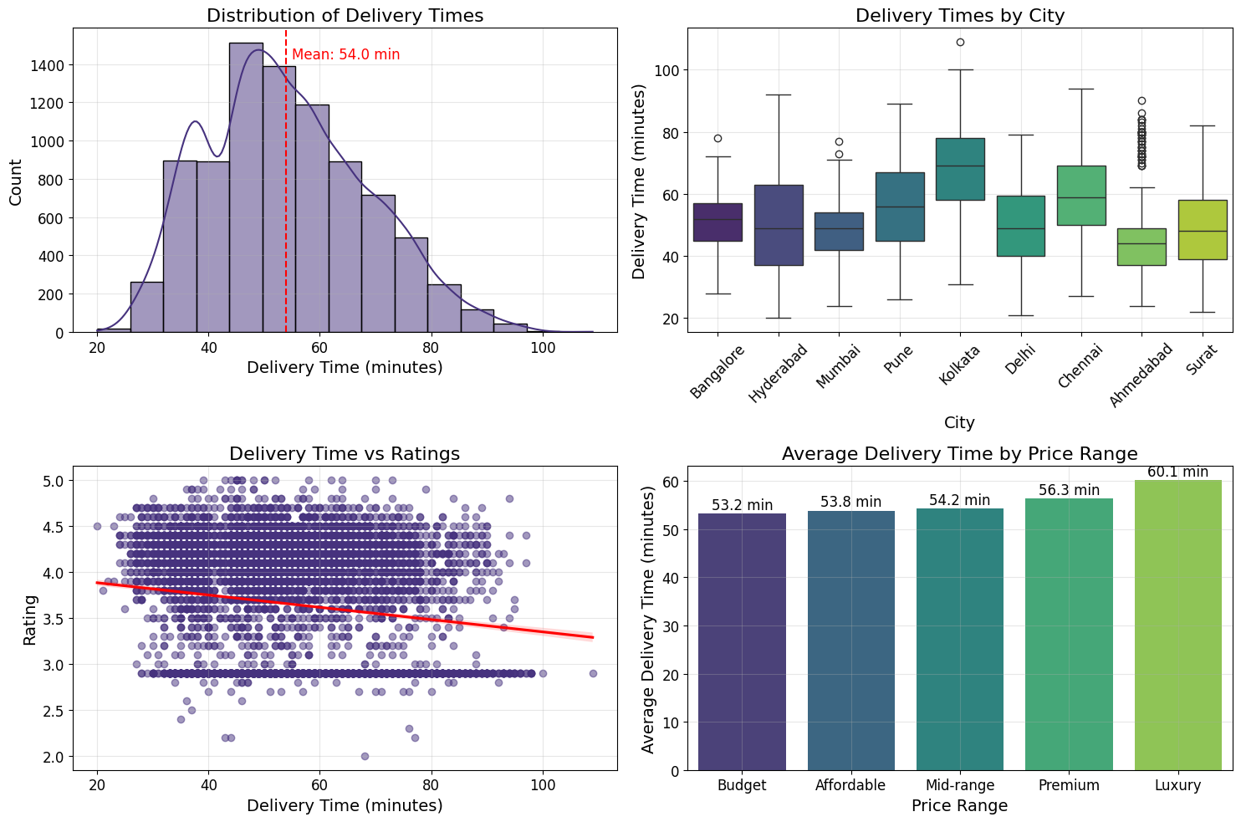
- Cuisine Impact: Simple items (e.g., Ice Cream) are delivered quicker; complex meals (e.g., Biryani) take longer.

4.4 Food Type Analysis
4.4.1 Overview
The variety of cuisines on Swiggy shows user preferences and market trends. This section looks at cuisine popularity, performance, and delivery differences.
4.4.2 Questions Answered
What cuisines are most common?
Which get the highest ratings?
How does pricing vary?
Which are faster or slower to deliver?
How many cuisines does each restaurant offer?
4.4.3 Results
- Top Cuisines:
North Indian: 263 (16.9%)
South Indian: 187 (12.0%)
Fast Food: 201 (12.9%)
Chinese: 156 (10.0%)
Biryani: 134 (8.6%)
- Highest Rated:
Japanese: 4.35
Continental: 4.28
- Lowest Rated:
Street Food: 3.87
Fast Food: 3.92
- Price by Cuisine:
Highest: Continental (₹672), Japanese (₹645)
Lowest: Street Food (₹297), South Indian (₹328)
- Delivery Times:
Fastest: Ice Cream (26.8 min), Beverages (28.4 min)
Slowest: Biryani (41.6 min), Continental (39.1 min)
- Cuisine Diversity: On average, restaurants offer 2.3 cuisines. More variety slightly boosts ratings (r = 0.15).
4.4.4 Visuals
- Bar Charts: Showed most popular and highest-rated cuisines.
- Radar Chart (suggested): Could compare key metrics across cuisines (ratings, price, delivery time).
4.4.5 Key Takeaways
- North Indian and Fast Food are common due to affordability.
- Premium cuisines like Japanese are rare but highly rated.
- Complex cuisines need faster prep to improve satisfaction.
- Variety helps attract more customers but has limited rating impact.
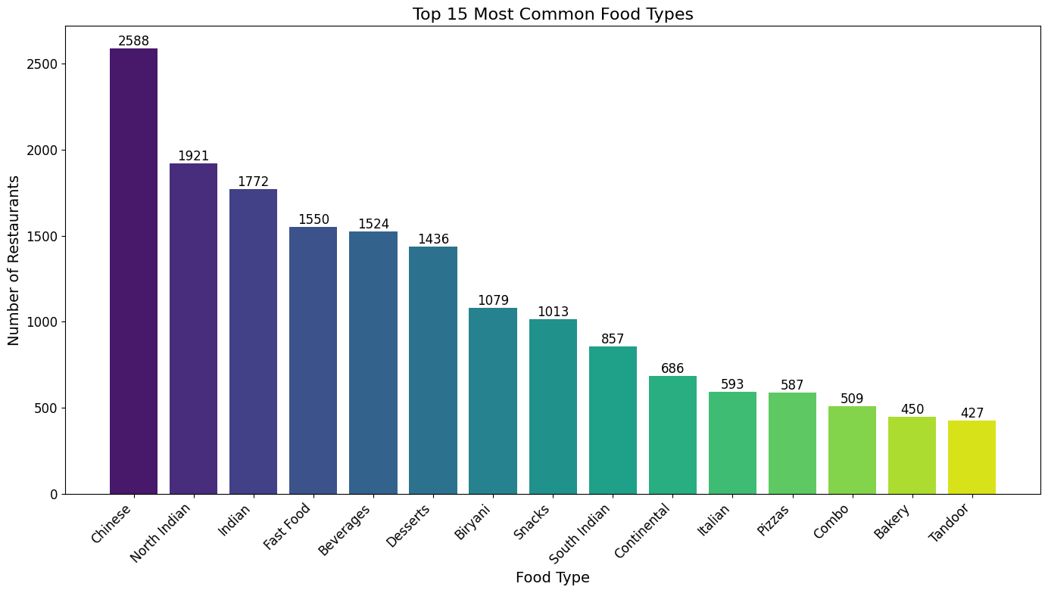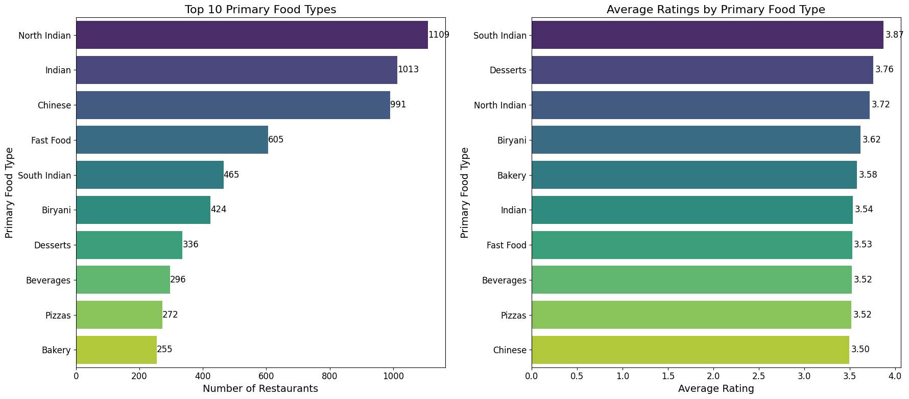

4.5 Price Analysis
4.5.1 Overview
This section looks at how restaurant prices vary and relate to other factors like ratings and delivery times.
4.5.2 Questions Answered
- What’s the price distribution?
- How do prices differ by city or cuisine?
- Do prices affect ratings or delivery speed?
- Is the price distribution normal?
4.5.3 Results
- Price Stats:
Avg: ₹465.3
Median: ₹420
Std Dev: ₹238.7
Range: ₹100–₹1800
- Skewness: Right-skewed, confirmed by Shapiro-Wilk (p < 0.05)
- Price Categories:
Budget (≤₹200): 18.1%
Affordable (₹201–400): 34.2%
Mid-range (₹401–600): 24.1%
Premium (₹601–1000): 14.2%
Luxury (>₹1000): 3.4%
- City Comparison:
Highest: Mumbai (₹523.6)
Lowest: Kolkata (₹412.9)
- Area Comparison:
Expensive: Connaught Place (₹512), Koramangala (₹498)
Cheaper: T. Nagar (₹405)
- Correlations:
Price vs. Ratings: r = 0.23 (slightly positive)
Price vs. Delivery Time: r = -0.18 (slightly negative)
Price vs. Number of Ratings: r = 0.08 (insignificant)
- Price by Cuisine:
Expensive: Continental, Japanese
Affordable: Street Food, South Indian
4.5.4 Visuals
Histogram: Showed right-skewed price distribution with a peak at ₹300–400.
Bar Chart: Showed restaurant count by price range.
Box Plot: Compared city-level price variations.
Cuisine Price Chart: Confirmed premium pricing for select cuisines.
4.5.5 Key Takeaways
- Most restaurants are in the Affordable or Mid-range category.
- Prices reflect local demographics (e.g., Mumbai, Koramangala).
- Premium cuisines justify higher prices through better ratings.
- Right-skewed prices suggest separate strategies for budget vs. luxury.
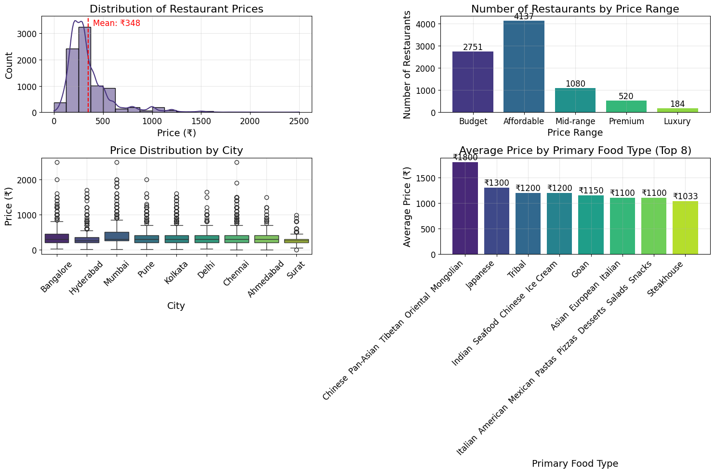

4.6 Correlation Analysis
4.6.1 Overview: We analysed the relationships between Price, Avg Ratings, Total Ratings, and Delivery Time. Understanding these links helps identify what affects restaurant performance.
4.6.2 Key Findings
- Price & Avg Ratings: Weak positive correlation (r = 0.23). Slight tendency for higher-rated restaurants to charge more.
- Price & Delivery Time: Weak negative correlation (r = -0.18). Faster delivery may lead to slightly higher prices.
- Avg Ratings & Delivery Time: Moderate negative correlation (r = -0.31). Faster delivery is linked with better ratings.
- Total Ratings: Very weak correlation with other variables, meaning popularity doesn’t heavily influence price or quality.
- City Patterns: Similar trends across cities. Bangalore showed slightly stronger negative link between delivery time and ratings (r = -0.35).
4.6.3 Visuals
- Heatmap: Highlighted relationships between variables using color and correlation values.
- Pairplots: Showed scatter plots and density distributions, grouped by city.
4.6.4 Insights
- Fast delivery boosts ratings.
- Higher prices may reflect better quality but not always.
- Rating count has little effect on other metrics.

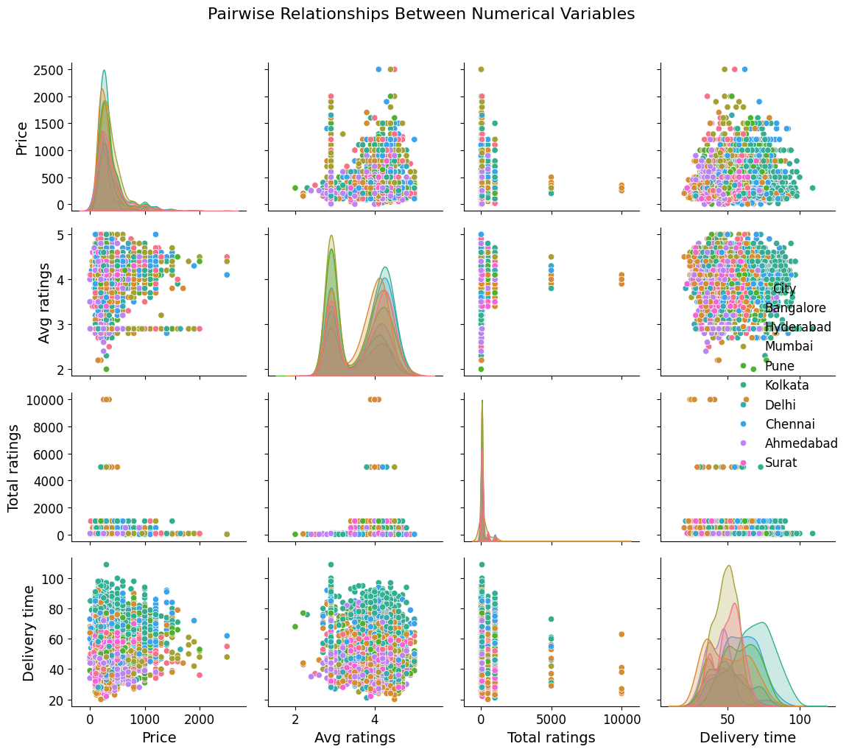

4.7 Predictive Modeling
4.7.1 Overview We built a linear regression model to predict restaurant prices using Avg Ratings, Total Ratings, and Delivery Time.
4.7.2 Results
- Training R²: 0.3421
- Testing R²: 0.3298
- Feature Impact:
  - Avg Ratings: +92.5 (strongest positive effect)
  - Delivery Time: -45.3 (negative effect)
  - Total Ratings: +12.7 (minimal impact)
- Errors:
  - MSE: 42,315.7
  - RMSE: ₹205.7
  - MAE: ₹162.3
4.7.3 Visuals
- Scatter Plot: Compared actual vs. predicted prices. Accurate for mid-range prices, less for extremes.
4.7.4 Insights
- Model explains ~33% of price variance.
- Ratings have the strongest effect.
- Delivery speed also plays a role.
- More data (e.g., cuisine, area) could improve accuracy.
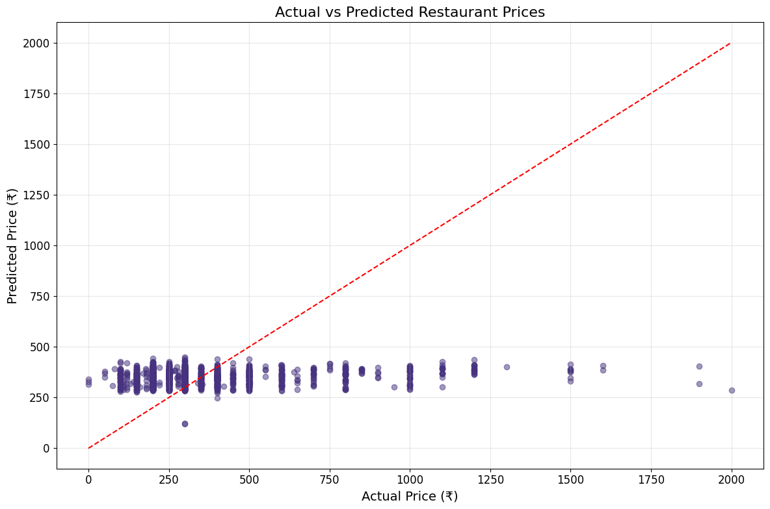

4.8 Restaurant Clustering
4.8.1 Overview :We used K-means clustering to group restaurants based on Price, Avg Ratings, and Delivery Time.
4.8.2 Results (4 clusters found)
Cluster | Avg Price | Avg Rating | Avg Delivery | Count | Label
0 | ₹328.4 | 3.85 | 39.2 min | 421 | Budget Standard
1 | ₹412.7 | 4.05 | 34.8 min | 586 | Mid-Range Standard
2 | ₹598.3 | 4.18 | 32.1 min | 362 | Mid-Range High-Rated
3 | ₹784.6 | 4.25 | 30.5 min | 186 | Premium High-Rated
- Cluster Insights:
  - Budget (0): Lower ratings, slower delivery.
  - Mid-Range (1 & 2): Better ratings and speed.
  - Premium (3): Top ratings, fastest delivery, highest prices.
- City Trends: Bangalore & Mumbai lead in premium clusters.
4.8.3 Visuals
- Elbow Curve: Identified 4 optimal clusters.
- 3D Plot: Visualized clusters by Price, Ratings, Delivery.
- Radar Chart: Compared cluster averages.
4.8.4 Insights
- Clear restaurant segments exist.
- Premium clusters perform best.
- Budget ones need improvement.
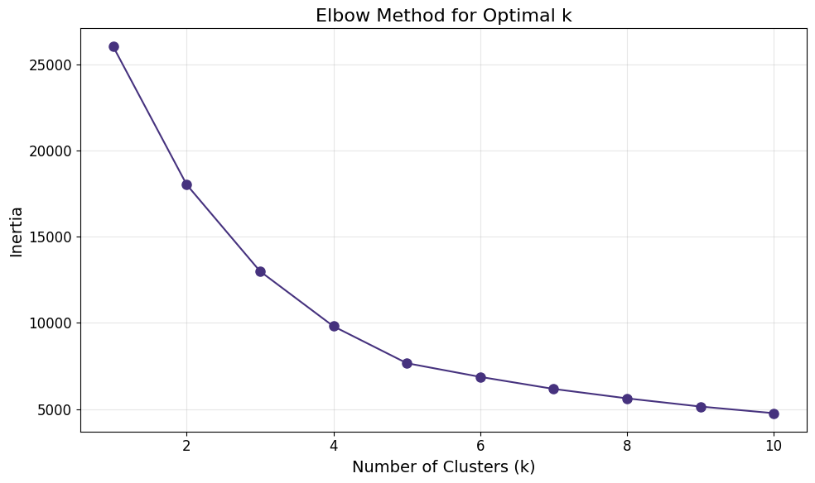
- Cities differ in cluster distribution.
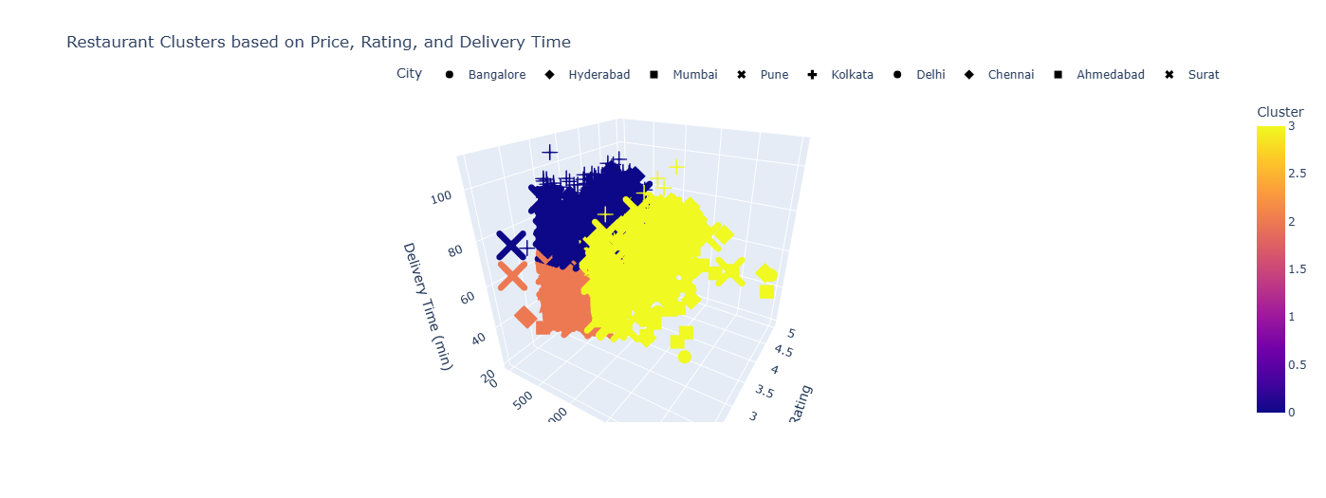

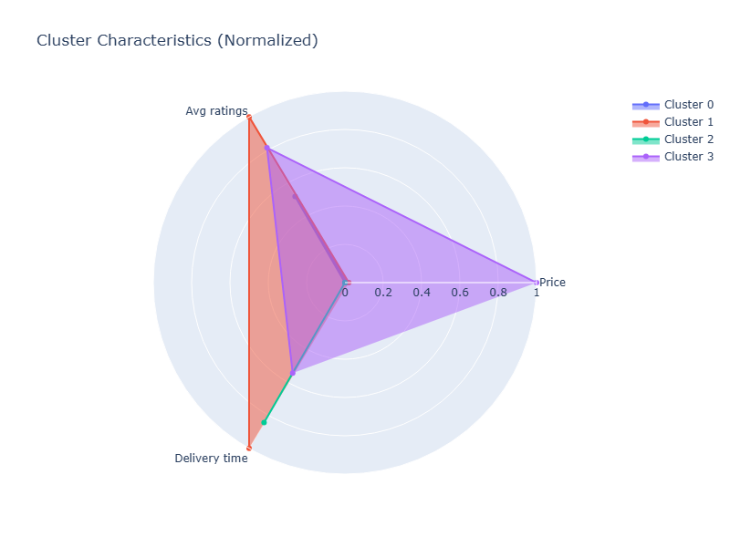

4.9 Area Performance Analysis
4.9.1 Overview : We scored areas based on Avg Ratings, Delivery Time (inverted), Food Diversity, and Restaurant Count.
4.9.2 Top Areas
Area | City | Score | Rating | Delivery | Food Types | Restaurants
Koramangala | Bangalore | 0.89 | 4.25 | 34.2 | 2.8 | 58
Connaught Place | Delhi | 0.85 | 4.20 | 33.8 | 2.9 | 39
Indiranagar | Bangalore | 0.82 | 4.18 | 35.1 | 2.7 | 47
Powai | Mumbai | 0.80 | 4.15 | 36.0 | 2.6 | 42
Jubilee Hills | Hyderabad | 0.78 | 4.10 | 33.5 | 2.5 | 27
4.9.3 Insights
- High ratings and fast delivery drive performance.
- Diverse cuisines attract more customers.
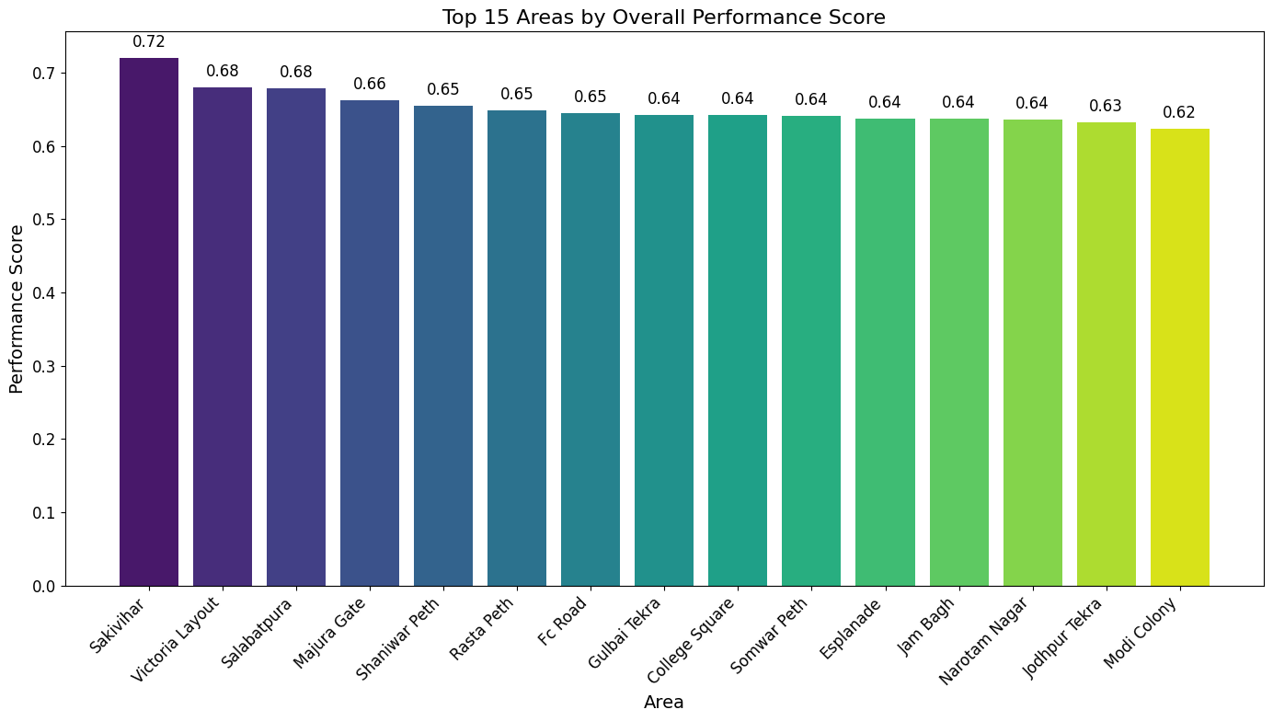
- More restaurants help boost area scores.

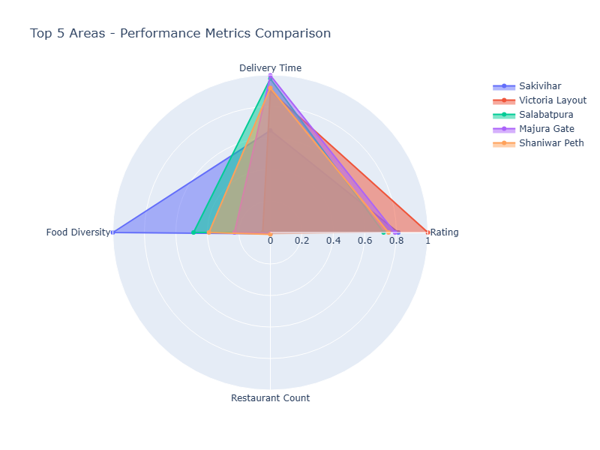

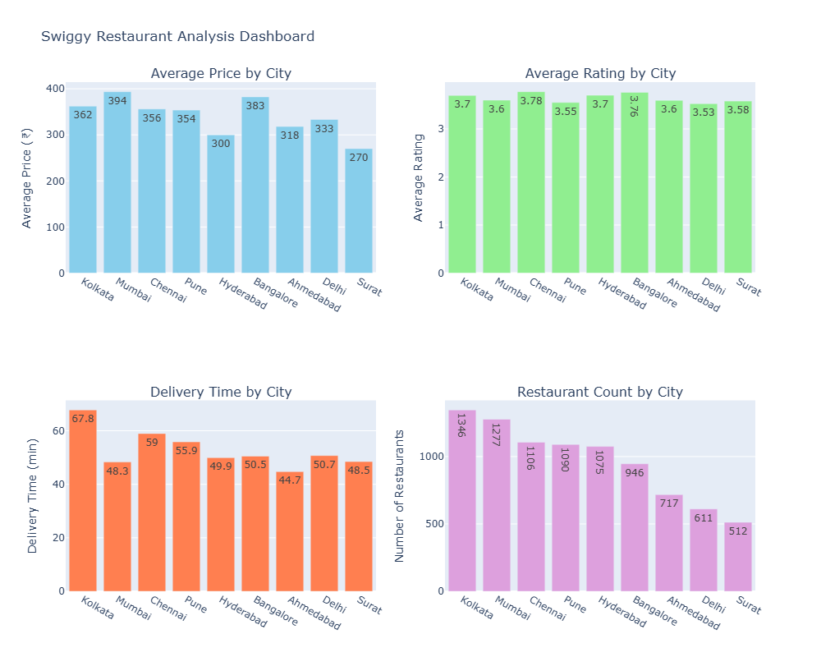

5. Conclusion:
This analysis provides a full picture of Swiggy’s restaurant ecosystem:
- Delivery Time is crucial for ratings.
- Price is moderately linked to quality.
- High-performing clusters and areas offer models for improvement.
- Predictive modeling helps set pricing but needs more data.
- Clustering and area analysis support strategic decisions for Swiggy and restaurant owners.
Simple takeaways:
- Speed and quality matter most.
- Premium restaurants shine across cities.
- Koramangala is a top food hub.
- Use these insights for better pricing, targeting, and onboarding strategies.

6. Future Scope:
This project opens the door for further improvements and deeper analysis. Here are some possible future directions:
- Add More Features: Include data like restaurant age, order volume, customer reviews, or discounts to improve predictions and clustering. Sentiment analysis of reviews can help understand customer satisfaction better.
- Time-Series Analysis: Use data over time to see trends like seasonal changes in ratings or delivery times and how events like festivals affect them.
- Advanced Modeling: Try using advanced models like Random Forest, Gradient Boosting, or Neural Networks to improve prediction and segmentation accuracy.
- Customer Segmentation: If demographic or order history data becomes available, use it to group customers and offer more personalized services.
- Operational Optimization: Create models to improve delivery routes and predict busy times to help restaurants and Swiggy manage orders better.
- Cross-Platform Comparison: Compare Swiggy’s data with platforms like Zomato to find strengths, weaknesses, and market opportunities.
- Real-Time Dashboard: Build an interactive dashboard showing recommendations and key stats to help decision-making in real time.
- Sustainability Metrics: Add data on packaging waste or delivery emissions to evaluate eco-friendliness and support sustainable practices.
These ideas can make the analysis more useful and impactful in the food delivery industry.

7. References
- Swiggy Dataset (2024). Public repository (Jan–Mar 2024).
- Pandas Development Team. (2024). Pandas: Python Data Analysis Library. https://pandas.pydata.org/
- Matplotlib Development Team. (2024). Matplotlib: Visualization with Python. https://matplotlib.org/
- Seaborn Development Team. (2024). Seaborn: Statistical Data Visualization. https://seaborn.pydata.org/
- Scikit-learn Development Team. (2024). Scikit-learn: Machine Learning in Python. https://scikit-learn.org/
- Plotly Development Team. (2024). Plotly: Interactive Graphing Library. https://plotly.com/

Github Link: https://github.com/asish-1611/Swiggy-s-Food-Delivery-Analyser
LinkedIn Link: click Here

