# Polynomial Regression

More complex functions of a single input

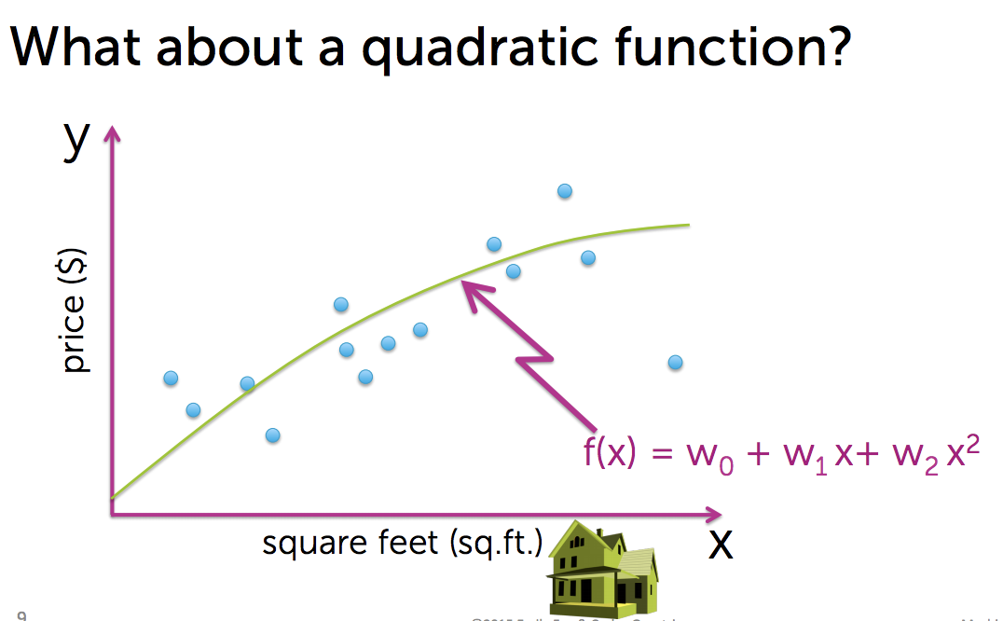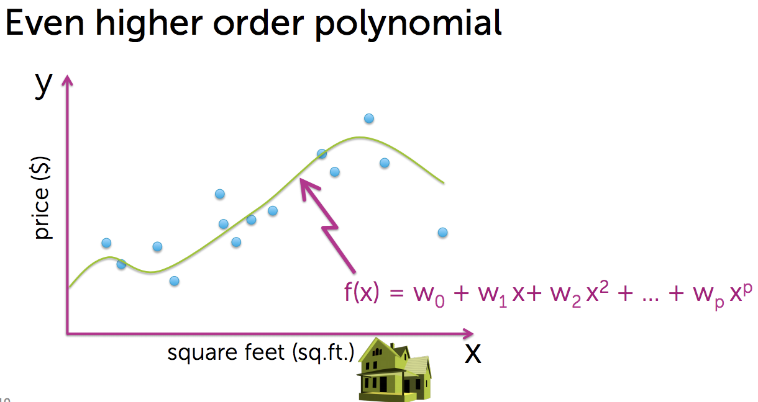

Polynomial Model:

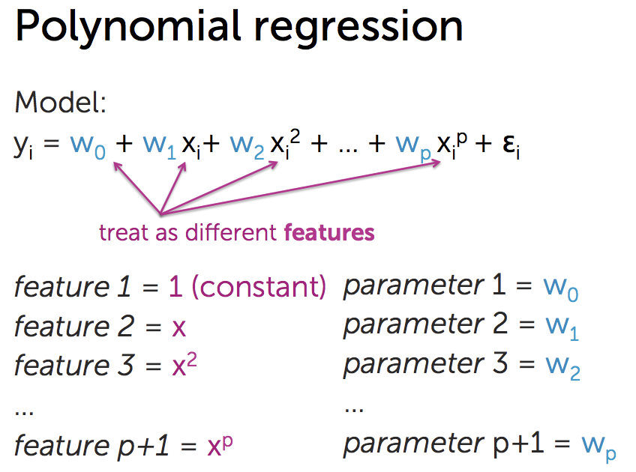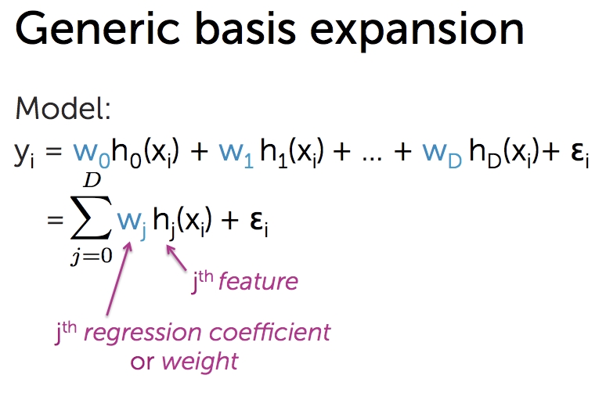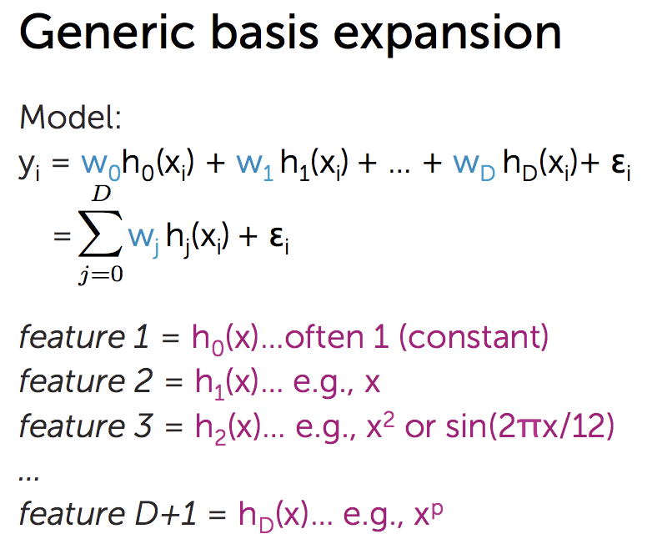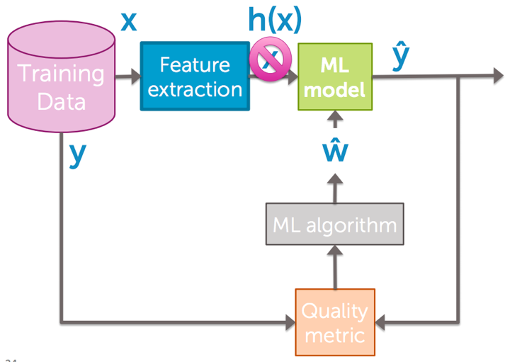

# Multiple Regression

Instead of computing with a single feature, multiple regression consideres more than one input features.

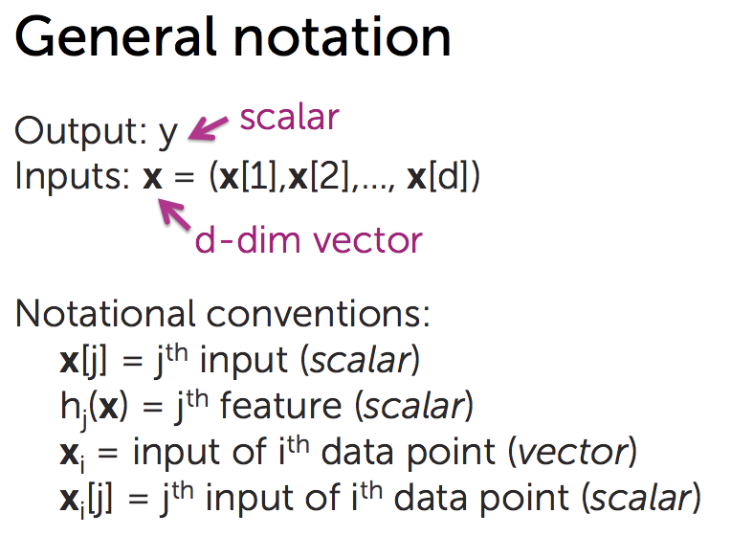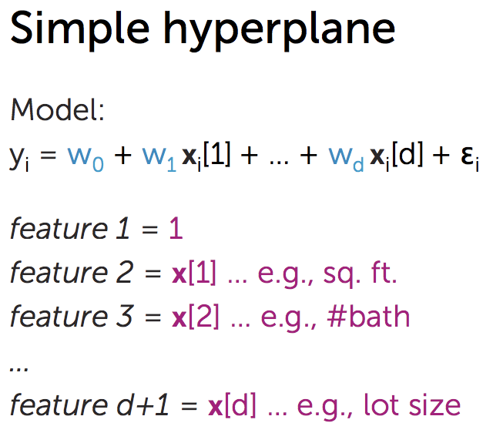

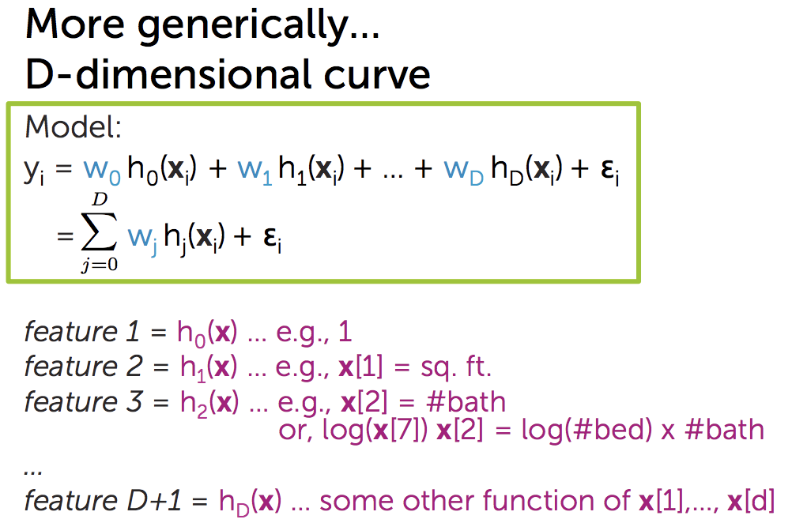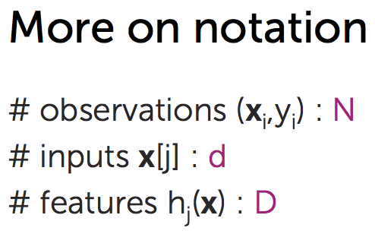

Incorporating multiple inputs: When calculating one feature let other parameters as fixed. But if one parameter is somehow related to another parameter then you can’t follow this approach and you can’t interprete the coefficient.

**[ML Algorithm]**

What happenes under the hood when we run fit function of a model with multiple features? It tries to find minimum cost for each fit and take the best fit. And to calculate cost again we have two approaches: (1) using RSS (2) using gradient descent.

Approach 1: **Closed way** (Calculating RSS)

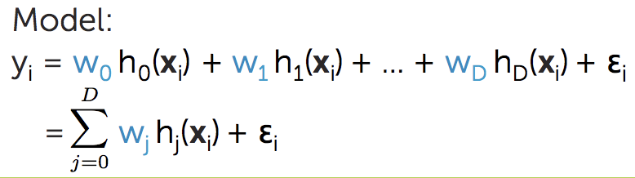

Approach 2: **Gradient descent**:

**[Quality Metric]**

Finding the cost for multiple regression: Residual sum of squares (RSS)

Approach 1: **Closed way**: Calculating RSS and then calculating the gradient of RSS

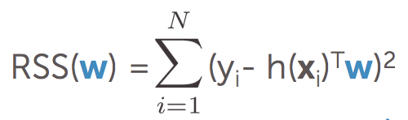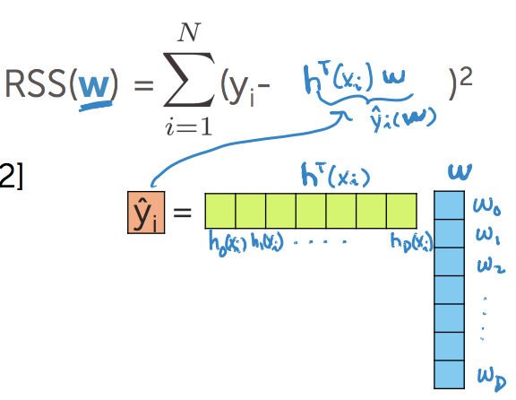

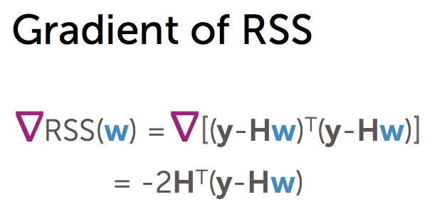

Approach 2: Gradient descent: Until we converge (since gradient descent almost never reaches to zero, so let’s iterate until the tolerance is achieved)

