# Cost: Measure of error

Three types of error:

1. Training error
2. Tru error (Generalization error)
3. Testing error
4. Training error:

Once a model is fit with training data and the parameters are selected (with minimum RSS), we measure difference between the actual output (y) and the predicted output. That is called training error. There are different loss functions to mesure error:

1. Squared error
2. Absolute error
3. …
4. True error (Generalization error): If we had chance to know all the possible data including future data, then the generalization error would be the difference between our prediction and that future actual output.

We can not compute actual generalization error.

1. Testing error:

At the beginning as model complexity increases training error decreases. But after certain point training error starts to increase as model complexity increases, this is called Bias variance tradeoff.

3 sources of error + Bias variance tradeoff:

1. **Noise**: Non deterministic reason behind error of observation. Not reducible term.
2. **Bias**: Difference between the average fit (considering fits from different dataset) and the ‘true function’.

In human term, bias of a model means the model predicts the output fevering towards the model and not reality. Usually low complex models are more bised.

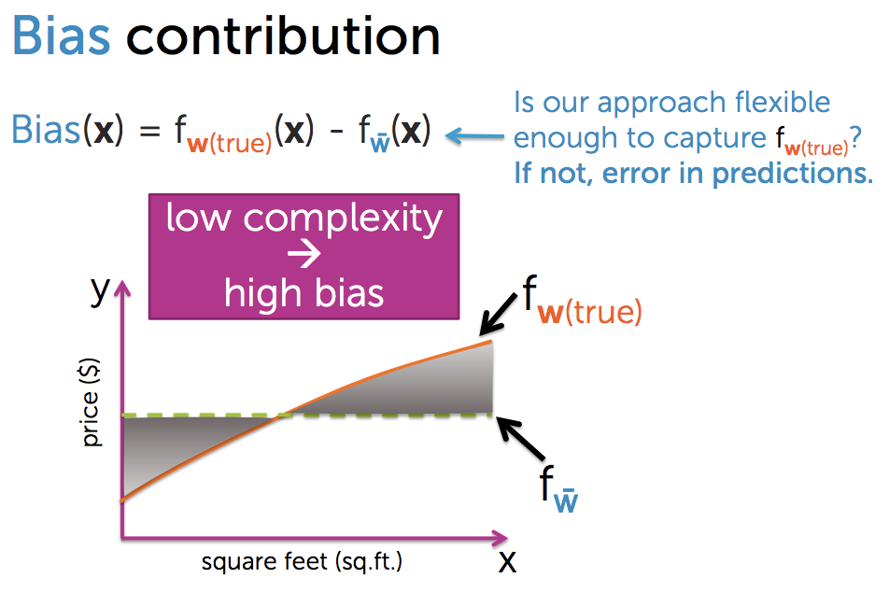

1. **Variance**: How much a fit can vary for different dataset? If they vary dramatically then your prediction has become very specifit to that particular dataset and not flexible for other dataset. That would cause error in your prediction.

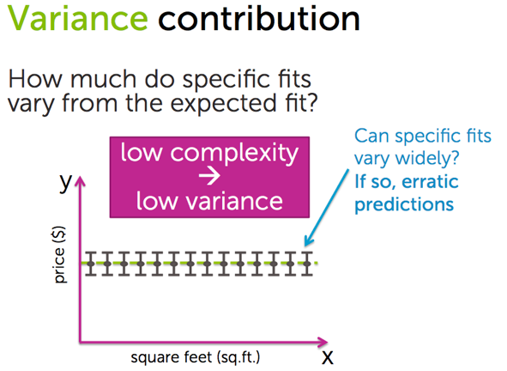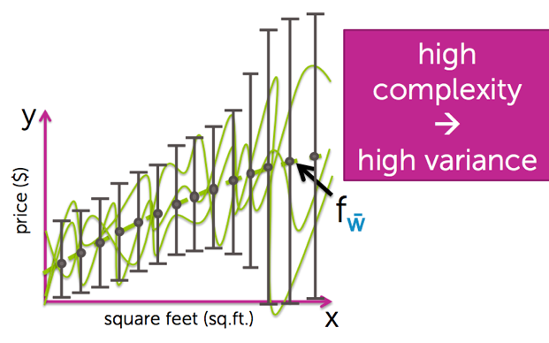

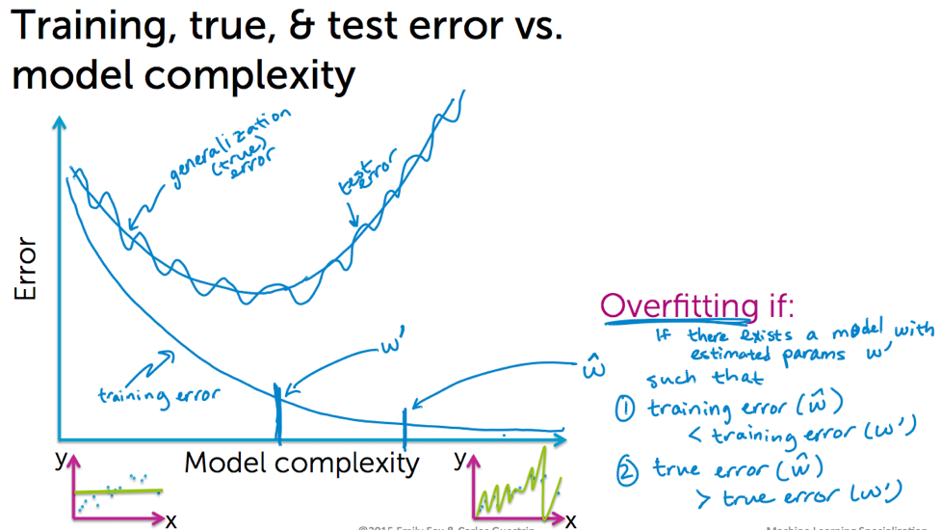

1. **Bias-Variance tradeoff:**

Usually low complex models are more bised and as the complexity increases bias decreases. But on the hand variance is low for simple models and as complexity increases variance increases. We need to find a sweet-spot in between this two.

