MEMORANDUM

ATTENTION: CEO of Car Rental Company

DATE: August 1, 2019

FROM: DB Analysts (Lin Yunan, Shu Wenjun)

SUBJECT: Expand the business by cultivating longer rental relationship

Executive Summary

CarRental should expand the business by targeting on longer rental agreements in the next fiscal year. Based on the database analytical report, three outlets out of nigh are evident more profitable. These three outlets are all located in Pittsburgh with education and non for profits organization customers as the main source. These two groups of customers are prone to longer rental relationship which means less idle rate for our cars. To sum up, the company will be more profitable on developing longer rental agreements.

Introduction

CarRental owns nigh outlets which located in Pittsburgh, Rocky Mount, Macomb, Chicago, Charlotte, Little Rock and Burr Ridge. This year financial report performance did not achieve the expectations of investors. Thus, we tried to fabricate different analysis reports with several combination of variables. We found out the combinations with revenue of different outlets and client type with rental duration, total revenue and average daily rate are critical.

Data Analysis

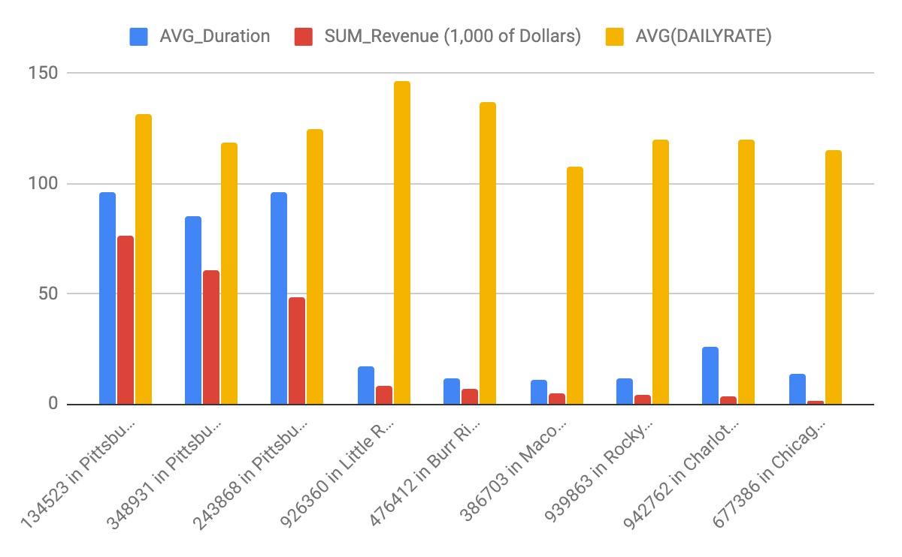

OUTLET INFO CLIENT TYPE AVG_Duration SUM_Revenue AVG(DailyRate)

--------------------------- ------------------------------------ ---------------- ---------------- ----------------

134523 in Pittsburgh, PA EDUCATION 104.35 $41920 $133.33

134523 in Pittsburgh, PA NON-FOR-PROFIT ORGANIZATION 87.30 $34320 $130.00

134523 in Pittsburgh, PA 95.82 $76240 $131.67

243868 in Pittsburgh, PA EDUCATION 101.43 $26520 $130.00

243868 in Pittsburgh, PA NON-FOR-PROFIT ORGANIZATION 91.01 $21710 $120.00

243868 in Pittsburgh, PA 96.22 $48230 $125.00

348931 in Pittsburgh, PA EDUCATION 79.43 $19200 $120.00

348931 in Pittsburgh, PA NON-FOR-PROFIT ORGANIZATION 87.84 $41160 $117.50

348931 in Pittsburgh, PA 85.03 $60360 $118.33

386703 in Macomb, IL FOR-PROFIT COMPANY 5.63 $660 $110.00

386703 in Macomb, IL PERSONAL 12.45 $4150 $106.67

386703 in Macomb, IL 10.74 $4810 $107.50

476412 in Burr Ridge, IL FOR-PROFIT COMPANY 11.52 $6565 $137.25

476412 in Burr Ridge, IL 11.52 $6565 $137.25

677386 in Chicago, IL GOVERNMENT AGENCY 13.45 $1610 $115.00

677386 in Chicago, IL 13.45 $1610 $115.00

926360 in Little Rock, AR GOVERNMENT AGENCY 12.79 $1300 $100.00

926360 in Little Rock, AR PERSONAL 19.12 $6630 $170.00

926360 in Little Rock, AR 17.01 $7930 $146.67

939863 in Rocky Mount, NC FOR-PROFIT COMPANY 12.86 $3240 $120.00

939863 in Rocky Mount, NC NOT AVAILABLE 8.45 $1080 $120.00

939863 in Rocky Mount, NC 11.39 $4320 $120.00

942762 in Charlotte, NC FOR-PROFIT COMPANY 25.67 $3120 $120.00

942762 in Charlotte, NC 25.67 $3120 $120.00

EDUCATION 96.39 $87640 $128.57

FOR-PROFIT COMPANY 12.89 $13585 $127.38

GOVERNMENT AGENCY 13.12 $2910 $107.50

NON-FOR-PROFIT ORGANIZATION 88.36 $97190 $122.22

NOT AVAILABLE 8.45 $1080 $120.00

PERSONAL 15.12 $10780 $132.00

52.61 $213185 $125.44

CarRental runs these nigh outlets with non-specific approaches. But the report displays different revenue outcome based on the performance of each outlet. Three outlets’ revenue in Pittsburgh are apparent higher than the rest of six. Moreover, duration time and customer type are also two main crucial differences. Thus, implementing corrective actions is indispensable.

Recommendation

CarRental should expand the business targeting on longer agreements. Like customers of top three outlets are education and non for profits organization groups. These two groups of clients require longer rental relationship which makes the less idle time of our cars. But this situation just perfectly matches the Pittsburgh area which is a city with many scholars and teachers. So, every region of outlet should focus on how to attain longer rental agreements. The main goal is to increase the duration time and lower the idle time simultaneously.

Question:

This year financial report performance did not match the analysts’ anticipations. In order to implement the corrective actions, find out which factors are crucial to be improved. Based on the repetitive trials, we found out the total revenue of each outlet would be the best criteria to compare. Moreover, analyze the source of customers and their agreements duration time with average daily rate.

Verify which outlets are more profitable and list the client type, average of duration time, average of daily rate and the information of each outlet, order by outlet information and client type.

Answer:

SQL> SELECT (OutNo || ' in ' ||outlet.city||','|| outlet.state) AS "OUTLET INFO",

2 (CASE

3 WHEN LOWER(WebAddress) LIKE '%.edu' THEN 'EDUCATION'

4 WHEN LOWER(WebAddress) LIKE '%.gov' THEN 'GOVERNMENT AGENCY'

5 WHEN LOWER(WebAddress) LIKE '%.org' THEN 'NON-FOR-PROFIT ORGANIZATION'

6 WHEN LOWER(WebAddress) LIKE '%.com' THEN 'FOR-PROFIT COMPANY'

7 WHEN WebAddress IS NULL THEN 'NOT AVAILABLE'

8 ELSE 'PERSONAL'

9 END) AS "CLIENT TYPE",

10 TO_CHAR(AVG(MONTHS_BETWEEN(returndate,startdate)*30), '9990.99') AS "AVG_Duration",

11 TO_CHAR(SUM(CEIL(MONTHS_BETWEEN(returndate,startdate)*30)*DailyRate), '$999990') AS "SUM_Revenue",

12 TO_CHAR(AVG(DailyRate), '$990.99') AS "AVG(DailyRate)"

13 FROM ragreement JOIN vehicle USING (LicenseNo) JOIN outlet USING (outNo) JOIN client USING (clientNo)

14 GROUP BY CUBE ((OutNo || ' in ' ||outlet.city||','|| outlet.state), (CASE

15 WHEN LOWER(WebAddress) LIKE '%.edu' THEN 'EDUCATION'

16 WHEN LOWER(WebAddress) LIKE '%.gov' THEN 'GOVERNMENT AGENCY'

17 WHEN LOWER(WebAddress) LIKE '%.org' THEN 'NON-FOR-PROFIT ORGANIZATION'

18 WHEN LOWER(WebAddress) LIKE '%.com' THEN 'FOR-PROFIT COMPANY'

19 WHEN WebAddress IS NULL THEN 'NOT AVAILABLE'

20 ELSE 'PERSONAL'

21 END))

22 ORDER BY 1,2;

OUTLET INFO CLIENT TYPE AVG_Duration SUM_Revenue AVG(DailyRate)

--------------------------- ------------------------------------ ---------------- ---------------- ----------------

134523 in Pittsburgh, PA EDUCATION 104.35 $41920 $133.33

134523 in Pittsburgh, PA NON-FOR-PROFIT ORGANIZATION 87.30 $34320 $130.00

134523 in Pittsburgh, PA 95.82 $76240 $131.67

243868 in Pittsburgh, PA EDUCATION 101.43 $26520 $130.00

243868 in Pittsburgh, PA NON-FOR-PROFIT ORGANIZATION 91.01 $21710 $120.00

243868 in Pittsburgh, PA 96.22 $48230 $125.00

348931 in Pittsburgh, PA EDUCATION 79.43 $19200 $120.00

348931 in Pittsburgh, PA NON-FOR-PROFIT ORGANIZATION 87.84 $41160 $117.50

348931 in Pittsburgh, PA 85.03 $60360 $118.33

386703 in Macomb, IL FOR-PROFIT COMPANY 5.63 $660 $110.00

386703 in Macomb, IL PERSONAL 12.45 $4150 $106.67

386703 in Macomb, IL 10.74 $4810 $107.50

476412 in Burr Ridge, IL FOR-PROFIT COMPANY 11.52 $6565 $137.25

476412 in Burr Ridge, IL 11.52 $6565 $137.25

677386 in Chicago, IL GOVERNMENT AGENCY 13.45 $1610 $115.00

677386 in Chicago, IL 13.45 $1610 $115.00

926360 in Little Rock, AR GOVERNMENT AGENCY 12.79 $1300 $100.00

926360 in Little Rock, AR PERSONAL 19.12 $6630 $170.00

926360 in Little Rock, AR 17.01 $7930 $146.67

939863 in Rocky Mount, NC FOR-PROFIT COMPANY 12.86 $3240 $120.00

939863 in Rocky Mount, NC NOT AVAILABLE 8.45 $1080 $120.00

939863 in Rocky Mount, NC 11.39 $4320 $120.00

942762 in Charlotte, NC FOR-PROFIT COMPANY 25.67 $3120 $120.00

942762 in Charlotte, NC 25.67 $3120 $120.00

EDUCATION 96.39 $87640 $128.57

FOR-PROFIT COMPANY 12.89 $13585 $127.38

GOVERNMENT AGENCY 13.12 $2910 $107.50

NON-FOR-PROFIT ORGANIZATION 88.36 $97190 $122.22

NOT AVAILABLE 8.45 $1080 $120.00

PERSONAL 15.12 $10780 $132.00

52.61 $213185 $125.44

31 rows selected.