E­-BARBER

Submitted in partial fulfilment of requirements for Diploma in CSE

SUBMITTED BY-

Abinash Barik (F19029007002)

Asish Kumar Barik (F19029007006)

Arnada Prasad Pattanaik (F19029007005)

T.Prabin Patra (F19029007028)

Vishal Raj (F19029007030)



C.V. RAMAN POLYTRECHNIC, BBSR

DEPARTMENT OF COMPUTER SCIENCE & ENGINEERING

BIDYANAGAR, MAHURA, JANLA, BHUBANESWAR-75054, ODISHA

ACADEMIC YEAR-2019-22

C.V. RAMAN POLYTRECHNIC, BBSR

DEPARTMENT OF COMPUTER SCIENCE & ENGINEERING

BIDYANAGAR, MAHURA, JANLA, BHUBANESWAR-75054, ODISHA

ACADEMIC YEAR-2019-22



**CERTIFICATE**

This is to certify that the work in this project report entitled “**E-BARBER**” efficient being submitted by Abinash Barik, Asish Kumar Barik, Vishal Raj, Arnada Prasad Pattanaik, T.Prabin Patra bearing registration No.F19029007002,F19029007006,F19029007005,F19029007028, F19029007030 has been carried out under my supervision in pratial fulfilment of the requirement for the diploma in “computer science” during session 2019-2022 in department of computer science of C.V Raman polytechnic, Bhubaneswar and this work is original work of above students.

**SIGNATURE OF STUDENT GUIDE HOD**

C.V. RAMAN POLYTRECHNIC, BBSR

DEPARTMENT OF COMPUTER SCIENCE & ENGINEERING

BIDYANAGAR, MAHURA, JANLA, BHUBANESWAR-75054, ODISHA

ACADEMIC YEAR-2019-22



**ACKNOWLEDGEMENT**

We are pleased to acknowledge our guide Asst. Prof. Sambhu Prasad Panda for their invaluable guidance during the course of this project work.

We extend our sincere thanks to our HOD of CSE Mrs. Prangya Paramita Mohapatra for the immeasurable support.

We are also grateful to other members of the Department and college who cooperated with us in carrying out the work successfully.

Team Members:

Abinash Barik (F19029007002)

Asish Kumar Barik (FI9029007008)

Arnada Prasad Pattanaik (F19029007005)

T.Prabin Patra (F19029007028)

Vishal Raj (F19029007030)

**Abstract**

Searching out for the best barbershops or hair salons within your vicinity is a very tiresome task. Also, visiting a barbershop or salon without a prior appointment booking can keep you waiting in a queue thereby taking away your precious time. To solve this issue, we have developed an android based barbershop application. By choosing from listed categories this android app will generate a list of nearby barbershops & salons. Both the barbershop owners & users can access the application by registering themselves on the app by submitting the necessary details. The barbershop owners can update their profiles by adding photos & a list of services provided by them. The users can view the shops' profiles, photos & services, based on which they can book an appointment as per their desired time & date in their favorite shops. The users can also review & rate a shop through this app. This System can be used by barber shops & users who want to enjoy online bookings instead of waiting in a queue.

**SIGNATURE OF STUDENT GUIDE HOD**

# Table Of Contents

|  |  |
| --- | --- |
| **Contents** | **Pg. no.** |
| 1. INTRODUCTION | 7 |
| 1. EXISTING SYSTEM | 8 |
| 1. DRAWBACKS OF EXISTING SYSTEM | 9 |
| 1. PURPOSED SYSTEM | 10 |
| 1. ADVANTAGES OF E BARBER | 11 |
| 1. WATERFALL MODEL | 12 |
| 1. REQUIREMENT ANALYSIS    1. FUNCTIONAL REQUIREMENTS    2. NON-FUNCTIONAL REQUIREMENTS    3. CLASS DIAGRAM    4. USE CASE DIAGRAM    5. USE CASE TABLE | 13 - 17 |
| 1. SYSTEM DESIGN    1. PRODUCT PERESPECTIVE    2. PRODUCT FUNCTIONS    3. CONSTRAINTS    4. FLOW CHART    5. DATA FLOW DIAGRAM    6. GANTT CHART    7. PERT CHART    8. TREE STRUCTURE OF E BARBER    9. UI OF APP | 18 – 30 |
| **Contents** | **Pg. No.** |
| 1. IMPLEMENTATION    1. SOFTWARE REQUIREDMENTS    2. MINIUM HARDWARE REQUIREDMENTS | 31 |
| 1. TESTING | 32 - 33 |
| 1. DEPLOYMENT | 34 |
| 1. MAINTAINCE | 35 - 36 |
| 1. LIMITATIONS | 37 |
| 1. FUTURE WORKS | 38 |
| 1. CONCLUSION | 39 |
| 1. REFERENCES | 40-41 |

**INTRODUCTION**

Searching out for the best barbershops or hair salons within your vicinity is a very tiresome task. Also, visiting a barbershop or salon without a prior appointment booking can keep you waiting in a queue thereby taking away your precious time. To solve this issue, we have developed an android based barbershop application. By choosing from listed categories this android app will generate a list of nearby barbershops & salons.

Both the barbershop owners & users can access the application by registering themselves on the app by submitting the necessary details. The barbershop owners can update their profiles by adding photos & a list of services provided by them. The users can view the shops’ profiles, photos & services, based on which they can book an appointment as per their desired time & date in their favourite shops. The users can also review & rate a shop through this app.

Barber Application is used for booking barber services through the android application. Admin is the authorized user who will verify the Barbershop & its services. Admin can also block any barber account if needed. Users can get a list of all the Barber shops nearby and check and book its services. Barber can check the bookings and accordingly manage them. Users can rate & review the shop & services.

**Existing System**

1. Miosalon:- MioSalon is a software product curated for hair, nail, and beauty salons and spas, and health and wellness centers. It is a cloud-based software that specializes in customer engagement and retention. The software helps businesses to flourish and grow by managing important aspects including appointment scheduling, client data management, inventory management, payment processing, and client marketing.
2. Appointy:- Appointy owns and provides various websites, services, and software that facilitate online scheduling of appointments (collectively, the "Services") by accessing .
3. YesMadam.com:- Yes Madam boasts of well-trained beauty experts who have been handpicked from the top salons of the city for their skill and experience. And you do not even have to step out of your house! Because we are an at-home service, we also do a mandatory background check and police verification of each of the experts on board so that you can rest assured in terms of the quality of services and your safety.
4. Zoylee Salon &Spa Booking App:- Zoylee is a hyperlocal, on-demand appointment booking platform for beauty, grooming, and personal care services. Designed to bridge the gap between salons, spas, and beauty parlors and end consumers by bringing them on a unified platform, Zoylee stands as a single point of contact to facilitate easy bookings and delivery of services with no waiting time.
5. StyleSeat :- Book Hair & Beauty.
6. E Salon:- Students developed this app for the project propose.

**Drawbacks existing System**

1. **Miosalon:-** It has so many hidden charges and many extra charges including the salon charges and booking charges.
2. **Appointed:-** The app doesn't provide all the salons near to the customer, only costly salons are available in this.
3. **YesMadam.com:-** They respond usually in 2 Days means any customer stuck in any situation they are available after 2 Days. And also this app is not available in India.
4. **Zoylee Salon &Spa Booking App:-** This software is only located in the Delhi region, no other region salons can be registered.
5. **StyleSeat-Book Hair & Beauty:-** This app is not available in India.
6. **E Salon:-** This app is not in operation anymore.

**Purposed System**

This proposed system E Barber App is an appointment booking application used for booking barber services through an android application. Users can get a list of all the Barber shops nearby and check and book its services. Barber can check the bookings and accordingly manage them. Users can rate & review the shop & services. Application Admin is the authorized user who will verify the Barbershop & its services for authenticity.

**Advantages of E-Barber**

• Easy searching of top nearby salons by venue, city, or area.

• Easy booking user interface.

• Separate Dashboard for both customer and service provider.

• Option to choose from different categories (Men, Women & Unisex).

• Facility to go through reviews of different Salons.

• Easy Cancelation and Refund Policy.

• Provider can post for barber vacancy.

• Users can pay from various payment methods.

• We verify and approve each registered salon manually for security purposes.

• Live Seat/Advance Booking.

**Waterfall Model**

**REQUIREMENT ANALYSIS**

**Functional Requirements**

* The system supports customers booking and able to modify them.
* When a customer search for salon, spa, beauty parlour and the search result must contain salon, spa, beauty parlour information (Address, Ratings, and Price) and also its availability within choosing check in and check out date.
* Customers able to cancel their booking from their account.
* Staffs able to edit customers booking information (updating slot booking, and also cancelling booking).
* Customers can book online and pay with credit or debit card.
* The system must send booking confirmation email after successful payment.
* Customers can write reviews about salon, spa, and beauty parlour and also rate them.
* Customers able to check their booking status from their individual account.
* Customers can send feedback or call the company for booking purposes.
* Customers can check for latest promotion or deal.

**Non-Functional Requirements**

* The system must ensure that all the transferable data for example customer's credit or debit card number, CVV Code, and e-payment should be done in a secured connection.
* The system must be able to handle multiple transactions at a time.
* The system must provide customers with 24*7 hours online booking service.
* The system should support almost all browsers (Internet Explorer, Safari, Chrome, and Firefox).
* The application should support the android operating system.
* Customers need to cancel the booking before 24 hrs. Otherwise, their credit card will be charged for one day.

**Class Diagram**

This is the most used UML diagram in the field of software engineering design. It is called as a main building block of any object-oriented solution. Usually, it illustrates the classes in a system, attributes and operations of each class and also the relationship between each class.

Below is the “***CLASS DIAGRAM***” of our new proposed system.

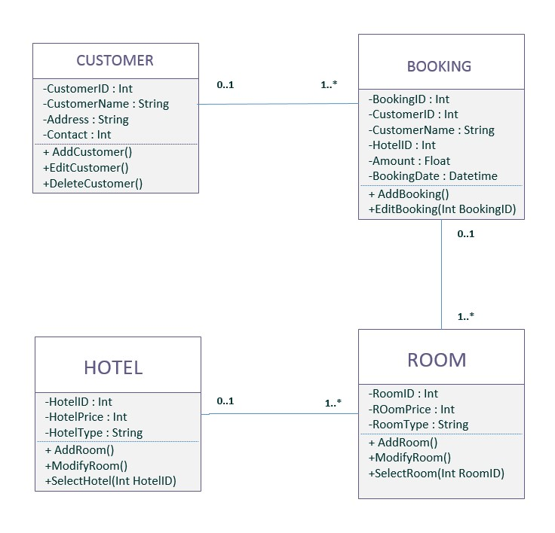

Barber Shop

Shop id: Int

Shop Price: Int

Shop type: String

*Fig. Class diagram*

**Use Case Diagram**

It is also called behavioural UML diagram. It gives a graphic over-view of the actors involved in a system directly. It shows how different functions needed by the actors how they are interacted.

Below is the “***USE CASE DIAGRAM***” of our new proposed system.

E Barber Appointment Booking System

Update slot availability

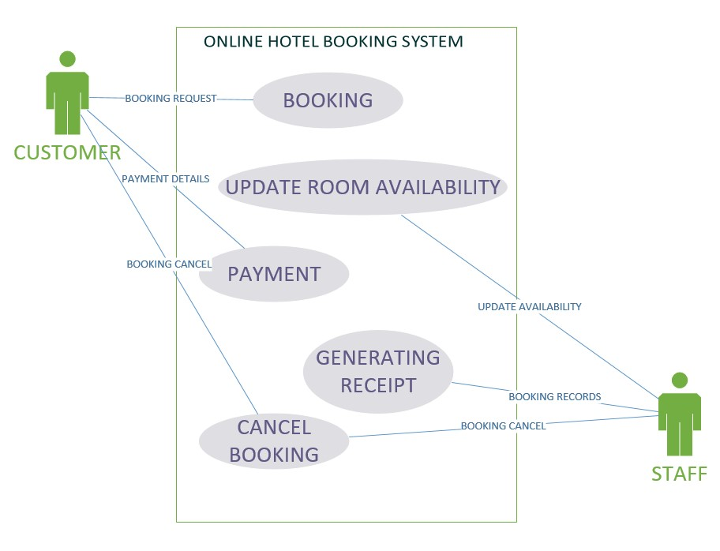

**FIGURE 3: USE CASE DIAGRAM**

**Use case table**

|  |
| --- |
| Name : Booking |
| Actor : Customer |
| Description : Describe the process used to add a new booking |
| Successful Completion : 1. Customers can book  2. Staffs enter the customer’s details into the database |
|  |
| Alternative : None |
| Precondition : Customers registered as a member |
| Post condition : Slot is booked by customer |

|  |
| --- |
| Assumption : None |
| Name : Update Slot Availability |
| Actor : Staff |
| Description : Can update the availability of slot |
| Successful Completion : 1. New availability for slot booking  2. Staffs enter the available slot details into the database |
| Alternative : None |
| Precondition : Staffs update the system entering new slot availability |
| Post condition : Customers can see the latest availability of slot |
| Assumption : None |

|  |
| --- |
| Name : Payment |
| Actor : Customer |
| Description : Describe the process of payment through the system |
| Successful Completion : 1. Customers will receive the invoice  2. Staffs enter the customers payment details into database |
| Alternative : Pay after arrive into the destinations |
| Precondition : Customers registered as a member |
| Post condition : Slot is booked by customer |
| Assumption : None |

|  |
| --- |
| Name : Generating Receipt |
| Actor : Staff |
| Description : Describe the process used to generate the booking details |
| Successful Completion : 1. Staff can check the booking details  2. Staffs will keep the copy of the generated receipt |
| Alternative : None |
| Precondition : |
| Post condition : Slot is booked by customer |
| Assumption : None |

|  |
| --- |
| Name : Booking |
| Actor : Customer |
| Description : Describe the process used to add a new booking |
| Successful Completion : 1. Customers can book  2. Staffs enter the customers details into the database |
| Alternative : None |
| Precondition : Customers registered as a member |
| Post condition : Slot is booked by customer |
| Assumption : None |

**System Design**

This app is created for easy online booking of e-barber appointments has following design structure.

* Sign In
* Log In- Provider/ Customer
* Search Nearby barber shops.
* Choose the Barber shop according to you.
* Book your appointments.

**Sign up**:-

There is a quality sign up window because this is more secure than the other Sign-up forms as in a normal Sign-up window. A provider or a customer will first sign up the app, then he/she will able to use the app.

**Log In**:-

There is a quality log in window because this is more secure than other log in forms as in normal log in window there are multiple logins available so that more than one person can access to book appointments with their individual logins. But in this project there is only one login id i.e. provider or customer id and password by which a person enter the app and access the all services provided by ‘E-BARBER’.

**Search nearby barber shops:-**

A customer will first search nearby barber shops. He/she check all shops reviews in our app/website. Then he/she will choose his/her favourite shop accordingly. A customer can book appointments with in a minute.

**Appointment Bookings:-**

After selecting a barber shop, a customer can book appointments effortlessly according to his/her time. Also the customer can cancel the booking before a specific time.

**Product Perspective:-**

**User Interface:-**

1. The application will have a friendly and menu-based interface. The following screens will be provided;
2. There is a Sign-up screen for new providers and users.
3. A login screen for entering the username and password will be provided. Access to different screens will be based on the user.
4. There is a screen displaying information regarding all the nearby barber shops.
5. There is a screen for displaying information regarding the categories of shops like Male, Female, and Unisex.
6. There is a screen displaying information regarding the different services provided by the barbershop.
7. There is a screen for displaying information regarding booking appointments.

**Product Functions:-**

1. The application will allow access only to authorized users with a specific role
2. Provider- The provider provides the different types of services.
3. User- A user books the appointment for services through this app from different shops available.

**Constraints:-**

* Since the database being used is My SQL, which is a very popular DBMS, it will be able to store a very huge number of records.
* An extra security as SSL must be used to secure the marks detailed and other provider and customer information.

**Flow Charts**

*Fig. Overview flow chat*

*Fig. login/signup flow chat*

**Data Flow Diagram**

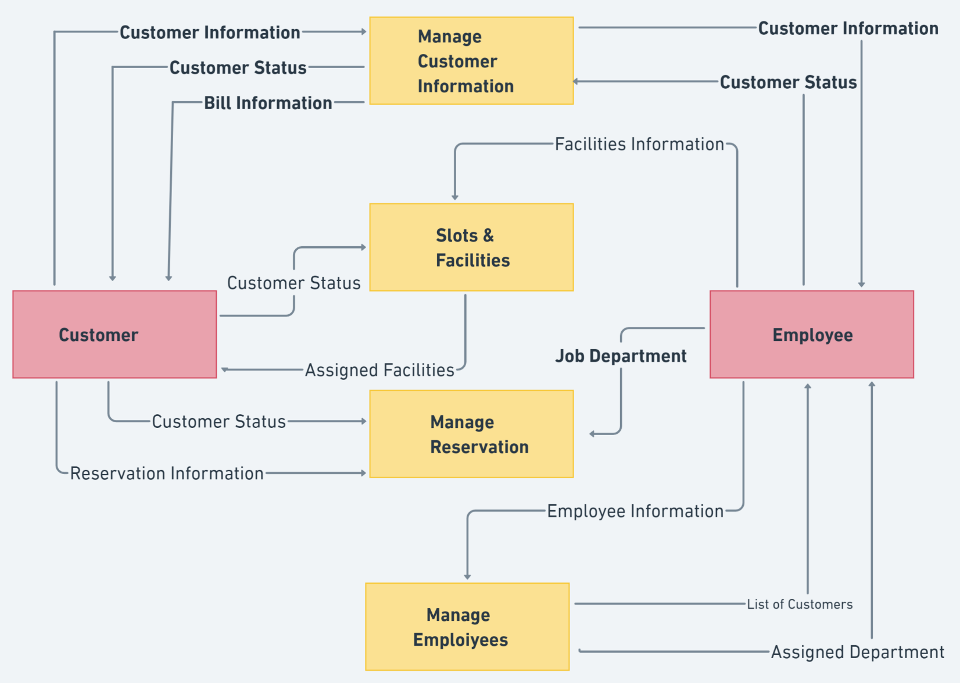

**Gantt Chart**

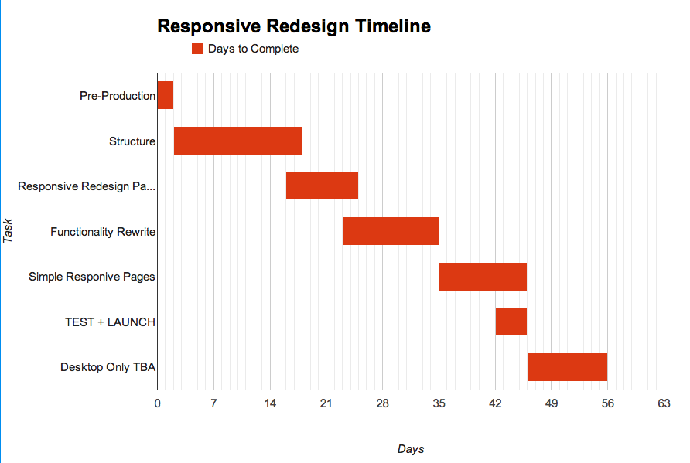

**Pert Chart**

**Tree Structure**

E- BARBER

Home Log in / Sign up Dashboard Pricing About us Contact Us Privacy Policy T & C

Search Nearby

Select a Category Trail Contact Us Privacy Policy T & C

Men Saloon Provider Provider Bronze

Unsex Saloon Gold

Women Saloon User User Platinum

**USER INTERFACE OF THE APPLICATION**

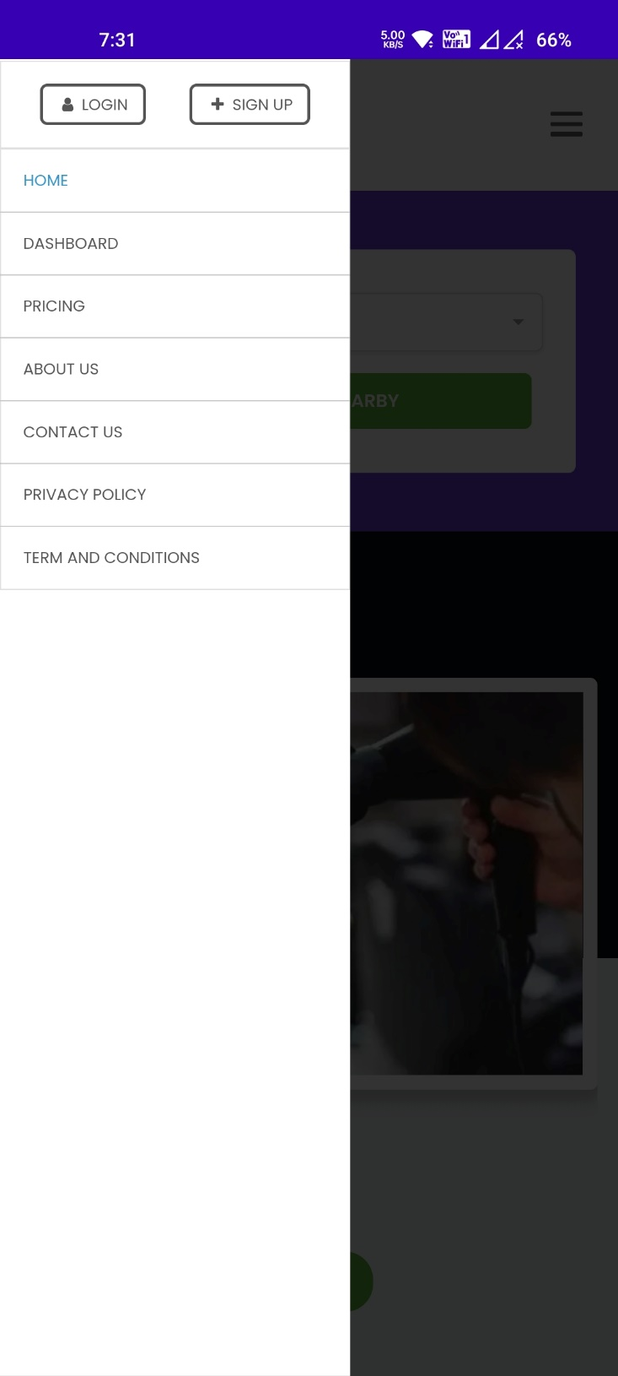 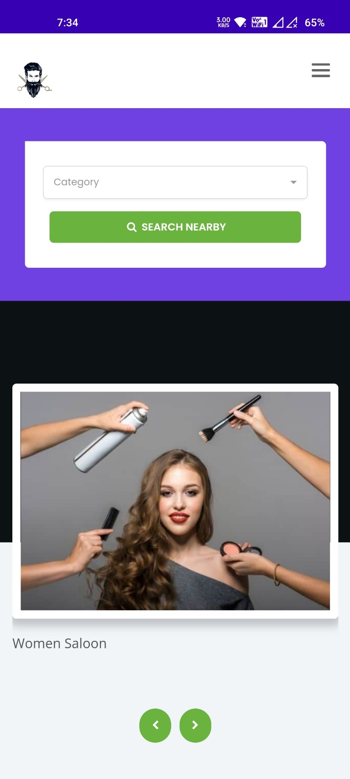

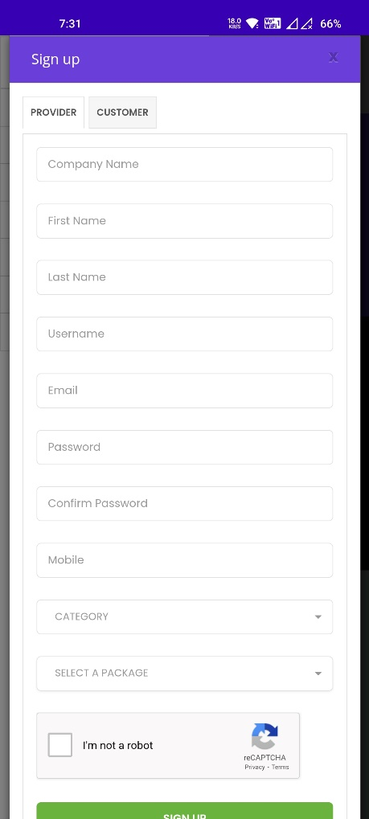 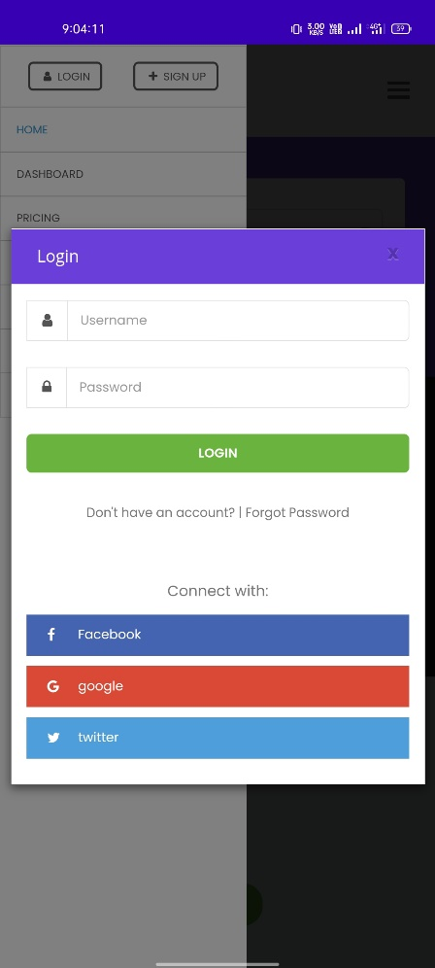 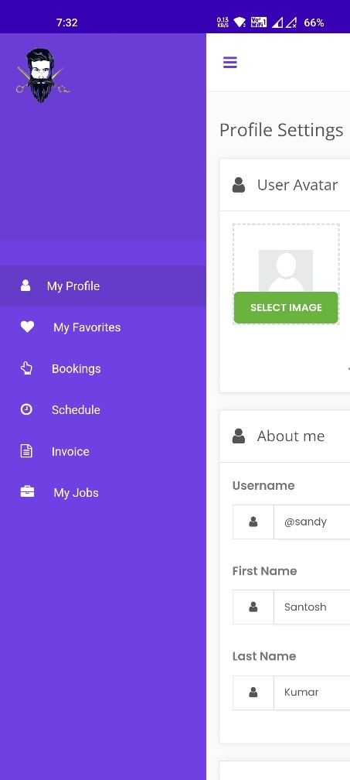 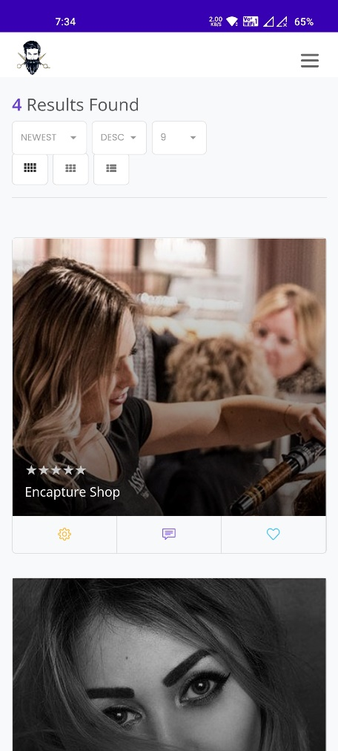 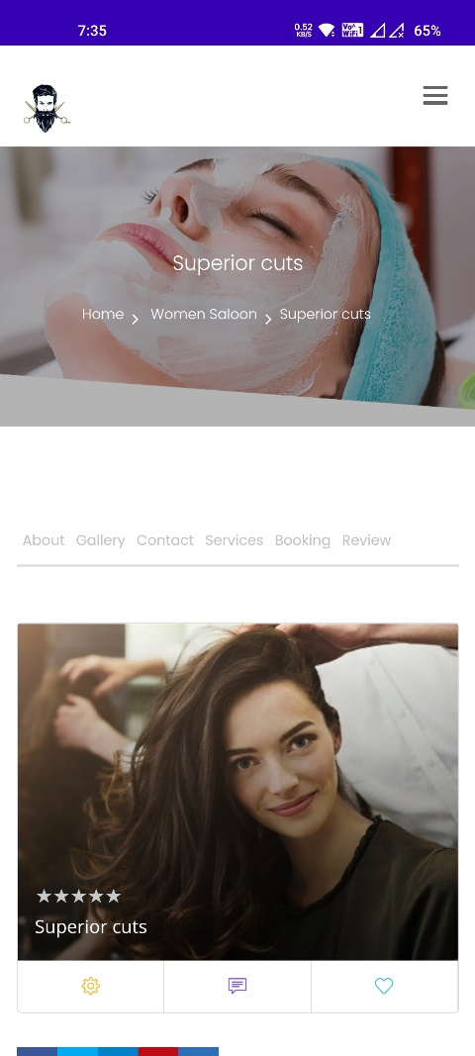 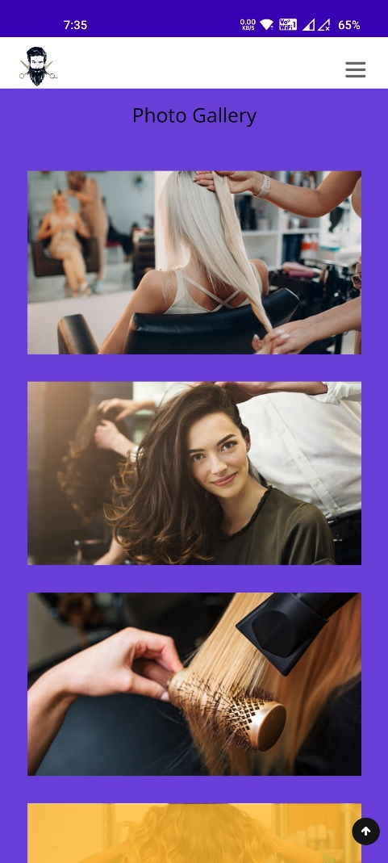 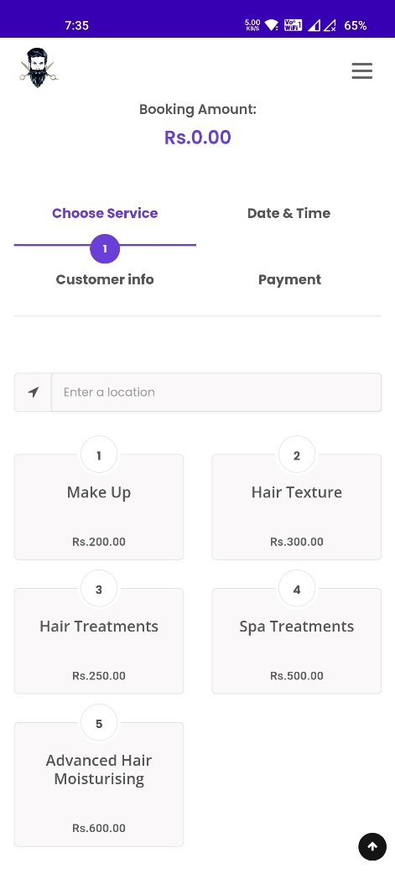 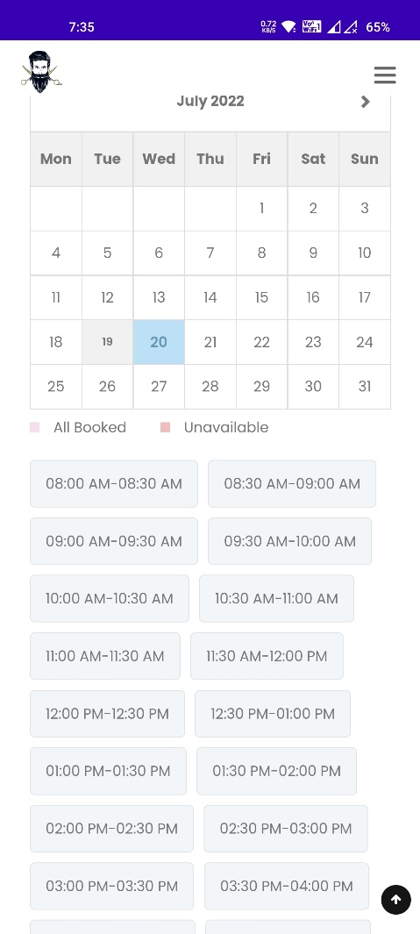 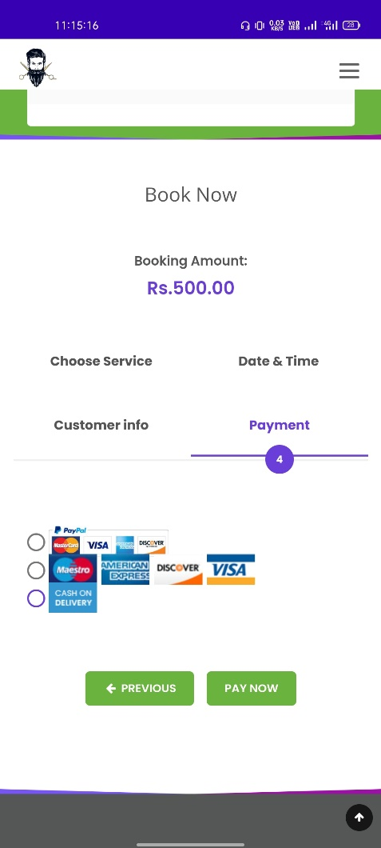

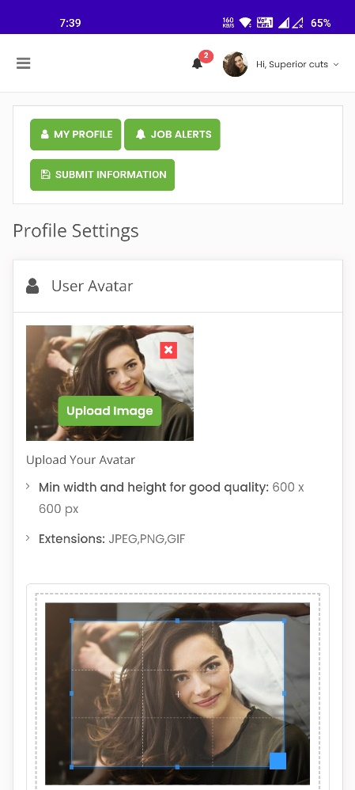 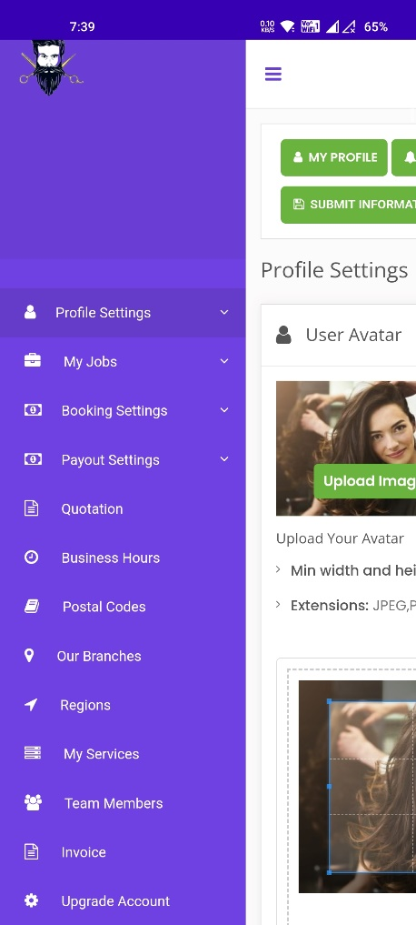 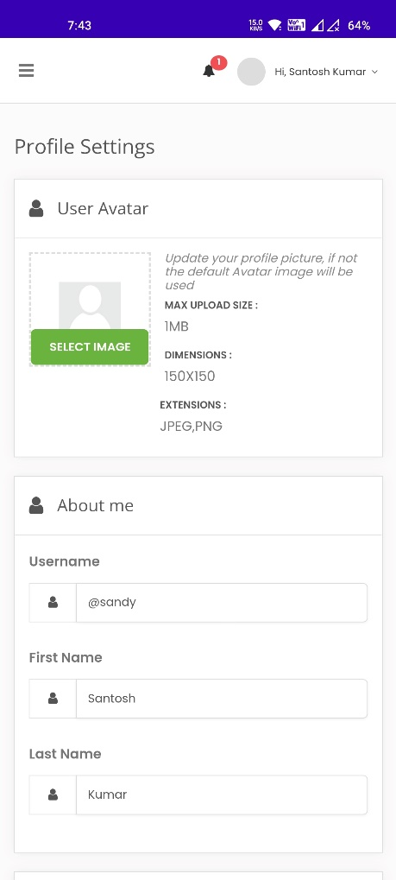

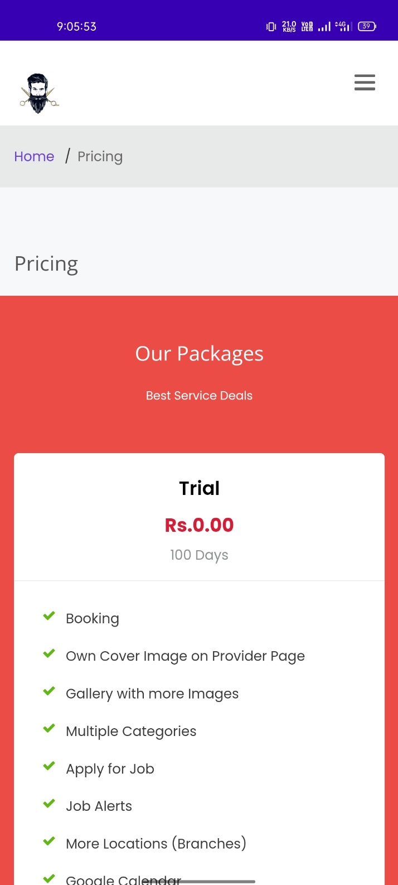 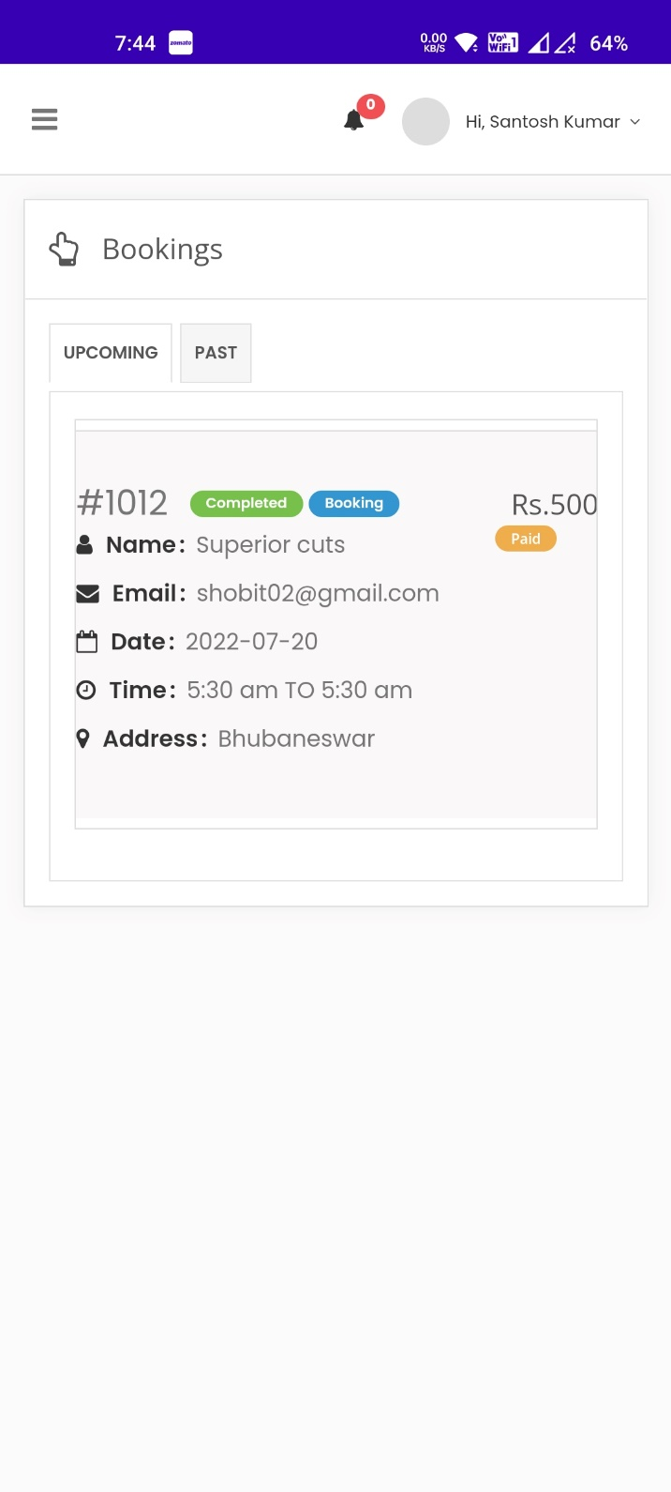

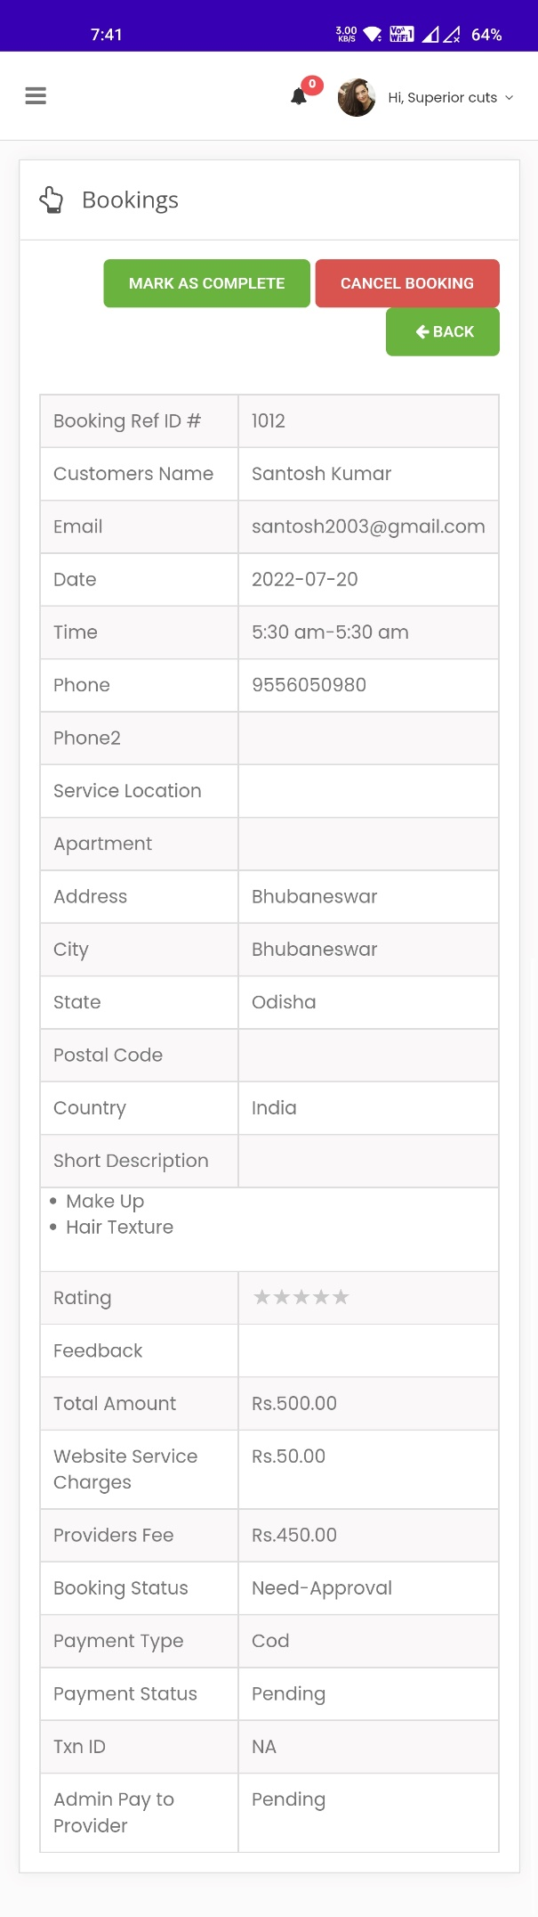 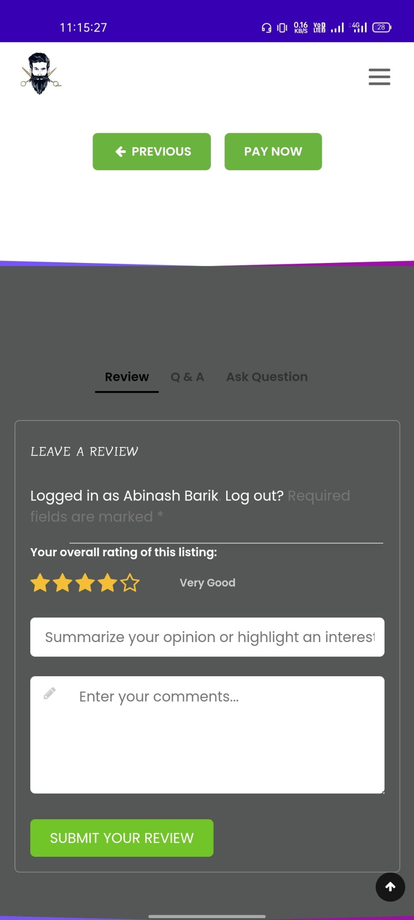

**IMPLEMENTATION**

With inputs from the system design, the system is first developed in small programs called units, which are integrated in the next phase. Each unit is developed and tested for its functionality, which is referred to as Unit Testing.

**Software Requirement:-**

* **Operating System**: Windows (XP, 7, 8, 8.1) or Mac OSX (Tiger, Leopard, Snow Leopard, Lion, Yosemite).
* **Web Browser:** Google Chrome, Internet Explorer (ver. 8 or later), Mozilla Firefox, Safari (Mac).
* **Database Management System:** MySQL, SQL Server, Microsoft Access, Oracle.
* **Web Development System:** Visual Studio 2010 or later, Adobe Dreamweaver, Notepad, and Notepad++.
* **Others:** .NET FRAMEWORK.

**Minimum Hardware Requirement:-**

* **RAM:** Minimum 2GB or higher.
* **HDD:** Minimum 50 GB.
* **Processor:** Intel Pentium 4 or AMD.

**TESTING**

**Test Case 001**

* **Test Title:** **E-BARBER Icon**
* **Test Procedures:** Click on the icon.
* **Test Data:** Users need to click on the icon bar.
* **Expected Result:** It will redirect to the system home page.

**Test Case 002**

* **Test Title:** **Customer & Provider Login.**
* **Test Procedures:** Type username & password.
* **Test Data:** Username & password must be alphanumeric. Otherwise, the system will show an error (ex. Please enter valid alphanumeric data).
* **Expected Result:** It will redirect to the login page.

**Test Case 003**

* **Test Title:** **Sign Up**
* **Test Procedures:** Click ***sign-up*** page.
* **Test Data:** Input the customer’s information and click on the button “***SIGN UP***”.
* **Expected Result:** It will register a new customer.

**Test Case 004**

* **Test Title:** **Search.**
* **Test Procedures:** Type Salons name with selecting slots.
* **Test Data:** Valid salons name with date.
* **Expected Result:** System will search according to the customer’s choice. .

**Test Case 005**

* **Test Title: Manage Booking.**
* **Test Procedures:** Click on the link “***Manage Booking***”.
* **Test Data:** ***Add***, ***Edit***, ***Del*** & ***Save*** button.
* **Expected Result:** Staff can edit, add, and Del individual customer booking records.

**Test Case 006**

* **Test Title: Username & Password**
* **Test Procedures:** Enter customers or staff’s valid username (Upper Case and Lower Case) and password (Alphanumeric).
* **Test Data:** Invalid password will show the warning message (Please Enter Valid Password).
* **Expected Result:** The system will follow the validation pattern.

**Test Case 007**

* **Test Title: View Booking Cancel Button**
* **Test Procedures:** Customers need to sign in and can cancel the booking when they press the cancel button.
* **Test Data:** Cancel their particular booking record.
* **Expected Result:** Will cancel their booking records from the database.

**Test Case 008**

* **Test Title: Change Search**
* **Test Procedures:** Customers can change their search according to changing their slots and salons.
* **Test Data:** Click on the button “**Change Search**” from the salon availability page.
* **Expected Result:** Customers can select their new slot with salons.

**Deployment**

To release our native mobile app, we must submit it to the appropriate app store, Google Play for our Android app. However, we will need a developer account with Google Play Store before launching our mobile app.

While packaging our app for app store submission, use a name and bundle identifier that is different from the QA version of our app. This will help us separate QA and production versions of our app. This way we can continue to test future upgrades to our app prior to releasing them.

An app’s release in the app store requires preparing metadata including:

* our app’s title
* Short description
* Description
* Category
* Keywords
* Launch icon
* App Store screenshots
* Banner graphic
* Promotional video

Our app requires users to log in, then we will need to provide a test user account as part of the submission process. Once submitted, apps go through the app store review process. This may take a few days, depending on the quality of our app and how closely it follows the app store’s guidelines. If rejected, we will be notified with a reason for rejection. After correcting the issues, we can resubmit the app and go through additional review until the app is approved and published in the app store ie. Google play store.

**Maintenance**

With technologies changing daily, one cannot escape from mobile app maintenance unless one wants to lose their users. With growing technologies, there are better apps every day, and one has to constantly stay ahead of the race to hold back their customers and acquire new ones.

**Here are some reasons why we should pay attention to the Maintenance of E Barber.**

* Better User-Experience
* Retain existing users and acquire new ones
* To keep up with the competitors

Well, now that we know the reasons for the maintenance of mobile apps, here are the essential things to include in our application maintenance plan.

1. Bug Fixes

Repeated bug issues or unresolved technical problems can drive our app users away. Bug issues cannot just make the User experience terrible, but it can result in the app crashing or failure when left unattended. They may not just frustrate our users but may also prevent them from returning to our app. Hence our mobile app maintenance service package or checklist needs to have regular bug fixes in it.

2. Performance Monitoring

Low performance is equal to more uninstalls or lesser usage. An app with lesser loading time and higher response time will always attract more users, making their online processes quick and seamless. our mobile app maintenance services package cannot be complete without performance monitoring.

3. Operating System Compatibility

This is one of the essential things that any mobile app maintenance services would include in its package. Apps need to be updated regularly along with the new Window, Android and IOS updates. The compatibility of the apps with the operating system highly affects the user experience.

4. Add New Features

New and unique features that enhance the customer experience will always increase sales and yield higher revenue. With plenty of applications to choose from, users tend to select the ones that are simple yet effective. So to add new features to the app is necessary to attract customers. Adding new features is the most crucial part to be included in mobile application development and support plan.

5. Improve User Experience

With Technology growing faster and faster and competitors trying to provide the best technical service possible, it is vital to give a smooth, advanced and enhanced user experience. It is also essential to understand and analyse the analytics like retention and conversion rate, customer usage time, engagement and more to reduce uninstalls. our mobile app maintenance services package must involve—detailed report of the above metrics.

6. License Renewals

Most of the apps these days use technologies that are licensed and incur charges for the same. License renewal charges can come up as sudden shocks to the bank accounts, so it's recommended to keep an eye on license renewal dates and make the necessary payments within the stipulated time. Maintenance of the mobile app also includes maintaining records of the renewals and expenses for the same.

7. Security Checks

Online security is one of the biggest challenges of mobile app development services. Any ignorance in the app security can result in loss of confidential information and cause severe losses to the organization. Hence it is crucial to conduct occasional security checks and improve current safety.

**LIMITATIONS**

Although this system will provide booking facilities to customers, it is having some limitations. In case of inquiry when customers send their feedback through the system, it will go directly to the staff mailbox. It means the system doesn’t have a separate web page for checking all the customer's inquiries and sending replies promptly. Besides the system also doesn’t have online banking (Phone Pay, Paytm, Google Pay, UPI) for customers.

**FUTURE WORKS**

In the future, we will build an IOS APP and we will available our app on both the play store and the app store, We will have flexible booking slots 30mins to as customer’s needs, We will add more salons on our app, and as well as We will make our app user experience better.

**CONCLUSION**

The system is having some benefits for customers too. On the home page, customers can put their email address or phone number for downloading the booking apps directly on their phone. The application will work for both OS platforms (IOS & Android). By This customer can book by using this application. Besides, customers can also book online without registering into the system. Again, customers no need to worry about payment. But for reservations, they need to key in their credit card details for verification purposes. It will not charge them promptly. So, overall this system will give the customers a better user-friendly environment to book online.

**REFERENCES**

1. Agoda.com, 2014. *Agoda.com.* [Online] Available at: http://www.agoda.com/msmy/?type=1&site_id=1415444&url=http://www.agoda.com/&tag=10c75ac0-c743-4ffe-8b015901339559ef&device=c&network=g&adid=54270519426&rand=5482813827515076520&expid=42801 52&adpos=1t1&gclid=Cj0KEQjwq52iBRDEvrC12Jnz6coBEiQA2otXAn7IruJOTl [Accessed 20 October 2014].
2. Booking.com, 2014. *Booking.com.* [Online]

Available at: http://www.booking.com/index.html?aid=378266;label=booking-name-

sONOsHFUDs3qkZY8eHVLqgS35420572471:pl:ta:p1:p2544,000:ac:ap1t1:neg;ws=&gclid=Cj0KEQjwq52iB RDEvrC12Jnz6coBEiQA2otXAp8sdf2xl13y5p6ad6X7mKjuGFwi8-0hZO3yvMK1P9QaAvtt8P8HAQ [Accessed 20 October 2014].

1. EASYTOBOOK.COM, 2014. *EASY TO BOOK.* [Online]

Available at: http://www.easytobook.com/?amu=2599051302&utm_nooverride=1 [Accessed 5 December 2014].

1. Expedia AU, 2014. *Expedia AU.* [Online] Available at: http://www.expedia.com.au/Hotels [Accessed 19 October 2014].
2. Hotel Club, 2014. *Hotel Club.* [Online]

Available at: http://www.hotelclub.com/Australia/ [Accessed 19 October 2014].

1. Hotels.com, n.d. *Hotels.com.* [Online] Available at:

http://www.hotels.com/?PSRC=SEMB&rffrid=sem.hcom.E5.google.003.00.01.s.kwrd=ZzZz.sEaLM1M5C.

0.51707353162.10200p829340.d.c&gclid=Cj0KEQjwq52iBRDEvrC12Jnz6coBEiQA2otXAqoAxb7bw_O4y4

24TF_D5-O9XCDcDH_OB46NcdzA14QaAkz58P8HAQ [Accessed 20 October 2014].

1. Marriot, 2014. *Marriot.* [Online]

Available at: http://www.marriott.com.au/default.mi [Accessed 19 October 2014].

1. Quickbeds, 2014. *Quickbeds.* [Online] Available at: http://www.quickbeds.com/ [Accessed 19 October 2014].