**Asish Kumar Panda**

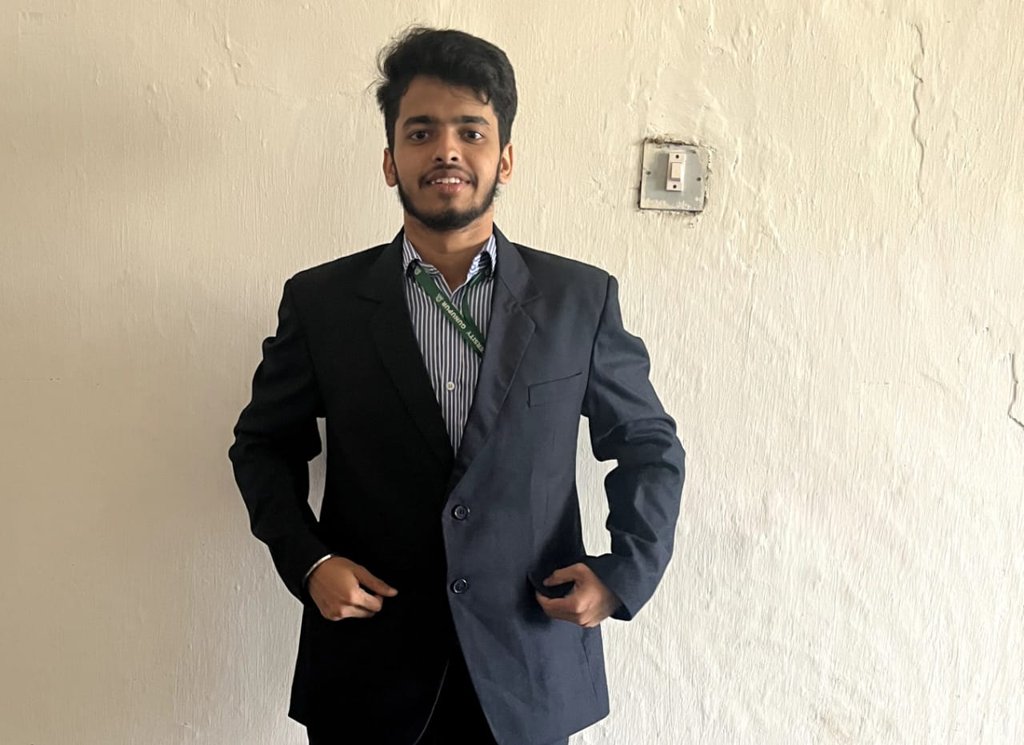

Computer Science and Engineering

Email: asishkumarpanda500@gmail.com

Phone: +91-7735007723

**Career Objective**

Web development enthusiast and proficient in Data Structures and Algorithms. Seeking a dynamic role to apply coding skills and creative problem-solving in a collaborative environment. Eager to contribute to innovative projects, leveraging technical expertise to deliver impactful solutions and grow professionally in the evolving tech industry.

**Educational Qualifications**

|  |  |  |  |
| --- | --- | --- | --- |
| Degree and Year | Institute | Board | Marks/CGPA |
| B. Tech (CSE) | GIET UNIVERSITY, GUNUPUR |  | 7.7 |
| +2 Science in 2021 | GYANA VIKASH HIGHER SECONDARY SCHOOL, GANJAM | CHSE | 475 |
| 10th in 2019 | SARASWATI SISU VIDYA MANDIR ,GANJAM | HSE | 480 |

**Training / Certification**

* The Joy of Computing (NPTEL)
* C Certification Exam (Spoken Tutorial)
* Internship on Web Development (RINEX)
* Internship on Web Development (INTERNPE)
* Cambridge Capable Program (ENGLISH)

**Achievements and Extracurricular activities**

* Have a 4 Star in Java Programming on Hacker Rank.
* Problem solving Event
* Getting Started with UI/UX Design
* Technical Workshop
* Programming club
* Project Leadership

**Technical Skills**

* Frontend (HTML, CSS, JS)
* Microsoft Word
* Backend & API
* C
* Java
* Python
* Microsoft PowerPoint

**Internship Programs**

Web-Development using HTML, CSS, JS, BOOTSTRAP at Rinex Technology Pvt. Ltd. which was conducted on 28-May-2023 to 03-Jul-2023 and did an interactive project.

**Internship Project Details**

|  |  |
| --- | --- |
| **Description** | I have learned how to use HTML, CSS, JS, Bootstrap, MONGODB, EXPRESS JS and NODE JS.  I completed three projects: Netflix website clone to practice designs, A TO-DO Lists app for practical use and Own Portfolio for creating Interactive resumes. |

**Project Details**

|  |  |
| --- | --- |
| **Name of the Project** | **Student Management System** |
| **Language used** | HTML, CSS and JAVASCRIPT |
| **Description** | The Student Management System project utilizes HTML, CSS, and JavaScript to create an interactive platform for managing student information. With a user-friendly interface, it allows administrators to add, edit, and view student details, fostering efficient academic record keeping and organization. |

|  |  |
| --- | --- |
| **Name of the Project** | **Note Management** |
| **Languages used** | HTML, CSS, JS, BOOTSTRAP, NODE JS, MONGODB |
| **Description** | |  | | --- | | The Car Rental System project utilizes HTML, CSS JavaScript, PHP to create an interactive platform for managing Car Rental System information. With a user-friendly interface, having two interfaces one is admin interface and another one is user interface.it allows administrators to add, edit, and view Cars details, fostering efficient Booked record keeping and organization. | |

|  |  |
| --- | --- |
| **Name of the Project** | **Job Application** |
| **Language used** | HTML, CSS, BOOTSTRAP, MONGODB, NODEMON, NODE JS |
| **Description** | Developed a robust job application platform using HTML, CSS, Bootstrap for frontend design, and MongoDB with Node.js for backend functionality. The platform offers a user-friendly interface for job seekers and employers, enhancing the hiring process with efficient data. |

**Personal Details**

|  |  |
| --- | --- |
| Date of Birth | 25/06/2003 |
| Gender | MALE |
| Father's Name | ARJUNA PANDA |
| Address | AT/PO – ACHULI, PURUSHOTTAMPUR, GANJAM, ODISHA ,761018 |
| Alternate phone number | 9438850710 |
| Language Known | ENGLISH, HINDI, ODIA |
| Interests & Hobbies | GAMING, PLAYING BADMINTON, WATCHING MOVIE, COMEDY ENTHUSIAST |

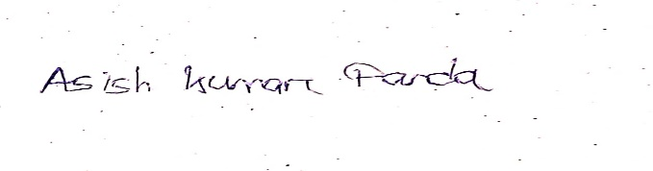 Place: GUNUPUR, ODISHA Signature

Date: 29/12/2023