**20MCA245**

MINI PROJECT

**SERVIX**

## Rough Record

**Project Guide Group Members**

Prof. Shalu Murali Asish Sabu

Leo Thomas Sankar S

Abraham Jerin John

# Introduction

In August 2021, the government launched the e-Shram portal for better execution of various social security schemes for unorganised sector workers. This helps for the welfare of workers in the unorganized sector who are not members of the EPFO or ESIC. Inspite of that we are developing a website which allows customers to book workers for their jobs.

This helps to ensure job for many ones and reduced the effort made by the customers in search of a worker. Customers get workers with a feasible rate. Skilled labours for various works within a region can be viewed and book through this website. Customers can give feedbacks based on workers and workers can view the same through this application.

## Module Description

The project SERVIX (online worker hiring website/portal) has three modules-

### Administrator(Admin)

* **Worker/employee**

### User

1. **Admin**
   * The admin is responsible for verification of details and certificates provided by the worker.
   * After verification he can accept/reject worker’s profile based on eligibility criteria.
   * Admin is also responsible to solve the issues raised by the customers.
   * Admin also has the responsibility to check online transaction.

### Worker/Employee

* + Any person having essential qualification and experience in the relevant field can register here.
  + For registering, the person has to go through employee registration.
  + The person seeking job has to fill the form in the site by providing his basic details along with Qualification and experience certificate.
  + After verification by the administrator the users can see his profile in the workers list and can avail his service to the registered customers.

### User

* + Anybody who is desired to get any workers can register here as a user.
  + For first time user they have to register here by giving their basic details like name, location, etc.
  + If the user is already registered he can login and search workers in his surrounding areas.
  + The user has also the facility to desired workers based on their wages.
  + Another facility provided is the user can also see the availability of workers based on users time.
  + User can also cancel the work if he is not available at the time.
  + There is also online payment option.
  + At the end the user has the facility to give feedback and ratings.

|  |  |  |
| --- | --- | --- |
| **PRODUCT BACKLOG** | | |
| **SL NO** | **REQUIREMENTS** | **PRIORITY** |
| 1 | **ADMIN** |  |
| As an Admin I want to login | 1 |
| As an admin I want to approve or reject workers | 3 |
| As an admin I want to accept customer request | 4 |
| As an administrator I want solve issues raised by customers | 15 |
| As an administrator I want to verify the worker profile | 2 |
| As an administrator I want to verify the transactions | 13 |
| 2 | **USER** |  |
| As a user I want to register | 5 |
| As a user I want to login | 6 |
| As a user I want to view worker details | 9 |
| As a user I want to avail workers available | 10 |
| As a user I want to register complaints | 14 |
| As a user I want to give feed back | 16 |
| As a user I want to pay in online or cash mode | 12 |
| 3 | **WORKER** |  |
| As a worker I want to register | 7 |
| As a worker I want to login | 8 |
| As a worker I want to update wage details | 17 |
| As a worker I want to update by available time and place | 11 |
| As a worker I want to view feedback of customers | 18 |

# Sprint Backlog

|  |  |  |  |  |  |
| --- | --- | --- | --- | --- | --- |
| **SPRINT 1** | **SL NO** | **TASKS** | **START DATE** | **END DATE** | **STATUS** |
| 1 | FOUND OUT SUITABLE PROJECT TOPIC | 25-11-21 | 30-11-21 | COMPLETED |
| 2 | DISCUSSION OF TOPIC AND REQUIREMENTS | 01-12-21 | 02-12-21 | COMPLETED |
| 3 | DISCUSSION OF DIFFERENT MODULES AND ITS FUNCTIONALITIES | 03-12-21 | 04-12-21 | COMPLETED |
| 4 | PLANNING ALL THE REQUIRED DEPENDENCIES FOR IMPEMENTNTING THE FUNCTIONALITIES | 03-12-21 | 04-12-21 | COMPLETED |
| 5 | PREPARATION OF PRESENTATION SLIDES TO BE PRESENTED FOR ZEROTH REVIEW | 04-12-21 | 14-12-21 | COMPLETED |
| **SPRINT 2** | 6 | DISCUSSION ABOUT DATA BASE DESIN FOR LOGIN AND REGISTRATION | 14-12-21 | 15-12-21 | COMPLETED |
| 7 | DISCUSSION ABOUT CODING FOR LOGIN AND REGISTRATION | 15-12-21 | 20-12-21 | COMPLETED |
| **SPRINT 3** | 8 | CODE FOR HOME PAGE | 22-12-21 | 25-12-21 | COMPLETED |
| 9 | CODE FOR CUSTOMER,USER AND ADMIN PAGE | 22-12-21 | 26-12-21 | COMPLETED |
| 10 | CODE FOR DATABASE CONNECTION | 28-12-21 | 30-12-21 | COMPLETED |
| **SPRINT 4** | 11 | PREPARATION OF SLIDES FOR FIRST REVIEW | 16-01-22 | 18-01-22 | COMPLETED |
| 12 | WEBSITE HOSTED IN LOCAL HOST FOR TESTING | 18-01-22 | 18-01-22 | COMPLETED |
| **SPRINT 5** | 13 | CODING ON VARIOUS SECTION AT ADMIN MODULE. | 21-01-22 | 23-01-22 | COMPLETED |
| **SPRINT 6** | 14 | ADMIN MODULE WAS CREATED | 25-01-22 | 30-01-22 | COMPLETED |

|  |  |  |  |  |  |
| --- | --- | --- | --- | --- | --- |
|  |  | AND CONNECTED TO THE DATABASE |  |  |  |
| **SPRINT 7** | 15 | CUSTOMER MODULE WAS  CREATED AND CONNECTED TO THE DATABASE | 02-02-22 | 06-02-22 | COMPLETED |
| **SPRINT 8** | 16 | WORKER MODULE WAS CREATED AND FUNCTIONALITIES ARE ADDED | 15-02-22 | 24-02-22 | COMPLETED |

**Daily Sprint**

|  |  |  |  |
| --- | --- | --- | --- |
| **SL**  **No** | **DATE** | **TASKS** | **STATUS** |
| 1 | 30-11-2021 | * Find out suitable project topic and discussed thetopic with project guide. * Scheduled a team meeting and discussed therequirements * Allocation of positions for each member- Asish as scrum master, Abraham as   product owner, Leo& Shankar as developers. | COMPLETED |
| 2 | 01-12-2021 | Prepared abstract for the topic and meet the  projectguide. Added more features to project topic | COMPLETED |
| 3 | 03-12-2021 | * Set up appserv * Started learning PHP. * Started learning CSS. | COMPLETED |
| 4 | 04-12-2021 | Scheduled a team meeting and discussed about the slidepreparation, design etc | COMPLETED |
| 5 | 08-12-2021 | Started preparation for zeroth review | COMPLETED |
| 6 | 10-12-2021 | Collected details and materials for slides | COMPLETED |
| 7 | 13-12-2021 | Prepared slides and git updation | COMPLETED |
| 8 | 14-12-2021 | Got approval for the project and started | COMPLETED |
| 9 | 15-12-2021 | Discussed about the database design | COMPLETED |
| 10 | 17-12-2021 | Draw DFD | COMPLETED |
| 11 | 23-12-2021 | Database designing | COMPLETED |
| 12 | 27-12-2021 | Template designing | COMPLETED |
| 13 | 28-12-2021 | Registration form for users and workers | COMPLETED |
| 14 | 05-01-2022 | Database connection established | COMPLETED |
|  |  |  |  |

|  |  |  |  |
| --- | --- | --- | --- |
| 15 | 15-01-2022 | Scheduled meeting and discussion for first review | COMPLETED |
| 16 | 19-01-2022 | Complete slides & record for presentation | COMPLETED |
| 17 | 21-01-2022 | Scheduled a meeting and discussed with Project Guide about the modifications on template designing and added  more features | COMPLETED |
| 18 | 23-01-2022 | View table for admin is created and connected to the database. | COMPLETED |
| 19 | 25-01-2022 | Discussion about adding features to worker was started. | COMPLETED |
| 20 | 28-01-2022 | Update details in worker was created an connected to the database. | COMPLETED |
| 21 | 30-01-2022 | Feedback and Complaint form in worker module is created. | COMPLETED |
| 22 | 01-02-2022 | Database connection in feedback was completed. | COMPLETED |
| 23 | 02-02-2022 | Added option to book workers in customer module. | COMPLETED |
| 24 | 02-02-2022 | View table for customer is created and connected to the database. | COMPLETED |
| 25 | 04-02-2022 | Feedback and complaint form in customer module is created. | COMPLETED |
| 26 | 06-02-2022 | Feedback form in customer was connected to the database. | COMPLETED |
| 27 | 09-02-2022 | Scheduled meeting and discussion for second review. | COMPLETED |
| 28 | 10-02-2022 | Modified slides and git status is updated. | COMPLETED |
| 29 | 17-02-2022 | Template was edited. | COMPLETED |
| 30 | 23-02-2022 | Errors on the slide are fixed. | COMPLETED |
| 31 | 24-02-2022 | Slides modified and git was updated. | COMPLETED |

**Data Flow Diagram(DFD)**

### LEVEL 0

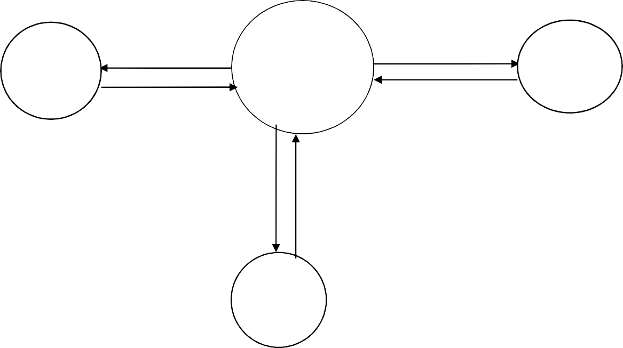

Admin

Servix

User

Workers

**Level 1**

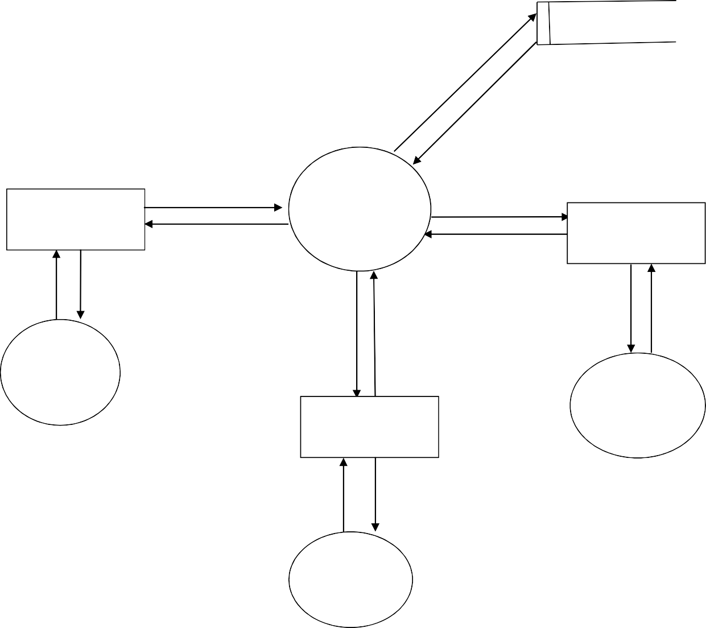

**Level 1.1**

Approve/ Reject workers

Worker registration

View worker details

Admin

View customer’s request details

View feedback from workers and customers

View worker VdeiteawilsComplaints

Worker allocation

Feedback

Complaint

**Level 1.2**

**Level 1.3**

**DATABASE DESIGN**

1. Table Name : User login

Table Description : Table contains user login details

|  |  |  |  |
| --- | --- | --- | --- |
| **Field Name** | **Data type** | **Constraints** | Comments |
| uid | varchar(20) | Primary key | Login Id of user |
| name | varchar(20) | Not null | Name of user |
| Email id | Varchar(20) | Not null | Uer email id |
| password | varchar(15) | Not null | User Password |
| role | varchar(15) | Not null | Service required |

1. Table Name : Workers registration

Table Description : Table contains different user registration details.

|  |  |  |  |
| --- | --- | --- | --- |
| **Field Name** | **Data type** | **Constraints** | **comments** |
| eid | varchar(20) | Primary key | Login id |
| name | varchar(20) | Not null | Name of worker |
| Aadhar no | int | Not null | Aadhar no of worker |
| email | varchar(20) | Not null | email of worker |
| name | varchar(20) | Not null | name |
| phno | int | Not null | Phone no of worker |
| role | varchar(20) | Not null | Type of service providing |

1. Table Name : worker allocation

Table Description : Table contains worker alloaction details.

|  |  |  |  |
| --- | --- | --- | --- |
| **Field name** | **Data type** | **Constraints** | **Comment** |
| worker_id | int(20) | Primary key | Unique id for employee |
| Name | varchar(30) | Not null | Name of employee |
| Role | varchar(30) | Not null | Type of service provided |
| Date & Time | date | Not null | Prefered time of work |
| Duration | varchar(20) | Not null | Expected duration |
| Salary | int(10) | Not null | Salary of employee |

1. Table Name : Complaint table

Table Description : Table contains details of complaint.

|  |  |  |
| --- | --- | --- |
| **Field name** | **Data types** | **Constraints** |
| cid | int(12) | Primary key |
| complaint | varchar(50) | Not null |
| Date | varcahr(30) | Not null |
| Time | varchar(15) | Not null |
| Username | varchar(5) | Not null |
| Reply | varchar(50) | Not null |

1. Table Name : Feedback Table

Table Description : Table contains details of feedbacks.

|  |  |  |
| --- | --- | --- |
| **Field name** | **Data types** | **Constraints** |
| fid | int(5) | Primary key |
| Feedback | varchar()20 | - |
| Time | varchar(50) | - |
| Date | varchar(50) | - |
| Userid | varchar(50) | Foreign key |

1. Table Name : Customer registration table

Table Description : Table contains details of customer.

|  |  |  |
| --- | --- | --- |
| **Field name** | **Data types** | **Constraints** |
| Name | varchar(5) | - |
| Address | varchar(30) | - |
| Email | varchar(50) | Primary key |
| Contact | varchar(10) | - |

**Git commit history**



