Decentralization of Aadhar using Ethereum and Raspberry Pi

THIRD YEAR DESIGN PROJECT REPORT



submitted by

Arya Thampi
Asish Shaji Thomas
Aswin C S
Aswin P P

ACKNOWLEDGEMENT

We would like to express our special thanks of gratitude to my teachers and Ms. as well as our HOD Mrs. Devi and Principal Mrs. Sudha.S who gave me the golden opportunity to do this wonderful project on the topic “Decentralization of Aadhar using blockchain”, which also helped our team in doing a lot of research and WE came to know about so many new things we’re really thankful to them.

ABSTRACT
The primary concern regarding Aadhar is that a centralized database containing demographic and biometric data of over a billion people is an obvious honeypot for hackers.
The recent data leaks shows the same.One of the successful solutions to these problem explained in this paper is rather than using a centralized database we use a distributed decentralized database.That is a blockchain.This paper make use of Ethereum blockchain.This make sure that the data of its users a safely stored.The data is decentralized and distributed over the nodes connected to the ethereum network.
Keywords: Ethereum, Aadhar, Blockchain,

Contents
Acknowledgement
Abstract
Chapter 1 INTRODUCTION
Chapter 2 ETHEREUM
Chapter 3 PROPOSED SYSTEM
Chapter 4 RESULTS AND CONCLUSION
REFERENCES
Appendix A: Screen Shots

CHAPTER 1
INTRODUCTION

UIDAI’s Aadhaar is the worlds biggest biometric database project. In which 111 crore people of the total 125 crore Indians are already connected with the identity scheme.On January 10, 2018, An anonymous hacker named Elliot Alderson exposed the first Aadhaar related security issues. He found that biometrics are being stored in the local database of the mAadhaarApp. In that string used to create a password is weak, and that is why it is easy to crack.
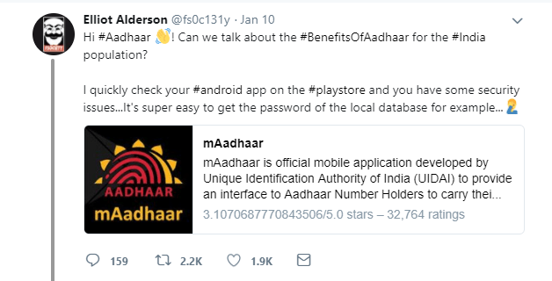
Elliot’s interest in it was increasing day by day, On February 25 he founded a Basic SQL Injection vulnerability in Telangana government’s benefit disbursement portal TSPost Website. Due to this, he had accessed the database contained user information, including Aadhaar numbers, of 56 lakh National Rural Employment Guarantee scheme beneficiaries and 40 lakh beneficiaries of the social security pensions.
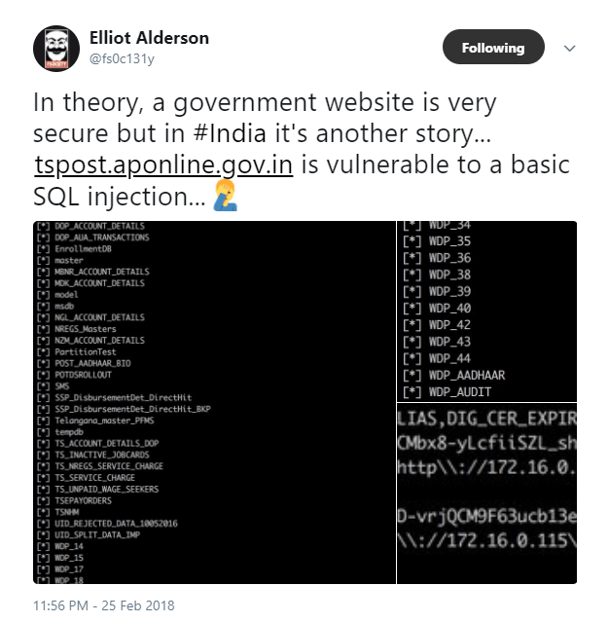
The website has been shut down by the government after this exposure, telling to TOI “It was online due to certain dependencies. We have taken off the site from the web”.

A malicious patch, sold on whatsapp for as little as 2500 Indian Rupee lets a user bypass critical security features such as biometric authentications of enrollment operations to generate unauthorised Aadhat numbers.The patch disables the enrollment softwares inbuilt GPS security feature(used to identify the physical location of every enrollment centre), which means anyone anywhere in the world can use the software to enroll users.

The patch reduces the sensitivity of the enrollment software’s iris recognition system, making it easier to spoof the software with a photograph of a registered operation, rather than requiring the operator to be present in person.

All the database of our government is either centralized or decentralized. Decentralization helps in stopping DOS attack. But what we actually need to build is distributed decentralized database system, in a more democratic way.

CHAPTER 2
ETHEREUM
Satoshi Nakamoto's development of Bitcoin in 2009 has often been hailed as a radical development in money and currency, being the first example of a digital asset which simultaneously has no backing or intrinsic value and no centralized issuer or controller. However, another - arguably more important - part of the Bitcoin experiment is the underlying blockchain technology as a tool of distributed consensus, and attention is rapidly starting to shift to this other aspect of Bitcoin. Commonly cited alternative applications of blockchain technology include using on-blockchain digital assets to represent custom currencies and financial instruments (colored coins), the ownership of an underlying physical device (smart property), non-fungible assets such as domain names (Namecoin), as well as more complex applications involving having digital assets being directly controlled by a piece of code implementing arbitrary rules (smart contracts) or even blockchain-based decentralized autonomous organizations (DAOs). What Ethereum intends to provide is a blockchain with a built-in fully fledged Turing-complete programming language that can be used to create "contracts" that can be used to encode arbitrary state transition functions, allowing users to create any of the systems described above, as well as many others that we have not yet imagined, simply by writing up the logic in a few lines of code.

History
The concept of decentralized digital currency, as well as alternative applications like property registries, has been around for decades. The anonymous e-cash protocols of the 1980s and the 1990s, mostly reliant on a cryptographic primitive known as Chaumian blinding, provided a currency with a high degree of privacy, but the protocols largely failed to gain traction because of their reliance on a centralized intermediary. In 1998, Wei Dai's b-money became the first proposal to introduce the idea of creating money through solving computational puzzles as well as decentralized consensus, but the proposal was scant on details as to how decentralized consensus could actually be implemented. In 2005, Hal Finney introduced a concept of reusable proofs of work, a system which uses ideas from b-money together with Adam Back's computationally difficult Hashcash puzzles to create a concept for a cryptocurrency, but once again fell short of the ideal by relying on trusted computing as a backend. In 2009, a decentralized currency was for the first time implemented in practice by Satoshi Nakamoto, combining established primitives for managing ownership through public key cryptography with a consensus algorithm for keeping track of who owns coins, known as "proof of work".
The mechanism behind proof of work was a breakthrough in the space because it simultaneously solved two problems. First, it provided a simple and moderately effective consensus algorithm, allowing nodes in the network to collectively agree on a set of canonical updates to the state of the Bitcoin ledger. Second, it provided a mechanism for allowing free entry into the consensus process, solving the political problem of deciding who gets to influence the consensus, while simultaneously preventing sybil attacks. It does this by substituting a formal barrier to participation, such as the requirement to be registered as a unique entity on a particular list, with an economic barrier - the weight of a single node in the consensus voting process is directly proportional to the computing power that the node brings. Since then, an alternative approach has been proposed called proof of stake, calculating the weight of a node as being proportional to its currency holdings and not computational resources; the discussion of the relative merits of the two approaches is beyond the scope of this paper but it should be noted that both approaches can be used to serve as the backbone of a cryptocurrency.

Ethereum
The intent of Ethereum is to create an alternative protocol for building decentralized applications, providing a different set of tradeoffs that we believe will be very useful for a large class of decentralized applications, with particular emphasis on situations where rapid development time, security for small and rarely used applications, and the ability of different applications to very efficiently interact, are important. Ethereum does this by building what is essentially the ultimate abstract foundational layer: a blockchain with a built-in Turing-complete programming language, allowing anyone to write smart contracts and decentralized applications where they can create their own arbitrary rules for ownership, transaction formats and state transition functions. A bare-bones version of Namecoin can be written in two lines of code, and other protocols like currencies and reputation systems can be built in under twenty. Smart contracts, cryptographic "boxes" that contain value and only unlock it if certain conditions are met, can also be built on top of the platform, with vastly more power than that offered by Bitcoin scripting because of the added powers of Turing-completeness, value-awareness, blockchain-awareness and state.

Ethereum Accounts
In Ethereum, the state is made up of objects called "accounts", with each account having a 20-byte address and state transitions being direct transfers of value and information between accounts. An Ethereum account contains four fields:
- The nonce, a counter used to make sure each transaction can only be processed once
- The account's current ether balance
- The account's contract code, if present
- The account's storage (empty by default)
"Ether" is the main internal crypto-fuel of Ethereum, and is used to pay transaction fees. In general, there are two types of accounts: externally owned accounts, controlled by private keys, and contract accounts, controlled by their contract code. An externally owned account has no code, and one can send messages from an externally owned account by creating and signing a transaction; in a contract account, every time the contract account receives a message its code activates, allowing it to read and write to internal storage and send other messages or create contracts in turn.
Note that "contracts" in Ethereum should not be seen as something that should be "fulfilled" or "complied with"; rather, they are more like "autonomous agents" that live inside of the Ethereum execution environment, always executing a specific piece of code when "poked" by a message or transaction, and having direct control over their own ether balance and their own key/value store to keep track of persistent variables.

Applications
In general, there are three types of applications on top of Ethereum. The first category is financial applications, providing users with more powerful ways of managing and entering into contracts using their money. This includes sub-currencies, financial derivatives, hedging contracts, savings wallets, wills, and ultimately even some classes of full-scale employment contracts. The second category is semi-financial applications, where money is involved but there is also a heavy non-monetary side to what is being done; a perfect example is self-enforcing bounties for solutions to computational problems. Finally, there are applications such as online voting and decentralized governance that are not financial at all.
Decentralized File Storage
Over the past few years, there have emerged a number of popular online file storage startups, the most prominent being Dropbox, seeking to allow users to upload a backup of their hard drive and have the service store the backup and allow the user to access it in exchange for a monthly fee. However, at this point the file storage market is at times relatively inefficient; a cursory look at various existing solutions shows that, particularly at the "uncanny valley" 20-200 GB level at which neither free quotas nor enterprise-level discounts kick in, monthly prices for mainstream file storage costs are such that you are paying for more than the cost of the entire hard drive in a single month. Ethereum contracts can allow for the development of a decentralized file storage ecosystem, where individual users can earn small quantities of money by renting out their own hard drives and unused space can be used to further drive down the costs of file storage.
The key underpinning piece of such a device would be what we have termed the "decentralized Dropbox contract". This contract works as follows. First, one splits the desired data up into blocks, encrypting each block for privacy, and builds a Merkle tree out of it. One then makes a contract with the rule that, every N blocks, the contract would pick a random index in the Merkle tree (using the previous block hash, accessible from contract code, as a source of randomness), and give X ether to the first entity to supply a transaction with a simplified payment verification-like proof of ownership of the block at that particular index in the tree. When a user wants to re-download their file, they can use a micropayment channel protocol (eg. pay 1 szabo per 32 kilobytes) to recover the file; the most fee-efficient approach is for the payer not to publish the transaction until the end, instead replacing the transaction with a slightly more lucrative one with the same nonce after every 32 kilobytes.
An important feature of the protocol is that, although it may seem like one is trusting many random nodes not to decide to forget the file, one can reduce that risk down to near-zero by splitting the file into many pieces via secret sharing, and watching the contracts to see each piece is still in some node's possession. If a contract is still paying out money, that provides a cryptographic proof that someone out there is still storing the file.

CHAPTER 3
PROPOSED SYSTEM
Proposed Idea

The preposed idea is to use blockchain technology. The reason behind this data leak is that the UIDAI may use a centralized or distributed centralized servers. The centralized servers have single point of failure. To solve this piece of puzzle distributed centralized server is used.
But the there still exist a chance for cracker to exploit the system. He could target all the servers that UIDAI uses and the number of servers will still be small enough for cracker to gain access.
To solve all these security issues, we propose the use of Blockchain technology.This make sure that the data is decentralized and distributed over all the nodes connected to the ethereum network.

Block diagram
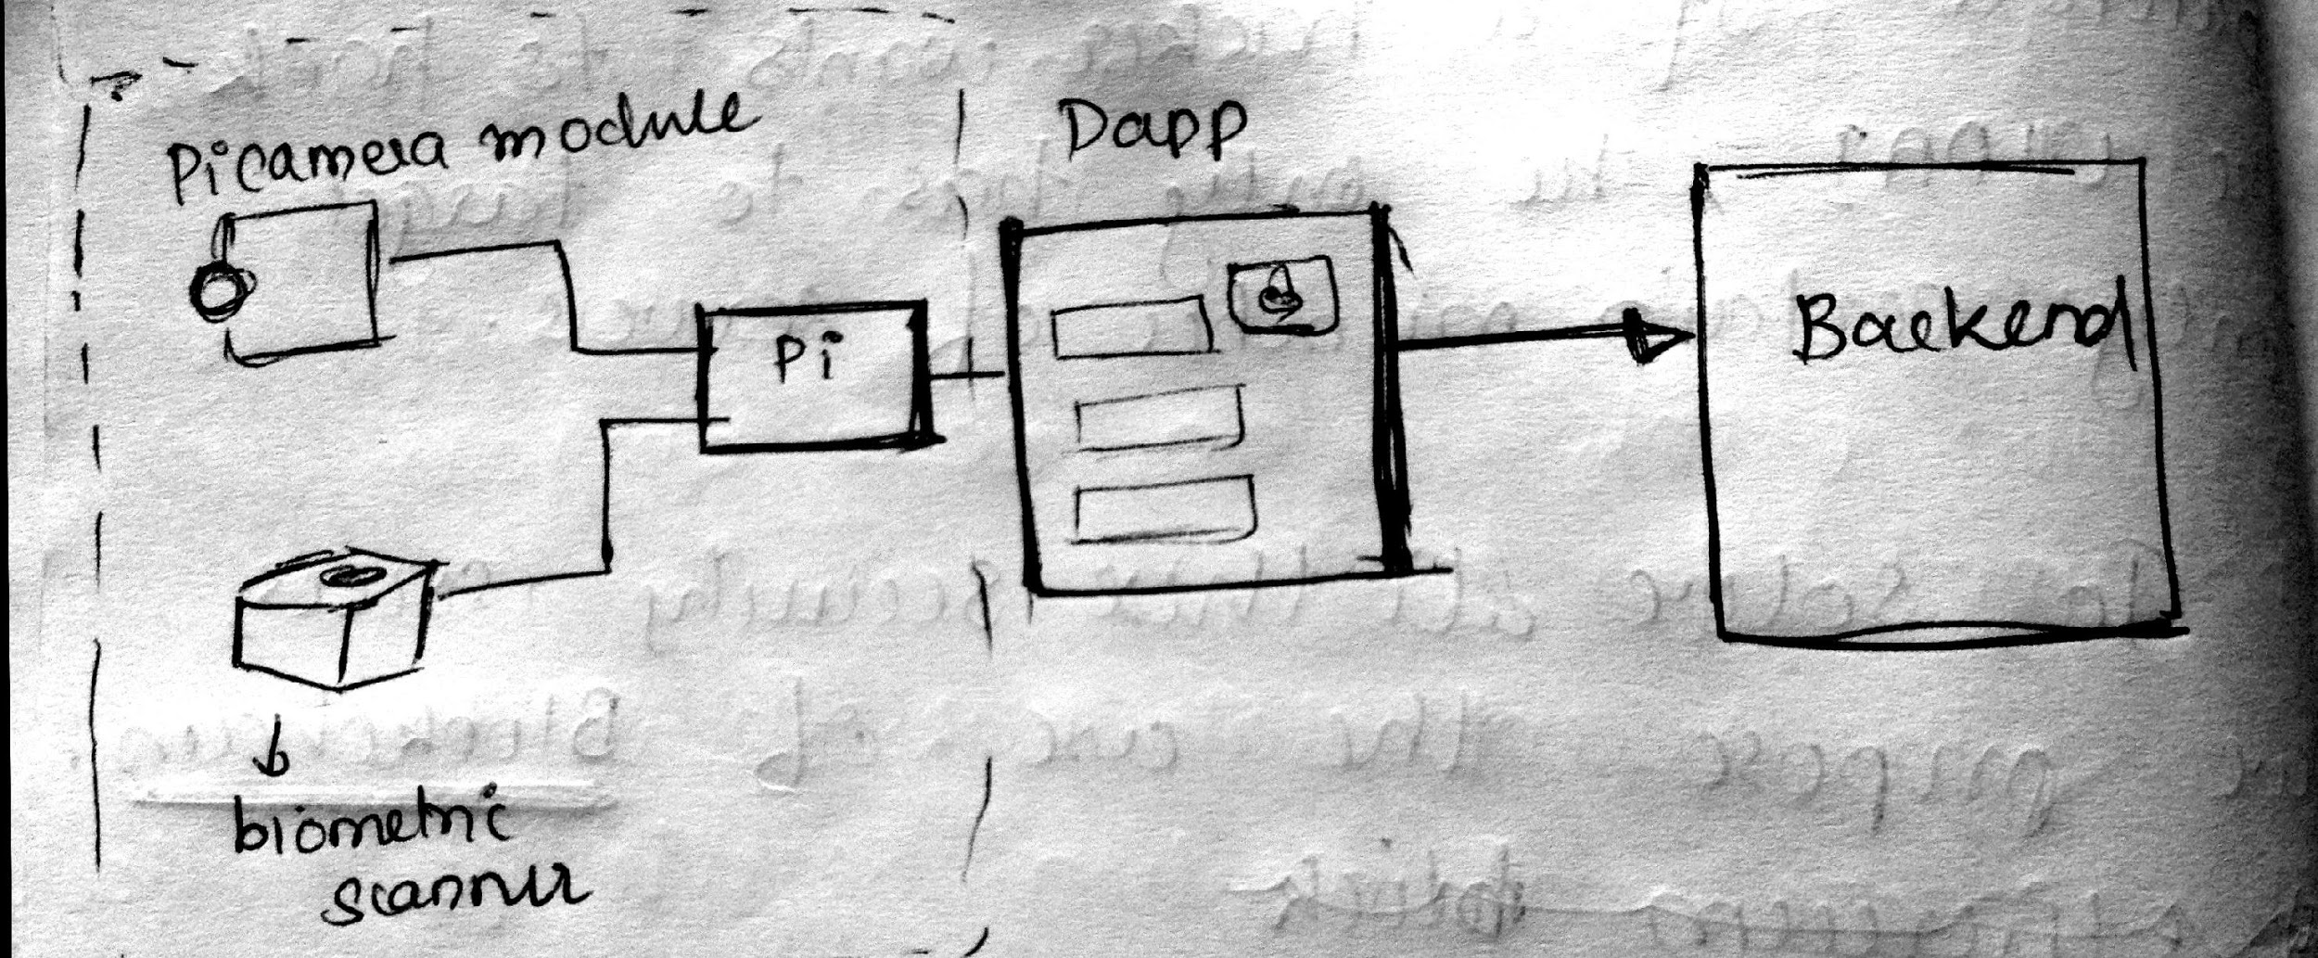

Here backend used is blockchain network, more specifically an ethereum network. Web3 library is used to interact between blockchain network and Dapp. Pi sends user details like image, biometric data etc entered via the Decentralized Application(Dapp). Interplanetary File System (IPFS) is used to store the documents.

CHAPTER 4
RESULTS AND CONCLUSION
The main aim of this project is to introduce an efficient way to store data.During this project we establised a strong base in Ethereum, Raspberry Pi and Python. We found that Ethereum backend is less susceptable to major hacks.

REFERENCES
[1] Ethereum whitepaper https://github.com/ethereum/wiki/wiki/White-Paper
[2] Techiescoops https://techiescoops.com/aadhaar-data-leak-uidai/20/2018/
[3] S Nakamoto https://bitcoin.org/bitcoin.pdf

Appendix A: Screenshots
