Spirits To BottlePOS Export Rules
Version: 7.2.26
Date: 2026-07-02

Purpose
This document explains the rules the utility follows when it creates BottlePOS export files from Spirits/KSV DBF data. It is intended to be a practical reference for reviewing output and setting expectations before import.

Output Package
The utility writes selected export files to a temporary output folder, creates a timestamped ZIP archive, then removes the temporary folder. The final ZIP is the expected handoff file.
When inventory is selected, these reference files may also be included:
- reference_InactiveItems.csv
- reference_SalePrices.csv
- reference_UPCModifierLinkAudit.html
The UPC audit report is generated as an HTML file because it includes embedded memo details for each unlinkable UPC.

General Formatting Rules
- Text is trimmed and generally converted to uppercase.
- Double quotes are removed from text fields.
- Line breaks inside source text are flattened to spaces.
- Money values in import CSV files use 2 decimal places.
- Sale price reference values use 4 decimal places.
- Whole-number values are truncated rather than rounded.
- SKUs are exported as text. Short SKUs are padded to the expected text format.

Export Selection Rules
The selected checkboxes control which data sets are exported. If a selected export requires source tables that are not present, the utility reports the missing source data before processing.
Export | Main source data
Departments | CAT.DBF, TYP.DBF
Vendors | VND.DBF
Customers | CUS.DBF
Inventory | INV.DBF, STK.DBF, PRC.DBF, UPC.DBF, tax, vendor, category, and discount support tables
Gift cards | GIFTCARD.DBF

Inventory Pricing Rules
Inventory pricing comes from selected PRC.DBF rows where QTY > 0.
When Use Price Level is enabled, only the selected level is used. When it is disabled, levels 7, 8, and 9 are excluded.
If pricing exists for the active store, active-store pricing is preferred. If no active-store pricing exists, store 1 is preferred.
The first selected quantity becomes the base price row. Additional selected quantities become modifier quantities and prices.

Quantity Rules
ADD QTY=1 IF MISSING is off by default.
When this option is off, inventory quantity is based on back stock divided by the inventory quantity divisor. The divisor is normally the smallest selected priced quantity.
When this option is on and a SKU has pricing but no QTY = 1, the utility can add an internal unit row for export calculations. This option should only be used when the team intentionally wants that behavior.

Inventory Column Placement
The inventory export keeps the existing code column and adds two new columns directly after it:
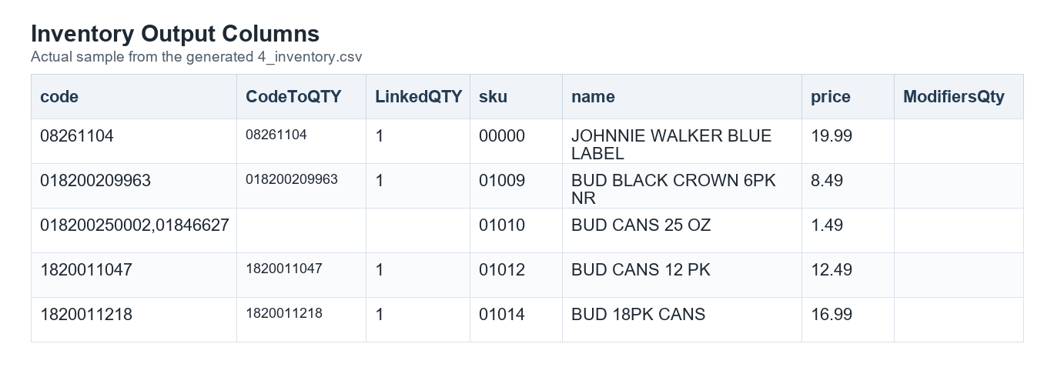
Inventory columns sample
The placement keeps the existing UPC list intact while making the new UPC-to-QTY relationship easy to review.

UPC-To-QTY Linking Rules
The utility uses the existing Spirits hierarchy to identify which UPC code belongs to which selected quantity. It does not export UPC.LEVEL or PRC.LEVEL in 4_inventory.csv.
A UPC is linkable only when:
- UPC.DBF.SKU matches PRC.DBF.SKU.
- The UPC is numeric.
- UPC.DBF.LEVEL is not blank.
- UPC.DBF.LEVEL matches one selected PRC.DBF.LEVEL.
- That matched PRC level resolves to one selected quantity.
- No other UPC for the same SKU links to that same quantity.
When a UPC is linkable, it is added to CodeToQTY. The matching quantity is added to LinkedQTY in the same position.
Example:
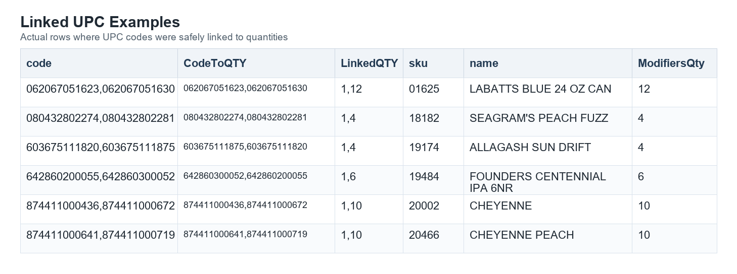
Linked UPC sample
In the example, each UPC in CodeToQTY lines up with the quantity in the same position in LinkedQTY.

Duplicate Quantity Protection
If two UPC codes point to the same quantity for one SKU, the utility does not choose one. Both UPC codes are treated as unlinkable for CodeToQTY.
This prevents an import from guessing which code should control a modifier quantity.
The UPC codes still remain in the original code column.

UPC Audit Rules
The UPC audit report includes only UPC codes that could not be safely linked.
Common audit reasons include:
- no selected PRC quantity exists for the SKU
- the UPC appears under multiple UPC levels
- the UPC level is blank
- the matching PRC level has more than one quantity
- no selected PRC level matches the UPC level
- multiple UPCs point to the same quantity
The ISSUE column opens an embedded memo for the row. The memo explains why that UPC stayed out of CodeToQTY and LinkedQTY.
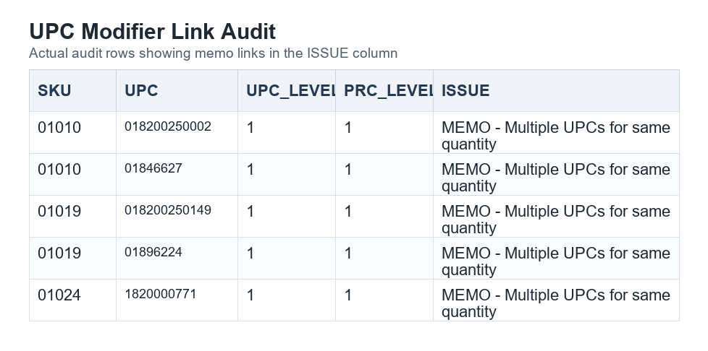
UPC audit sample

Inactive Item Rules
Inactive status is based on the selected store's STK.DBF.STAT value.
- Status 2 and 8 are active.
- Other statuses are treated as inactive.
- Inactive items are always written to reference_InactiveItems.csv.
- Inactive items are included in 4_inventory.csv only when Include inactive products is selected.

Sale Price Rules
Sale pricing is not written to 4_inventory.csv.
Sale pricing is exported only to reference_SalePrices.csv, using rows where PRC.DBF.ONSALE is true for the active store.
The sale price file contains:
- SKU
- SALE_PRICE
- REGULAR_PRICE

ZIP And Completion Rules
The utility creates the ZIP archive through a temporary file first. The final ZIP is moved into place only after creation succeeds.
After a successful run, the completion dialog includes an Open ZIP Folder option.

