UPC To QTY Linkage Rules
Version: 7.2.26
Date: 2026-07-02

Purpose
This document explains how the utility decides whether a UPC code can be linked to a modifier quantity in the inventory export.
The goal is to show clear UPC-to-quantity relationships without changing the existing code column behavior.

Inventory Columns
The utility keeps the current code column and adds two columns immediately after it:
Column | Purpose
code | Existing UPC list. This remains unchanged.
CodeToQTY | UPC codes that can be safely linked to a quantity.
LinkedQTY | Quantities linked to the UPC codes in CodeToQTY.
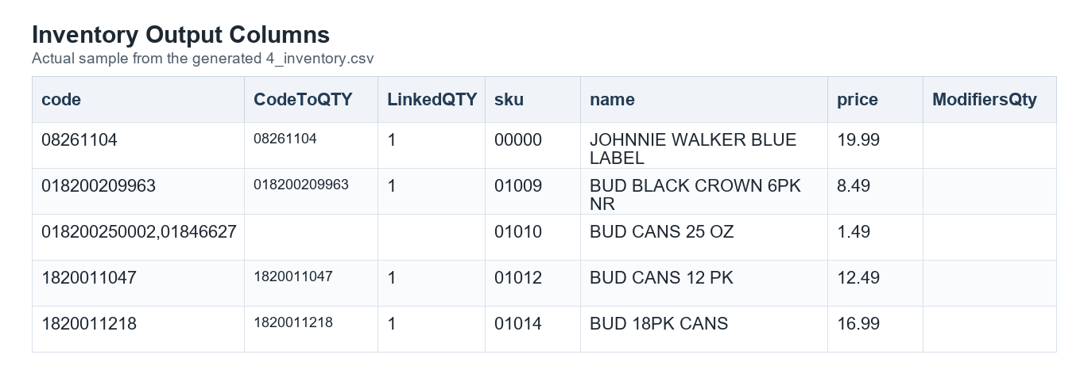
Inventory columns sample

How To Read The Link
Values in CodeToQTY and LinkedQTY line up by position.
For example:
CodeToQTY | LinkedQTY
062067051623,062067051630 | 1,12
This means:
- 062067051623 links to quantity 1
- 062067051630 links to quantity 12
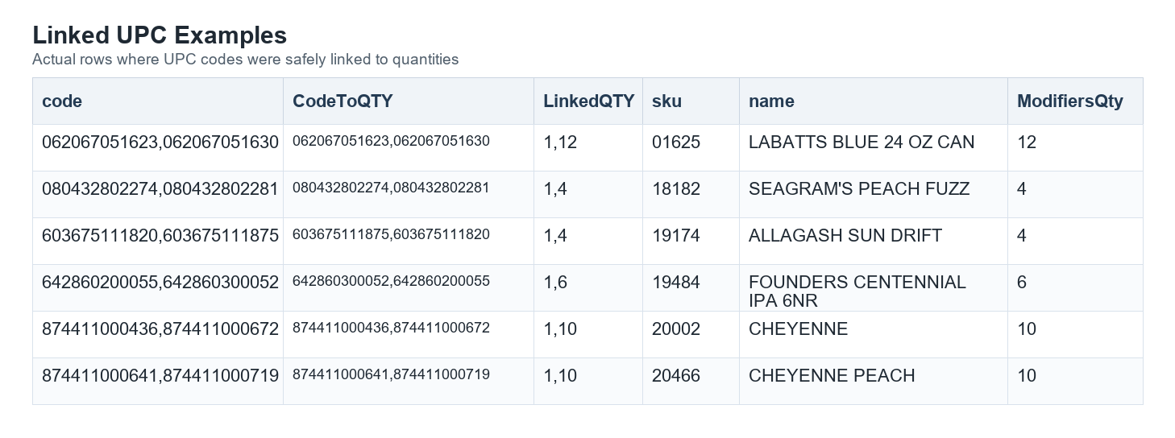
Linked UPC sample

Linkable UPC Rule
A UPC is linkable only when the utility can prove a one-to-one relationship.
All of these must be true:
- UPC.DBF.SKU matches PRC.DBF.SKU.
- The UPC is numeric.
- UPC.DBF.LEVEL is not blank.
- UPC.DBF.LEVEL matches one selected PRC.DBF.LEVEL.
- The matched PRC level resolves to one selected PRC.DBF.QTY.
- No other UPC for the same SKU links to the same quantity.
When all rules pass, the UPC is added to CodeToQTY and the quantity is added to LinkedQTY.

Ordering Rule
Linked values are ordered by quantity, not by UPC code.
This keeps CodeToQTY and LinkedQTY in a predictable numeric order.

Duplicate Quantity Rule
If more than one UPC links to the same quantity for one SKU, the utility treats those UPC codes as unlinkable.
This means:
- neither UPC is added to CodeToQTY
- the repeated quantity is not added to LinkedQTY
- the UPC codes remain in the original code column
- the UPC codes are listed in the audit report
This protects the import from guessing when the source data does not identify one clear UPC for one quantity.

Audit Report Rule
The audit report includes only UPC codes that could not be linked.
The report is named:
reference_UPCModifierLinkAudit.html
Common audit reasons include:
- no selected PRC quantity exists for the SKU
- the UPC appears under multiple UPC levels
- the UPC level is blank
- the matching PRC level has more than one quantity
- no selected PRC level matches the UPC level
- multiple UPCs point to the same quantity
The ISSUE column opens the row memo. The memo is embedded in the HTML report and explains why the UPC was not added to CodeToQTY or LinkedQTY.
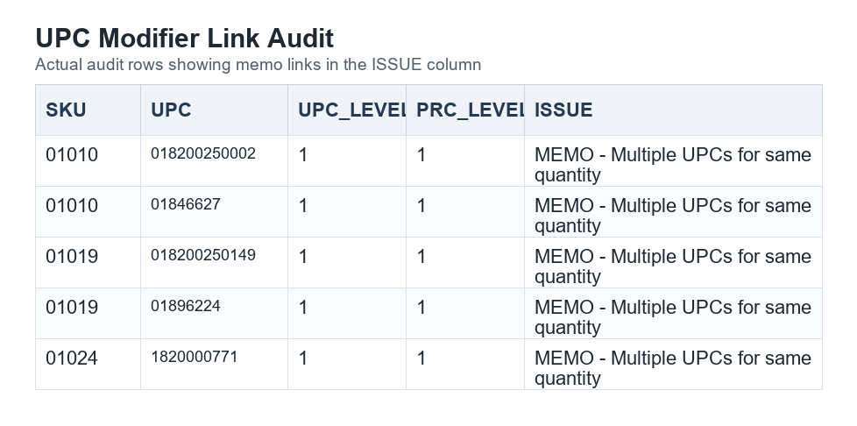
UPC audit sample

Expected Result
The export should be read this way:
- code remains the complete UPC list used by the existing import process.
- CodeToQTY shows only UPC codes with a safe quantity link.
- LinkedQTY shows the matching quantities in the same order.
- The audit report explains UPC codes that were not safe to link.

