Module Five Artifact Three Enhancement README: Databases
Aaron Sissom
CS-499 Computer Science Capstone
Southern New Hampshire University
Prof. Brooke Goggin
October 5, 2024

About the Project
The web application integrates with an existing animal shelter database built using Python, the PyMongo driver, the Dash framework, and MongoDB. It helps identify and categorize dogs for specialized rescue training, such as water rescue, wilderness rescue, disaster recovery, or tracking a specific person by scent. The app allows users to interact with and visualize dog profiles stored in the MongoDB database. Its intuitive dashboard reduces errors and shortens training time.
This multi-tier application follows the Model-View-Controller (MVC) design pattern. The RESTful API extends HTTP to enable seamless communication between components. The main interface is a dashboard, developed using Python and the Dash framework, with components that align well with MVC principles. MongoDB handles the data (model), Dash widgets serve as the user interface (view), and the controller manages database interactions using a Python CRUD module.
Motivation
Grazioso Salvare, an innovative international rescue-animal training company, identifies dogs that are good candidates for search-and-rescue training. The company has noted specific types and breeds of dogs to train. For instance, search-and-rescue training is generally more helpful for dogs no more than two years old. Additionally, certain breeds of dogs are proficient at different types of rescue, such as water rescue, mountain or wilderness rescue, locating humans after a disaster, or finding a specific human by tracking their scent. These dogs can find and help rescue humans or other animals when trained, often in life-threatening conditions. To help identify dogs for training, the company agrees with non-profit agencies that operate animal shelters in some specific regions. These non-profit agencies provide the company with data from their shelters.
Getting Started
Before proceeding, you should have a working knowledge of the Python programming language and the MongoDB framework. Understanding how the MongoDB database, Python driver PyMongo, and the Python Dash framework all interact with each other is important to getting the app to function properly. You will also need to install Jupyter to gain access to Jupyter Notebooks, a helpful testing tool. This can be accomplished by downloading and installing the latest distribution of Anaconda, a Python/R data science toolset.
To get a local copy up and running of the web app, make sure you have properly installed and running Python and MongoDB:
- Anaconda version 3.12 (https://www.anaconda.com/download)
  - Includes Python, Jupyter Notebooks, and the Spyder IDE (not used in this project) among other tools
- MongoDB version 7.0 or better (https://www.mongodb.com)
- MongoDB Database Tools (https://docs.mongodb.com/database-tools/installation/installation-windows/)
- Git for Windows (https://git-scm.com/downloads/win)
Installation
The Grazioso Salvare Search for Rescue Animals Web App uses the Python driver PyMongo the officially supported Python driver by MongoDB, and the Python framework Dash. PyMongo (https://pymongo.readthedocs.io/en/stable/) is a Python distribution that provides tools to work with MongoDB.
To install PyMongo execute the following:
pip install pymongo
Dash (https://dash.plotly.com/) is a productive Python framework for building analytic web applications. Dash framework provides the view and controller structure for the web application. To install Dash libraries, execute the following:
pip install dash
Having installed the Python driver and framework, you need to upload the Austin Animal Center Outcomes data set into MongoDB by inserting the CSV file using the mongoimport tool in your terminal (Git Bash used in this project) or the MongoDB GUI.
Using “mongoimport”:
** Replace the “#####” with your MongoDB port number. **
mongoimport /port:##### /db:AAC /collection:animals /type:csv /file:./aac_shelter_outcomes.csv /headerline
Using the MongoDB GUI:
Click on the “+” button to add a new database, then add the database name and collection name.
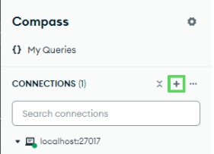
Click the "ADD DATA" button to upload the CSV.
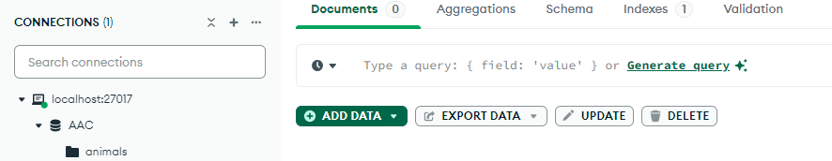
In the MongoDB shell, create or switch to the "admin" database and create a new user account called "aacuser" with a password and role “readWrite” for the database "AAC."
** You will need to exit MongoDB and restart the service regardless which method you choose **
Usage
The dashboard is comprised of a Python class file called “database_functions.py”, which enables the database's CRUD functionality and houses the “AnimalShelter” class, and the “dashboard.py” file that generates the user dashboard in a browser based on the components of the Dash framework. This is the link between the user and the database. To run the web app, enter the following command:
python dashboard.py start
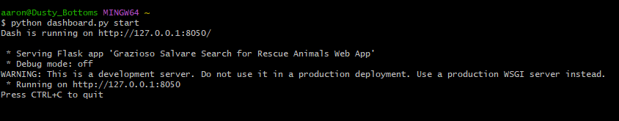

CRUD Module
The “database_functions.py” file supports code reusability by enabling the “AnimalShelter” class constructor to be imported by other Python scripts as a module. To test the script module, create a new “app.py” file and import the “AnimalShelter” constructor.

You will need to authenticate the user in the applicable database using the following code:
“<your_var> = AnimalShelter(username, password, dbname)”
where the username, password, and database name variables are either predefined in the “database_functions.py” file or stored in the admin database collection called “users.”
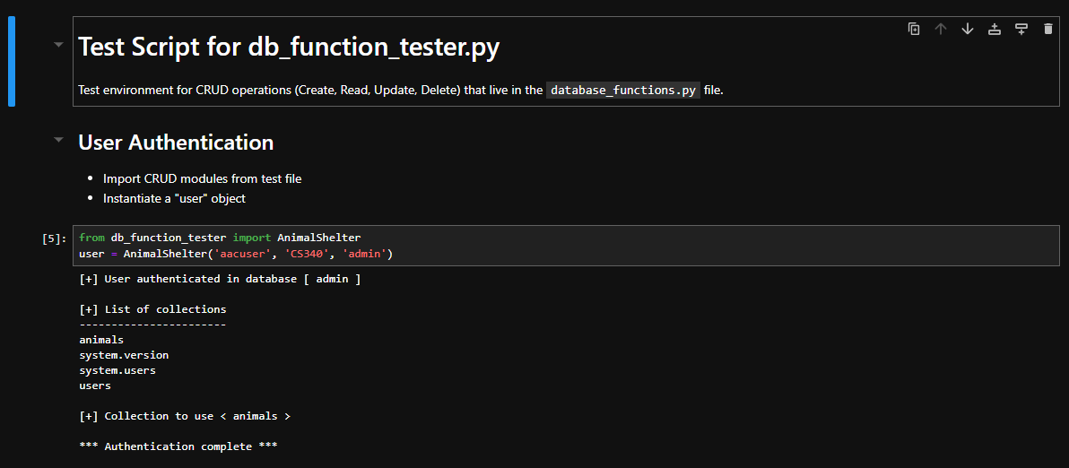
CRUD operations include:
1. Create
- Inserts animal data into the database using the insert_many() function call.
- <your_var>.create({dict_one}, {dict_two}, ...)
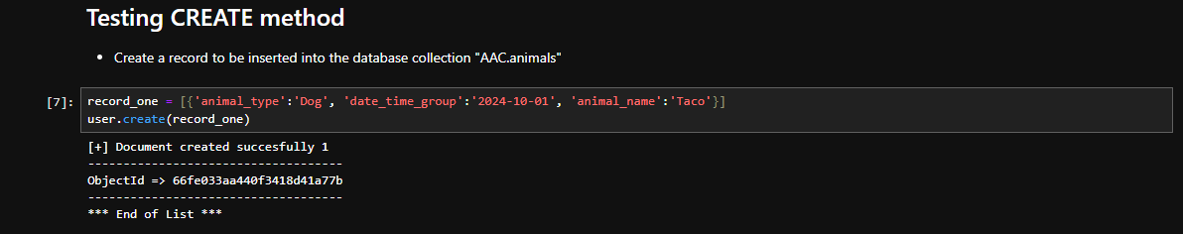
2. Read
- Utilizes the “find()” function call to return matching records from the database without including the '_id' field.
- <your_var>.read(<your_query>)
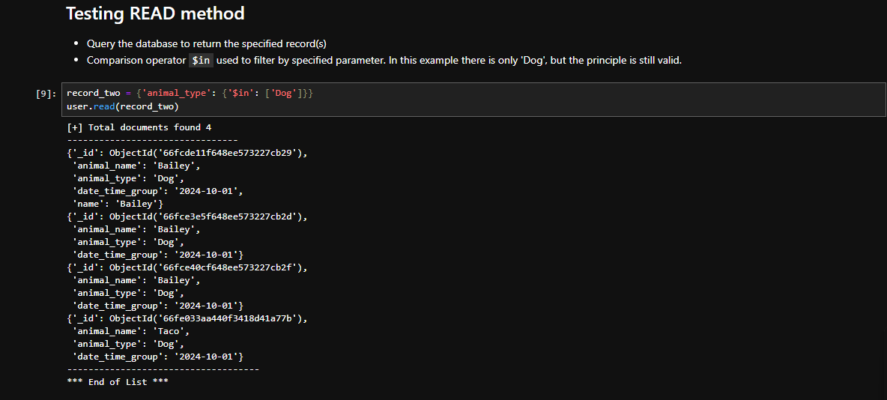
3. Update
- Uses the update_many() function call to apply changes to all matching records.
- <your_var>.update(<your_query>)
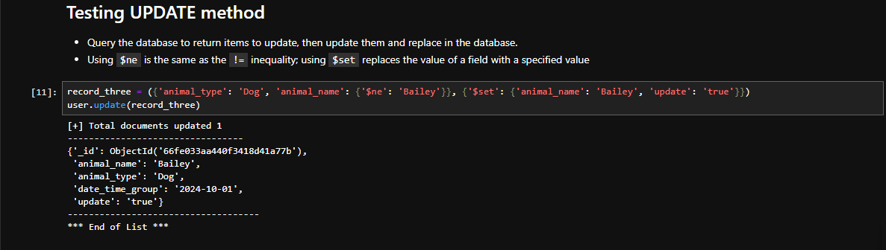
4. Delete
- Calls the delete_many() function to remove all specified records that match the given criteria.
- <your_var>.delete(<your_query>)
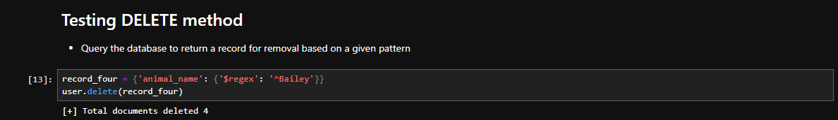
Dashboard File
To launch the application dashboard, refer to the section titled “Usage.”
Once you have started the dashboard, open a new browser tab and navigate to the localhost port you specified in the dashboard.py file.
The dashboard’s visual components consist of the Grazioso Salvare company logo and the following widgets:
Interactive filter options (buttons and dropdowns):
- Cat
- Dogs
- Reset
- Dropdown menu with rescue categories:
  - Water Rescue
  - Mountain or Wilderness Rescue
  - Disaster Rescue or Individual Tracking
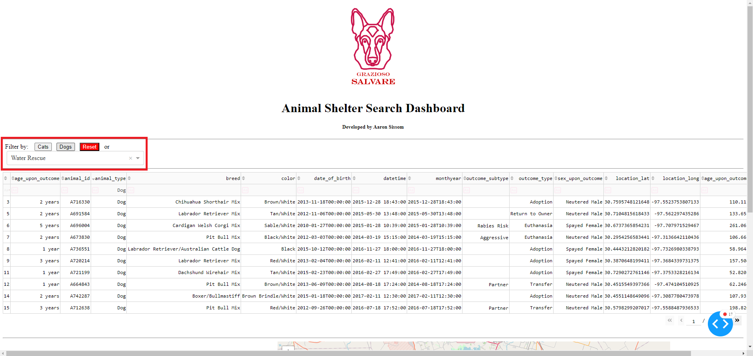
• A data table that dynamically responds to the filtering options
• A geolocation chart and a pie chart that dynamically responds to the filtering options
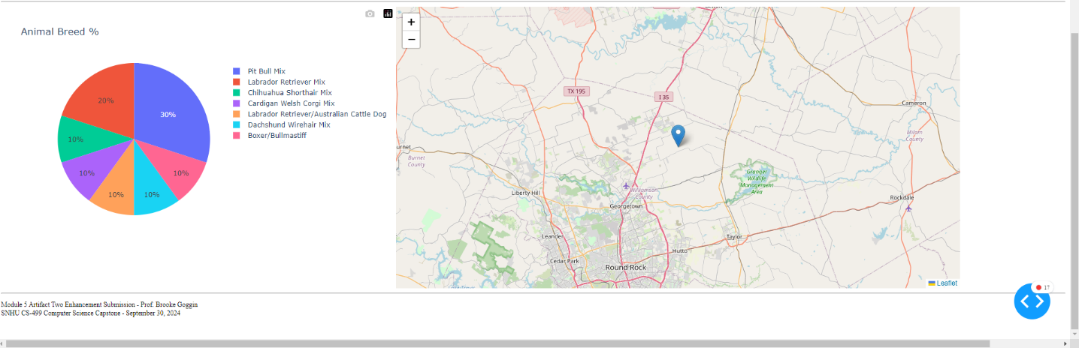
Rescue Type and Preferred Dog Breeds Table
The rescue categories filter is based on research and experience training rescue dogs. This table was a guide for writing the applicable database queries for each rescue type. Rescue Type | Preferred Breeds | Preferred Sex | Training Age
Water Rescue | Labrador Retriever Mix, Chesapeake Bay Retriever, Newfoundland | Intact Female | from 26 weeks to 156 weeks old
Mountain or Wilderness Rescue | German Shepherd, Alaskan Malamute, Old English Sheepdog, Siberian Husky, Rottweiler | Intact Male | from 26 weeks to 156 weeks old
Disaster Rescue or Individual Tracking | Doberman Pinscher, German Shepherd, Golden Retriever, Bloodhound, Rottweiler | Intact Male | from 20 weeks to 300 weeks old

Interactive Filter Options
The filter options generate instantaneous database queries to gather the specified data. The current interactions allow the dashboard user to retrieve data related to dog rescue types and filter by animal type. The dog rescue categories grouped in the filter dropdown menu are:
- Water Rescue
- Mountain or Wilderness Rescue
- Disaster or Individual Tracking
The filter widget buttons are reset using the “Reset” button, and the dropdown menu filter are reset by clicking on the "x" icon next to the selected category. When one of the interactive options is selected, the interactive data table and pie chart update show the selected filter records and statistics. The page is set up to display only 10 records per filter operation, with arrow keys in the bottom right-hand corner of the table indicating additional pages of data.
Each cell in the table is clickable, and the entire row of the selected cell is highlighted when clicked. The maplet automatically shows the location of the animal shelter along with the animal’s basic identifying information, if available, when clicked. The percentage of animals per breed is displayed by the pie chart, and updates based on the user’s filter selections.

