Machine vision pipeline for invariant object grouping
Technical assignment report | Index number 220155B | 24 October 2026

Purpose and outcome
This project implements a complete image-to-group pipeline for noisy images containing one dominant object. It reduces outlier and Gaussian noise, segments the foreground by thresholding, describes the outer boundary with a 32-digit chain code and groups similar outlines despite rotation, uniform scaling and translation. All vision and matching algorithms are written directly in Python. Pillow handles image decoding and diagnostic image encoding only.
The supplied 12 PNG images were processed with no input failures in 12.31 seconds in the recorded run. At the selected distance cutoff of 0.06, the pipeline produced three similarity groups. Twelve automated regression tests passed. These results establish executable behavior and specified invariance cases; the sample set has no supplied reference labels, so classification accuracy cannot be measured.

Design assumptions and lecture foundation
Unit 1 presents machine vision as an ill-posed inference problem requiring constraints. Here, the image contains one dominant connected object; most of its frame border shows background; foreground and background differ sufficiently in intensity; and the required identity is external shape. Unit 2 explains how illumination, sensor noise and sampling affect the measured image. The input geometry lecture motivates handling planar RST variation, while perspective and nonuniform scaling remain outside the model.
Unit 3a motivates luminance conversion and geometric normalization. Unit 4 supplies median and Gaussian filtering principles, and Image as Functions explains neighborhood convolution and border padding. Unit 6 supplies iterative inter-means thresholding, connected components and contour tracking. Unit 7 motivates chain codes, equal-length boundary segments and normalization. The implementation combines these concepts with explicit choices for robust border estimation, continuous heading normalization, reconstructed-code matching and complete-link clustering.

Processing sequence
Image decoding → luminance and box reduction → median filter → Gaussian approximation → threshold and foreground polarity → largest connected component → hole filling → outer contour → smoothing and 32 equal-perimeter samples → normalized chain code → pairwise code distance → complete-link groups → text output.

Noise reduction and threshold segmentation
RGB pixels become grayscale using I = round(0.21R + 0.72G + 0.07B), following the luminance approximation in Unit 3a. Images larger than 320 pixels on their longest dimension are reduced by native rectangular box averaging. Aspect ratio is preserved within integer rounding. This limits pure-Python execution cost, with the tradeoff that very small details may disappear.
A 3 by 3 median filter replaces each pixel by the fifth value in its sorted neighborhood. It rejects isolated extreme values without averaging them into nearby pixels. A subsequent separable binomial filter [1,2,1]/4 horizontally and vertically approximates Gaussian smoothing. Its effective 2D kernel is [[1,2,1],[2,4,2],[1,2,1]]/16. Both filters replicate border values and write to separate output arrays to avoid scan-order bias.
FOR each pixel p
M[p] = median of replicated 3 by 3 neighborhood
H = convolve rows of M with [1, 2, 1] / 4
F = convolve columns of H with [1, 2, 1] / 4
The inter-means threshold starts at the mean grayscale level. Pixels are divided into two classes; their means are computed from a 256-bin histogram, and the new threshold is their midpoint. Iteration stops below a change of 0.05 gray levels or after 100 steps. Uniform images are rejected. The majority class on the image border determines background polarity.
A midpoint alone can exclude dark shadows on a textured object. The implementation trims the lowest and highest 10 percent of border intensities, then computes their mean and standard deviation. For bright objects, the effective threshold is the smaller of the inter-means threshold and border mean + max(8, 3 sigma). For dark objects the corresponding maximum and subtraction are used. This refinement assumes representative border background and is not a substitute for local illumination modeling.
T = mean intensity
REPEAT at most 100 times
low, high = pixels <= T, pixels > T
newT = (mean(low) + mean(high)) / 2
STOP if abs(newT - T) < 0.05
T = newT
Infer background from border; refine T using border statistics
Threshold image; retain largest 4-connected foreground region
Flood fill exterior background; fill all remaining holes
Four-neighbor breadth-first searches remove disconnected foreground noise by retaining the largest component. A one-pixel background frame supports exterior flood fill. Filling enclosed holes stabilizes the outer silhouette but deliberately discards internal topology. Components below 16 pixels are rejected.

Boundary representation and invariance
Moore neighbor tracing walks the eight-neighbor outer contour clockwise in image coordinates, where x increases right and y increases down. Termination requires re-entering the first directed edge, rather than simply revisiting one pixel. A finite iteration guard rejects contours that do not close. The padded image also supports components near the original frame edge.
A circular moving average smooths contour coordinates with radius max(1, L // 128), where L is the traced point count. Euclidean edge lengths then define the perimeter P. Linear interpolation samples the closed contour at distances kP/32, k = 0,...,31. This implements the equal-length boundary approach of Unit 7 method 3. Chords between the samples produce precisely 32 direction symbols.
For each candidate cyclic origin s, let theta_i be the continuous heading of segment i. The code digit is floor(((theta_(s+i) - theta_s) modulo 2pi)/(pi/4) + 0.5) modulo 8. The lexicographically smallest candidate is retained. Digit 0 is aligned with the candidate first segment; digits advance clockwise in 45-degree increments. The stored result is a relative-direction octal string, not a differential turn sequence or a decimal integer.
Q = 32 equal-perimeter boundary samples
angles = headings of consecutive closed polygon edges
FOR origin s in 0..31
FOR i in 0..31
relative = (angles[(s+i) mod 32] - angles[s]) mod 2pi
candidate[i] = nearest 45-degree direction(relative) mod 8
RETURN lexicographic minimum of all candidate strings
Variation | Normalization
Translation | Coordinate differences remove absolute position.
Uniform scale | Sampling at perimeter fractions gives corresponding segments.
Rotation | Subtract continuous headings before direction quantization.
Starting sample | Canonicalize all 32 cyclic reindexings.
For the same continuous sampled polygon, a positive uniform scale, translation and rigid rotation preserve the descriptor except at floating-point quantization ties. Subtracting continuous angles before quantization also handles rotations other than multiples of 45 degrees. Rasterizing or resegmenting a transformed image can change the silhouette and sampling phase; practical invariance therefore requires tolerant matching. Cyclic minimization removes the origin among the 32 selected samples, while a different subsegment sampling phase remains approximate.

Chain code matching and grouping
Matching uses only the stored 32 digits. Each digit becomes a unit vector at its indicated angle. Accumulating the vectors reconstructs an approximate polygon. Quantization can leave a nonzero endpoint displacement; subtracting i/32 of this residual from vertex i closes the polygon. The vertices are centered at their mean and divided by their root mean square radius.
For each of 32 cyclic alignments, the dot and cross correlations between normalized vertex pairs give the best planar rotation analytically. If rho is the magnitude of their summed dot and cross terms divided by 32, the distance is sqrt(max(0, 2 - 2rho))/2. Lower values indicate closer outlines. This smooth geometric comparison tolerates isolated direction changes better than literal string equality. Equal step lengths approximate the original chords, so the reconstructed contour is not an exact recovery.
FOR every pair of image codes
Decode unit vectors; distribute closure error
Center and normalize reconstructed vertices
FOR each cyclic alignment
Compute best rotation using dot and cross correlations
Keep smallest normalized RMS discrepancy
Start one cluster per image
REPEAT
Find cluster pair with smallest maximum cross-pair distance
STOP if no pair is within cutoff
Merge selected clusters
Complete linkage requires every cross-cluster pair to be within the cutoff, avoiding long chains of individually similar objects. Input filenames are sorted case-insensitively; pair and merge ties have deterministic index order. The default cutoff 0.06 is exploratory and was inspected on the supplied data. It has not been calibrated on an independent labeled dataset.

Recorded sample results
Group | Image filenames
1 | im-1.png, im-2.png, im-3.png, im-4.png, im-5.png, im-6.png
2 | im-10.png, im-12.png, im-9.png
3 | im-11.png, im-7.png, im-8.png
The masks retain the main external silhouette in all 12 inputs. Codes for im-3.png, im-4.png and im-5.png are identical, showing stability across those supplied variants. im-7.png visually resembles the textured family but joins im-11.png and im-8.png under the selected metric. This is an observed ambiguity of the coarse descriptor, not evidence of correct object identity. Closely related outlines can merge, and changed sampling or segmentation can split one object family.
Sensitivity analysis using the same saved codes produced six groups at 0.045, three at 0.06, two at 0.07 and one at 0.16. This makes the dependence on the cutoff explicit. A labeled validation set is needed to select a cutoff for a particular recognition task.

Verification and reproducibility
Check | Observed result
12 supplied images | 12 processed; no failures; 3 groups at cutoff 0.06.
Median and Gaussian filters | Impulse rejection, constant preservation and noise variance reduction passed.
Segmentation | Both polarities, hole filling and disconnected noise removal passed.
Continuous polygon RST | 5 rotations and 32 cyclic origins each; positive scale and translation; exact codes matched.
Raster transformations | 3 transformed ellipses grouped at a tolerance of 0.16.
Distinct shapes | Circle and elongated ellipse separated at 0.16.
CLI and failures | PNG/JPG/JPEG, corrupt image and empty folder checks passed.
Tests use deterministic values and a fixed random seed. The raster test validates the stated 0.16 tolerance; it does not demonstrate perfect grouping at the stricter default 0.06. The recorded sample JSON stores every code, threshold, boundary sample, processing dimension and pairwise distance for independent inspection. Diagnostic images show grayscale conversion, filtering, filled masks and sample locations.
From the project folder, create a Python 3.10 or newer virtual environment, install requirements.txt and run the following commands. Pillow is the only runtime third-party dependency; the document-generation tools are not needed to run the assignment.
python -m pip install -r requirements.txt
python main.py "../Samples (1)"
python -m unittest discover -s tests -v
python tools/package_submission.py --index 220155B
The principal output is results/groups.txt; results/groups.json provides traceability and results/diagnostics contains intermediate images. Exit code 0 means all selected images processed, 1 indicates one or more failed inputs, and 2 identifies invalid arguments or an empty supported-image set. Valid files still produce results when another file is corrupt. The submission ZIP includes source, tests, README, dependencies, this report and the actual output files.

Cost and limitations
For N processing pixels, fixed-size filters, histogram thresholding and component scans are O(N); contour tracing is O(L). The direct smoothing implementation costs O(Lr), where r is its radius. Pairwise matching costs O(M squared times 32 squared) for M images. The simple repeated cluster search is O(M to the fourth) in the worst case; it is suitable for a small assignment dataset rather than a large image repository. Memory includes decoded source RGB pixels, processing arrays and component sets, plus O(M squared) pair distances.
The model cannot resolve distinct objects with sufficiently similar 32-digit external descriptions. It discards internal holes, color and texture; does not guarantee reflection, perspective or affine invariance; and assumes useful intensity contrast and background borders. Severe shadows, clipping, small objects or large connected clutter can invalidate segmentation. Larger sample counts, adaptive illumination handling and labeled threshold calibration are reasonable future extensions, but would alter the present assignment representation.

Visual inspection and references
The following contact sheet shows the filled foreground masks, using the same processing settings as the recorded run. Each mask is produced from the image pixels without filename-specific rules. The white region is the retained object; small disconnected regions have been removed and enclosed holes filled.
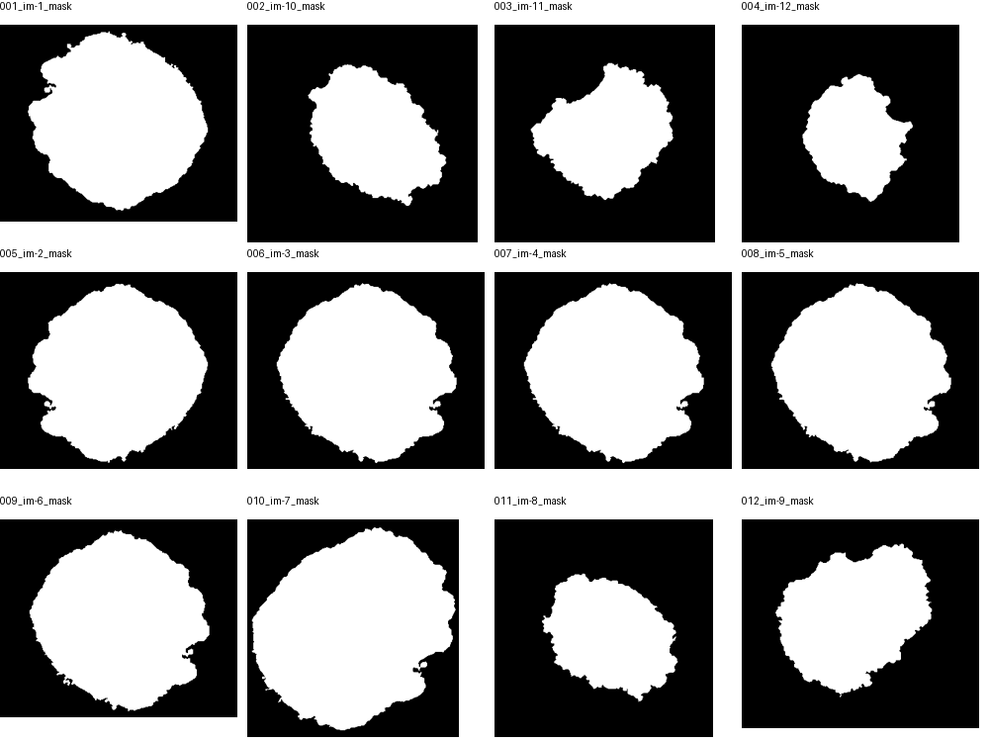
Figure 1 Filled foreground masks for the 12 supplied images. The contact sheet labels identify the corresponding input file.
Primary sources are the supplied Department of Computer Science and Engineering, University of Moratuwa, Computer Vision / Machine Vision lecture files. Page numbers below refer to the slide labels in those files.
Unit 1 Introduction, slides 5 and 10: constraints and the vision process.
Unit 2 From physical world to digital world, slides 5, 7 and 17 to 23: illumination, sensor response, pixelation and quantization.
Unit 3 Part B Input geometry: projection and image geometry.
Unit 3a Image registration and normalization, slides 2 and 21 to 26: normalization, grayscale conversion and histograms.
Unit 3b Point operations, slides 2 and 6 to 9: pixel transforms and histogram operations. Histogram equalization was reviewed but is not required in this pipeline.
Image as Functions Convolution LSIS and filtering, slides 9 and 12 to 17: convolution, neighborhood processing and image borders.
Unit 4 Noise and noise filtering, slides 5, 7 to 8 and 11: Gaussian and outlier noise, weighted smoothing and median filtering.
Unit 6 Image segmentation, slides 5 to 6, 13, 15 to 16 and 25: contour tracking, region growing, components, thresholding and inter-means.
Unit 7 Segment representation and Signatures, slides 2 to 9: invariant descriptors, chain-code methods and normalization.

