Credit Card Fraud Detection: Capstone 20.1 Summary of Findings
Asit Kar · Initial Report and Exploratory Data Analysis
Jupyter notebook: https://github.com/asitkar/capstone-eda/blob/main/notebooks/fraud_detection_eda_baseline.ipynb
GitHub repository: https://github.com/asitkar/capstone-eda

Research question
Can a supervised ML model tell fraudulent card transactions from legitimate ones while keeping the combined business cost of missed fraud and false alerts as low as possible? The model is trained on anonymised transaction features and built for extreme class imbalance (~0.17% fraud).

Data and cleaning
- ULB Credit Card Fraud Detection dataset (Kaggle): 284,807 transactions with Time, Amount, V1–V28 (PCA) and Class.
- No values were missing. 1,081 exact duplicate rows were removed, leaving 283,726 transactions and 473 frauds (0.167%).
- Outliers were analysed with the IQR rule and kept on purpose. Rows that are outliers on any of the top-5 outlier features make up 8.2% of the data but hold 88.6% of all fraud.

Key EDA findings
- The most discriminative features by KS statistic are V14 0.84, V10 0.80, V12 0.78, V4 0.76, V11 0.75 and V17 0.74.
- Micro transactions (≤ €1) have a 0.56% fraud rate, 4.7× the rate for all other transactions, which points to card testing.
- The fraud rate peaks at night (≈1.45% at hour 2, against ≈0.1–0.2% during the day) as legitimate volume drops.
- Engineered features: log_amount, is_micro_amount, is_night and cyclical hour_sin / hour_cos.
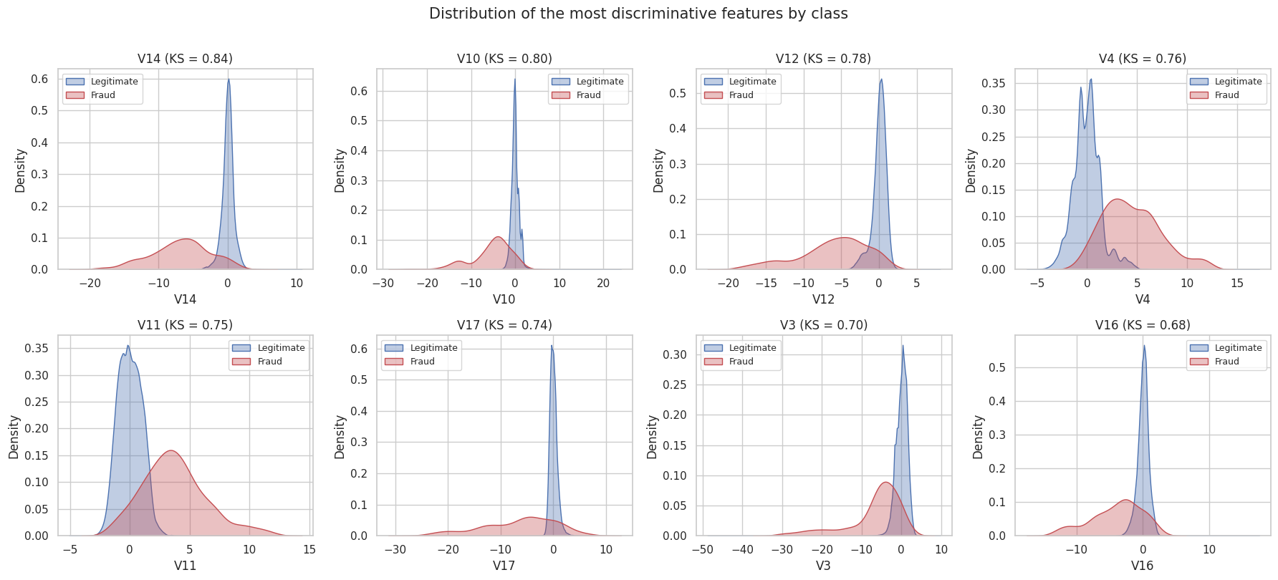

Baseline model and evaluation metric
The primary metric is PR-AUC (average precision). With only 0.17% positives, accuracy and ROC-AUC are inflated by the large number of true negatives, and the no-skill PR-AUC equals the fraud rate (0.0017). Supporting metrics are the F2-score, which weights recall twice as heavily as precision, and expected cost with FN = $200 and FP = $5. The cost-optimal threshold is chosen on a validation split taken from the training data.
Model | Threshold | PR-AUC | Recall | Precision | Cost
Dummy (always legitimate) | – | 0.002 | 0% | – | $19,000
Logistic Regression | 0.50 | 0.695 | 60.0% | 86.4% | $7,645
Logistic Regression (balanced) | 0.50 | 0.679 | 87.4% | 5.5% | $9,500
Logistic Regression (baseline) | 0.02 | 0.695 | 78.9% | 58.6% | $4,265
Logistic Regression (balanced) | 0.96 | 0.679 | 80.0% | 46.9% | $4,230

Interpretation: the logistic regression ranks fraud far above chance (PR-AUC 0.695 against a floor of 0.0017). Moving from the default 0.5 threshold to the cost-optimal 0.02 catches 18 more frauds for 44 extra alerts and cuts test-set cost from $7,645 to $4,265 (−44%). This unweighted logistic regression at its cost-optimal threshold is the baseline for Module 24.
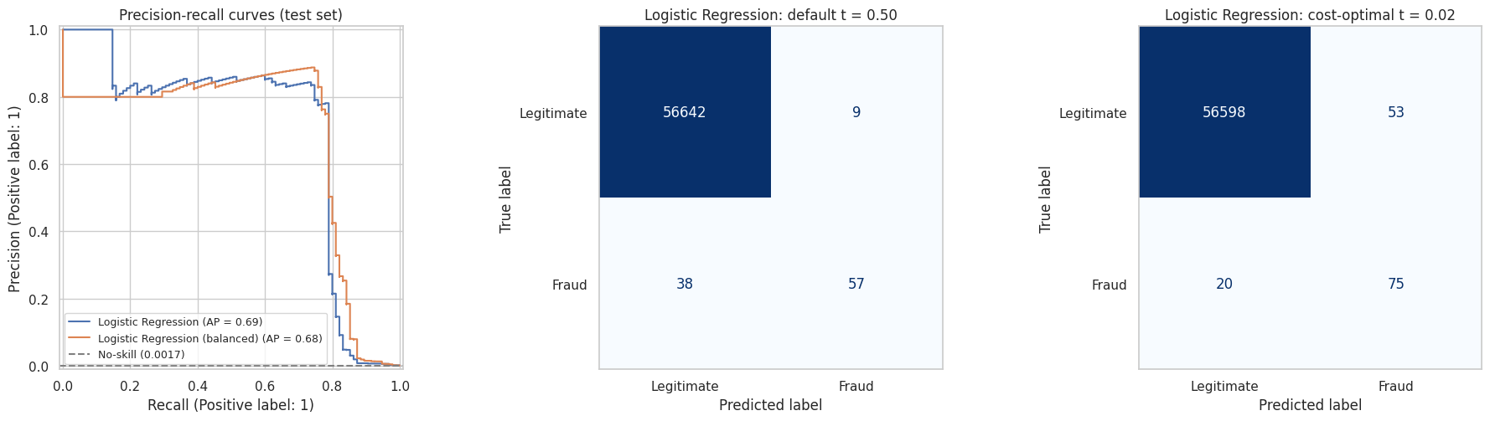

Next steps (Module 24)
- Compare k-NN, Decision Tree, SVM-RBF, Random Forest and XGBoost with GridSearchCV, scored on PR-AUC.
- Test RandomUnderSampler, SMOTE and ADASYN inside imblearn pipelines.
- Re-tune the cost-optimal threshold for each model and report savings against this baseline.
- Deliver a model card and a plain-English threshold recommendation.

