1. Cd /root/
2. git clone <https://github.com/ashishrpandey/example-voting-app>
3. cd /root/example-voting-app/k8s-specifications
4. **kubectl apply -f .**

**5.**

7.

8.

9. Once I am tried deleting the pod it will automatically create another Pod, but after deleted the

db pod the data will be lost.

10. DB is not storing the Result from the Voting app.

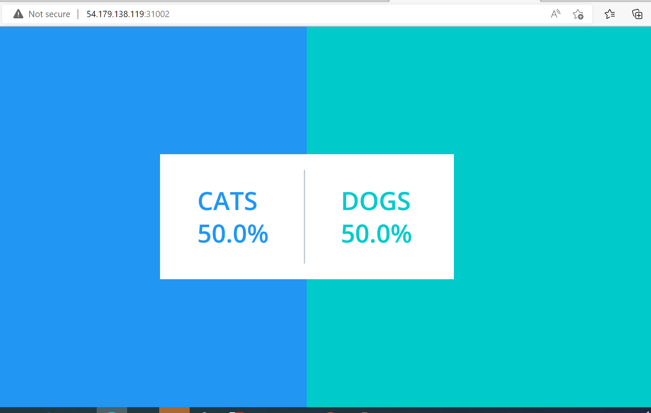

11. Made the Result Pod in to working stage by redeploying it

12. Deleted the Result Pod and then new pod is created then it is working fine.