Creating and Yaml file with one Replica with the Container image as Nginx

Pod Deployed and Running:

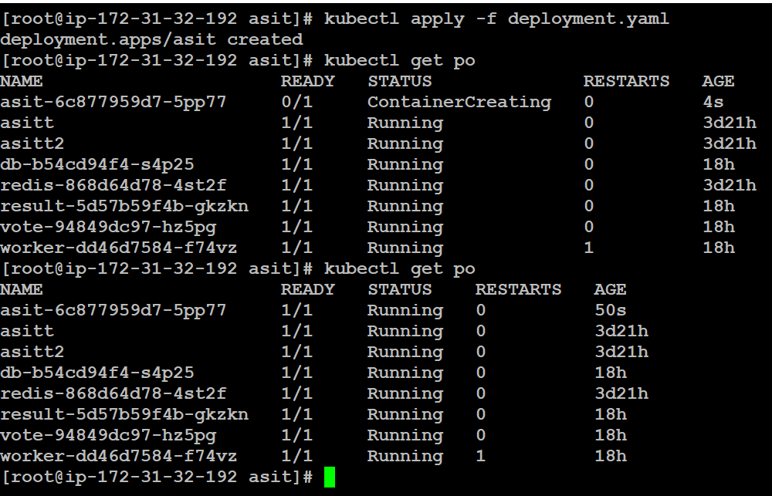

Describing the POD:

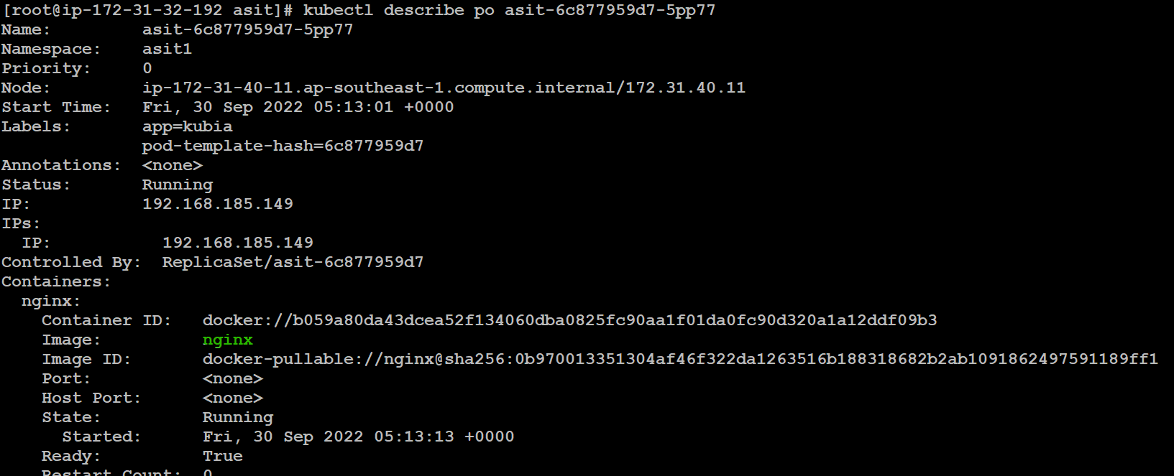

Now just changing the image of the Container in the same YAML file.

After Deployed with the new Container Image old pod got terminating and new pod came UP.

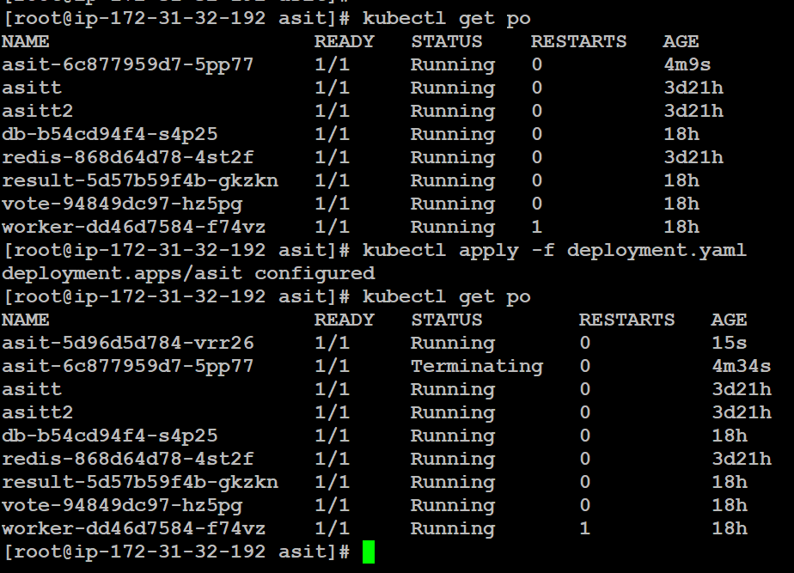

Now the Container Image Changed to NodeJS

