1. How to create a data bricks environment via terraform.

We need to create a folder in module as azure_databricks_nonprod_%name% as per the environment and put the same structure as other data bricks folder ex main.tf, variabes.tf, outputs.tf, versions.tf

<https://github.com/uhc-mris/Isdc-platform/tree/main/Terraform/modules>

Next step would be to add the data bricks code in the below git repository.

<https://github.com/uhc-mris/Isdc-platform/blob/main/Terraform/main/nonprod/databricks.tf>

We need to add the private and public subnet for the new cluster.

<https://github.com/uhc-mris/Isdc-platform/blob/main/Terraform/main/nonprod/subnet.tf>

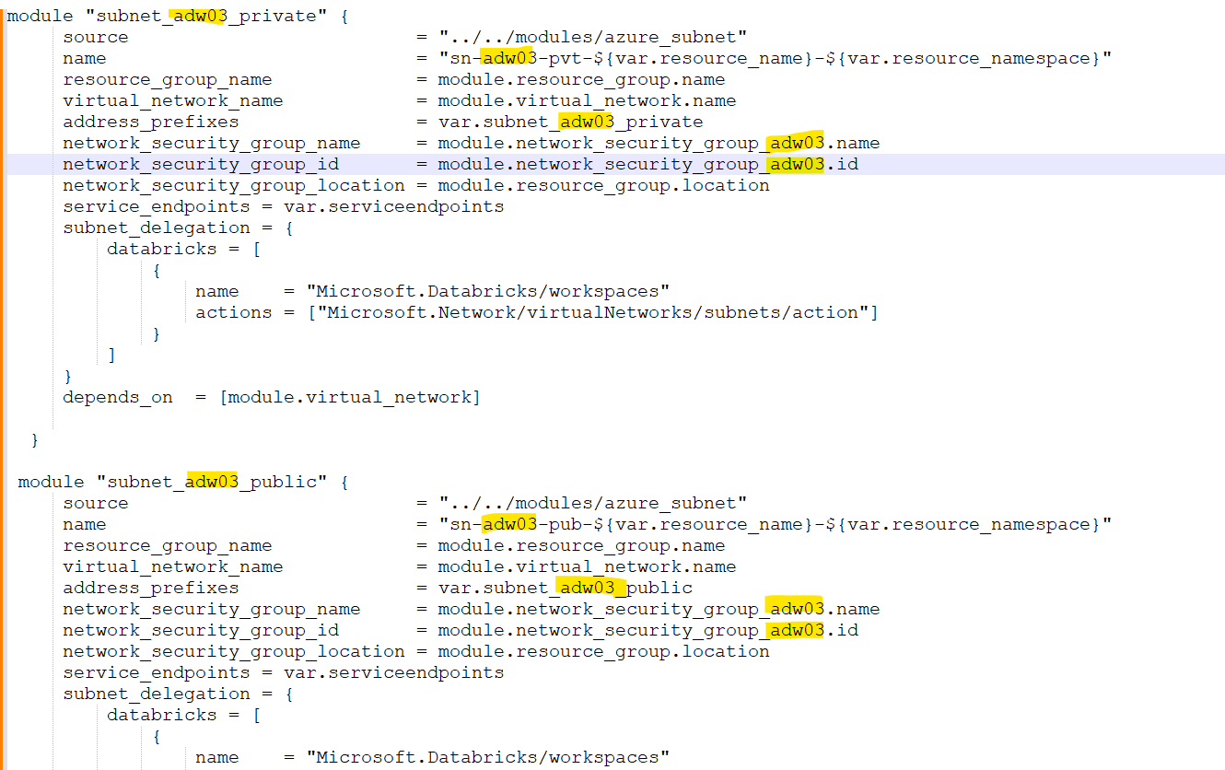

We need to add those newly subnet as a variable in the below repo.

<https://github.com/uhc-mris/Isdc-platform/blob/main/Terraform/main/nonprod/variables.tf>

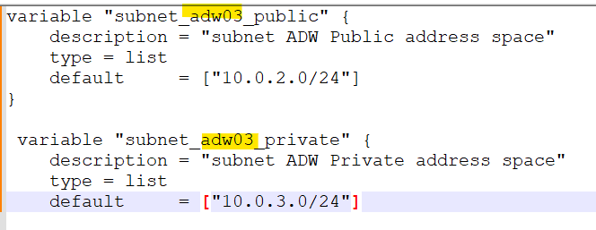

We need to ad network security group for newly data bricks cluster.

<https://github.com/uhc-mris/Isdc-platform/blob/main/Terraform/main/nonprod/network_security_group.tf>

Then we need to add the subnet IP addresses in terraform.tfvars file.

<https://github.com/uhc-mris/Isdc-platform/blob/main/Terraform/environments/nonprod/terraform.tfvars>

Next to validate the terraform changes need to go below repo and comment the Apply section to see if anything gets removed or added those changes which we added part of new cluster.

<https://github.com/uhc-mris/Isdc-platform/blob/main/.github/workflows/isdc-tf-nonprod-deploy.yml>

Line no 83 to 117 to be commented to validate the terraform plan.

To check the pipeline and make it executable, as per below screenshot run the CICD.

We need to work on diff branch and choose the same branch to run via GitHub actions.

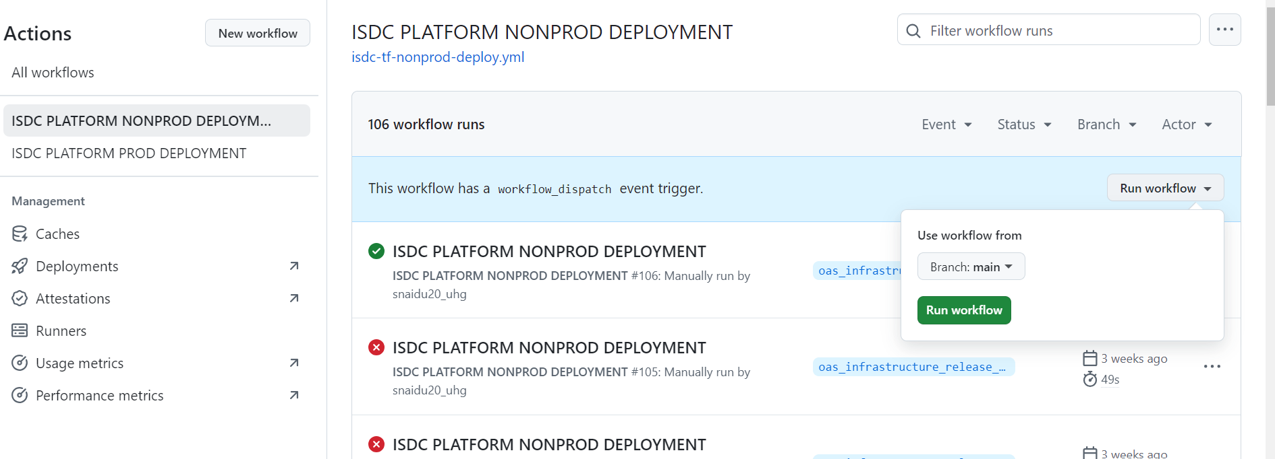

If everything looks good as per terraform plan, then we can comment the Terraform apply script and re-apply , execute the CICD pipeline.

Next, we can go Azure portal, then Azure data bricks we will be seeing the workspace being created.

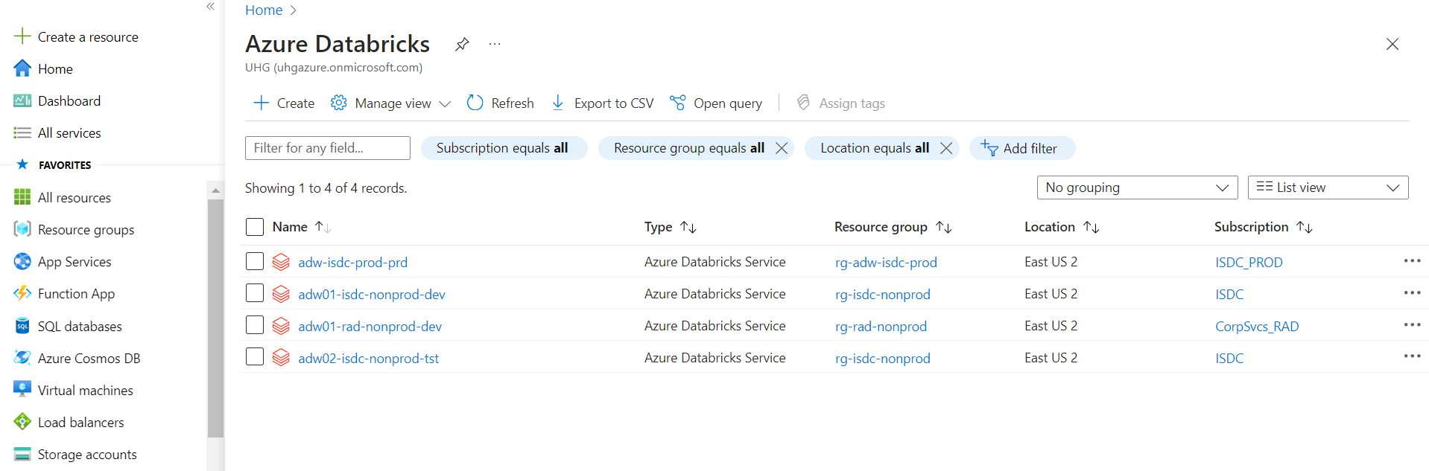

1. How to create a new ADF instance via terraform.

We need to go the platform repo and add the new module for ADF instance.

<https://github.com/uhc-mris/Isdc-platform/blob/main/Terraform/main/nonprod/datafactory.tf>

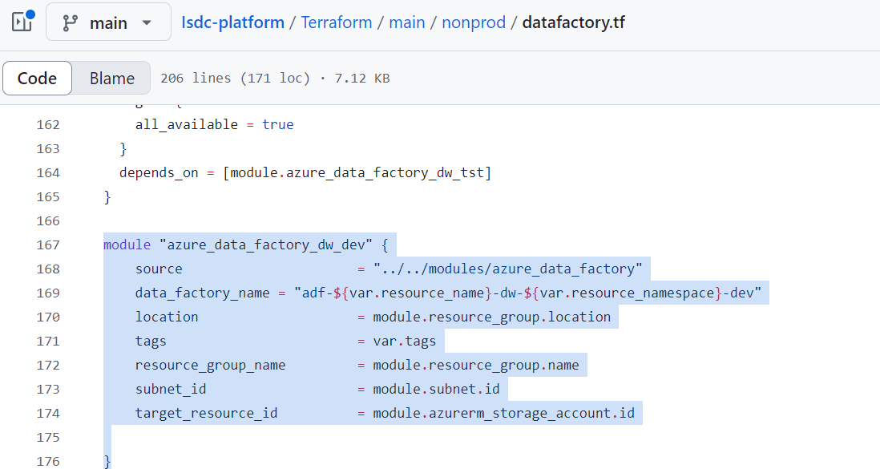

Next, we can apply the same procedure to validate the terraform plan and apply through CICD pipeline.

1. How we can provide IAM roles for ADF and data bricks instance.

Need to go the Azure portal , data bricks instance click on Access control(IAM) .

Note: Only admin can provide the IAM role to the respective instance.

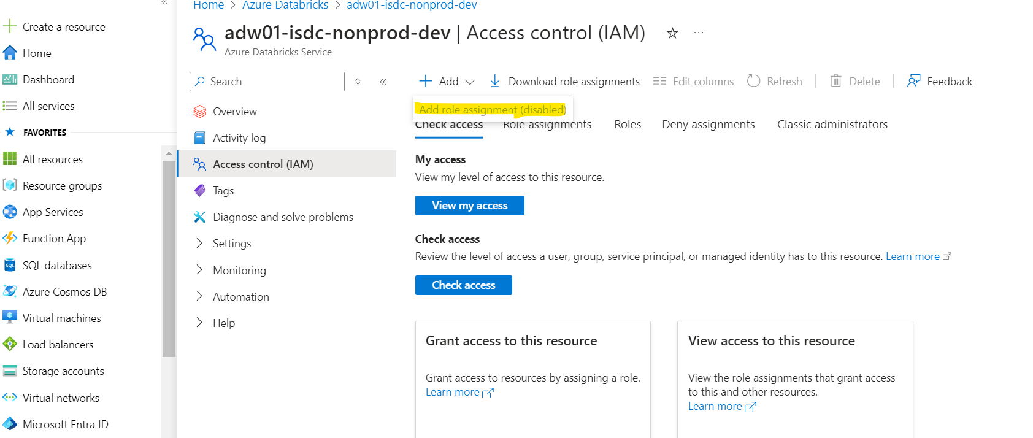

Same process would be followed for ADF instance IAM role.

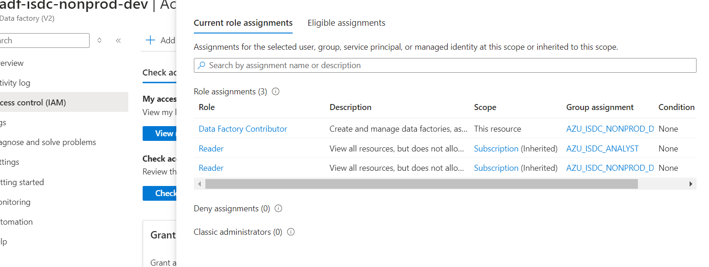

1. How we can provide IAM roles for Azure key vaults and Access policies.

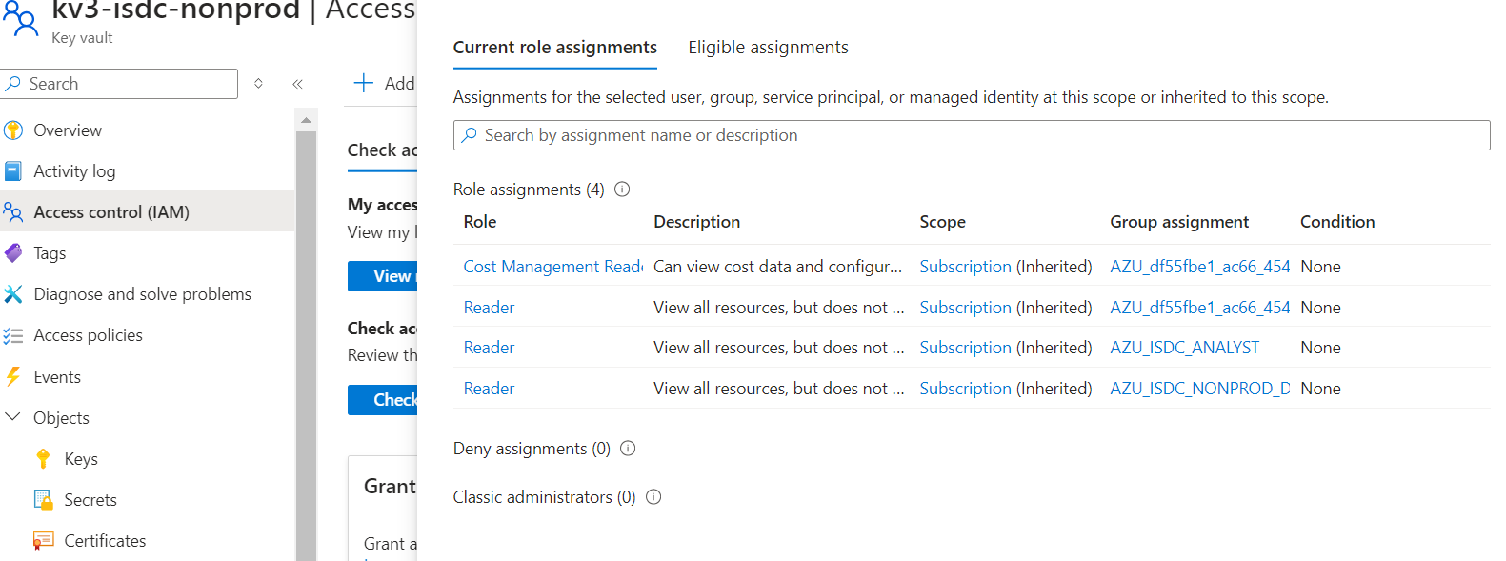

Access policies.

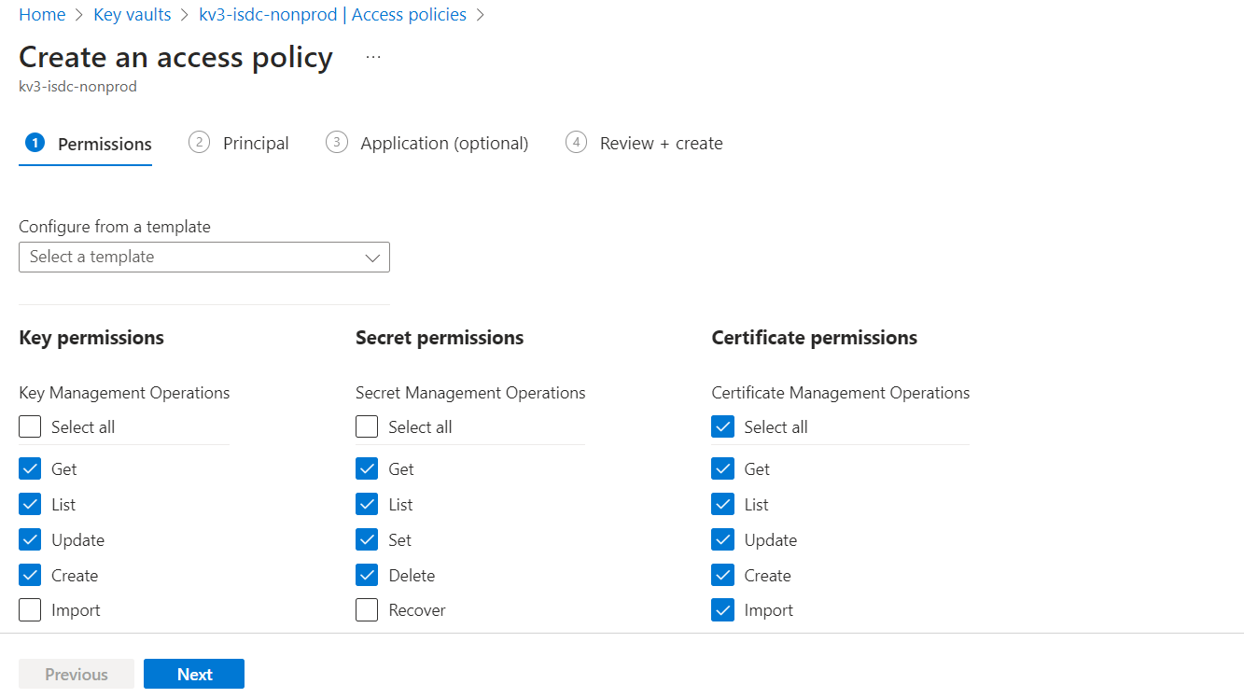

Next step would be to give access to any principal ID or any user .

1. How we can provide IAM roles for Blob storage.

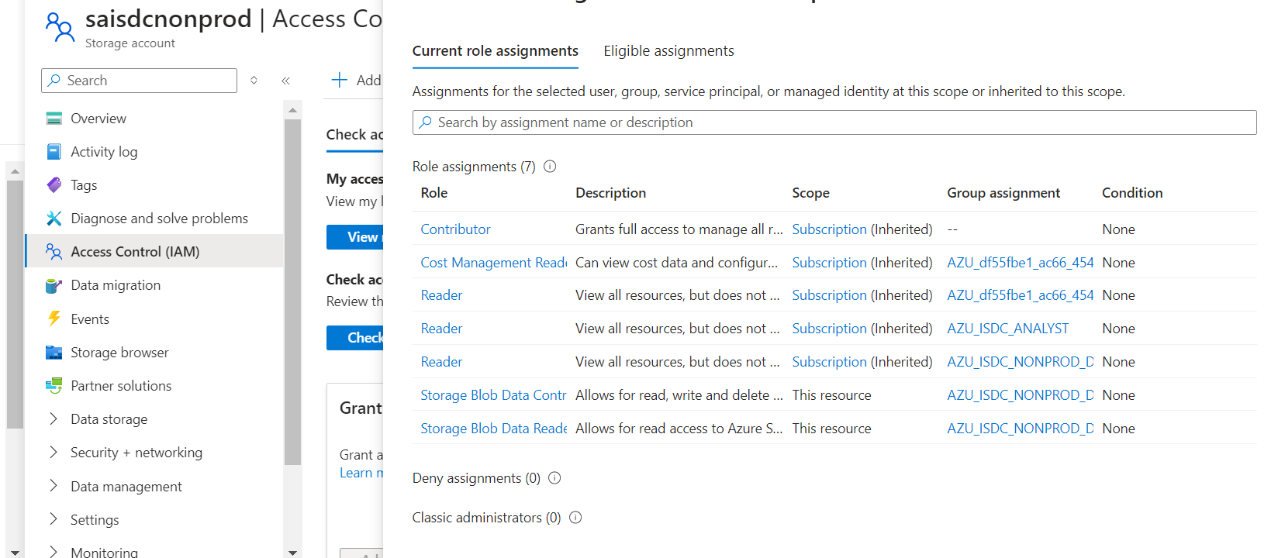

1. How to create a new storage account for Blob storage via terraform?

Need to add new storage account details as per below screenshot in the Main Module.

Then we can validate the terraform plan and apply through GitHub actions if everything looks good as per the plan.

1. How we can add the role assignment via terraform for the newly created any storage or any services of Azure line ADF also.

