# AWS Login and Management of EC2

URL: <https://aws.amazon.com/console/>



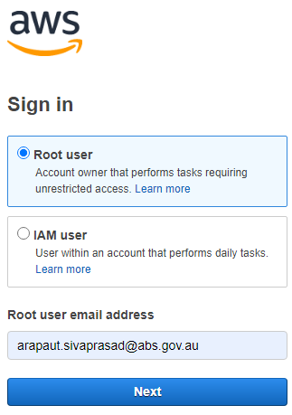

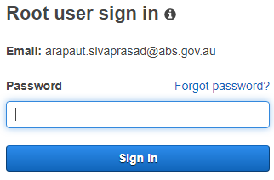

4G2K