# Connecting to an existing EC2 instance

1. Click the AWS-EC2 icon in toolbar



1. Click any of the links that shows a number below.
   1. If instances are stopped after use, only the second link will show a number

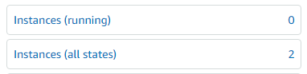

1. Check the one that is stopped. The ‘Terminated’ cannot be started. It is gone forever!

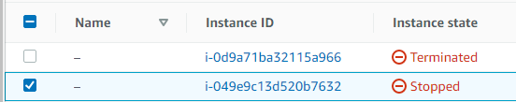

1. From the dropdown on ‘Instance State’, click ‘Start Instance’.

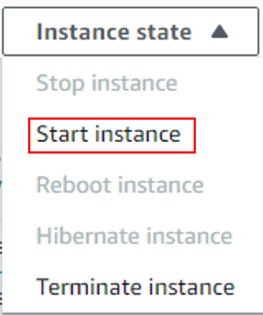

1. Refresh the browser. Now the ‘Connect’ button activates. Click it.



1. Click the ‘EC2 Instance Connect’ tab.

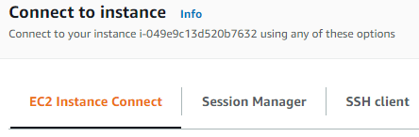

1. Click ‘Connect’



1. A tab will open with a Linux Centos shell window.
2. Play with it as you normally would on a Linux server.
   1. Always prepend the ‘sudo’ to commands that try to install something.

NOTES

* Requires the following private key to launch a new instance. It is automatically loaded when accessing from the office PC. On others, like in MobaXterm, it must be presented separately.
  + P:\Downloads\aws_linux_2_AMI.pem

# Launching a new EC2 instance

1. Click the AWS-EC2 icon in toolbar



1. Click ‘Launch Instance/Launch Instance’

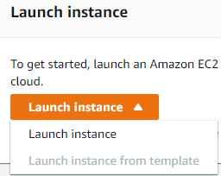

1. Choose ‘Amazon Linux’

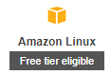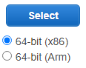

1. Choose the ‘Free Tier Eligible’ server.



1. Click ‘Review and Launch’



1. Click ‘Launch’



1. List all versions of the files.



