# Creating and using S3 buckets

1. Click the S3 console button



1. Create a new bucket (up to 100 buckets allowed. Not sure how many for the free user)



1. Use an existing bucket by clicking its link. Checkbox is to empty or delete the bucket.

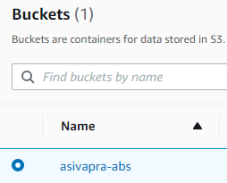

1. Create folders and/or upload files.

