# **Help to use wps_mean_polygon.ipynb**

This Jupyter Notebook page requires the manual input of a polygon coordinates. This help document is not required if you are adept at specifying the X, Y coordinates of all corners of a polygon. If not, read on to understand the process to create it using TerriaMap.

## Requirements

* A web browser (Chrome preferred)
* TerriaMap URL: <http://130.56.242.6/terria/> or <https://nationalmap.gov.au/>[1]
* A config file – **wps.json** – with the contents below. Save it in a local folder.

{  
 "catalog": [  
 {  
 "name":"WPS GetCaps (Production)",  
 "url":"http://gsky.nci.org.au/ows/geoglam",  
 "type":"wps-getCapabilities",  
 }  
 ]  
}

## Operation

* Start TerriaMap and click on the ‘Load local/web data | Add Local Data’ button.

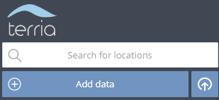 

* Click Browse to Locate and open the ‘wps.json’ file.



* Click on left frame 
* Select 
* Click 
* Mark a polygon as: 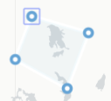
* Click Done 
* Select and copy the polygon coordinates into clipboard.
* 
* Insert into the Jupyter Notebook
* 
* Execute the Notebook via ‘Cell | Run All’

**___End of Document___**

1. If using this URL, must make sure that you are not behind any firewall.