GSKY through ArcGIS

Usage, errors, suggestions and observations

Created on: 2/1/19

Contact: [Arapaut.Sivaprasad@anu.edu.au](mailto:Arapaut.Sivaprasad@anu.edu.au)

**SUMMARY**

The GSKY Web Map service is currently provided through TerriaMap, which is a software created by CSIRO and is not widely known. Though TerriaMap is probably the best client for GSKY in terms of functionality, ease of use and clarity of the images, enabling other clients for using GSKY may increase the user base considerably. We are investigating ArcGIS, QGIS, Google Earth and NASA World Wind as potential clients for GSKY. This document explores the capabilities of three programs in the ArcGIS package and describes their usage. Each has some advantages over another and some drawbacks. These will be explained along with their usage.

**DISCLAIMER**

This document is NOT an in-depth description of all features of the ArcGIS applications. It will take weeks of intense study to learn all. Links to several online courses are provided for it. The content of this document is based on my current knowledge of the ArcGIS program(s) and the GSKY code. There may be errors and omissions in the content, which will be corrected as more knowledge is acquired. Some of the contents may have come from external sources. While the external sources are cited with a link to their pages, there may be occasional omissions.



# TL; DR

* **ArcGIS** is a commercial GIS software suite that works under Windows only.
* There is a free app, **ArcGIS Earth**, which is useful as a GSKY client.
* Three separate software can be used as GSKY clients, *viz.,*
  + **ArcGIS Pro** – A commercial licence is required.
  + **ArcGIS Earth** – Free software but will require a free or paid ArcGIS Online licence.
  + **ArcMap** – Commercial. Does not require online account.
* In addition, there is **ArcGIS Online** which is not yet evaluated as a GSKY client.
  + If it supports GSKY, then it will be useful for MAC users.
  + First look revealed problems with connecting to GSKY server.
* **ArcGIS Pro** and **ArcMap** send bounding box (Bbox) values as Lat/Lon (EPSG:4326?)
  + This causes some timeout issues.
* **ArcGIS Earth** sends the Bbox values in EPSG:3857 format.
  + It has errors at ArcGIS end.
* GSKY code may require modifications to be efficient with **ArcGIS Pro**.
  + Fails to detect that zoom level is lower than threshold.
  + Picture quality is low.
  + Sometimes the GSKY server hangs.

# INTRODUCTION

This document describes the basics of the ArcGIS suite of programs and how they can be used as GSKY clients. Detailed and animated graphics-based tutorials are in separate PowerPoint presentations (see [ArcGIS_Pro_Desktop_Tutorial.pptx](https://github.com/asivapra/gsky/blob/master/Documents/ows/ArcGIS_Pro_Desktop_Tutorial.pptx), [ArcGIS_Earth_Tutorial.pptx](https://github.com/asivapra/gsky/blob/master/Documents/ows/ArcGIS_Earth_Tutorial.pptx), [ArcGIS_Online_Tutorial.pptx](https://github.com/asivapra/gsky/blob/master/Documents/ows/ArcGIS_Online_Tutorial.pptx), [ArcMap_Tutorial.pptx](https://github.com/asivapra/gsky/blob/master/Documents/ows/ArcMap_Tutorial.pptx)).

# Obtain an Institutional Licence (ANU)

To use ArcGIS you need an Advanced Level Institutional licence and an ArcGIS Online licence. All staff and students of the ANU can obtain a licence from the Fenner School of Environment and Society (FSES) who manages the service and support for ArcGIS and the ANU. Given below are short instructions on how to get the licence and install it. See <https://arcgis.anu.edu.au/> for details and other links.

## Installation

Browse to the [ArcGIS Wattle Course](https://wattlecourses.anu.edu.au/course/view.php?id=21946), and log in with your ANU UniID.



IMPORTANT NOTE: Installation order is critical! - Instructions can be found on the [ANU ArcGIS Website](https://arcgis.anu.edu.au/).

Install all the files below ***in that order***.

|  |  |
| --- | --- |
|  | ArcGIS 10.6.1ArcGIS 10.6.1 |

|  |  |  |
| --- | --- | --- |
|  |  | [exe fileArcGIS_Data_Interop_for_Desktop_1061_163752.exe](https://wattlecourses.anu.edu.au/pluginfile.php/1800129/mod_folder/content/0/ArcGIS_Data_Interop_for_Desktop_1061_163752.exe?forcedownload=1) |
|  |  | [exe fileArcGIS_Data_Reviewer_for_Desktop_1061_163753.exe](https://wattlecourses.anu.edu.au/pluginfile.php/1800129/mod_folder/content/0/ArcGIS_Data_Reviewer_for_Desktop_1061_163753.exe?forcedownload=1) |

|  |  |  |
| --- | --- | --- |
|  |  | [exe fileArcGIS_Desktop_1061_163864.exe](https://wattlecourses.anu.edu.au/pluginfile.php/1800129/mod_folder/content/0/ArcGIS_Desktop_1061_163864.exe?forcedownload=1) |
|  |  | [exe fileArcGIS_Desktop_BackgroundGP_1061_163876.exe](https://wattlecourses.anu.edu.au/pluginfile.php/1800129/mod_folder/content/0/ArcGIS_Desktop_BackgroundGP_1061_163876.exe?forcedownload=1) |

|  |  |  |
| --- | --- | --- |
|  |  | [exe fileArcGIS_Workflow_Manager_for_Desktop_1061_163759.exe](https://wattlecourses.anu.edu.au/pluginfile.php/1800129/mod_folder/content/0/ArcGIS_Workflow_Manager_for_Desktop_1061_163759.exe?forcedownload=1) |

## Get an ArcGIS Online account

Go to <https://arcgis.anu.edu.au/arcgis-online-signingin.html>

* Follow the steps to sign up for an account.
* Choose “Using Australian National University”

## Request ArcGIS Pro Standalone Licence (for your own laptop)

<https://arcgis.anu.edu.au/request/arcgis-pro-standalone.php>

You will get in email a “provisioning file” and instructions to install it.

* Start | ArcGIS Administrator on your Laptop
* Follow the steps to activate.
  + Locate and open the provisioning file.

## Request ArcGIS Pro Licence for an ANU desktop.

<https://arcgis.anu.edu.au/arcgis-pro-on-anu-desktop.html>

* Follow the steps online

# ArcGIS Suite of Programs

There are several Apps within the ArcGIS Desktop suite. Some of these are for admin purposes, some are subsidiary applications to others and some are standalones. The standalone apps that can be used as GSKY clients are described below. Detailed instructions on their usage will follow.

“ArcGIS is composed of ArcMap, ArcGlobe, ArcScene, and ArcCatalog. Essentially, ArcMap is the application which allows you to create and modify maps and analysing (2D) spatial data, ArcScene is ArcMap with 3D capabilities (like terrain mapping), ArcGlobe is like Google Earth and ArcScene combined, and ArcCatalog is our data manager where you can create and manage datasets and other files.”[[Ref](https://www.quora.com/What-is-the-difference-between-ArcMAP-and-ArcGIS)]

## ArcGIS Pro

“[*ArcGIS Pro*](https://esriaustralia.com.au/arcgis-pro) is a powerful 64-bit application that sits centrally within the ArcGIS Desktop suite. It puts advanced and intuitive 2D and 3D mapping capabilities at your fingertips and allows you to process your data quickly and visualise it in stunning detail.”[[Ref](https://esriaustralia.com.au/arcgis-pro)]

This software must be licensed through [ANU ArcGIS portal](https://arcgis.anu.edu.au/) which will give you access to **ArcGIS Desktop** and **ArcGIS Online**. The ArcGIS Desktop includes the main program, **ArcGIS Pro**, and several subsidiary programs including **ArcMap** and **ArcGIS Earth**, two applications that are also useful as GSKY clients. See [ArcGIS_Pro_Desktop_Tutorial.pptx](https://github.com/asivapra/gsky/blob/master/Documents/ows/ArcGIS_Pro_Desktop_Tutorial.pptx) to learn the basics to some level of advanced use of this software. It also includes animated tutorials on how to use ArcGIS Pro as a GSKY client.

## ArcMap

“ArcMap and *ArcGIS Pro*, the two primary desktop applications for GIS professionals, are both part of *ArcGIS Desktop*. [*ArcMap*](http://desktop.arcgis.com/en/arcmap/latest/get-started/introduction/a-quick-tour-of-arcmap.htm) and its companion application, [*ArcCatalog*](http://desktop.arcgis.com/en/arcmap/latest/get-started/introduction/a-quick-tour-of-arccatalog.htm), as well as [*ArcGlobe and ArcScene*](http://desktop.arcgis.com/en/arcmap/latest/get-started/introduction/choosing-the-3d-display-environment.htm), work together to provide a full spectrum of GIS capabilities. These applications are the focus of this help system. Information about *ArcGIS Pro*, the newest member of this group, is available at [*http://pro.arcgis.com*](http://pro.arcgis.com/).” [[Ref](http://desktop.arcgis.com/en/arcmap/latest/get-started/main/get-started-with-arcmap.htm)]

ArcMap is included if you install ArcGIS Pro Desktop on your Windows’ PC. No separate licence is required but, to use online free resources, you will need an ArcGIS Online licence. The latter is part of the ANU licence for ArcGIS or can be signed as a free public licence.

## ArcGIS Earth

“Explore any part of the world with ArcGIS Earth. Work with a variety of 3D and 2D map data formats including KML. Display data, sketch placemarks, measure distances and areas, and add annotations. ArcGIS Earth has everything you need to easily understand spatial information, so you get the full picture.” [[Ref](https://www.esri.com/en-us/arcgis/products/arcgis-earth)]

ArcGIS Earth is included if you install ArcGIS Pro Desktop on your Windows’ PC. No separate licence is required but, to use online free resources, you will need an ArcGIS Online licence. The latter is part of the ANU licence for ArcGIS or can be signed as a free public licence.

See [ArcGIS_Earth_Tutorial.pptx](https://github.com/asivapra/gsky/blob/master/Documents/ows/ArcGIS_Earth_Tutorial.pptx) to learn the basics. The above presentation also includes instructions on how to use ArcGIS Earth as a GSKY client as well as explanation of the errors when using it.

# Using ArcGIS apps as GSKY clients

It is required to have at least a basic understanding of the apps, their settings and controls. These apps are not intuitive and can be intimidating to a first-time user. Once mastered, however, they are almost as easy to use as TerriaMap.

Given below are textual descriptions of the usage, which are good as a reference after you have gained a basic understanding through the PowerPoint presentations. Neither this word doc nor the PPT is claimed to be exhaustive and authoritative documents for advanced usage of these very complex applications. If you need to be an advanced user there are online tutorials, forums, YouTube videos, webinars and paid courses. Some of the promising ones are listed below.

1. [**Esri's MOOC Program**](https://www.esri.com/training/mooc/) – Free. 4 to 6 weeks’ self-paced courses.
2. [**EDX course**](https://edge.edx.org/courses/course-v1:NotreDame+GIS000+0000/about) : Geographic Information Systems (GIS) – Unknown cost. 13 modules over several weeks.
3. [**Uni of California Davis**](https://www.coursera.org/specializations/gis) **–** Five courses each of four weeks. Cost is unknown. Probably free unless you want a certificate.
4. [**ArcGIS Book**](http://learn.arcgis.com/en/arcgis-book/): learn-by-doing guide into ArcGIS. Free. Self-paced.
5. [**ESRI Courses**](https://www.esri.com/training/catalog/search/): Free and paid ones.

## ArcGIS Pro

If there is a commercial licence for it, this is the **best** of the three applications to be used as GSKY client. It shows marginally better pixel quality compared to the others.

See [ArcGIS_Pro_Desktop_Tutorial.pptx](https://github.com/asivapra/gsky/blob/master/Documents/ows/ArcGIS_Pro_Desktop_Tutorial.pptx) to learn from basics to some level of advanced use of this software. The following section only deals with using it as a GSKY client.

### INSTRUCTIONS

1. Run the application as ‘Start | ArcGIS Pro’



* 1. When the program starts, pin its icon to the taskbar so that it can be invoked easily later. It takes up to a minute to start.



1. Click ‘Blank’ to start a new project or select an existing project.



1. Give the new project a name and storage location.

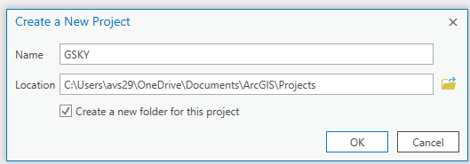

1. Under the ‘Projects | Insert’ tab click on ‘New Map’, ‘New Global Scene’ or ‘New Local Scene’

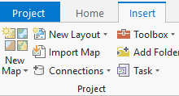 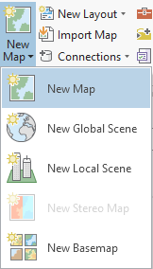 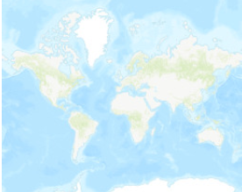

* 1. New Map and New Local Scene: 2D
  2. New Global Scene: 3D
  3. New Stereo Map: Not available without an Image Analyst licence.
  4. New Basemap: Does not work(?) Basemap can be added later.

1. Selected maps will be added to the ‘Catalog | Contents’.

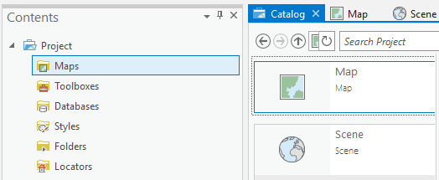

* 1. Click ‘Contents | Maps’ to see the list.
  2. Right click any map under ‘Catalog’ and ‘Delete, Rename, Convert, etc.’
     1. You can convert a 2D map to 3D and vice versa.

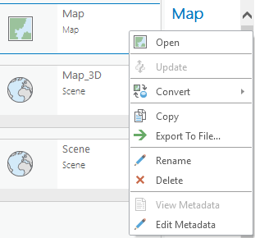 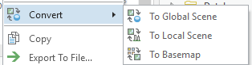

1. Add the GSKY server via ‘Projects | Insert | Connections | New WMS Server’

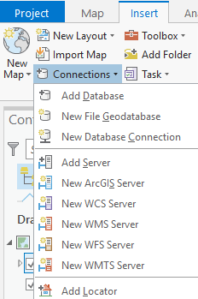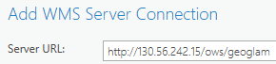

* 1. It will be added to ‘Contents | Servers’

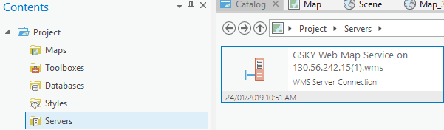

  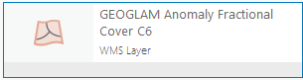

* 1. Double click the server icon on right repeatedly until the layers are displayed
  2. Right click the required layer and choose ‘Add to Map’

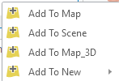

* 1. It will now be listed under ‘Map | Contents | Map’, and the map will show the layer.

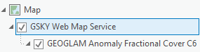

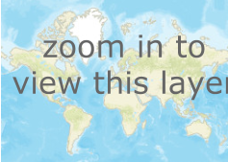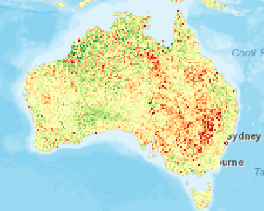

1. Zoom in/out to see the layer clearly.
2. Make sure that the GSKY layer is on top of all other layers.
   1. It means the map labels become invisible under the GSKY layer
   2. Unsure how/whether to set transparency of layers.

### BUGS and/or GAPS in KNOWLEDGE

## ArcGIS Earth

This is a free software that gets installed as part of the ArcGIS Desktop suite. It can also be downloaded separately. To use it one needs an ArcGIS Online account, either public or a time-limited free trial. The public account is free, but not sure whether it too is time/feature limited. With the ANU licence comes an ArcGIS online account. Just to use as GSKY client you probably don’t need anything from the online account, but the program will not run without logging into it.

See [ArcGIS_Earth_Tutorial.pptx](https://github.com/asivapra/gsky/blob/master/Documents/ows/ArcGIS_Earth_Tutorial.pptx) to learn the basics of this software. This app does not have the bells and whistles of ArcGIS Pro. It is probably the choice for those who do not want to pay for a commercial licence. However, a drawback is that only 3D map is available and GSKY does not work well with 3D (though it works to some extent). There is also an apparent error within ArcGIS Earth in sending the bounding box values under certain zoom levels.

### INSTRUCTIONS

1. Run the application as ‘Start | ArcGIS Earth’



* 1. When the program starts, pin its icon to the taskbar so that it can be invoked easily later. It takes up to a minute to start.



* 1. When the program starts it will auto load a 3D map and ask to sign into ArcGIS online account.

 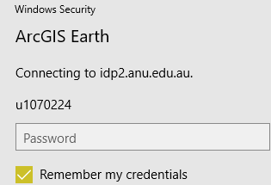 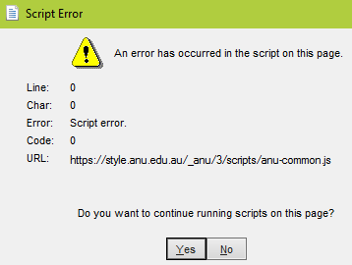

* 1. Ignore and dismiss the JavaScript Error message that appears.
  2. Note: Though GSKY client does not require other online resources, without logging on to ArcGIS Online there will be no Basemap to overlay the GSKY layers.

1. Click the ‘Basemap’ icon on the toolbar and select a map.
   1. The selected map will be overlaid on the globe. Even though previously the globe showed the continents, without adding a basemap the GSKY layers will not become visible.



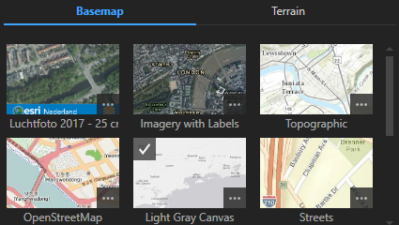

1. Click the ‘Add data’ icon on the toolbar.



1. Click ‘Enter a URL’, choose ‘Type: OGC WMS’ and enter the GSKY server’s URL.

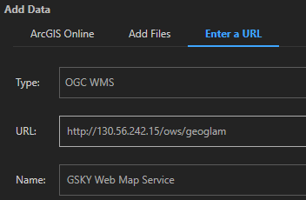

1. Expand the ‘My Data | GSKY Web Map Service’ and check the layer(s) to be shown on the map.



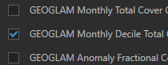

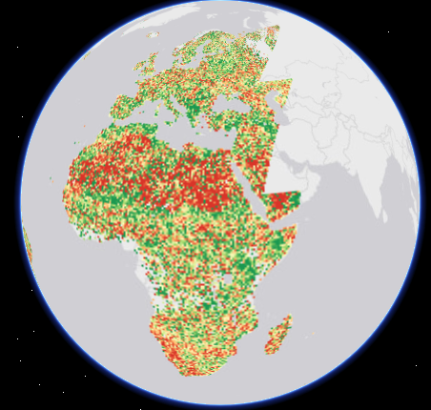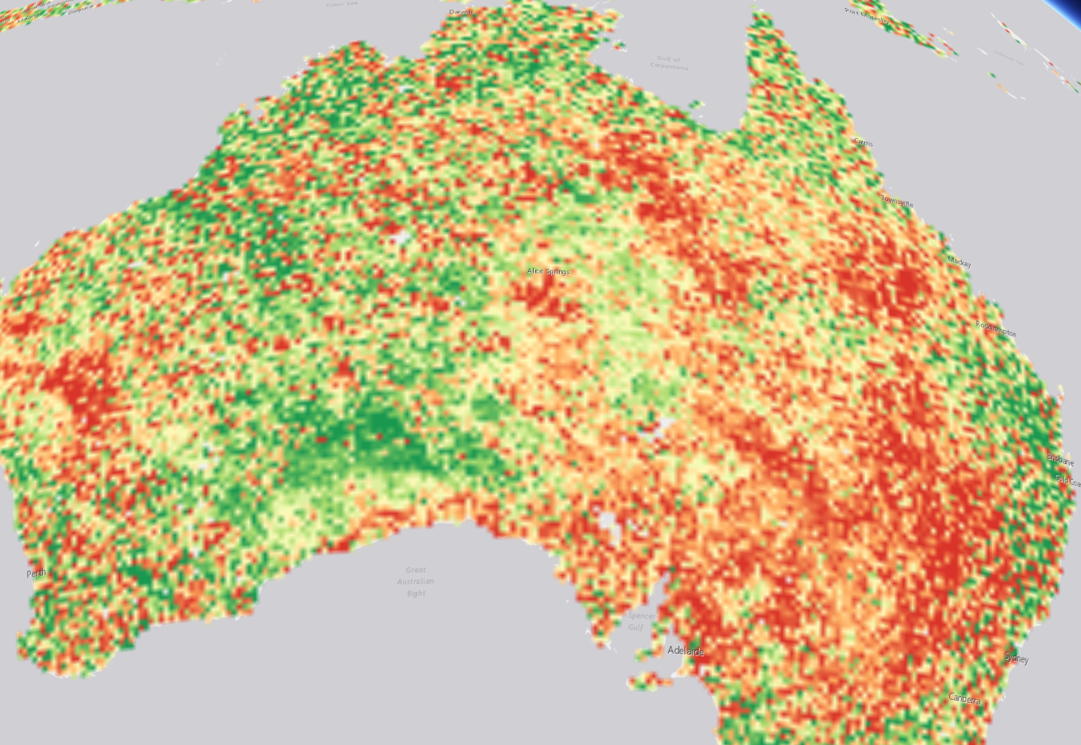

1. NOTE: Zooming out is not supposed to lose the GSKY layer but owing to an apparent error in the Bbox values sent by ArcGIS Earth, the layer disappears from Australia under lower zoom levels than the one shown above. Specifically, the Bbox being sent when the zoom level is lower does not include Australia but is to the east of the continent. This may be correctable (probably not!) in the GSKY code.
2. Though it says on the web that ArcGIS Earth supports both 3D and 2D maps, there is no option in the program to choose a 2D map. Further studies may reveal it.

## ArcMap

This standalone app does not require ArcGIS Online account. It works with only 2D maps and sends the Bbox values as Lat/Lon.

### INSTRUCTIONS

1. Run the application as ‘Start | ArcMap’



1. When the program starts, pin its icon to the taskbar so that it can be invoked easily later. It takes up to a minute to start.



* 1. When the program starts it will show a dialog to open an existing map. Dismiss it to start a new map.



1. Click ‘Add data’ to add a base map.

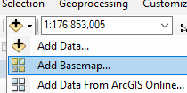 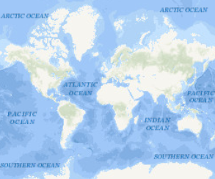

1. Click ‘Add Data’ again to add the GSKY service and type in the GSKY URL

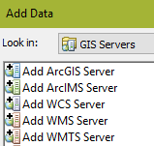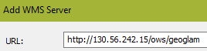

* 1. Add the service



* 1. Choose the service title and add again.

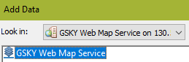



* 1. Expand the layers and choose the required one.

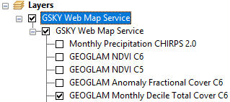

1. Zoom in to see the added layer

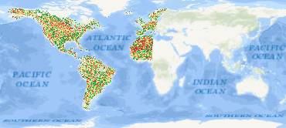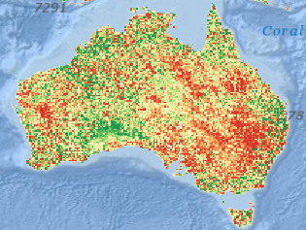

Note: There are inconsistencies in the Bbox values sent and hence some parts are blank at low zoom levels. The software also appears to hang at times. If so, close it and start again.

### BUGS and/or GAPS in KNOWLEDGE

1. Added GSKY Map service cannot be deleted or re-used. Must add it each time.
2. Hangs if zoomed too fast and frequently.
   1. Possibly because a previous request is still on the way to GSKY server.