**Project 8**

**AI Security Surveillance System**

**Objective:**

With the rapid growth of urbanization and technological advancements, ensuring **public and private security** has become an essential concern. Traditional surveillance systems often rely onmanual monitoring, making them inefficient in detecting and responding to security threats in real-time. This project aims to develop a **AI-powered video surveillance system** capable of real-time threat detection, gesture recognition, and anomaly identification. The system leverages advanced deep learning and computer vision models to ensure intelligent monitoring of live video feeds, detecting suspicious activities and generating immediate alerts. This solution is designed to enhance security for both residential and commercial spaces, reducing the risk of security breaches and ensuring proactive intervention.

**Methodology:**

The proposed system follows a multi-stage pipeline that integrates advanced AI models for real-time video analysis and threat detection.

1. **Live Video Processing**: The system continuously receives live video feeds from CCTV cameras or IP cameras, which are processed in real-time to detect and analyze actions.
2. **Object and Human Detection (YOLOv8)**: The YOLOv8 model is utilized for real-time object detection, identifying humans and other objects (e.g., bags, weapons) in the video frames. YOLOv8 is known for its high accuracy and real-time processing speed, making it ideal for detecting moving entities in dynamic environments.
3. **Gesture and Action Recognition (SlowFast + LSTM)**: For action recognition, the SlowFast ResNet-50 model combined with Long Short-Term Memory (LSTM) networks is applied to identify specific human gestures such as waving, pointing, and running.

These gestures are indicative of certain human activities that can trigger a security alert. The SlowFast model captures fast-moving actions while simultaneously processing slow-motion movements for more comprehensive recognition.

1. **Abnormal Behavior Tracking (ST-GCN + Optical Flow)**: The system employs Spatio-Temporal Graph Convolutional Networks (ST-GCN) and ConvLSTM to track human movements and detect abnormal behaviors, such as loitering, aggressive actions, and sudden movements. These models analyze spatial and temporal data of human

actions, identifying patterns of behavior that are likely to signify threats or suspicious activities.

1. **Motion and Anomaly Detection (ConvLSTM)**: To track motion-based anomalies, the system uses ConvLSTM networks, which combine the power of convolutional networks for feature extraction with LSTM units to analyze motion patterns over time. This helps detect unusual activities such as sudden movements or unexpected behavior in a scene.
2. **Alert Mechanism**: Upon detection of an anomaly or abnormal behavior, the system automatically triggers an alert mechanism. Alerts are generated in real-time and can be sent via SMS, email, or IoT-based notification systems to homeowners, security personnel, or relevant authorities, ensuring a quick response to any security incident.

**Block Diagram:**

Live Video

Capturing

Object Gesture

Detection Detection

Abnormal Behavior Detection

Blind Spot and Hidden

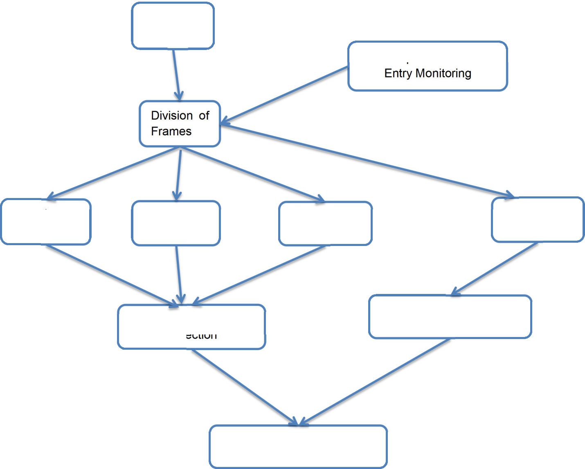

Individual Object

Recognition Tracking

Anamoly and Suspicious

Activity Identification

Immediate Alarms

**Components:**

The system is built upon several key components that work seamlessly together:

* **YOLOv8**: For real-time object and human detection, ensuring the system can track and detect various objects and individuals in the video frames.
* **SlowFast ResNet-50 + LSTM**: For gesture recognition, enabling the identification of human actions and gestures to understand intent.
* **ST-GCN and ConvLSTM**: For motion tracking and anomaly detection, helping to identify abnormal human behaviors and activities in the environment.
* **Alert System**: Integrated alert mechanisms that provide real-time notifications via SMS, email, or IoT-based systems, enabling immediate action in case of detected threats.

**Estimated Cost for AI-Based Real-Time Video Surveillance System:**

**1. Hardware Costs –** **₹50,000**

CCTV cameras, storage, and networking setup.

**2. Software Costs – ₹20,000** (AI model development only)

Covers object detection, gesture recognition, and anomaly detection models.

**3. Deployment & Maintenance Costs – ₹10,000**

Cloud services for real-time processing

Server costs for video storage & streaming

AI model integration with live feeds

System updates & maintenance

**Final Total Cost: ₹80,000**

This budget ensures a fully functional AI-powered surveillance system with real-time tracking, anomaly detection, and automatic alerts. The estimates may be adjusted as the project advances and resource needs become more defined.

**Estimated Budget:**

Estimated Cost for AI-Based Real-Time Video Surveillance System

1. Hardware Costs – ₹49,800

CCTV cameras, storage, and networking setup.

2. Software Costs – ₹62,000

AI model training, cloud GPU usage, and database integration.

3. Development & Maintenance Costs – ₹2,90,500

AI model customization, system integration, and future updates.

💰 Final Total Cost: ₹4,15,000

This budget ensures a fully functional AI-powered surveillance system with real-time tracking, anomaly detection, and automatic alerts. 🚀

**Outcome:**

The proposed system provides a **robust, intelligent solution** for **real-time video surveillance** and **security monitoring**. The integration of advanced AI-based models for human behavior analysis and motion detection ensures high accuracy and efficiency in detecting threats. With the ability to automatically recognize suspicious gestures, detect abnormal movements, and generate instant alerts, the system enhances **s**ecurity awareness, reduces the need for constant human intervention, and provides proactive threat management. The system’s real-time processing capabilities, **s**calability, and customizability make it ideal for deployment in various environments, including residential areas, offices, and public spaces, ensuring the safety of individuals and property.

**Team Members:**

N200649 Venkateswari Thota

N200171 Lahari Sanapala

N200170 Asiya Tabasum Shaik