Objective Questions

- List the different dtypes of columns in table “ball_by_ball” (using information schema).
Ans: There is only one data type in the table “ball_by_ball” is “int”
Using Query describe ball_by_ball;

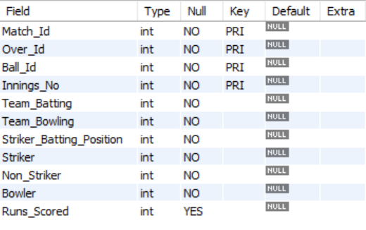

- What is the total number of runs scored in 1st season by RCB (bonus: also include the extra runs using the extra runs table)
- According to the given query there are no any matches played in 1st Season
select * from matches
where Season_Id = 1;
- According to given query RCB plays 682 matches
select distinct count(*) from player_match
where Team_Id = 2;
- By Applying the query the output is NULL

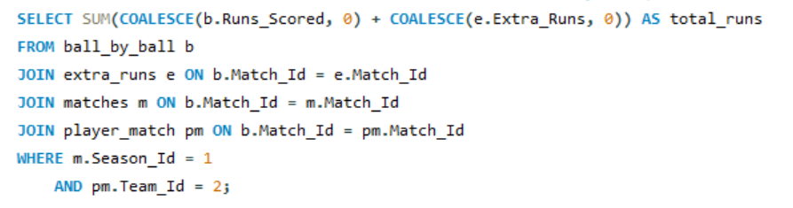

- How many players were more than the age of 25 during season 2014?
Ans:- There are total 89 players were more than age 25 during season 2014
Season id is 7 for season year 20214
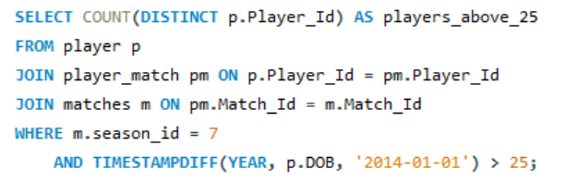

- How many matches did RCB win in 2013?
Ans:- RCB secured a total of 5 victories in the 2013 season.
Strategy: To determine the number of matches RCB won in Season 1, we queried the
matches table by filtering rows where the Season_Id is 1 (indicating the first season) and the Match_Winner is 2, which corresponds to RCB's team ID. This allowed us to count all the matches where RCB emerged as the winner during that season.
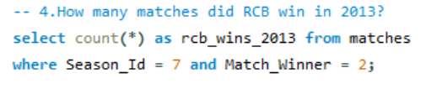

- List the top 10 players according to their strike rate in the last 4 seasons
Ans: The chart below displays the top 10 players based on their strike rate over the last 4 seasons.
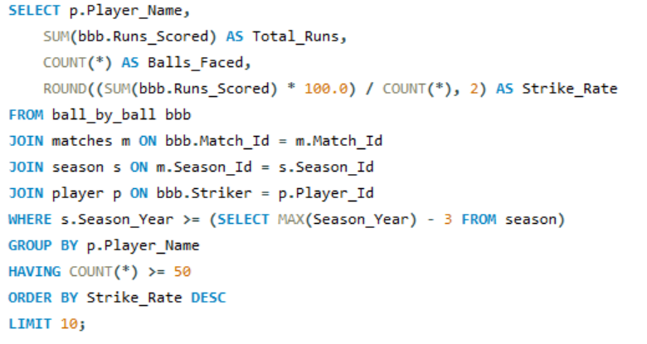
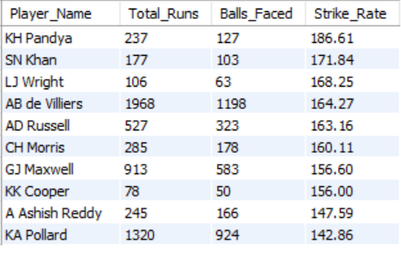
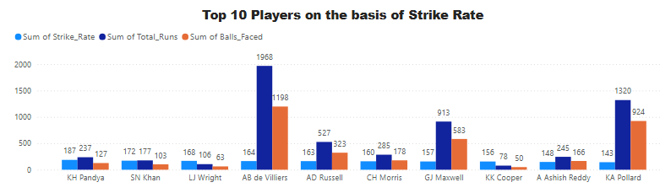

- What are the average runs scored by each batsman considering all the seasons?
Ans:- The list below highlights some of the batsmen along with their average runs scored
across all seasons.
Strategy: The query calculates the average runs scored per match for each batsman by summing the runs scored in all matches and dividing by the number of distinct matches they played in. It joins the ball_by_ball table with the player table to retrieve player names, groups the data by player, and sorts the results in descending order of average runs.
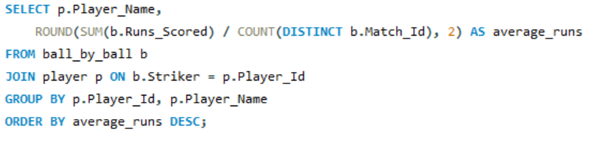
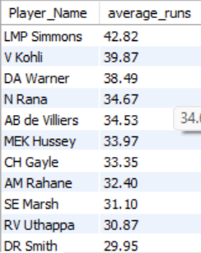

- What are the average wickets taken by each bowler considering all the seasons?
Ans:- Here are some of the bowlers ranked by their average number of wickets taken across all seasons.
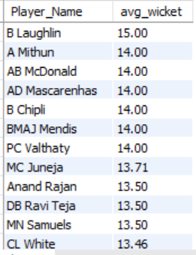
Strategy: This query calculates the average number of wickets taken per match by each player. It counts how many times a player was credited with a dismissal and divides that by the number of distinct matches they played in. The results are grouped by player name and sorted by average wickets in descending order.
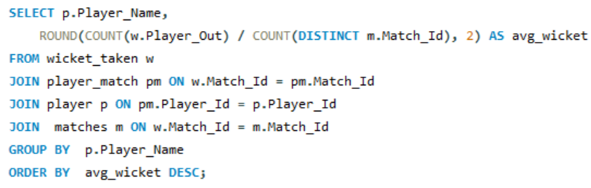

- List all the players who have average runs scored greater than the overall average and who have taken wickets greater than the overall average.
Ans:- This query identifies all-rounders who perform above average with both bat and ball. It first calculates average runs scored and average wickets taken per match for each player, then compares these figures against overall averages, and finally filters players who exceed both benchmarks.
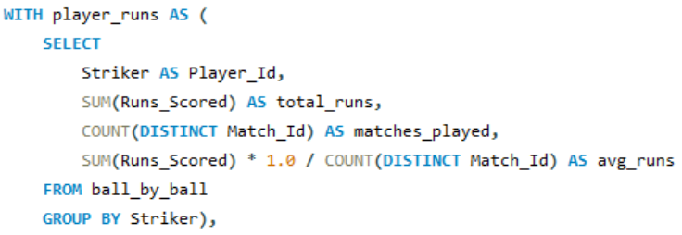
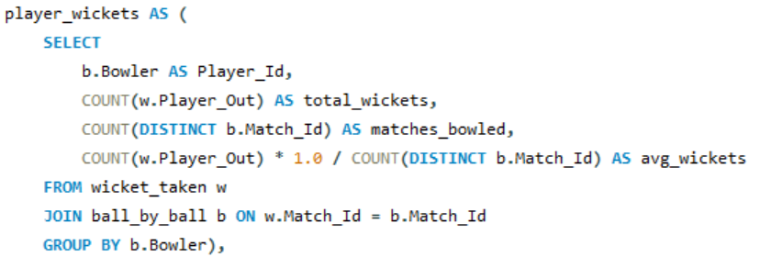
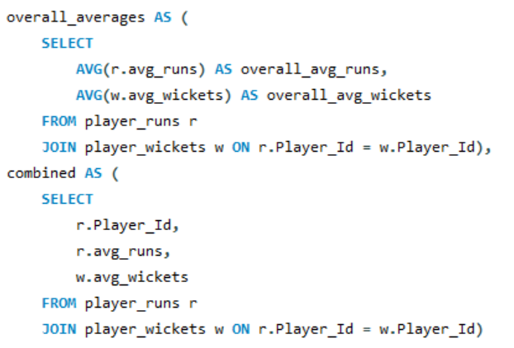
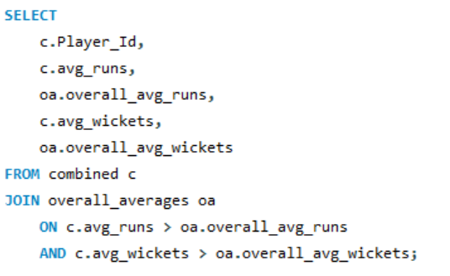

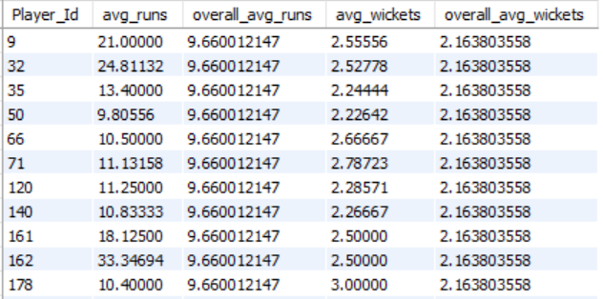

- Create a table rcb_record table that shows the wins and losses of RCB in an individual venue.
Ans:-
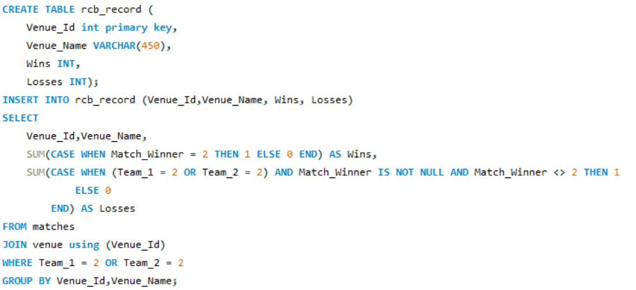
select * from rcb_record;
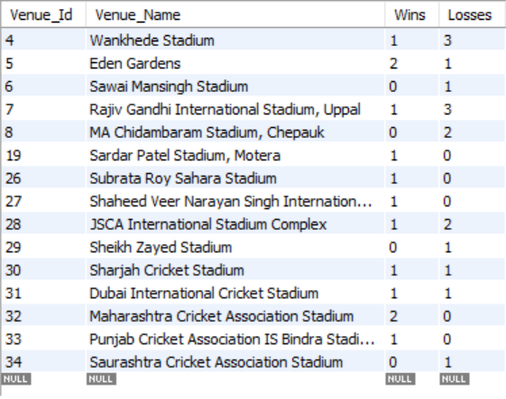

- What is the impact of bowling style on wickets taken?
Ans:- This query analyzes the effectiveness of different bowling styles by counting the total number of wickets taken for each style. It joins the wicket_taken, ball_by_ball, player, and bowling_style tables to match each wicket to a bowler and their respective skill, then groups by bowling skill to summarize total wickets.
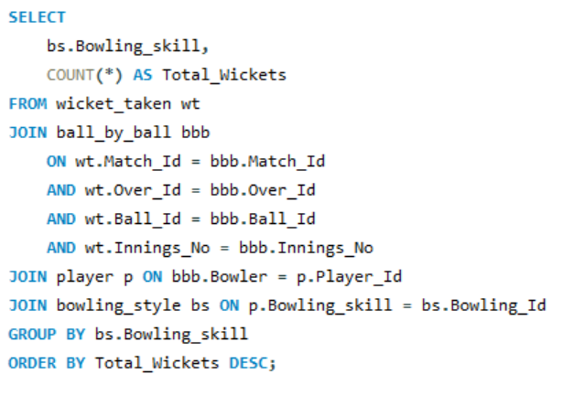
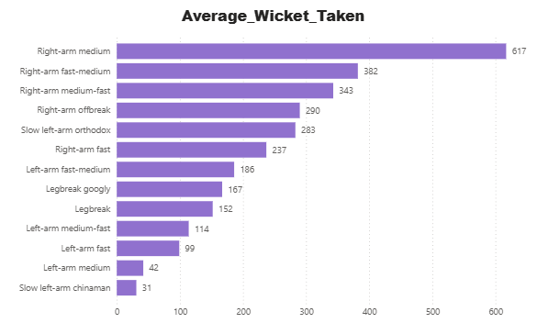

- Write the SQL query to provide a status of whether the performance of the team is better than the previous year's performance on the basis of the number of runs scored by the team in the season and the number of wickets taken.
Ans:- This query tracks each team's performance across seasons by comparing their total runs and wickets from one year to the next. It first computes seasonal stats per team, then joins each season with its previous one to classify performance as Improved, Declined, or Mixed, and finally presents a year-wise comparison for all teams.
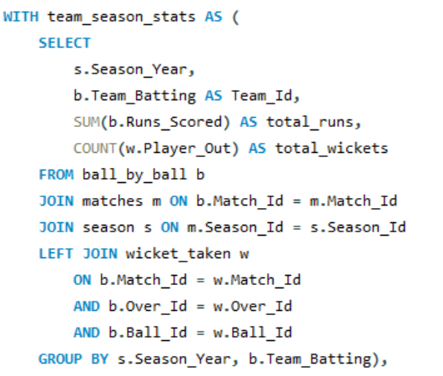
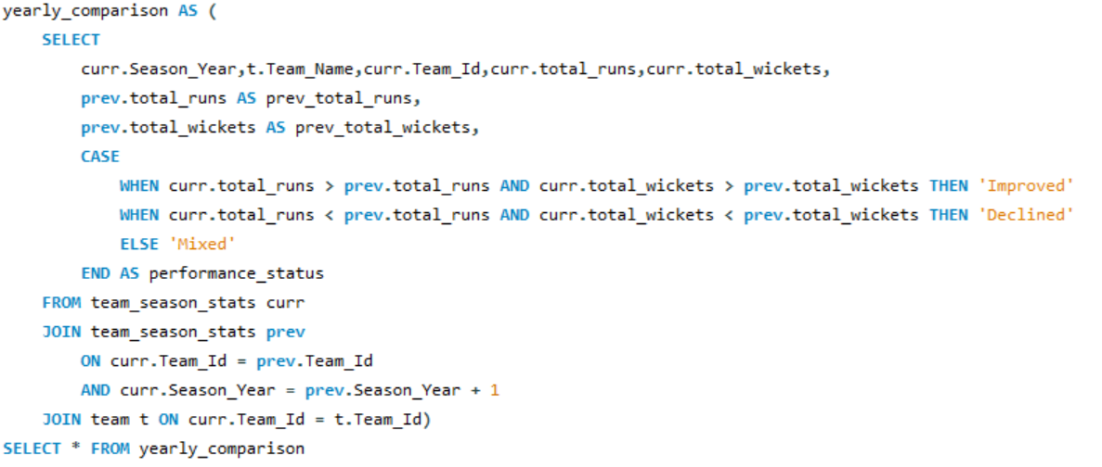
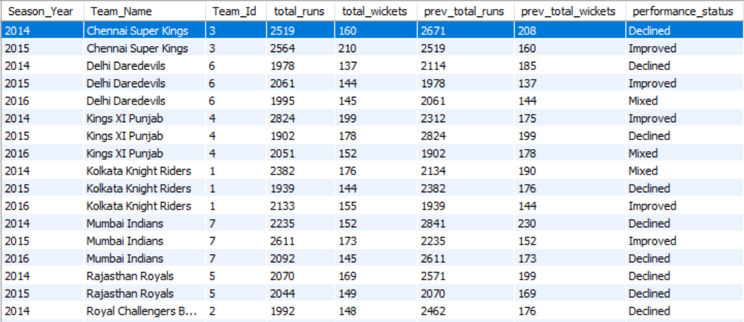

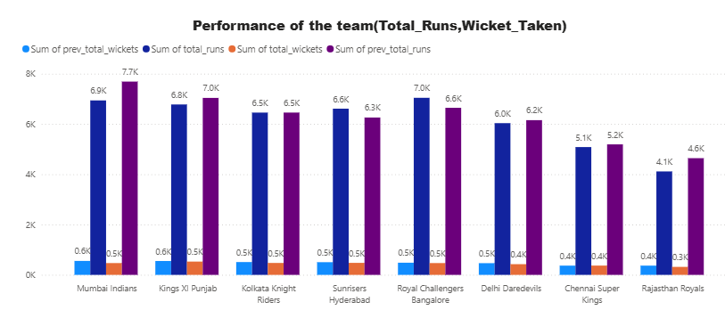

- Can you derive more KPIs for the team strategy?
Ans:- Key Performance Indicators (KPIs) for Team Strategy:
Bowling KPIs: Economy rate, average wickets per match, dot balls, runs conceded in powerplay and death overs.
Batting KPIs: Strike rate, average runs per match, number of boundaries, dot ball percentage
We compared current season KPIs such as strike rate and wickets taken with those from previous seasons to evaluate whether each team's performance is improving, declining, or remaining consistent.
Strategic Insights:
- The team should target openers with consistently high strike rates, especially effective in the first 6–7 overs.
- Focus on recruiting death-over specialists with proven low economy rates.
- Ideally, prioritize players who balance strong strike rates with efficient bowling (low economy), offering all-round value.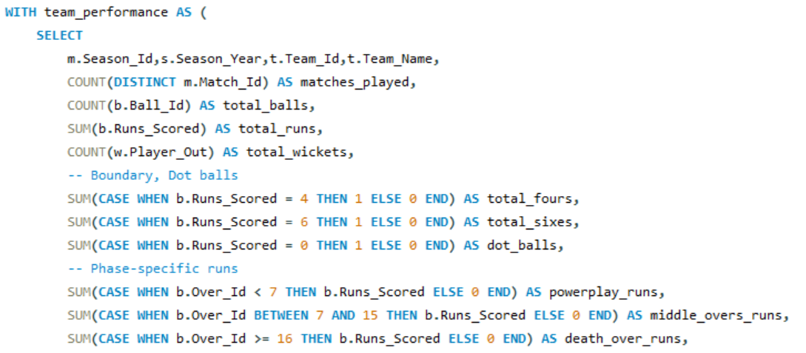
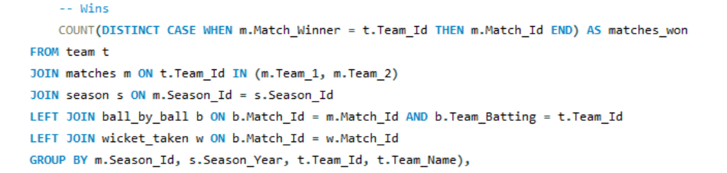
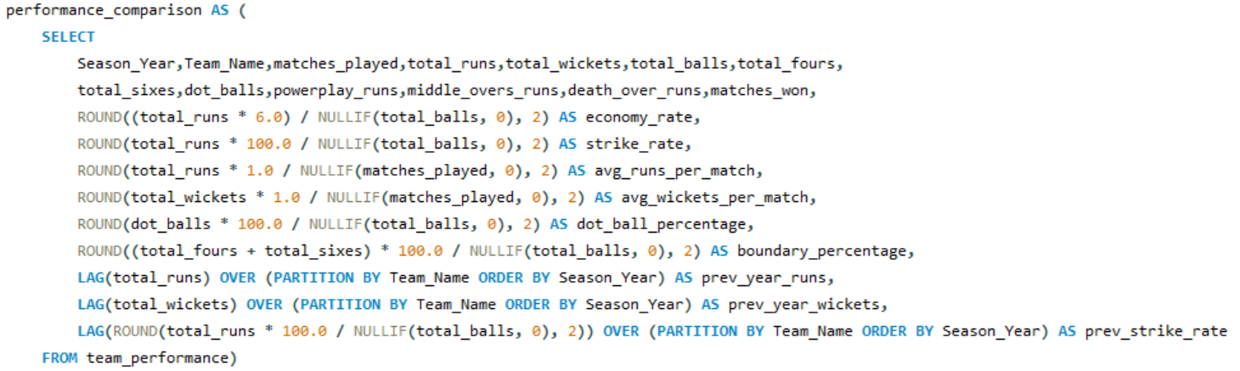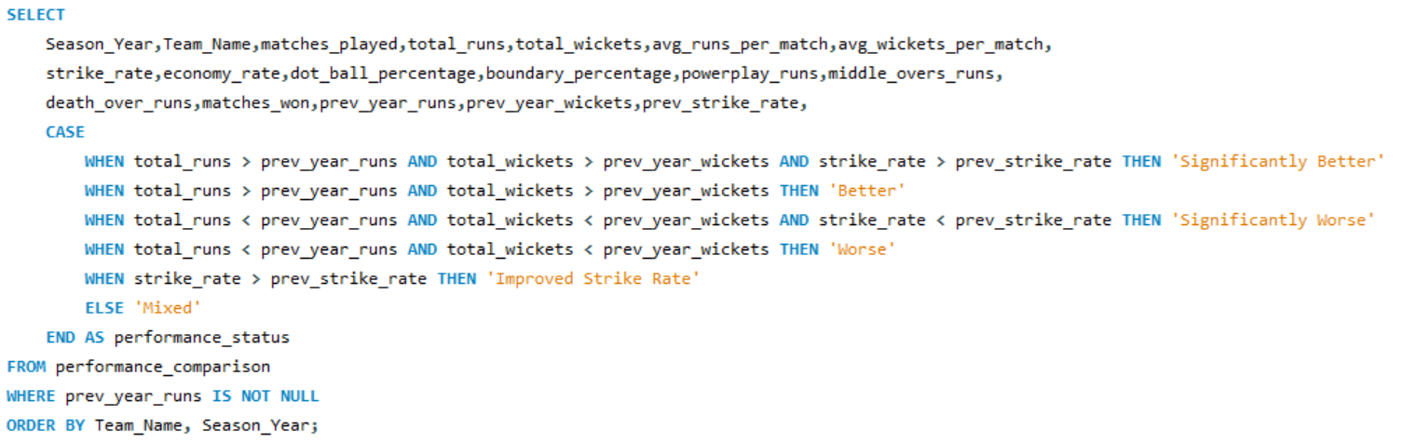
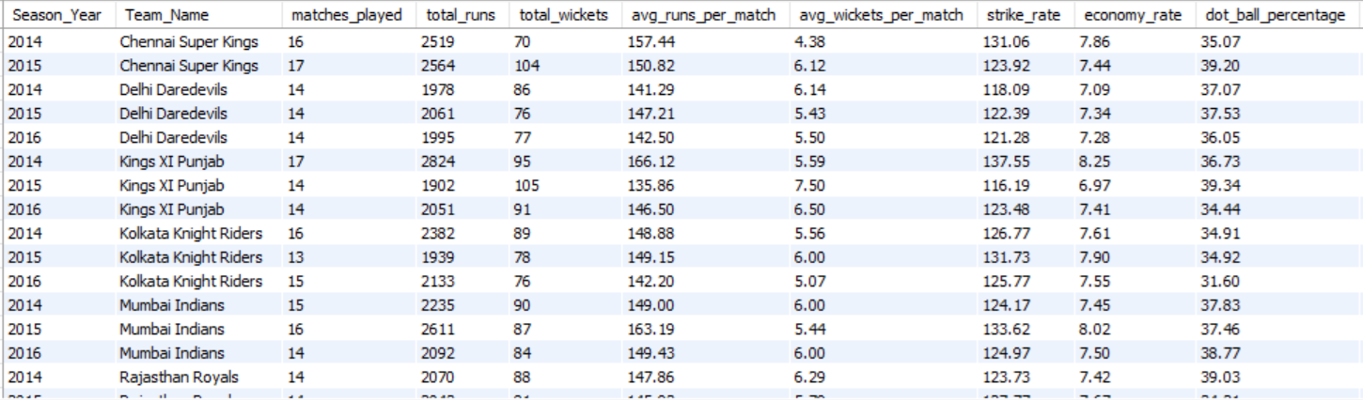
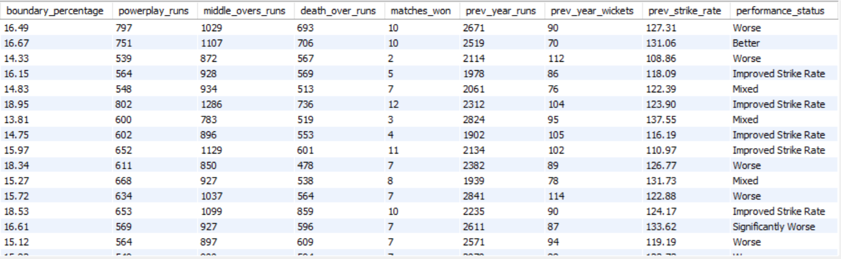

- Using SQL, write a query to find out the average wickets taken by each bowler in each venue. Also, rank the gender according to the average value.
Ans:- The query first calculates the total wickets taken and matches played by each bowler
at each venue. It then computes the average wickets per match per venue. Finally, it
ranks the bowlers within each venue based on their average wickets to identify top performers at each ground.
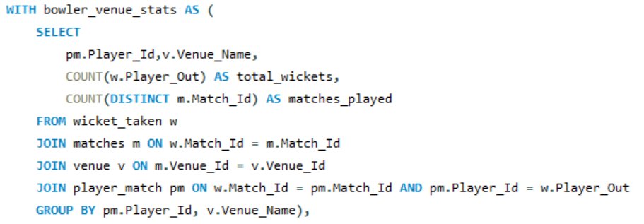
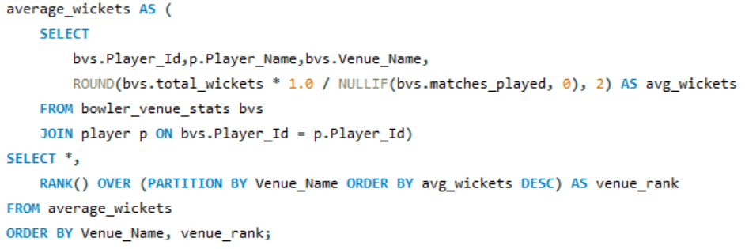
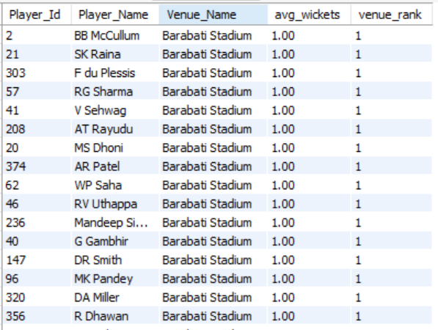

- Which of the given players have consistently performed well in past seasons? (will you use any visualization to solve the problem)
Ans:- The inner query calculates total runs scored by each player in individual matches. The outer query then computes each player's minimum, maximum, and average runs per match across all games. Player names are joined from the player table, and the results are sorted by average runs in descending order.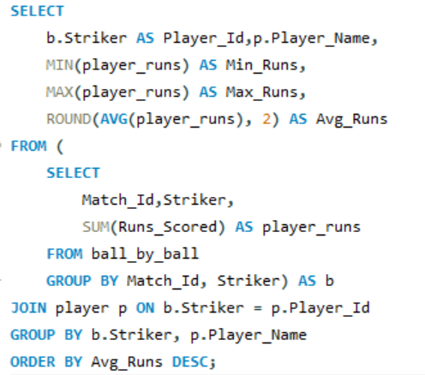

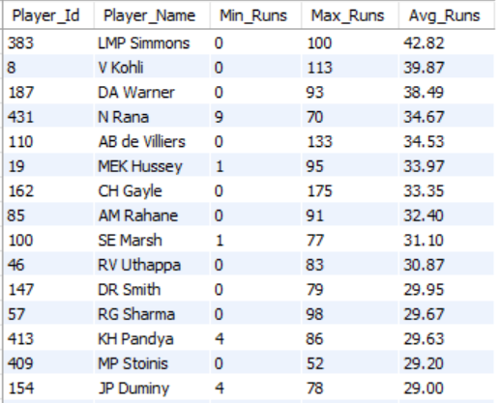

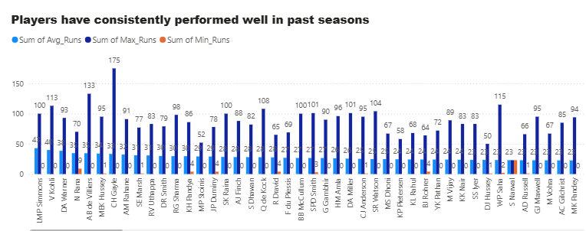

- Are there players whose performance is more suited to specific venues or conditions? (how would you present this using charts?)
Ans:- This query calculates each player's total and average runs at each venue. It joins ball_by_ball with matches, venue, and player tables, groups the data by player and venue, and computes the number of matches and average runs per venue. The results are ordered by player name and average runs.
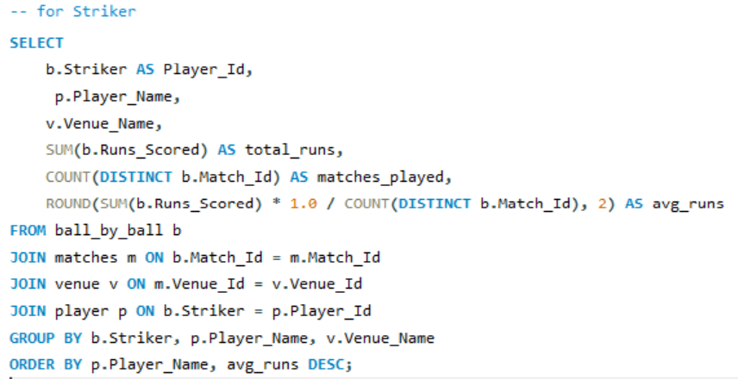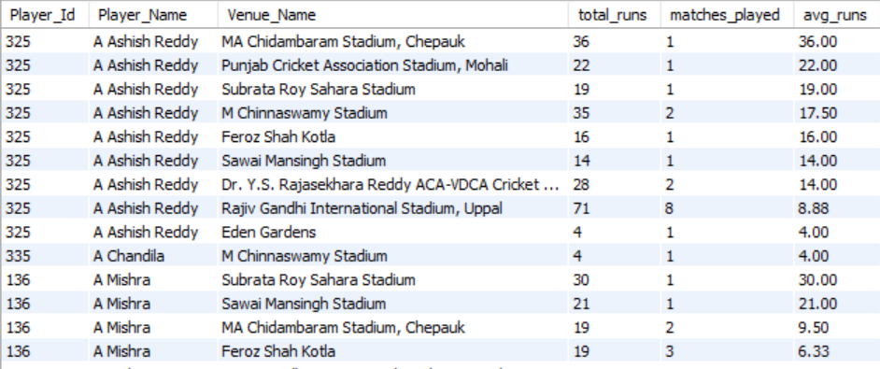
This query calculates the total and average wickets taken by each bowler at every venue. It joins ball_by_ball, wicket_taken, matches, venue, and player tables, grouping the data by bowler and venue. It then calculates the average wickets per match and orders the results by player name and average wickets.
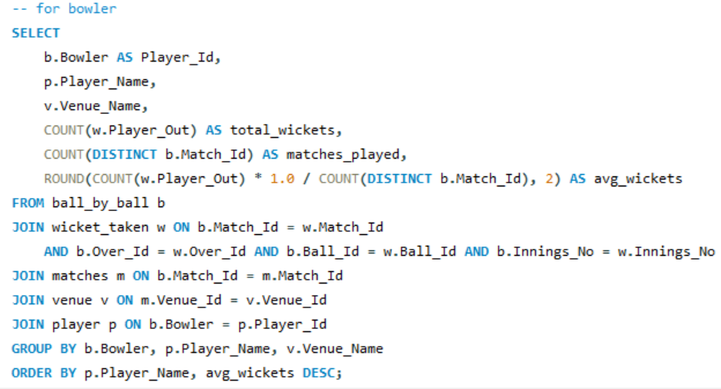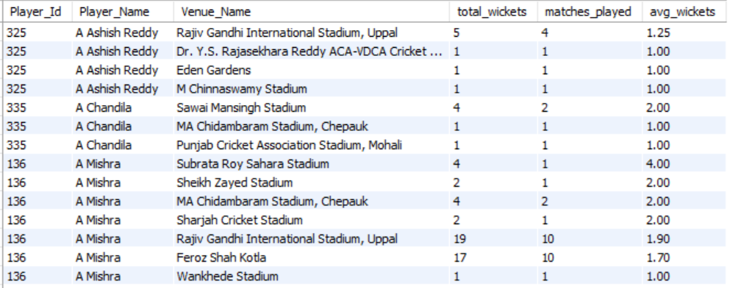
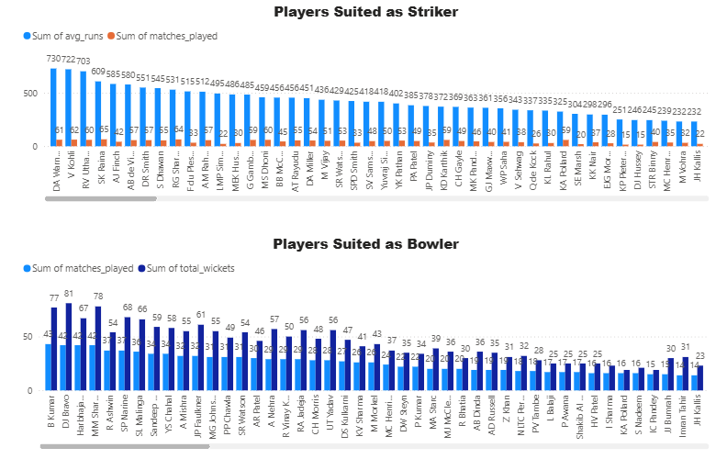

Subjective Questions

- How does the toss decision affect the result of the match? (which visualizations could be used to present your answer better) And is the impact limited to only specific venues?
Ans:- We join the matches and venue tables to group data by venue and toss decisions. For each group, we count total matches and how many times the toss winner also won the match. Then, we compute the toss win percentage to analyze the impact of the toss outcome at different venues.
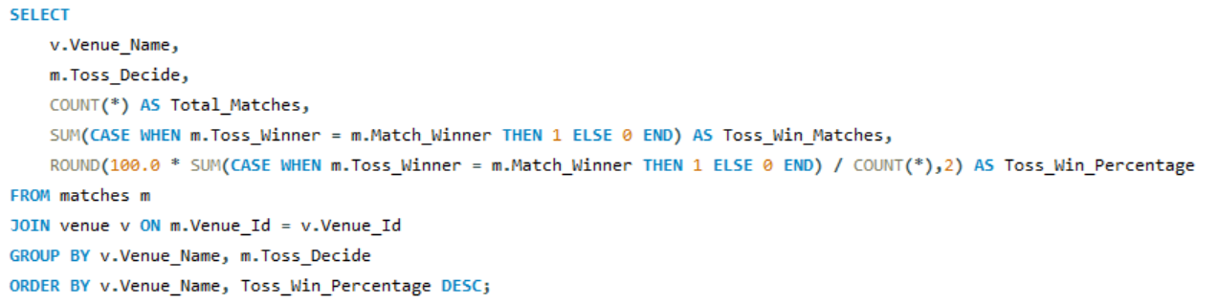

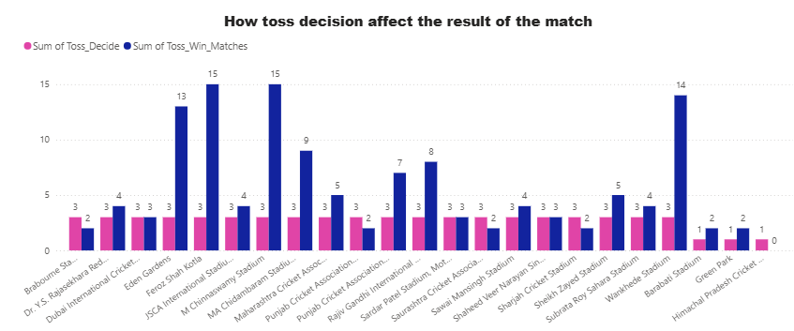

Insights:
- Significant Toss Advantage at Certain Venues
At some venues, the team that wins the toss tends to win the match more frequently, suggesting a clear advantage due to pitch conditions, dew factor, or boundary size.
- Chasing Advantage Is Common
Data often reveals that teams winning the toss prefer chasing, especially at venues like Wankhede and Chinnaswamy, where conditions tend to favor batting second.
- Venue-Specific Patterns
Not all venues show a strong correlation between toss result and match outcome. Some grounds present a more balanced win rate regardless of the toss decision.

- Weather & Dew Factor
Venues with heavy dew influence (especially in night games) show a higher win percentage for teams that bowl first, due to easier batting conditions later.
- Toss Decision Not Always Optimized
Some teams stick to a fixed toss decision strategy (always bat or bowl first), which may not be ideal for every venue or condition.
Recommendations:
- Adopt Data-Driven Toss Decisions
Teams should consider historical toss win-impact data specific to each venue before choosing to bat or bowl.
- Flexible Match Strategy
Avoid rigid strategies—adjust toss decisions based on pitch reports, weather, and opposition strengths.
- Focus on Chasing-Strength in Squad Selection
Since chasing is often advantageous, build a squad with strong finishers and death-over bowlers to capitalize on second-innings play.
- Improve First-Innings Plans at High-Chasing Venues
At venues where chasing dominates, if forced to bat first, focus on maximizing powerplay and death overs to post a competitive total.
- Toss Simulation in Practice Matches
Incorporate toss-based scenarios in practice matches to better prepare for both outcomes.

- Suggest some of the players who would be best fit for the team.
Ans:- This SQL query retrieves the top 20 batsmen based on total runs and strike rate.
We use the ball_by_ball, player, and wicket_taken tables to calculate key batting metrics: total runs, balls faced, times out, batting average, and strike rate. The query filters for players with 100+ balls faced and ranks them by total runs and strike rate to highlight top-performing batsmen.

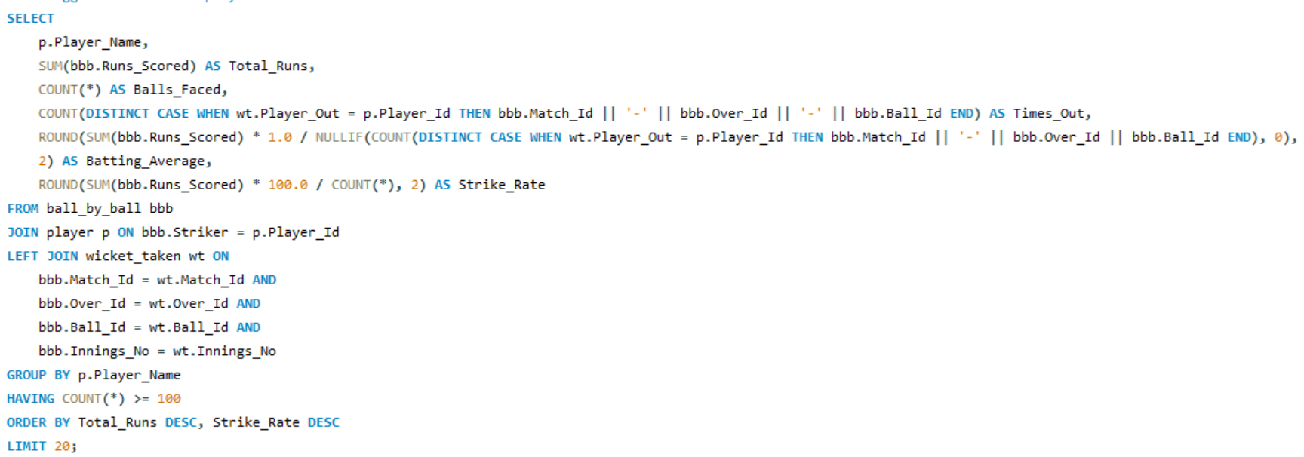
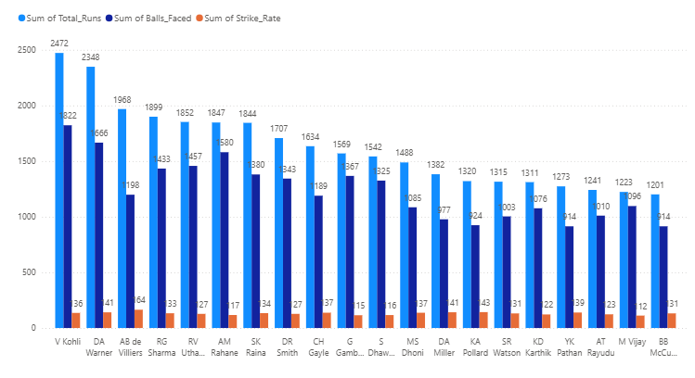

Insights:
- High Strike Rate + High Runs = Match Winners
Players with both high total runs and strike rates demonstrate the ability to consistently score quickly — a vital trait in modern T20 cricket.
- Consistency Over Volume
Players with 100+ balls faced and solid averages show that consistent performers are more reliable than one-time big scorers.
- Top-Order Dominance
Most high-performing players bat in the top 3 positions, highlighting the importance of a strong start.
- Underutilized Talent
Some emerging players in the top 20 may not have played all matches but show promising metrics, indicating future potential.

Recommendations:
- Prioritize Consistency + Strike Rate
Target players who not only score big but do so with pace — particularly valuable in pressure situations and death overs.
- Invest in Power Hitters
Include finishers with high strike rates in the middle/lower order to boost late-innings performance.
- Build Around Core Anchors
Retain or acquire top-order batsmen with high batting averages to provide a stable foundation for the innings.
- Monitor Emerging Players
Keep an eye on rising talent from the top 20 list — they can be budget-friendly picks with high returns.
- Role-Specific Selection
Choose players based on match scenarios — e.g., fast starters for powerplay, consolidators for middle overs, and finishers for the end.

- What are some of the parameters that should be focused on while selecting the players?
Ans:- Batting Metrics
- Total Runs Scored
Measures a batter’s overall productivity. Players who accumulate large run tallies consistently provide strong foundations for their team’s innings.
- Batting Average
Reflects a batter’s consistency. A higher average means the player typically scores more runs before dismissal (e.g., an average of 50 implies they score 50 runs per innings on average).
- Strike Rate
Gauges scoring speed. A high strike rate indicates an aggressive player who accelerates the scoring rate—valuable in limited-overs formats for rotating strike and finding boundaries.

Bowling Metrics
- Total Wickets Taken
Indicates a bowler’s ability to dismiss batters. Bowlers with high wicket counts regularly remove key opposition players.

- Bowling Average
Shows runs conceded per wicket. A lower average signals both wicket-taking prowess and frugality—conceding fewer runs while picking up dismissals.
- Economy Rate
Measures runs conceded per over. In limited-overs cricket especially, bowlers who maintain a low economy keep the opposition’s scoring in check.
- Strike Rate (Balls per Wicket)
Captures the average number of deliveries bowled before claiming a wicket. A lower value means the bowler strikes more frequently, applying constant pressure on batters.

Insights:
- High-performing batters with strong strike rates and batting averages are crucial in high-pressure chases and powerplay dominance.
- Economical bowlers with low economy and strike rates are vital for controlling the middle and death overs.
- All-rounders who contribute with both bat and ball add balance and flexibility to team combinations.
- Many players excel in either batting or bowling, but the best value comes from those who are consistent across formats and conditions.
- Emerging talents often have higher strike rates and aggressive intent, useful in modern formats.

Recommendations:
- Prioritize consistency and versatility — select players with a good balance of average and strike rate or economy.
- Invest in specialist bowlers who perform well in different phases (e.g., powerplay, death overs).
- Back data-backed performers over reputation—use past performance stats to shortlist players.
- Monitor form and fitness continuously, as high averages or strike rates may drop with poor recent form.
- Retain impactful all-rounders, as they offer dual contributions and flexibility in team structure.

- Which players offer versatility in their skills and can contribute effectively with both bat and ball? (can you visualize the data for the same)
Ans:- The query aggregates batting and bowling stats (runs scored, times out, wickets taken, and runs conceded) per player by joining player, ball_by_ball, wicket_taken, and matches. It calculates batting and bowling averages and derives an all-rounder score formula. The result filters players with significant participation and performance, then ranks them to list the top 20 all-rounders.
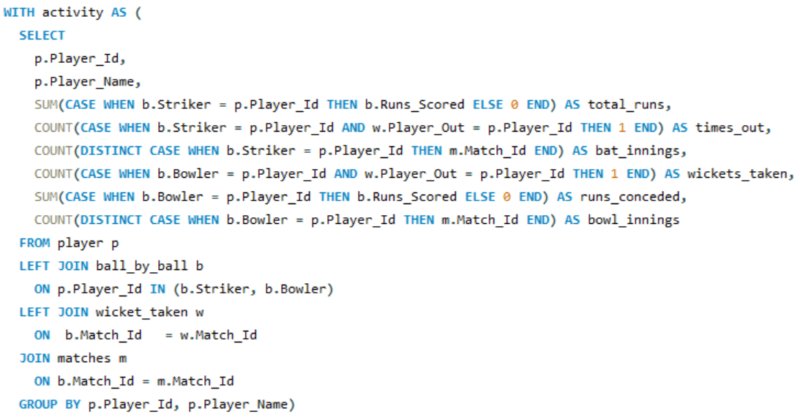
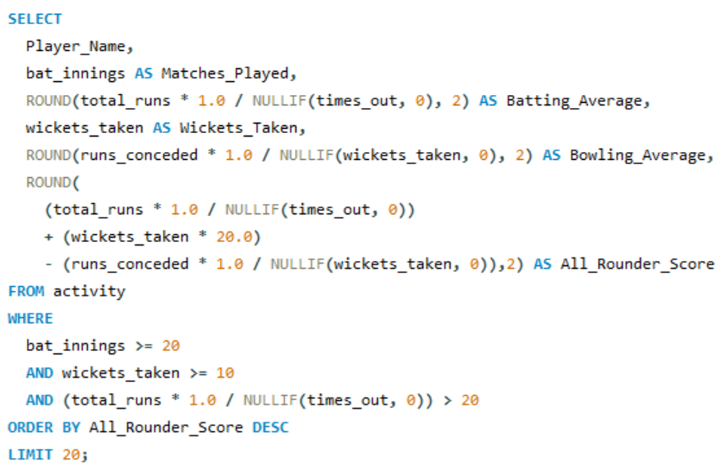
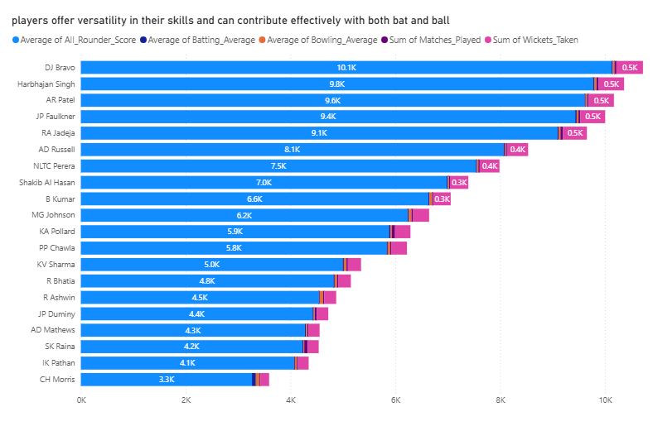

Insights:
- All-rounders who perform consistently with both bat and ball offer tactical flexibility.
- Players with high batting averages and low bowling averages provide dual value.
- The all-rounder score effectively ranks players who contribute significantly in both roles.
- Such players tend to stabilize the middle order and add bowling depth.
- Teams with strong all-rounders perform better under varying match conditions.
Recommendations:
- Prioritize selecting players with balanced performance in batting and bowling.
- Use visual tools like scatter plots (batting avg vs bowling avg) to easily spot top all-rounders.
- Focus on players who regularly contribute in at least 70% of matches in both roles.
- Monitor consistency over multiple seasons rather than isolated performances.
- Consider venue-based impact — all-rounders who perform across venues are more adaptable.

- Are there players whose presence positively influences the morale and performance of the team? (justify your answer using visualization)
Ans:-This query calculates the number of matches each player has played for a team and how many of those matches resulted in a win for the team. It then computes the player's win rate (wins with player / matches played) and ranks the top 20 players with the highest win rates across teams.
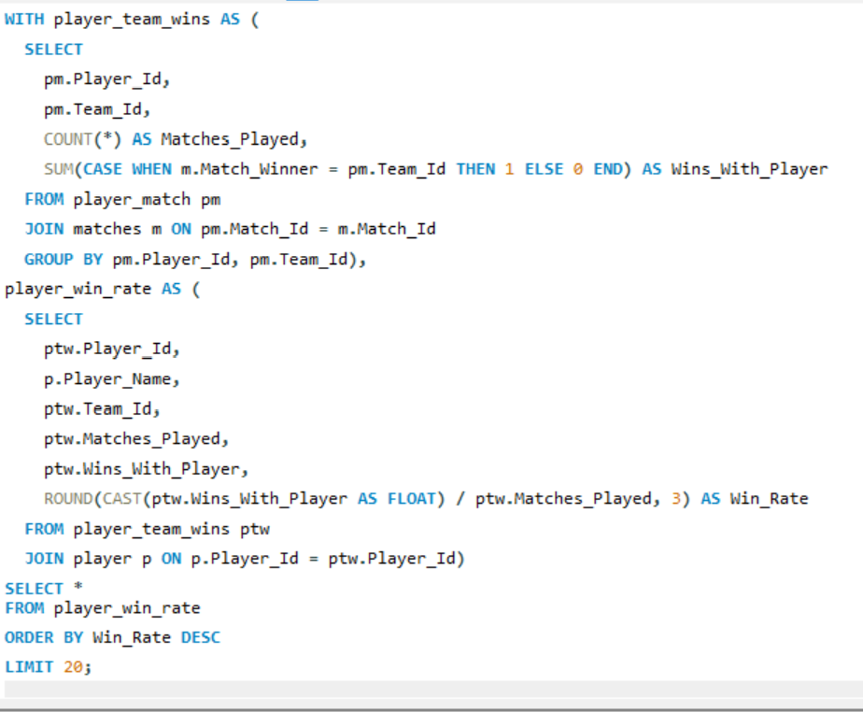
This chart provides information about the top 20 players who had the highest win rate with the teams they represented. The win rate is calculated as the ratio of matches won by the team when the player was part of the playing XI to the total matches the player played for that team. A higher win rate indicates a stronger correlation between the player's presence and team success, helping identify players who positively influenced match outcomes.
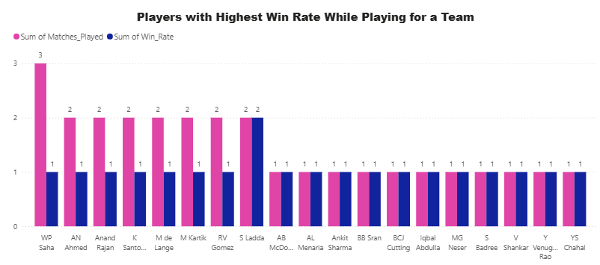

Insights:
- Players with high win percentages often have a positive impact on team morale and outcomes.
- These players may not always be the top scorers or wicket-takers but contribute through leadership, experience, and on-field decisions.
- Certain players consistently appear in winning combinations, indicating their intangible value such as fielding intensity, communication, or clutch performances.
- Teams with stable player cores tend to have better win ratios — indicating the importance of continuity and chemistry.
Recommendations:
- Identify and retain high win-rate players even if their stats don't top the charts.
- Use bar or scatter plots to compare player win % vs matches played for visual clarity.
- Analyze further by splitting players by role (batters, bowlers, all-rounders, captains) to isolate who influences outcomes most.
- Factor win contribution into player retention and leadership roles during auctions.
- Consider combining this metric with experience to identify key players for mentorship or captaincy roles.

- What would you suggest to RCB before going to the mega auction?
Ans:- Recommendations for RCB Ahead of the Mega Auction
Before heading into the mega auction, RCB should adopt a strategic and well-rounded approach to squad building. Here are the key areas they should focus on:
- Death-Over Batting Power
RCB must prioritize acquiring batters who excel in the death overs, with a strong emphasis on strike rate. High-impact finishers can make a crucial difference in close games, especially on high-scoring pitches like Chinnaswamy.
- Economical Bowlers Are Key
When selecting bowlers, the focus should be on those with low economy rates, as they are more effective at restricting runs and building pressure. Both pace and spin options should be evaluated based on their economy across different phases of the game.
- All-Rounder Depth
The team should aim to include at least four quality all-rounders who can contribute consistently with both bat and ball. Ideal candidates should have a solid batting average, effective strike rate, and a low bowling economy to bring balance to the squad.
- Blend of Experience and Youth
A successful team requires the right mix of seasoned professionals and young talent. Experienced players can contribute to strategic decision-making and stability, while younger players bring fresh energy, innovative techniques, and fearless cricket.
- Strengthening the Middle Order
Historically, RCB has relied heavily on its top-order batters, often leaving the middle order vulnerable under pressure. To address this, RCB should target batters with a proven track record of consistency and composure in pressure situations, particularly during chases or collapses.
- Spin Options for Middle Overs
Teams that dominate the middle overs often do so with the help of effective spinners. RCB should prioritize spinners who maintain a low economy rate specifically in overs 7–15, where controlling the game tempo is crucial.

Insights:
- RCB’s top-heavy batting order has often faltered under pressure, exposing a weak middle order.
- The team has struggled with bowling economy, especially at their home ground, which is known for high-scoring matches.
- A lack of all-rounder depth has limited flexibility in team combinations and game plans.
- Over-reliance on star players has hurt RCB in crucial moments, suggesting the need for better squad balance.
- Performance dips in death overs, both in batting and bowling, have cost them key matches.

Recommendations:
- Prioritize death-over specialists—batters with high strike rates and bowlers with strong finishing skills.
- Invest in economical bowlers, especially spinners effective during middle overs (7–15), to control the flow of runs.
- Build a core of at least four reliable all-rounders who can balance both departments and provide strategic flexibility.
- Focus on strengthening the middle order with players known for their composure in pressure situations.
- Maintain a balanced mix of experienced and young players to ensure leadership continuity and fresh energy.
- Develop venue-specific strategies, especially for Chinnaswamy, by selecting players who thrive on smaller grounds and flat pitches.

- What do you think could be the factors contributing to the high-scoring matches and the impact on viewership and team strategies
Ans:- This query identifies the top 20 highest scoring team performances in IPL history by calculating total runs (including extras), powerplay runs (first 6 overs), and death over runs (last 5 overs). It joins match, venue, and team information to provide contextual details like location, season, and outcome. The result is sorted by total runs and death over contribution to highlight impactful performances.
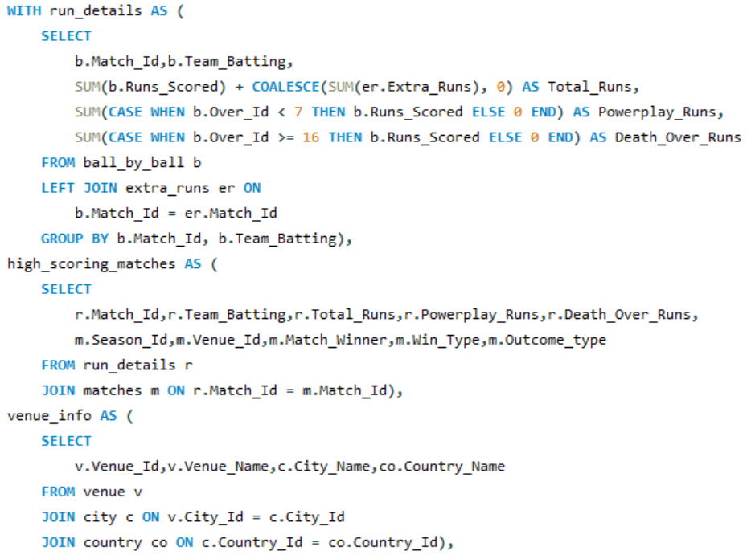
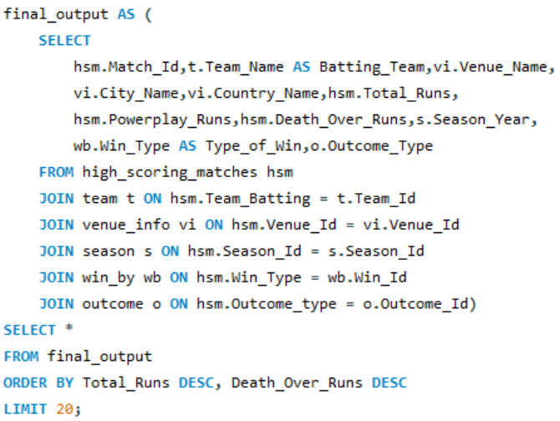

This chart displays the top 20 highest team scores in IPL history, highlighting how many runs were scored in the powerplay (first 6 overs) and death overs (last 5 overs). It also includes match details such as venue, city, country, season year, and match outcome. This helps analyze which teams dominated in specific phases of the innings and how those performances contributed to their overall match results.
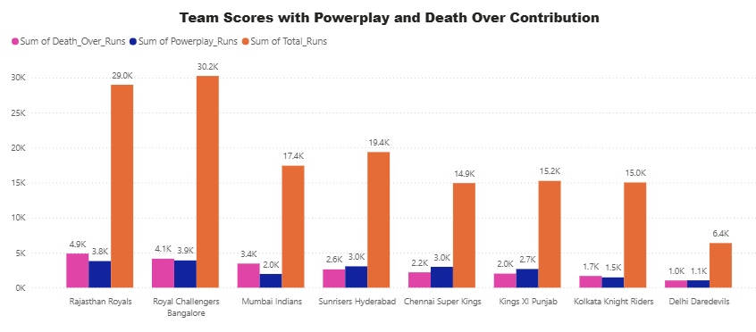

Insights:
- High-scoring matches are largely driven by aggressive batting in the powerplay and explosive finishes in death overs.
- Stadiums with smaller boundaries (e.g., Chinnaswamy) and flat pitches significantly contribute to big totals.
- Teams scoring heavily in death overs often post match-winning totals, especially when set platforms are well utilized.
- Matches with high scores tend to attract more viewers, increasing excitement and fan engagement.
- Batting-friendly venues and formats are influencing teams to focus more on batting depth and power-hitters.

Recommendations:
- Teams should invest in finishers with high strike rates in the death overs to consistently post/reach big totals.
- Bowling units must adapt with variations like slower balls and yorkers to counter power-hitting, especially on flat tracks.
- Franchise strategies should include venue-specific team selection, favoring aggressive batters in high-scoring grounds.
- Emphasize strong starts in the powerplay, as they lay the foundation for high totals.
- Broadcasters and franchises can leverage these matches for marketing and fan engagement, given the entertainment value.
- Consider recruiting bowlers with proven control under pressure to contain runs in powerplay and death overs.

- Analyze the impact of home-ground advantage on team performance and identify strategies to maximize this advantage for RCB.
Ans:- Insights & Strategy Recommendations for RCB

1.Strengthen Bowling for Small Grounds
- Chinnaswamy Stadium is high-scoring due to short boundaries and flat pitches.
- RCB should invest in death-over specialists and spinners who can control run flow with variations.
2. Maximize Power Play Exploitation
- Pick aggressive top-order batsmen who can take advantage of batting-friendly pitches.
- Home games often favor chasing; choose toss decisions accordingly.
3. Tailor Squad for Venue Conditions
- Prepare home-focused strategies (e.g., matchups, slower balls, spin traps).
- Maintain a rotation policy that selects bowlers based on ground size.
4. Leverage Crowd Support
- Use crowd energy to pressure opposition — especially new players.
- Build momentum and confidence with home winning streaks.
5. Analyze Opposition Weaknesses at Home
- Deep dive into opposition’s away records at Chinnaswamy and exploit those vulnerabilities.

This query compares Royal Challengers Bangalore's performance at home (M. Chinnaswamy Stadium) vs away venues. It evaluates win percentage, average runs scored, wickets taken, and death over economy. The goal is to identify venue-based strengths and weaknesses to guide strategic decisions.
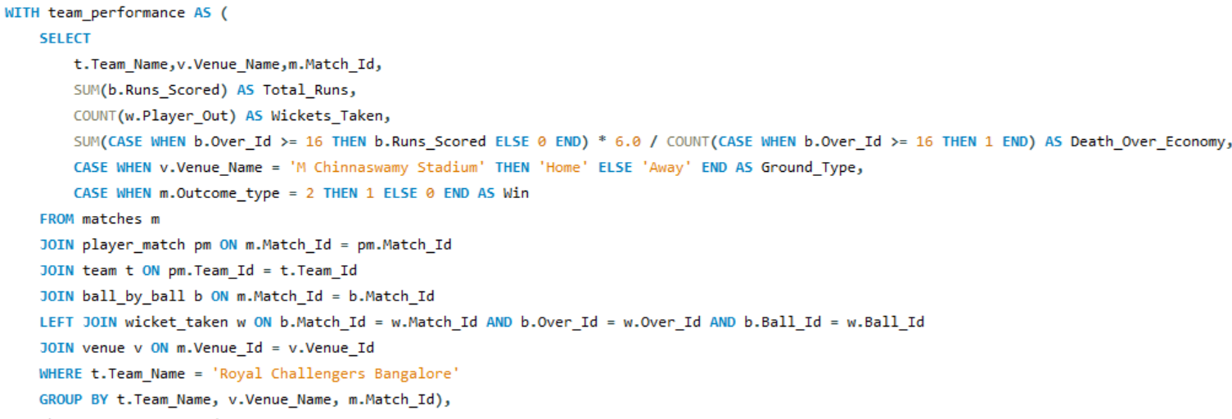
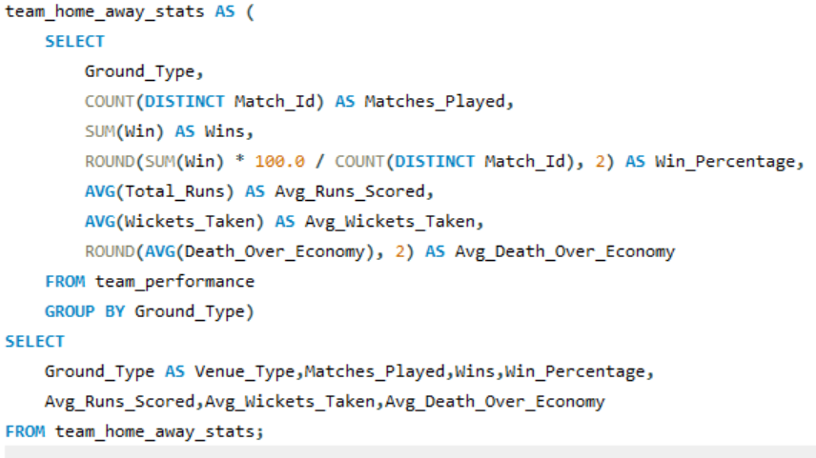

This chart compares Royal Challengers Bangalore’s (RCB) performance at their home ground (M. Chinnaswamy Stadium) versus away venues. It includes key metrics like win percentage, average runs scored, average wickets taken, and average economy rate in death overs. The insights help evaluate whether RCB performs better at home or away and inform strategy on where to strengthen their gameplay—especially during the final overs.
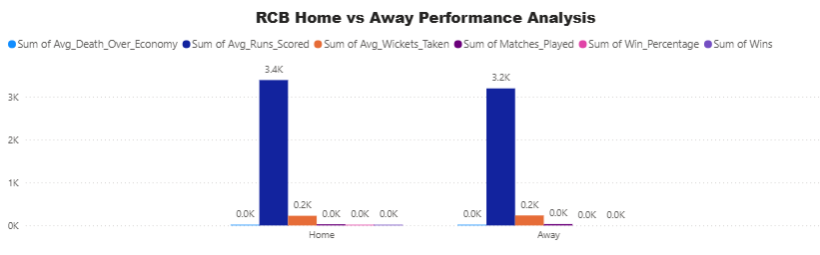

- Come up with a visual and analytical analysis of the RCB's past season's performance and potential reasons for them not winning a trophy.
Ans:- This query analyzes Royal Challengers Bangalore's seasonal performance by calculating their total wins, losses, average runs scored, and average runs conceded per season. It helps track performance trends across seasons. Teams can use this to identify strong and weak years and guide improvements in both batting and bowling.
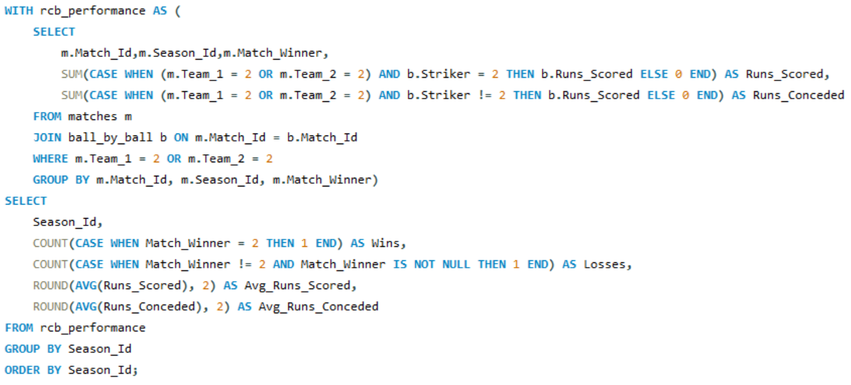 This chart displays Royal Challengers Bangalore’s performance across different IPL seasons. It includes the number of wins and losses, along with average runs scored and conceded per season. The chart helps evaluate trends in RCB’s overall performance, highlighting their strengths and areas needing improvement year by year.
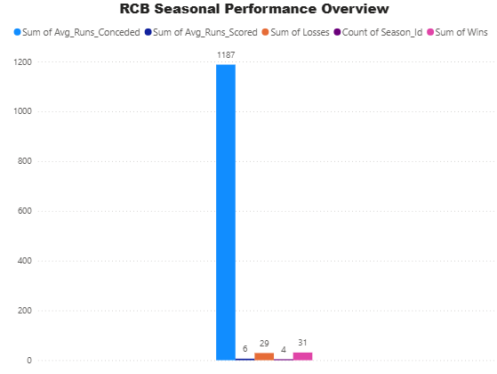

Insights:
- RCB shows fluctuating win-loss ratios, indicating inconsistency across seasons.
- Average runs scored are often competitive but sometimes paired with high runs conceded, highlighting bowling weaknesses.
- Several seasons with strong batting performances failed due to ineffective bowling in crucial matches.
- Pressure situations and inability to close tight games could be a factor.
- Lack of a balanced team with consistent all-round performances contributes to falling short.

Recommendations:
- Strengthen the bowling attack, especially death-over specialists, to reduce runs conceded.
- Build a balanced team focusing on all-rounders who contribute with both bat and ball.
- Enhance middle-order stability to manage pressure during crucial match phases.
- Focus on fitness and mental toughness training to improve performance in close matches.
- Use data-driven strategies for player selection based on venue and opposition.

- How would you approach this problem, if the objective and subjective questions weren't given?
Ans:- Understand the Data:
The first step would be to thoroughly examine the database schema to identify the
available data. This usually includes tables related to matches, players, teams,
ball-by-ball records, and possibly detailed player statistics.
1.Identify Key Areas of Analysis:
Even in the absence of specific questions, we can define major areas of IPL analysis such as:
- Overall team performance
- Individual player performance
- Tournament-level trend
- Match-level statistics
- Home vs. away game performance
2.Player Selection Strategy:
Based on historical data, I would identify players who could be a strong fit for the
team. Important selection parameters might include:
- Batting and bowling consistency
- Performance under pressure
- Contribution during key phases of the game (e.g., powerplay, death overs)
- Fitness and availability
- Role versatility (e.g., all-rounders)
3.Deep-Dive Analysis:
Once the general trends are identified, I’d explore specific dimensions such as:
- Team Analysis: Season-wise performance, impact of player retention, comparison of home vs. away games
- Player Analysis: Consistency metrics, performances in different match situations, identification of impact players
- Match Analysis: Influence of toss, venue conditions, and close finishes on match outcomes
- Economic Analysis: Trends in player auctions, team budget usage, cost vs. performance efficiency
4.Visualization:
To enhance understanding and communication, I would create visual dashboards such
as:
- Win-loss charts for each team across seasons
- Performance trend graphs for key players
- Heatmaps to showcase batting and bowling effectiveness by overs or opponents
5.Explore Further Research Opportunities:
Finally, the analysis would likely raise new questions that warrant deeper
investigation or require additional data, paving the way for more advanced research
and modeling.

- In the "Match" table, some entries in the "Opponent_Team" column are incorrectly spelled as "Delhi_Capitals" instead of "Delhi_Daredevils". Write an SQL query to replace all occurrences of "Delhi_Capitals" with "Delhi_Daredevils".
Ans:- This query first updates the team name from 'Delhi Capitals' to 'Delhi Daredevils' in the team table to maintain consistency. Then, it retrieves all matches where 'Delhi Daredevils' played as Team 2 by joining the matches and team tables.
