# **Tasks**

**Learners have to develop a dashboard to support the answers to the following questions and suggestions for places for newer restaurants.**

**Objective Questions**:

1. **What is the total no. of tables present in the data?**

The Zomato restaurant dataset consists of two tables:

* 1. **'Raw Data'** – This sheet includes restaurant-related information such as pricing, cuisine, and ratings.
  2. **'Country Description'** – This sheet maps country codes to their corresponding country names.

1. **What is the total no. of attributes present in the data?**

The Zomato restaurant dataset consists of two tables. The first table contains 20 attributes/fields, offering essential information about the Zomato restaurants. The second table includes 2 attributes/fields: the country name and its corresponding country code.

1. **How many categorical columns are there in the data? [Search about categorical and continuous data, and try to answer this question]**

There are total **16 Categorical Columns** are as follows ,

RestaurantID, RestaurantName, CountryCode, CountryName, City, Address, Locality, LocalityVerbose, Cuisines, Currency, Has_Table_booking, Has_Online_delivery, Is_delivering_now, Switch_to_order_menu, Price_range, Year

There are total **05 Continuous Columns** are as follows,

Longitude,Latitude Votes, Average_Cost_for_two_INR, Rating

1. **The data consists of some inconsistent and missing values so ensure that the data used for further analysis is cleaned.**

Data is missing in cuisines where those missing values are replaced by the mode

of the Cuisines.

1. Then after selecting the all data removed all duplicates values and trim the

whitespaces.

Select data -> Data -> Data Cleanup -> Remove duplicates/ Trim whitespaces

1. Remove unnecessary columns : Address, LocalityVerbose, Longitude, and Latitude
2. **Using the LookUp functions, fill up the countries in the original data using the country code.**

**Ans:-**Using XLOOKUP() I filled the CountryName in the original data.

=XLOOKUP(C2,'country description'!$A$2:$A$16,'country description'!$B$2:$B$16,0)

1. **Create a table to represent the number of restaurants opened in each country.**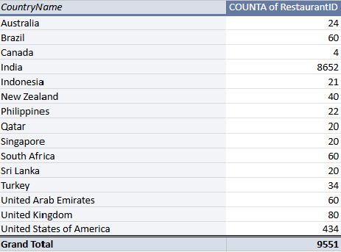

1. **Also, the management wants to look at the number of restaurants opened each year, so provide them with something here.**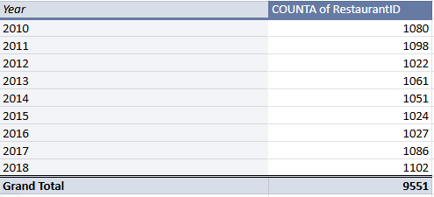
2. **What is the total number of restaurants in India in the price range of 4?**

In India there are total 388 restaurants having price range 4.,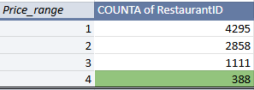

1. **What is the average number of voters for the restaurants in each country according to the data?**

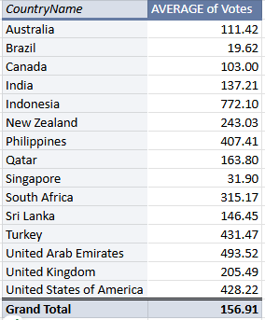

1. **Calculate the average rating for all the restaurants that have price_range < 4 and provide online delivery. Use only the “IF” function, Logical Operators, and Aggregation functions to solve this problem. [Note: Don’t use Conditional aggregation in this question.]**

**Ans:-**  The average rating for all the restaurants that have price_range < 4 and provide online delivery is **3.27** by applying formula given below,

=ARRAYFORMULA(AVERAGE(IF(('Raw Data'!$Q:$Q<4)*('Raw Data'!$N:$N="Yes"), 'Raw Data'!$U:$U)))

1. **Using Conditional formatting highlights the rows of restaurants that are located in the countries or cities that you’ve suggested to the management for opening new restaurants.**

**Ans:-** Conditional formatting is applied on raw data sheet

1. **Create a new customized price column that consists of the abbreviation/symbol of the currency along with the Average_cost_for_two value. [Use string operations to do this task]**

**Ans:**-

=CONCATENATE(MID(L2, FIND("(", L2) + 1, FIND(")", L2) - FIND("(", L2) - 1),T2)

=IF(L2="Indian Rupees(Rs.)",S2,(VLOOKUP(L2,'country description'!$D$1:$E$13,2,0)*S2))

1. **How can you create an array formula in Excel or Google Sheets to count the number of restaurants listed that do not offer online delivery, are in the lowest price range, and have an average cost for two people less than or equal to 250 Indian Rupees?**

**Ans:-** A total of 1,694 restaurants do not offer online delivery, are in the lowest price range, and have an average cost for two people of 250 Indian Rupees or less.

=ARRAYFORMULA(SUM(('Raw Data'!$N:$N="No") * ('Raw Data'!$Q:$Q=1) * ('Raw Data'!$T:$T<=250)))

**Subjective Question:**

1. **Suggest a few countries where the team can open newer restaurants with lesser competition. Which visualization/technique will you use here to justify the suggestions?**

| *CountryName* | COUNTA of Cuisines | MIN of Price_range | AVERAGE of Rating |
| --- | --- | --- | --- |
| Canada | 4 | 2 | 3.575 |
| Qatar | 20 | 2 | 4.06 |
| Singapore | 20 | 2 | 3.575 |
| Sri Lanka | 20 | 2 | 3.87 |
| **Grand Total** | **64** | **2** | **3.81875** |

### **Chart**

### **1. Canada**

**Insights**:

* **Restaurant Count**: Canada has **4 restaurants**, which is the lowest number among the listed countries.
* **Competitive Advantage**: With a lower number of restaurants compared to other regions, there is less competition, providing an opportunity to enter a less saturated market.
* **Growth Opportunity**: This could be a favorable market for new restaurants to explore diverse cuisines that are not widely available in other regions.

**Recommendation**:

* Focus on opening restaurants that offer unique, high-demand cuisines that are underrepresented in the area. Given the low competition, it would be beneficial to carve out a niche market.
* Consider pricing strategies that appeal to the local market's average spending capacity, and explore both dine-in and delivery options.

### **2. Qatar**

**Insights**:

* **Restaurant Count**: Qatar has **20 restaurants**, which is a moderate number of competitors in comparison to larger markets like India or the United States.
* **Ratings Opportunity**: With fewer competitors than larger countries, there may be an opportunity to provide higher-quality services and capture customer loyalty quickly.
* **Market Potential**: Qatar has a higher spending potential due to its economic landscape, making it a favorable location for mid-to-high-end restaurant offerings.

**Recommendation**:

* Focus on cuisines with an existing demand, such as Asian, Middle Eastern, or International cuisines, while ensuring quality and unique offerings.
* Given that competition is moderate, try to stand out with superior customer service, innovative marketing strategies, and a premium dining experience.

**3. Singapore**

**Insights:**

* **Restaurant Count**: Singapore has **20 restaurants**, which is also a relatively low number in comparison to other countries like the United States or the United Kingdom.
* **Cultural Diversity**: Singapore has a diverse population, leading to high demand for a variety of cuisines. This cultural richness provides a broad market for various restaurant concepts.
* **Tourism and Expats**: Singapore’s tourism industry and large expat population contribute to a stable market for restaurants, particularly for international cuisines.

**Recommendation:**

* Tap into the diverse market by offering a mix of international cuisines, with an emphasis on fusion concepts or local flavors.
* Focus on high-quality food, sustainability, and innovative dining experiences to attract the growing number of tourists and expats who are seeking new dining options.

**4. Sri Lanka**

**Insights:**

* **Restaurant Count**: Sri Lanka has **20 restaurants**, which is on the lower end compared to larger countries, indicating lower competition in the restaurant sector.
* **Emerging Market**: The restaurant industry in Sri Lanka is still in an emerging phase, and there is room for growth in key urban centers like Colombo.
* **Tourism Market**: Sri Lanka's tourism industry could provide an additional customer base for new restaurants, especially those that cater to international tourists looking for both local and global cuisine.

**Recommendation:**

* Explore both local Sri Lankan cuisine and popular international cuisines that may be underrepresented.
* Consider catering to the growing number of international tourists by offering a mix of traditional Sri Lankan dishes alongside international favorites.

1. **Come up with the names of States and cities in the suggested countries suitable for opening restaurants.**

These are the few names of cities in the suggested countries suitable for opening restaurants,

| *CountryName* | *City* | COUNTA of RestaurantID | AVERAGE of Rating | SUM of Price_range | AVERAGE of Average_Cost_for_two |
| --- | --- | --- | --- | --- | --- |
| Canada | Chatham-Kent | 1 | 3.7 | 2 | 25 |
|  | Consort | 1 | 3 | 2 | 25 |
|  | Vineland Station | 1 | 4.3 | 4 | 70 |
|  | Yorkton | 1 | 3.3 | 2 | 25 |
| Qatar | Doha | 20 | 4.06 | 73 | 223.75 |
| Singapore | Singapore | 20 | 3.575 | 73 | 155.75 |
| Sri Lanka | Colombo | 20 | 3.87 | 57 | 2375 |

1. **Customer Satisfaction (Ratings):**

* All four cities (**Chatham-Kent**, **Doha**, **Singapore**, **Colombo**) have **moderate to high average ratings** ranging from **3 to 4.3**. This indicates that customers generally express a satisfactory experience with the restaurants in these cities, but there's still room for improvement in terms of the quality of service and food across the board.

1. **Affordability & Price Range:**

* The **price range** varies significantly across the cities, with **Qatar** and **Sri Lanka** having higher price points compared to the more affordable options in **Canada** and **Singapore**. However, **Qatar** and **Sri Lanka** exhibit a broader market for premium, high-end dining experiences, whereas **Canada** and **Singapore** present opportunities for both **mid-range and affordable dining**.
* The **average cost for two** is significantly higher in **Sri Lanka** (**2375**) and **Qatar** (**223.75**), pointing towards a market for more luxurious dining options, while cities like **Canada** and **Singapore** have a more affordable dining scene with prices around **25 to 70** for an average cost for two.

1. **Potential for Restaurant Expansion:**

* The cities under consideration (**Canada: Chatham-Kent, Consort, Vineland Station, Yorkton**; **Qatar: Doha**; **Singapore: Singapore**; **Sri Lanka: Colombo**) have a mix of both **under-served markets** (where competition is less) and **established high-end markets** (with higher competition). Therefore, the market for restaurant expansion varies depending on the city and its specific consumer base.

1. **According to the countries you suggested, what is the current quality regarding ratings for restaurants that are open there?**

| *CountryName* | AVERAGE of Rating |
| --- | --- |
| Canada | 3.575 |
| Qatar | 4.06 |
| Singapore | 3.575 |
| Sri Lanka | 3.87 |

**Ans:-**

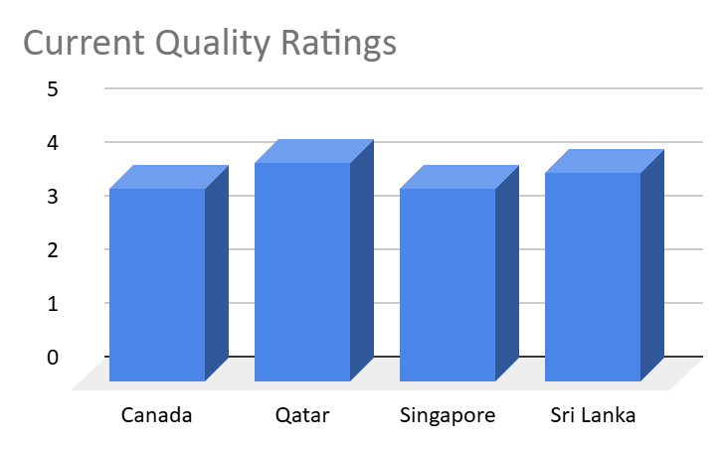

### **Insights:**

* **Moderate Ratings:  
  Canada**, **Singapore**, and **Sri Lanka** have average ratings in the **3.5 to 3.8** range, suggesting that while the restaurants meet customer expectations, there’s room for improvement, particularly in consistency and unique offerings.
* **High Ratings in Qatar:  
  Qatar** has a high average rating of **4.06**, indicating that restaurants in the region are performing well, likely due to superior customer service, food quality, and overall dining experiences.
* **Room for Improvement in Sri Lanka:**While Sri Lanka’s average rating is **good**, it still falls short compared to Qatar. The opportunity exists to enhance restaurant experiences further by improving food quality and service consistency.

### **Recommendations:**

* **Focus on Consistency:  
  Canada**, **Singapore**, and **Sri Lanka** should prioritize consistent food quality, service, and ambiance to elevate their ratings and compete with higher-rated regions.
* **Enhance Customer Experience:**All regions could benefit from offering more **personalized service** and **unique dining experiences**, differentiating them from competitors and improving overall satisfaction.
* **Leverage High Ratings in Qatar:  
  Qatar** should continue offering **premium dining experiences** and invest in customer engagement to maintain their **high ratings**.
* **Invest in Feedback Mechanisms:**Regularly gathering customer feedback can help identify areas for improvement and increase customer satisfaction, leading to better ratings across all regions.

1. **Also, what is the current expenditure on food in the suggested countries, so we can keep our financial expenditure in control?**

| *CountryName* | AVERAGE of Average_Cost_for_two_INR |
| --- | --- |
| Canada | 3166.4375 |
| Qatar | 5079.125 |
| Singapore | 13604.7625 |
| Sri Lanka | 641.25 |
| **Grand Total** | **6237.007813** |

**Ans:**

### **Insights:**

* **Canada(3166)** and **Singapore(13604)** have **moderate to high expenditure** on dining, indicating a focus on **quality dining experiences**, but may limit options for budget-conscious customers.
* **Qatar(5079)** has a **high average expenditure**, reflecting a **premium dining market**, while **Sri Lanka(641)** has the **lowest expenditure**, indicating a more budget-friendly market.
* There is a **diverse spending pattern** across countries, with **Qatar** and **Singapore** leading in higher spending, while **Sri Lanka** offers more **affordable dining**.

### **Recommendations:**

* **Canada & Singapore**:

1. Introduce **mid-range pricing** options to cater to a broader customer base.
2. Offer **promotions or combo meals** to balance affordability with quality.

* **Qatar**:

1. Maintain **premium options**, but introduce more **affordable alternatives** to cater to diverse customer segments.

* **Sri Lanka**:

1. **Introduce premium dining options** to cater to higher-income customers while maintaining affordable choices for the majority.
2. **Come up with the names of restaurants from the recommended states that are our biggest competitors and also those that are rated in the lower brackets, i.e. 1-2 or 2-3.**

| *CountryName* | *RestaurantName* | AVERAGE of Rating |
| --- | --- | --- |
| Canada | Consort Restaurant | 3 |
| Singapore | Makansutra Gluttons Bay | 3 |
| Sri Lanka | Elite Indian Restaurant | 2.4 |
|  | Queen's Cafe | 2.5 |
| **Grand Total** |  | **2.725** |

### **Insights:**

* **Canada**: The **Lake House Restaurant** (rating **4.3**) stands out as a key competitor, while **Consort Restaurant** (rating **3.0**) may be a vulnerable competitor due to its low rating. **Arigato Sushi** with a rating of **3.3** is also moderate and faces competition from higher-rated restaurants.  
  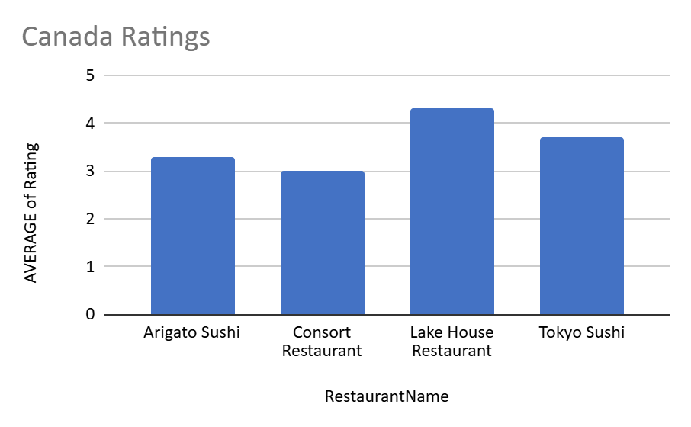
* **Qatar**: **Mainland China Restaurant** (rating **4.9**) and **Gymkhana** (rating **4.7**) are highly rated competitors. However, **7st by Mumbai Spices** (rating **3.4**) and **Indian Coffee House** (rating **3.4**) could be considered weaker competitors.

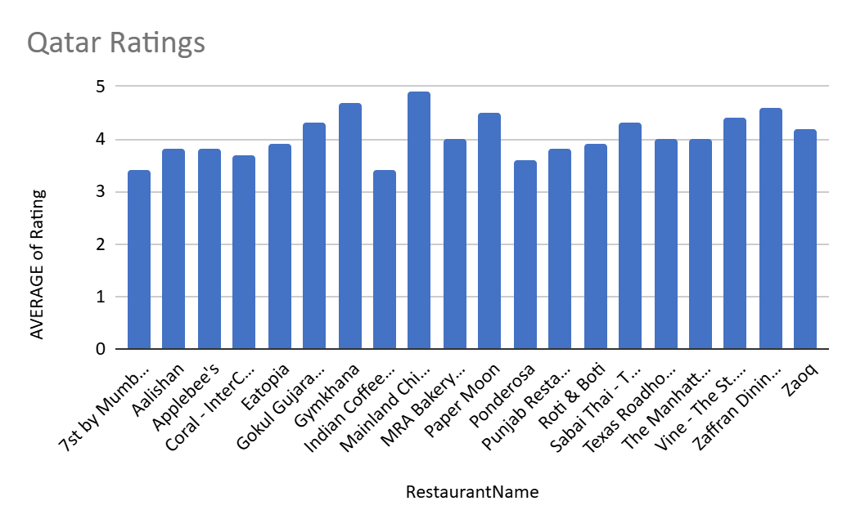

* **Singapore**: Restaurants like **Restaurant Andre** (rating **3.8**) and **Fratini La Trattoria** (rating **4.1**) are strong competitors. However, **Makansutra Gluttons Bay** (rating **3.0**) and **The Lokal** (rating **3.1**) are in the lower rating range and could be more vulnerable.  
  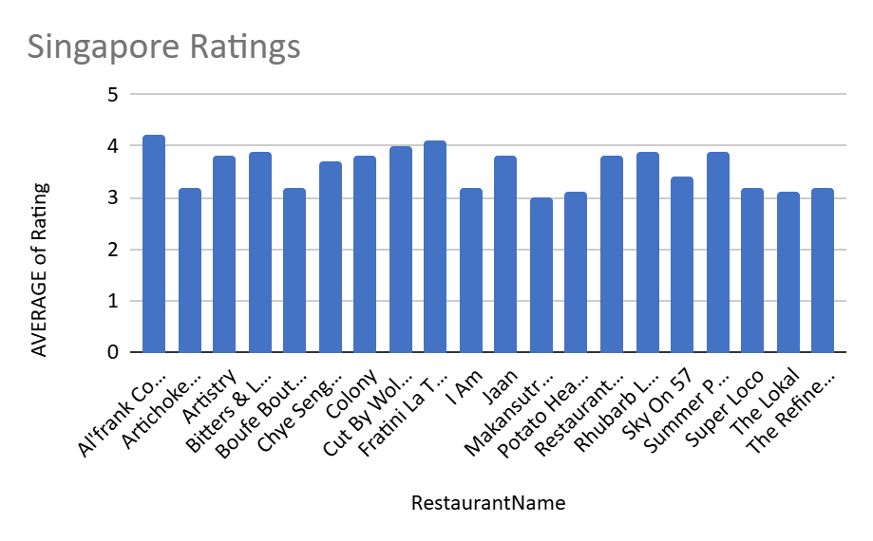
* **Sri Lanka**: **Ministry of Crab** (rating **4.9**) and **Simply Strawberries By Jagro** (rating **4.5**) are strong competitors. However, **Elite Indian Restaurant** (rating **2.4**) and **Queen's Cafe** (rating **2.5**) are rated poorly and might be struggling against higher-rated competitors.

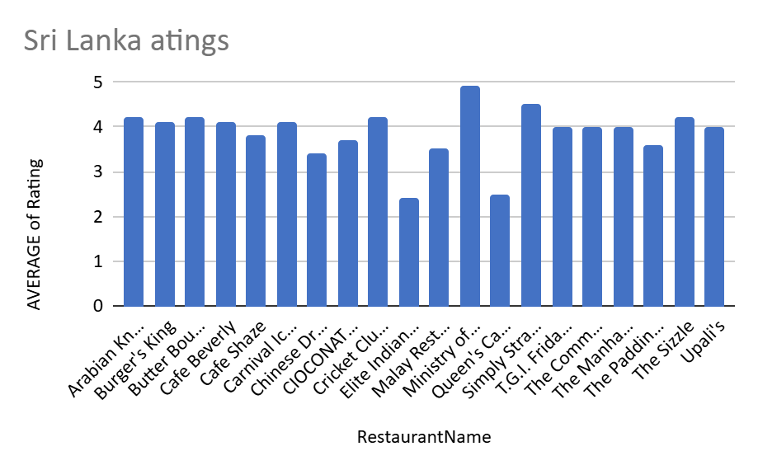

**Recommendations:**

1. **Target Lower-Rated Restaurants for Improvement**: The **Elite Indian Restaurant** (Sri Lanka), **Queen's Cafe** (Sri Lanka), **Makansutra Gluttons Bay** (Singapore), and **Consort Restaurant** (Canada) have low ratings. Opening a new restaurant with a focus on **quality food** and **service** could directly address the gaps in these regions.
2. **Focus on Offering Unique Cuisines**: For restaurants with lower ratings, introducing unique or underrepresented cuisines may help attract customers looking for something new. For example, consider offering **authentic local dishes** or **fusion food** to differentiate from existing competition.
3. **Which cuisines should we focus on in the newer restaurants to get better feedback? Does the choice of cuisines affect the restaurant ratings?**

**Ans:**

* Canada- Asian,Chinese, Canadian,Japanese, Sushi

(Price range between 1-2, having ratings > =3)

Italian, Mediterranean, Pizza

(price range 4, having ratings > =4)

* Qatar- Kerala, Indian, Chinese, Bakery

(Price range between 1-3, having ratings > =4)

Italian,Thai,Steak,Seafood, American,International,Pakistani

(price range 4, having ratings > =4)

* Singapore-Cafe,Singaporean, Chinese, Seafood, Malay, Indian

(Price range between 1-2, having ratings > =3)

American, Steak,Italian

(price range 4, having ratings > =4)

* Sri Lanka-North Indian, Chinese, Sri Lankan,Malaysian,

(Price range between 1-3, having ratings > =3)

Seafood, Italian,American, Steak,

(price range 4, having ratings > =4)

**Insights:**

* **In Canada**, the most popular cuisines that fall within the moderate price range (1-2) with decent ratings are **Asian**, **Chinese**, and **Sushi**. Higher-end options with better ratings focus on **Italian**, **Mediterranean**, and **Pizza**.
* **In Qatar**, there is a strong demand for both **local cuisines** (Kerala, Indian) and **international offerings** (Italian, Thai, Seafood). The price range for the most popular restaurants spans across moderate (1-3) to high-end (4).
* **Singapore** seems to favor **lower-priced, authentic cuisines** with cuisines like **Singaporean**, **Indian**, and **Chinese** receiving high ratings in the lower price range (1-2). However, high-end restaurants with **American**, **Steak**, and **Italian** are also highly rated.
* **Sri Lanka** offers a mix of **local cuisines** (Sri Lankan, North Indian) in moderate price ranges, while higher-end restaurants emphasize **Seafood**, **Italian**, **American**, and **Steak**.

**Recommendations:**

* **Focus on Regional Specialties**: Countries like **Qatar** and **Sri Lanka** appreciate a mix of local (Kerala, Sri Lankan, North Indian) and international cuisines (Italian, Seafood). Restaurants offering **authentic regional dishes** would likely do well, particularly with ratings of 4 or higher.
* **Offer Moderate Price Range Options**: For countries like **Canada**, **Singapore**, and **Sri Lanka**, offering moderate-priced dishes (ranging from 1-3) that have a focus on authenticity and quality is a good strategy to attract customers. Cuisines like **Chinese**, **Sushi**, and **Indian** tend to receive good feedback in this range.
* **Ensure High-Quality Offerings in Expensive Price Range**: **High-end restaurants** in **Canada**, **Qatar**, **Singapore**, and **Sri Lanka** that specialize in **Italian**, **Mediterranean**, and **Seafood** should focus on **quality** and **service** to maintain the high ratings (≥ 4).
* **Expand the Variety**: Offering a **diverse selection of cuisines** (ranging from Asian and Mediterranean to more localized options like **Kerala** and **Sri Lankan**) can help capture different customer preferences in **Qatar** and **Sri Lanka**, ensuring there is something for everyone while maintaining high ratings.

1. **According to our current data, should we go for online delivery and table booking? Does that affect the customer’s ratings?**

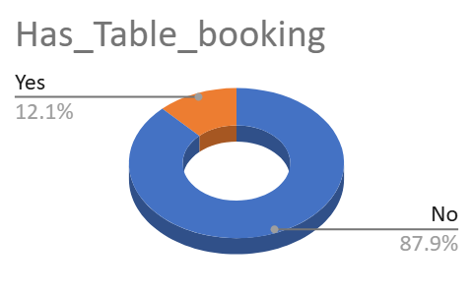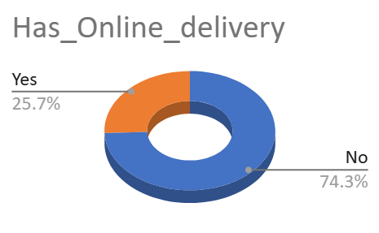

### **Table Booking Insights:**

* **Restaurants with Table Booking**: Out of 9551 restaurants, **1158** (12.14%) have table booking available, while **8393** (87.86%) do not.
* **Impact on Ratings**: The number of restaurants with table booking is relatively low, but it is important to note that the availability of table booking could imply a more premium, customer-centric service that might attract higher ratings.

| *Has_Table_booking* | COUNTA of RestaurantID |
| --- | --- |
| No | 8393 |
| Yes | 1158 |
| **Grand Total** | **9551** |

#### **Online Delivery Insights:**

* **Restaurants with Online Delivery**: Out of 9551 restaurants, **2451** (25.68%) offer online delivery, while **7100** (74.32%) do not.
* **Impact on Ratings**: The availability of online delivery is relatively high compared to table booking. Online delivery may contribute to higher customer satisfaction, as it provides convenience, which can influence ratings.

| *Has_Online_delivery* | COUNTA of RestaurantID |
| --- | --- |
| No | 7100 |
| Yes | 2451 |
| **Grand Total** | **9551** |

### **Does Table Booking and Online Delivery Affect Customer Ratings?**

* **Table Booking**: While **table booking** is less common (12.14%), its impact on customer ratings can be significant in specific restaurant types. The convenience of booking a table in advance can improve the customer experience, leading to better ratings, but this is dependent on the overall service and food quality.
* **Online Delivery**: With **25.68%** of restaurants offering **online delivery**, it appears that online delivery has become more common and can positively affect customer satisfaction. Offering online delivery can increase accessibility and convenience, especially for customers who prefer eating at home. This trend suggests that customers who value convenience may rate restaurants higher if they have online delivery options.

1. **Should the team keep the rate of cuisines higher? Will that affect the feedback? According to our data are the rates of cuisines and ratings, correlated?**

Correlation of Avg Cost for Two and Ratings is 0.06

=CORREL('Raw Data'!T2:T,'Raw Data'!U2:U)

A correlation close to 0 indicates that changes in the average cost for two do not have a significant impact on ratings.

Correlation of Price_Range and Ratings 0.46

=CORREL('Raw Data'!T2:T,'Raw Data'!U2:U)

A correlation of 0.46 suggests that higher price ranges tend to be associated with higher ratings, but the relationship is not very strong.

There could be other factors influencing ratings, such as food quality, ambiance, service, or customer expectations for the price.

### **Insights:**

* **Price and Customer Feedback**: While a higher **price range** may result in better ratings, it is not the only factor that influences customer feedback. Factors such as food quality, service, ambiance, and overall experience are likely to have a larger impact on ratings.
* **No Strong Link Between Cost and Ratings**: The **average cost for two** does not strongly correlate with ratings, meaning that customers are not solely concerned with the price of the meal when providing feedback. This suggests that a focus on improving food quality and customer experience would be more impactful than raising prices.

**Recommendations:**

**Focus on Enhancing Food Quality and Service**:

* Given that the **cost of the meal** does not have a significant impact on ratings, the focus should be on enhancing **food quality**, **service**, and **overall customer experience** rather than increasing prices.
* **Improved customer service** and **quality food** will help boost customer satisfaction and result in better reviews, even without raising the prices.

**Monitor Customer Feedback**:

* Keep track of the feedback and ratings from customers and evaluate the relationship between **ratings** and **other factors**. This can help in identifying areas for improvement beyond pricing strategies.

1. **What is the distribution of the number of restaurants of different price ranges in all the countries?**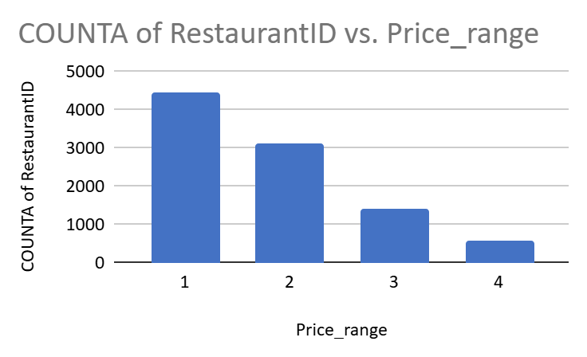

| *Price_range* | COUNTA of RestaurantID |
| --- | --- |
| 1 | 4444 |
| 2 | 3113 |
| 3 | 1408 |
| 4 | 586 |
| **Grand Total** | **9551** |

### **Insights:**

**Majority of Restaurants in Lower Price Ranges**:

* In most countries, the majority of restaurants seem to be in the **lower price ranges** (1-2). This indicates that customers in these regions may prefer more affordable options.

**Higher-End Restaurants**:

* Countries like **Qatar** and **Singapore** may have a higher concentration of **medium to high price range** restaurants (Price Range 3 and 4), reflecting the economic profile and customer preferences for higher-end dining experiences.

**Diversity in Pricing Strategies**:

* In countries with more varied price distributions, like **Canada**, restaurants may cater to a wider range of customer preferences and budgets.

### **Recommendation:**

* When considering opening a restaurant, you may want to:
* **Target lower price ranges** in countries where the majority of restaurants are priced lower, to cater to the larger customer base.
* **Evaluate the competition** in the higher price ranges, as countries with a significant presence of medium to high-priced restaurants may indicate a more competitive market in that segment.

1. **Explain your approach in brief for suggesting countries/cities in order to open new restaurants, if the objective and subjective questions would have not been given to assist you. [you have to give bullet pointers in order to answer this question]**

**Ans:**

Cities with High Ratings (4+ Stars):

* **Why**: Indicates customer satisfaction and demand for good quality restaurants.
* **Action**: These cities are prime candidates as they have an established market with a positive reception, suggesting a ready customer base for expansion.

Affordable Price Range (1–3):

* **Why**: Affordable pricing ensures that a broad customer base can access the restaurant,appealing to both middle-class and budget-conscious customers.
* **Action**: Targeting these cities is ideal for maximizing reach and volume of customers while still offering good quality food and service.

Online Delivery Available:

* **Why**: Online delivery is a key convenience factor, particularly with the growing trend in e-commerce and food delivery platforms.
* **Action**: Cities with online delivery options will enable restaurants to tap into a larger market, especially younger and tech-savvy customers who prefer ordering in.

Table Booking Options:

* **Why**: Availability of table reservations shows that customers are looking for a more personalized, comfortable dining experience.
* **Action**: Such cities reflect a preference for dining experiences that may justify investment in new restaurants with high-end features.

Cities with Medium-to-Low Ratings (Below 4 Stars):

* **Why**: These cities may have a less mature restaurant market or existing competition could be high.
* **Action**: These may not be ideal for general expansion, unless targeting a specific niche market or upgrading the existing offerings to improve customer experience.

Higher Price Range (4):

* **Why**: Higher prices might limit the customer base to an affluent demographic, making it less accessible for a larger market.
* **Action**: Cities with high-price ranges might be suitable only for premium restaurants catering to a high-end audience, with a focus on exclusivity.

Limited or No Online Delivery:

* **Why**: Without online delivery, the city might not have the infrastructure or market demand for convenient services.
* **Action**: These cities would require more traditional restaurant models that depend on in-house dining, making them less ideal for modern expansion strategies unless there’s a specific market for premium dining with reservations.