INDEX

Sl No | Name of the program | Date | Page No | Remarks
1 | Create your class time table using table tag. |  | 2
2 | Design a web Page for your college containing description of courses, department, faculties, library etc. Using list tags, href tags and anchor tags.

Program 1
Create class time table using table tag

Aim
Create a html page to display class time table

Program

<!DOCTYPE html>
<html>
<head>
<title>timetable</title>
<body>
<h1>2nd SEM BCA TIMETABLE</h1>
<table border="2">
<tr>
<th>Days</th>
<th>Hour 1</th>
<th>Hour 2</th>
<th>Hour 3</th>
<th>Hour 4</th>
<th>Hour 5</th>
</tr>
<tr>
<td>Day 1</td>
<td>DS</td>
<td>OS</td>
<td>English</td>
<td>Web Lab</td>
<td>Web Lab</td>
</tr>
<tr>
<td>Day 2</td>
<td>Hin/mal</td>
<td>DS</td>
<td>IC</td>
<td>Mathematics</td>
<td>OS</td>
</tr>
<tr>
<td>Day 3</td>
<td>DS</td>
<td>English</td>
<td>Hin/mal</td>
<td>OS</td>
<td>Mathematics</td>
</tr>
<tr>
<td>Day 4</td>
<td>OS</td>
<td>DS</td>
<td>English</td>
<td>Mathematics</td>
<td>Hin/mal</td>
</tr>
<tr>
<td>Day 5</td>
<td>Mahematics</td>
<td>IC</td>
<td>Web</td>
<td>DS Lab</td>
<td>DS Lab</td>
</tr>
</table>
</body>
</html>

Output

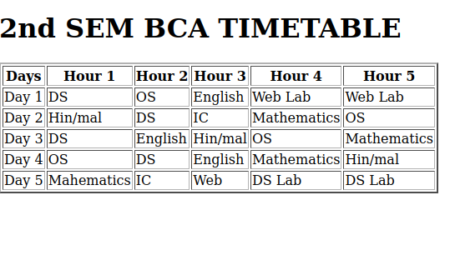

Program 2
Design a web Page for your college containing description of courses, department, faculties, library etc. Using list tags, href tags and anchor tags.

Aim
Design a web Page for your college containing description of courses, department, faculties, library etc. Using list tags, href tags and anchor tags.

Program

<!DOCTYPE html>
<html>
<head>
<title>college</title>
</head>
<body>
<img src="images.jpeg"alt="view">
<img src="sgc.jpeg"alt="view" width="400" height="200">
<img src="images.jpeg"alt="view">
<h1>ST.GEORGE'S COLLEGE ARUVITHURA</h1>
<p>St. George's College Aruvithura is a college under Mahatma Gandhi University, Kottayam. It is located in Aruvithura, Erattupetta, Kottayam District in Kerala, India. It was reaccredited with 'A++' Grade by NAAC for seven years in the fourth cycle.</p>
<p>St. George’s College Aruvithura, is a minority educational institution founded by St. George Forane Church, Aruvithura in 1965. Pioneered under the patronage of His Excellency Mar Sebastian Vayalil, the first Bishop of Pala, and cherished by a host of visionaries and philanthropists like Very Rev. Fr. Thomas Araythinal and Mr T. A. Thomman (Former Minister), the college, right from its inception, embarked on an odyssey towards academic pre-eminence. Very Rev. Fr. Thomas Manakkat, the founding manager and a great visionary, was truly instrumental in laying the foundations for a great beginning and Very Rev. Fr. Jacob Thazhathel, who followed him, was equally adept and insightful in his ideals, guiding the college during the early stages of its growth. For more than two decades, His Excellency Mar Joseph Pallickaparampil, the Bishop of Pala, had been the patron of the college. His Excellency Mar Joseph Kallarangattu is the present patron of this seat of learning.</p>
<h2>DEPARTMENTs</h2>
<ol>
<li>Department of Computer Applications (Aided)</li>
<li>Department of Computer Applications (SF) </li>
<li>Department of Botany and Zoology</li>
<li>Department of Commerce</li>
<li>Department of Economics</li>
<li>Department of Food Science and Technology</li>
</ol>
For more details about the courses<a href="courses.html"><h4>click here</h4></a>
<h1>LIBRARY</h1>
<h3>Resources</h3>
<p>The library at St. George's College, Aruvithura, has a rich history, having started functioning in 1965. Over the years, it has undergone significant upgrades and expansion to become a first-grade library. In 1978, the post of a first-grade Librarian and a IV-grade librarian were sanctioned, indicating the growing importance of the library as a vital academic resource.</p>

<p>Today, the library has a vast collection of resources to support the academic programs of the college. There are 32,330 books available on various subjects, including literature, science, technology, history, and philosophy. The library also has 58 periodicals, 250 CDs, and access to 8 newspapers, providing students and staff with access to the latest research and developments in their fields of interest.</p>
</body>
</html>

COURSES.html-Hyperlink

<!DOCTYPE html>
<html>
<head>
<title>course</title>
</head>
<body>
<h2>Department of Computer Applications (Aided)</h2>
<p>Established in 2014, the Department of Computer Applications is committed to providing quality education in the field of computer science. We currently offer a three-year undergraduate Bachelor of Computer Application (BCA) course, equipping students with the necessary skills to thrive in the ever-evolving world of technology.
</p>
<p>Our department boasts a team of experienced faculty members who are dedicated to nurturing students into software professionals with a strong sense of social commitment, leadership, and dedication. With their guidance and expertise, students gain a solid foundation in computer applications and are prepared to meet the challenges of the industry.</p>
<h2>Department of Computer Applications (SF)</h2>
<p>Welcome to the Department of Computer Applications (Self-Financing) at St. George's College Aruvithura!</p>
<p>
We take pride in offering the undergraduate Bachelor of Computer Application (BCA) course, which was introduced in the academic year 2014. This program, affiliated with M.G. University, Kottayam, has a batch strength of 38 students. The syllabus of our BCA program provides a strong foundation for pursuing post-graduation programs in computer science/applications. The knowledge and skills acquired by our students also equip them to meet the demands and requirements of the industry.</p>
<h2>Department of Botany and Zoology</h2>
<p>Our department has a rich history that dates back to 1965 when the college was established. Originally known as the Department of Biology, it began with just two dedicated staff members: Prof. Joseph Thomas in Botany and Prof. Sebastian Thomas in Zoology. As the department grew, Prof. V. S. Joseph joined their ranks. In 1980, Department of Biology was divided in to Botany and Zoology.</p>
<h2>Department of Commerce </h2>
<p>Established in 1980, the Department of Commerce (Aided) at St. George’s College, Aruvithura, marked the commencement of commerce education in the IVth Group stream .From its foundation under the leadership of Mr. P. M. Matew and early faculty members such as Mr. Edsel Joseph and Mr. Jacob James K. Veedon, the department has evolved into a dynamic academic unit with a steadfast commitment to excellence.
</p>
<p>The department offers a B.Com degree programme specializing in Finance & Taxation, in alignment with the MGU_UGP (Honours), leading to an Honours Degree. The department currently offers a value-added course (VAC) on Consumer Affairs and Protection, multi-disciplinary course (MDC) on Business Organisation and Entrepreneurship. Complementing the core programme offered under old CBCS system the department offers an open course on Capital Market and Investment Management .</p>
<h2>Department of Economics</h2>
<p>Since its inception in 1978, the Department of Economics has been dedicated to delivering a higher level of quality education. Our esteemed faculty, both past and present, are committed to maintaining an environment of intellectual pursuit and academic excellence. We offer a Bachelor of Arts in Economics with an annual intake capacity of 40 students.</p>
<h2>Department of Food Science and Technology</h2>
<p>Food science and Technology focuses on the importance of food science and food technology to humans and can be denned as the application of the basic sciences and engineering to study the fundamental physical, chemical and biochemical nature of foods and the concepts underlying food processing. Food technology is the application of food science to the selection, harvesting, preservation, processing, packaging, distribution, and use of safe food. </p>
</body>
</html>

Output

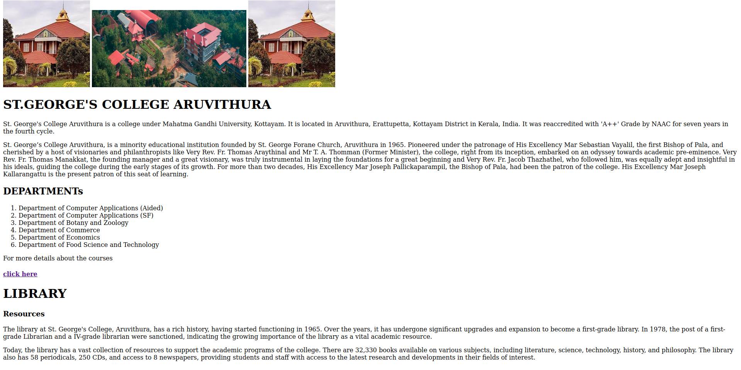

COURSES.html
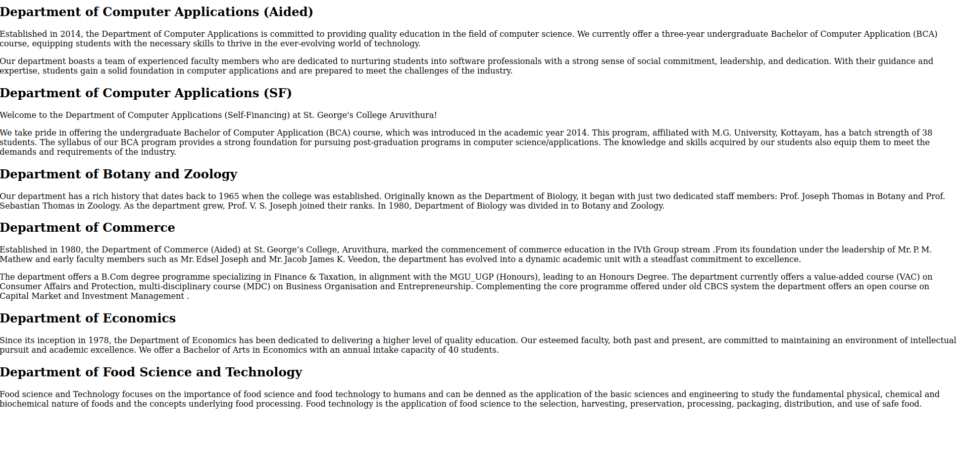

Program 3
Create Your Resume using HTML .Use text,link, and lists.

Aim
Create Your Resume using HTML .Use text,link, and lists.

Program

<!DOCTYPE.html>
<html>
<head>
<title>resume</title>
</head>
<body>
<center><h1>Resume</h1></center>
<h3>Personal Details</h3>
<p>
<b>Name:</b>Assiya Ansary<br>
<b>Email:</b>assiyaansary2007@gmail.com<br>
<b>Mobile:</b>9048639353<br>
<b>Address:</b>Valiyaveettil(H)Nadackal PO Erattupetta<br>
</p>
<h3>Profile</h3>
<p>I am a dedicated and responsible student with a strong interest in learning new technologies.Iam eager to improve my knowledge and skills, and apply them effectively in real-life situations.</p>
<h3>Education</h3>
<ul>
<li>10th</li>
school:MGHSS Erattupetta
Passed out with full A+
<li>12th</li>
school:MGHSS Erattupetta
passed out with 95%
<li>Degree</li>
college:St George's College Aruvithura<br>
1st year
2025-2029 Batch
</ul>
<h3>Skills</h3>
<ul>
<li>Programming Languages:C,C++</li>
<li>Web Technology:HTML,CSS</li>
<li>Communication</li>
</body>
</html>

Output

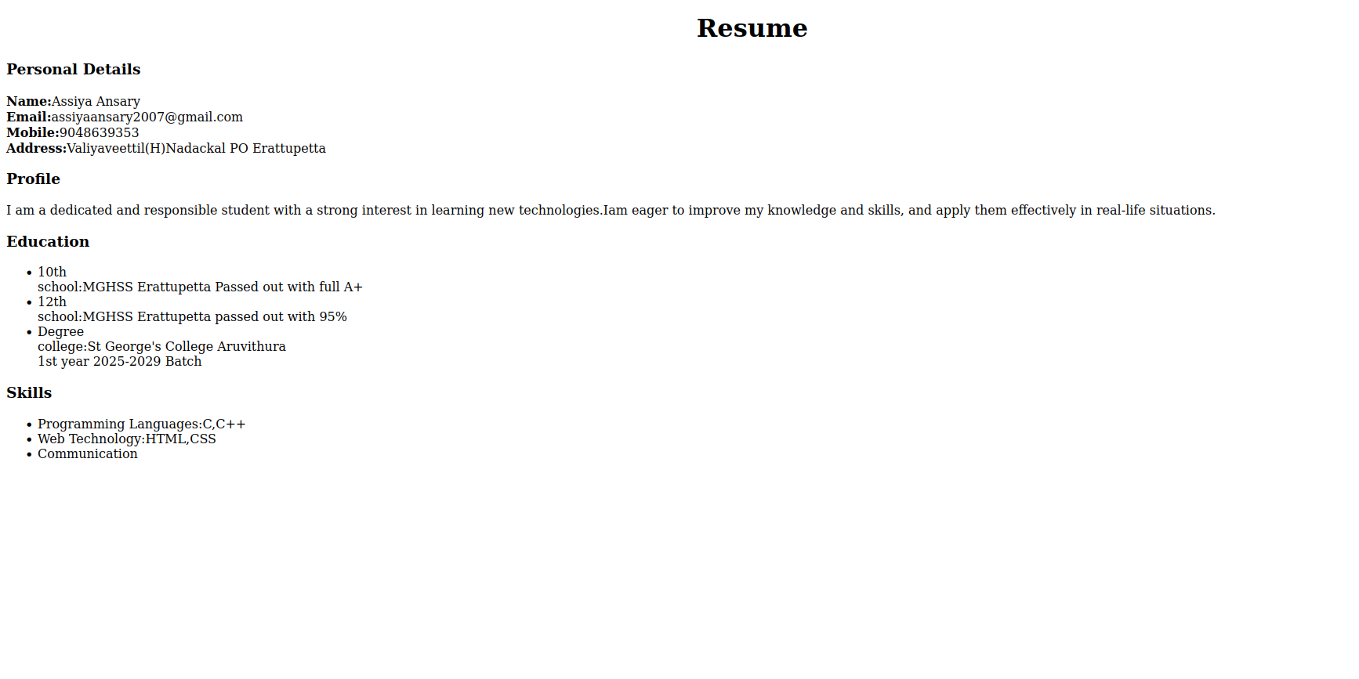

Program 4
Create a webpage of supermarket using internal CSS

Aim
Create a webpage of supermarket using internal CSS

Program

<!DOCTYPE html>
<html>
<head>
<title>Super Market</title>
<style>
h1{
color:red;
}
#new{
color:blue;
}
.nw{
color:green;
}
.veg{
color:cyan;
}
.nn{
color:red;
}
</style>
</head>
<body>
<h1> LULU SUPERMARKET</h1>
<ol>
<li id="new">Fruits</li>
<ul class="nw">
<li>Apple</li>
<li>Banana</li>
<ul>
<li>Ripe</li>
<li>Raw</li>
</ul>
<li>Orange</li>
<li>Mango</li>
<ul>
<li>Ripe</li>
<li>Raw</li>
</ul>
</ul>
<li id="new">Vegetables</li>
<ul class="veg">
<li>Potato</li>
<li>Tomato</li>
<li>Onion</li>
</ul>
<li id="new">Cool drinks</li>
<ul class="nn">
<li>Pepsi</li>
<li>Coco cola</li>
<li>Sprite</li>
</ul>
</ol>
</body>
</html>

Output
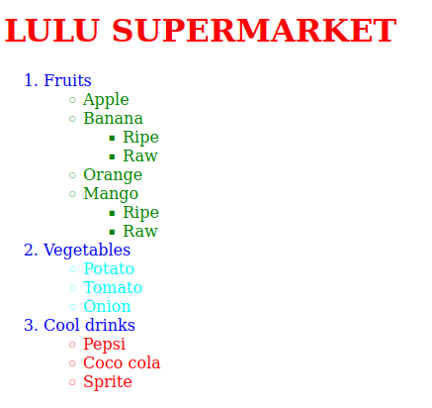

Program 5
Use inline CSS to format your resume created

Aim
Use inline CSS to format your resume created

Program

<!DOCTYPE.html>
<html>
<head>
<title>resume</title>
</head>
<body>
<center><h1>Resume</h1></center>
<div style="border:2px solid yellow;">
<h3>Personal Details</h3>
<p>
<b>Name:</b>Assiya Ansary<br>
<b>Email:</b>assiyaansary2007@gmail.com<br>
<b>Mobile:</b>9048639353<br>
<b>Address:</b>Valiyaveettil(H)Nadackal PO Erattupetta<br>
</p>
</div>
<h3 style="background-color:yellow;">Profile</h3>
<p style="font-family:sans-serif;">I am a dedicated and responsible student with a strong interest in learning new technologies.Iam eager to improve my knowledge and skills, and apply them effectively in real-life situations.</p>
<h3 style="background-color:cyan;">Education</h3>
<ul style="font-family:arial;">
<li>10th</li>
school:MGHSS Erattupetta
Passed out with full A+
<li>12th</li>
school:MGHSS Erattupetta
passed out with 95%
<li>Degree</li>
college:St George's College Aruvithura<br>
1st year
2025-2029 Batch
</ul>
<h3>Skills</h3>
<ul>
<li>Programming Languages:C,C++</li>
<li>Web Technology:HTML,CSS</li>
<li>Communication</li>
</body>
</html>

Output

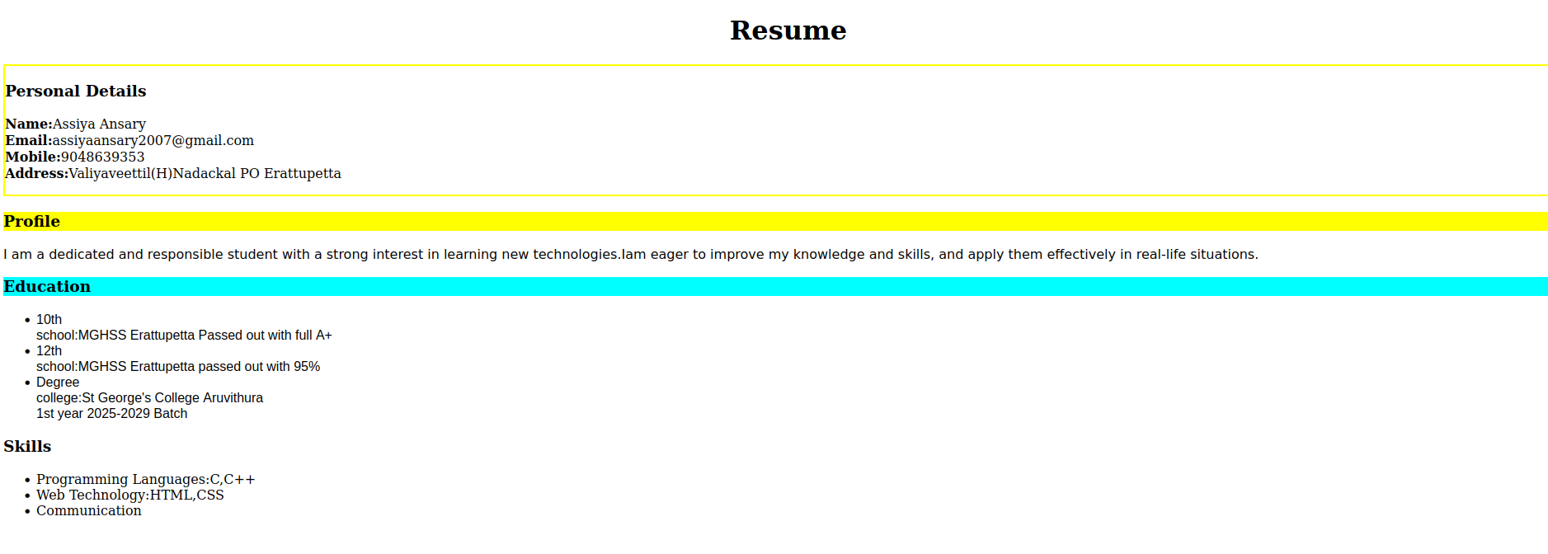

Program 6
Use external CSS to format your timetable created

Aim
Use external CSS to format your timetable created

Program

<!DOCTYPE html>
<html>
<head>
<title>timetable</title>
<link rel="stylesheet" href="styles.css">
<body>
<div>
<h1>2nd SEM BCA TIMETABLE</h1>
<table border="2">
<tr>
<th>Days</th>
<th>Hour 1</th>
<th>Hour 2</th>
<th>Hour 3</th>
<th>Hour 4</th>
<th>Hour 5</th>
</tr>
<tr>
<td>Day 1</td>
<td>DS</td>
<td>OS</td>
<td>English</td>
<td>Web Lab</td>
<td>Web Lab</td>
</tr>
<tr>
<td>Day 2</td>
<td>Hin/mal</td>
<td>DS</td>
<td>IC</td>
<td>Mathematics</td>
<td>OS</td>
</tr>
<tr>
<td>Day 3</td>
<td>DS</td>
<td>English</td>
<td>Hin/mal</td>
<td>OS</td>
<td>Mathematics</td>
</tr>
<tr>
<td>Day 4</td>
<td>OS</td>
<td>DS</td>
<td>English</td>
<td>Mathematics</td>
<td>Hin/mal</td>
</tr>
<tr>
<td>Day 5</td>
<td>Mahematics</td>
<td>IC</td>
<td>Web</td>
<td>DS Lab</td>
<td>DS Lab</td>
</tr>
</table>
</div>
</body>
</html>

External CSS

table{
color:blue;
font-size:20px;
border:2px solid cyan;
padding:7px;
font-family:arial;
background-color:yellow;
}

Output
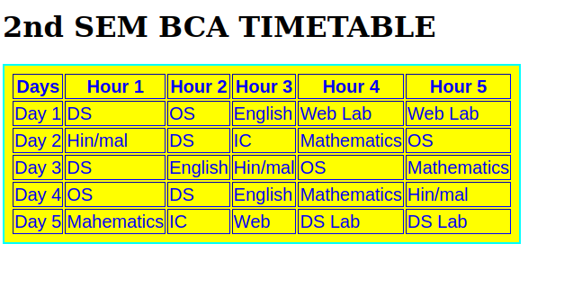

Program 7
Use all the CSS inline,internal,external to format the college webpage that you have created

Aim
Use all the CSS inline,internal,external to format the college webpage that you have created

Program

<!DOCTYPE html>
<html>
<head>
<title>college</title>
<link rel="stylesheet" href="style.css">
<style>
#new{
background-color:#3EB489;
}
</style>
</head>
<body>
<img src="images.jpeg"alt="view">
<img src="sgc.jpeg"alt="view">
<img src="images.jpeg"alt="view">
<h1 id="new">ST.GEORGE'S COLLEGE ARUVITHURA</h1>
<p>St. George's College Aruvithura is a college under Mahatma Gandhi University, Kottayam. It is located in Aruvithura, Erattupetta, Kottayam District in Kerala, India. It was reaccredited with 'A++' Grade by NAAC for seven years in the fourth cycle.</p>
<p>St. George’s College Aruvithura, is a minority educational institution founded by St. George Forane Church, Aruvithura in 1965. Pioneered under the patronage of His Excellency Mar Sebastian Vayalil, the first Bishop of Pala, and cherished by a host of visionaries and philanthropists like Very Rev. Fr. Thomas Araythinal and Mr T. A. Thomman (Former Minister), the college, right from its inception, embarked on an odyssey towards academic pre-eminence. Very Rev. Fr. Thomas Manakkat, the founding manager and a great visionary, was truly instrumental in laying the foundations for a great beginning and Very Rev. Fr. Jacob Thazhathel, who followed him, was equally adept and insightful in his ideals, guiding the college during the early stages of its growth. For more than two decades, His Excellency Mar Joseph Pallickaparampil, the Bishop of Pala, had been the patron of the college. His Excellency Mar Joseph Kallarangattu is the present patron of this seat of learning.</p>
<h2>DEPARTMENTs</h2>
<ol>
<li>Department of Computer Applications (Aided)</li>
<li>Department of Computer Applications (SF) </li>
<li>Department of Botany and Zoology</li>
<li>Department of Commerce</li>
<li>Department of Economics</li>
<li>Department of Food Science and Technology</li>
</ol>
For more details about the courses<a href="courses.html"><h4>click here</h4></a>
<h1>LIBRARY</h1>
<h3>Resources</h3>
<p style="font-family:sans-serif;">The library at St. George's College, Aruvithura, has a rich history, having started functioning in 1965. Over the years, it has undergone significant upgrades and expansion to become a first-grade library. In 1978, the post of a first-grade Librarian and a IV-grade librarian were sanctioned, indicating the growing importance of the library as a vital academic resource.

</p><p>Today, the library has a vast collection of resources to support the academic programs of the college. There are 32,330 books available on various subjects, including literature, science, technology, history, and philosophy. The library also has 58 periodicals, 250 CDs, and access to 8 newspapers, providing students and staff with access to the latest research and developments in their fields of interest.</p>
</body>
</html>

External CSS

p{
color:red;
font-size:20px;
font-family:arial;
background-color:#FFB6C1;
}

Output

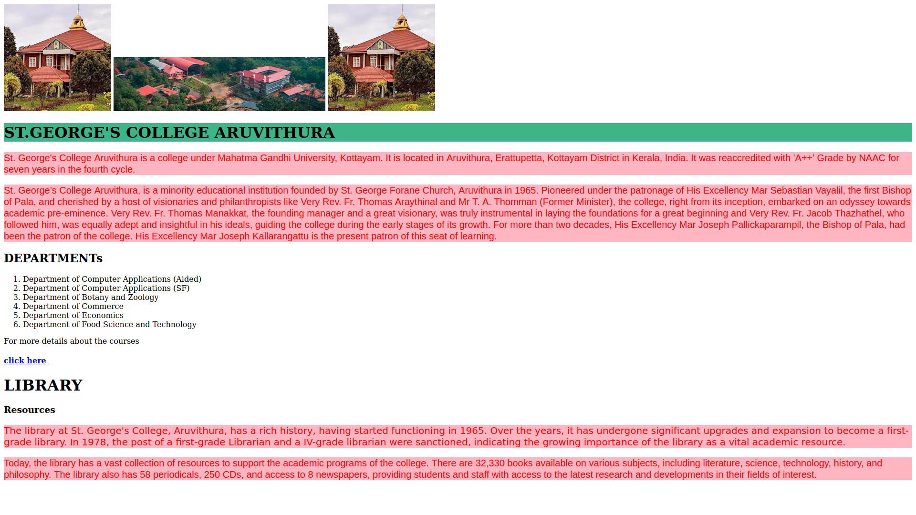

Program 8
Write a html program to create your college website for mobile devices

Aim
Write a html program to create your college website for mobile devices

Program

<!DOCTYPE html>
<html>
<head>
<meta name="viewport" content="width=device-width,initial-scale=1.0">
<title>test responsive</title>
<link rel="stylesheet" href="style3.css">
<style>
#new{
background-color:#3EB489;
}
</style>
</head>
<body>
<img src="images.jpeg"alt="view">
<img src="sgc.jpeg"alt="view">
<img src="images.jpeg"alt="view">
<h1 id="new">ST.GEORGE'S COLLEGE ARUVITHURA</h1>
<p>St. George's College Aruvithura is a college under Mahatma Gandhi University, Kottayam. It is located in Aruvithura, Erattupetta, Kottayam District in Kerala, India. It was reaccredited with 'A++' Grade by NAAC for seven years in the fourth cycle.</p>
<p>St. George’s College Aruvithura, is a minority educational institution founded by St. George Forane Church, Aruvithura in 1965. Pioneered under the patronage of His Excellency Mar Sebastian Vayalil, the first Bishop of Pala, and cherished by a host of visionaries and philanthropists like Very Rev. Fr. Thomas Araythinal and Mr T. A. Thomman (Former Minister), the college, right from its inception, embarked on an odyssey towards academic pre-eminence. Very Rev. Fr. Thomas Manakkat, the founding manager and a great visionary, was truly instrumental in laying the foundations for a great beginning and Very Rev. Fr. Jacob Thazhathel, who followed him, was equally adept and insightful in his ideals, guiding the college during the early stages of its growth. For more than two decades, His Excellency Mar Joseph Pallickaparampil, the Bishop of Pala, had been the patron of the college. His Excellency Mar Joseph Kallarangattu is the present patron of this seat of learning.</p>
<h2>DEPARTMENTs</h2>
<ol>
<li>Department of Computer Applications (Aided)</li>
<li>Department of Computer Applications (SF) </li>
<li>Department of Botany and Zoology</li>
<li>Department of Commerce</li>
<li>Department of Economics</li>
<li>Department of Food Science and Technology</li>
</ol>
For more details about the courses<a href="courses.html"><h4>click here</h4></a>
<h1>LIBRARY</h1>
<h3>Resources</h3>
<p style="font-family:sans-serif;">The library at St. George's College, Aruvithura, has a rich history, having started functioning in 1965. Over the years, it has undergone significant upgrades and expansion to become a first-grade library. In 1978, the post of a first-grade Librarian and a IV-grade librarian were sanctioned, indicating the growing importance of the library as a vital academic resource.

</p><p>Today, the library has a vast collection of resources to support the academic programs of the college. There are 32,330 books available on various subjects, including literature, science, technology, history, and philosophy. The library also has 58 periodicals, 250 CDs, and access to 8 newspapers, providing students and staff with access to the latest research and developments in their fields of interest.</p>
</body>
</html>

External CSS

p{
color:red;
font-size:20px;
font-family:arial;
background-color:#FFB6C1;
}
@media(max-width:768px){
body{
background-color:lightgreen;
color:darkgreen;
}
}

Output



