**Assignment No: - 2**

**Facial Recognition using OpenCV**

**Problem Statement:**

Facial Recognition Using OpenCV and Deep Learning for Binary Classification.

**Objective:**

* Understand the fundamentals of face detection and recognition.
* Learn to preprocess face data and extract facial embeddings.
* Implement a deep learning-based model to classify faces.
* Evaluate the model's accuracy and performance.
* Visualize the training process and performance metrics.

**S/W Packages and H/W apparatus used:**

* **Operating System:** Windows/Linux/MacOS
* **Kernel:** Python 3.x
* **Tools:** Jupyter Notebook, Anaconda, or Google Colab
* **Hardware:** CPU with minimum 4GB RAM; optional GPU for faster processing

**Libraries and packages used:**

* **TensorFlow/ Keras**
* **OpenCV**
* **Dlib**
* **face_recognition**
* **NumPy**
* **Pandas**
* **Matplotlib**
* **Scikit-Learn**

**Theory:**

**Definition:** A facial recognition system is a technology capable of identifying or verifying a person from a digital image or video frame. The system works by detecting facial features and matching them against a pre-stored database. In binary classification, the task is to distinguish between two classes, typically "face" and "no face."

**Structure:** It consists of:

* **Face Detection Module:** Detects the presence of a face in the input image using techniques like Haar Cascades or deep learning models (SSD or YOLO).
* **Feature Extraction Module:** Extracts unique facial features from the detected region using Convolutional Neural Networks (CNNs).
* **Classification Module:** Binary classifier (CNN or SVM) that outputs whether the detected region contains a face or not.

**Activation Functions:** Functions like ReLU (Rectified Linear Unit), Sigmoid, and SoftMax are used to introduce non-linearity into the classification model, enabling it to learn complex patterns.

**Backpropagation:** A critical algorithm for training the CNN-based model, where the error between predicted and true labels is propagated backward to update the weights in each layer to minimize classification error.

**Methodology:**

1. **Data Collection:** Gather a dataset containing face and non-face images.
2. **Preprocessing:** Use OpenCV for face detection and resize images to a uniform size. Normalize pixel values.
3. **Model Architecture:** Build a CNN using Keras/TensorFlow to classify images as face or no face.
4. **Training:** Train the model with labeled images, using binary cross-entropy loss and accuracy as a metric.
5. **Evaluation:** Test the model's performance using unseen data, evaluating accuracy and other metrics.
6. **Prediction:** Use the trained model to classify new images as containing a face or not.

**Advantages:**

* **High Accuracy:** Deep learning provides high precision in recognizing and classifying faces.
* **Real-Time Processing:** OpenCV allows for real-time face detection and recognition.
* **Automation:** The system can automate tasks such as authentication and access control.

**Limitations:**

* **Data Quality and Quantity:** Facial recognition systems require a large, diverse, and high-quality dataset for training. Poor-quality images or insufficient training data can lead to inaccurate predictions and difficulty in generalizing to new faces.
* **Illumination and Pose Variability:** Variations in lighting, pose, facial expressions, and occlusions (like glasses or hats) can significantly affect the model's accuracy, leading to false positives or false negatives.
* **Privacy Concerns:** Facial recognition technology raises significant ethical and privacy issues. The unauthorized collection and use of facial data can infringe on personal privacy rights, leading to regulatory and legal challenges.
* **Computational Complexity:** Deep learning-based facial recognition models, especially with large-scale datasets, require significant computational resources for training and deployment, which may not be suitable for real-time or low-power devices.
* **Overfitting:** If the model is overly complex or trained on limited or biased data, it can overfit to the training data, resulting in poor performance on real-world or unseen images.
* **Adversarial Vulnerabilities:** Facial recognition systems can be susceptible to adversarial attacks, where small perturbations in the image can fool the system into misclassifying a face.

**Applications:**

* **Security and Surveillance:** Facial recognition is widely used in security systems for access control, identifying individuals in surveillance footage, and monitoring high-security areas.
* **Biometric Authentication:** Facial recognition is employed in smartphones, laptops, and other devices for user authentication, providing a convenient and secure alternative to passwords.
* **Law Enforcement:** Police and other law enforcement agencies use facial recognition to identify suspects in criminal investigations, locate missing persons, or track criminals across large datasets.
* **Healthcare:** Facial recognition can be used in healthcare to monitor patient conditions, detect emotional states, and assist in diagnosing genetic disorders based on facial features.
* **Retail and Marketing:** In retail environments, facial recognition is used for personalized marketing, customer identification, and enhancing customer experience by analyzing shopping patterns.
* **Time and Attendance Systems:** Many businesses employ facial recognition for tracking employee attendance and enhancing workplace security by automating time-in/time-out processes.
* **Smart Cities:** Facial recognition technology can be integrated into smart city infrastructure for traffic monitoring, crowd control, and improving public safety.

**Working / Algorithm:**

**Step 1: Install Necessary Libraries**

The following Python libraries are required: numpy, matplotlib, opencv-python, scikit-learn, tensorflow. These are installed and verified in the Python environment using pip (pip install numpy matplotlib opencv-python scikit-learn tensorflow).

**Step 2: Load and Preprocess the Dataset**

* The scikit-learn fetch_lfw_people() utility fetches the LFW dataset, selecting only persons with ≥20 images.
* Images are converted to float, normalized to , and reshaped for CNN input.

**Step 3: Binary Label Encoding**

* The desired subject (e.g., "George W. Bush") is chosen.
* All labels are transformed into binary (1 for target, 0 for others).

**Step 4: Train/Test Split**

* The data is split into training (80%) and test (20%) sets to evaluate generalization

**Step 5: Model Definition**

* The model comprises two convolutional layers with ReLU activation, each followed by max-pooling, then flattening, followed by dense layers for final classification. The output is a sigmoid-activated neuron for binary classification.

**Step 6: Training**

* The model is trained for 10 epochs. Binary cross-entropy is used as the loss, and accuracy is tracked for both training and validation sets across epochs.

**Step 7: Evaluation**

* The model's accuracy and loss are computed on the test set after training. The code prints the test accuracy, which in the example is about 84%.

**Step 8: Inference and Visualization**

* A random test image is selected, predicted by the model, with both true and predicted labels displayed, alongside the respective image using Matplotlib.

**Diagram:**

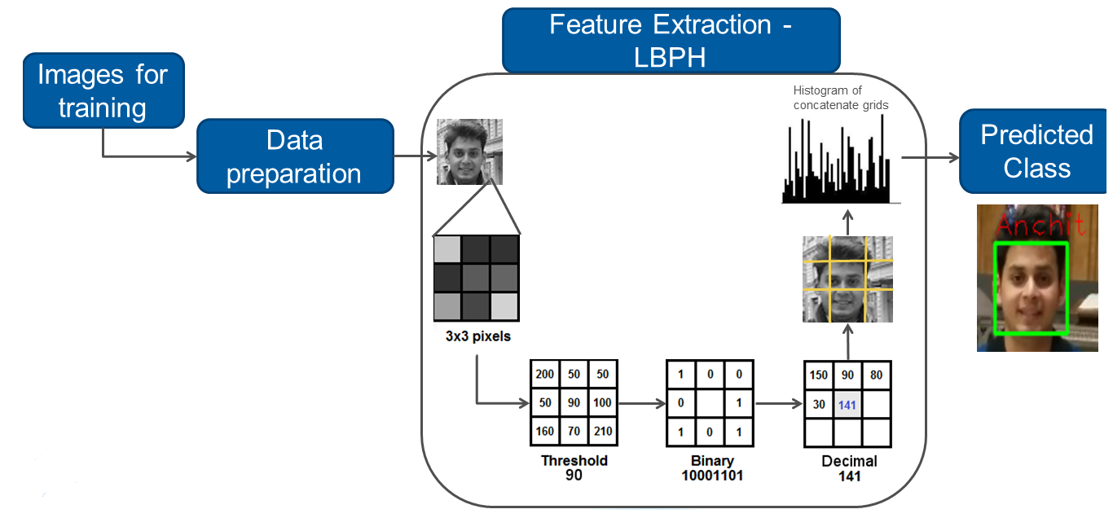

**Conclusion:**

This assignment successfully demonstrated the application of Convolutional Neural Networks (CNNs) for binary face recognition using the Labeled Faces in the Wild (LFW) dataset. By preprocessing images, normalizing pixel values, and employing a CNN architecture with convolutional, pooling, and dense layers, the model effectively learned discriminative facial features to classify images as a specific person (George W. Bush) or not. The trained model achieved a test accuracy of approximately 84%, validating its capability to generalize to unseen face images. This work highlights the strength of CNN-based models in face recognition tasks and the importance of proper data preparation and model design. Overall, the methodology and results underscore CNNs as a powerful approach for real-world facial identification applications and provide a foundation for further improvements, such as using deeper architectures or larger datasets for enhanced accuracy and robustness.