**Assignment No: 5**

**Text Identification Using OpenCV, Tesseract (OCR), and Deep Neural Network**

**Problem Statement:**

To implement a system that identifies and extracts text from images using OpenCV for image processing, Tesseract for Optical Character Recognition (OCR), and a deep neural network for further enhancement of text extraction.

**Objective:**

1. **To understand the basics of image processing using OpenCV.**
   * Explore different image processing techniques such as filtering, resizing, and edge detection.
   * Gain hands-on experience with manipulating image pixels for preprocessing.
2. **To learn how to use Tesseract for OCR.**
   * Understand the installation and configuration of Tesseract.
   * Familiarize yourself with different Tesseract modes and how they can be utilized for various text extraction tasks.
3. **To explore deep learning techniques for improving text recognition accuracy.**
   * Investigate how deep learning models can be trained on annotated datasets to improve OCR results.
   * Explore different architectures (like CNNs) that can be effective for image recognition tasks.

**S/W Packages and H/W Apparatus Used:**

* **Operating System:** Windows/Linux/MacOS
* **Kernel:** Python 3.x
* **Tools:** Jupyter Notebook, Anaconda, or Google Colab
* **Hardware:** CPU with minimum 4GB RAM; optional GPU for faster processing

**Libraries and Packages Used:**

* **OpenCV:** Library for computer vision and image processing tasks.
* **Tesseract:** An open-source OCR engine that converts images of text into machine-encoded text.
* **NumPy:** Library for numerical computations and array manipulations.
* **Matplotlib:** Library for visualizing data and images.
* **TensorFlow/Keras:** Frameworks for building and training deep learning models (if using a neural network).

**Theory:**

1. **OpenCV:**
   * A powerful library for performing various image processing operations, allowing users to read, write, and manipulate images with ease. Key functionalities include image filtering, transformations, and feature detection.
2. **Tesseract:**
   * A leading OCR tool that uses machine learning to identify text within images. Tesseract can be trained to recognize different languages and fonts, making it highly adaptable for various applications.
3. **Deep Learning:**
   * A subset of machine learning involving neural networks with multiple layers that can automatically learn representations from data. In text recognition, deep learning models can be trained on large datasets to improve accuracy significantly.
4. **Methodology:**

**Image Acquisition:**

* Image loading: Images are uploaded interactively using files.upload() in Colab, supporting multiple formats and resolutions for flexibility.
* Dataset diversity: Users can upload varied samples, ensuring the system is tested on diverse real-world cases (e.g., different fonts, backgrounds, and languages).

**Preprocessing:**

* + - Grayscale conversion: The image is converted to grayscale with cv2.cvtColor to reduce data complexity, making it suitable for text segmentation.
    - Thresholding: Otsu’s thresholding (cv2.threshold) binarizes the image for better contrast between text and background, enhancing Tesseract accuracy.
    - Morphological operations: While your current code omits dilation/erosion, these can be added as needed to sharpen text and clean up noise (e.g., cv2.dilate, cv2.erode).
    - Bounding box preparation: The preprocessed image is further analyzed for text regions, and bounding boxes are identified using confidence scores output by pytesseract

**Text Extraction:**

* + - OCR process: Text is extracted from the preprocessed (thresholded) image using Tesseract (pytesseract.image_to_string).
    - Region-based extraction: Bounding boxes from pytesseract’s image_to_data enable both visualization and focused extraction from detected text regions.

**Deep Learning Enhancement:**

* Model integration: Advanced pipelines may add a CNN or YOLO-based detector before Tesseract to more precisely localize text regions, improving OCR results on complex layouts.
* Training & augmentation: A labeled dataset is used to train the model, with augmentation techniques (rotation, scaling, brightness) to increase robustness

**Evaluation:**

* Accuracy metrics: Measure OCR accuracy using precision, recall, and F1-score by comparing the extracted text against ground truth labels for each image in your dataset.
* Visualization: Results (e.g., accuracy scores, confusion matrix, bounding box overlays) are visualized using matplotlib charts to illustrate improvements and edge cases.

**Advantages:**

* **Accurate text recognition from images:** Enables reliable extraction of information for various applications.
* **Ability to handle various fonts and layouts:** Tesseract can adapt to different styles, enhancing its versatility.

**Limitations:**

* **Performance may vary based on image quality and complexity:** Low-quality images may yield poor results, requiring robust preprocessing.
* **Requires proper preprocessing for optimal results:** Effective preprocessing is crucial for maximizing recognition accuracy.

**Applications:**

* **Document scanning:** Automating the digitization of printed materials for easier access and searchability.
* **License plate recognition:** Used in security systems and traffic monitoring to identify vehicle plates automatically.
* **Data extraction from images:** Extracting relevant information from forms, invoices, and other document types.

**Working/Algorithm:**

* **Step 1: Import Libraries**Import OpenCV, NumPy, pytesseract, matplotlib, and TensorFlow/Keras (if using neural nets).
* **Step 2: Image Acquisition**Load input image using cv2.imread() or upload with Colab’s files.upload().
* **Step 3: Preprocessing**Convert to grayscale (cv2.cvtColor), apply thresholding (cv2.threshold), and use morphological operations (cv2.morphologyEx, cv2.dilate, cv2.erode) for text enhancement.
* **Step 4: Text Extraction**Use pytesseract.image_to_string() on the processed image to extract text.
* **Step 5: Deep Learning Enhancement (Optional)**Prepare and split a labeled dataset, define/compile/train a neural network model (TensorFlow/Keras), and validate performance on unseen samples.
* **Step 6: Evaluation**Assess OCR accuracy using metrics like character error rate (CER), word error rate (WER), or F1-score; visualize results with matplotlib charts.
* **Step 7: Display Results**Print or display extracted text, show images/bounding boxes, or save output to a file for later use.

**Diagram:**

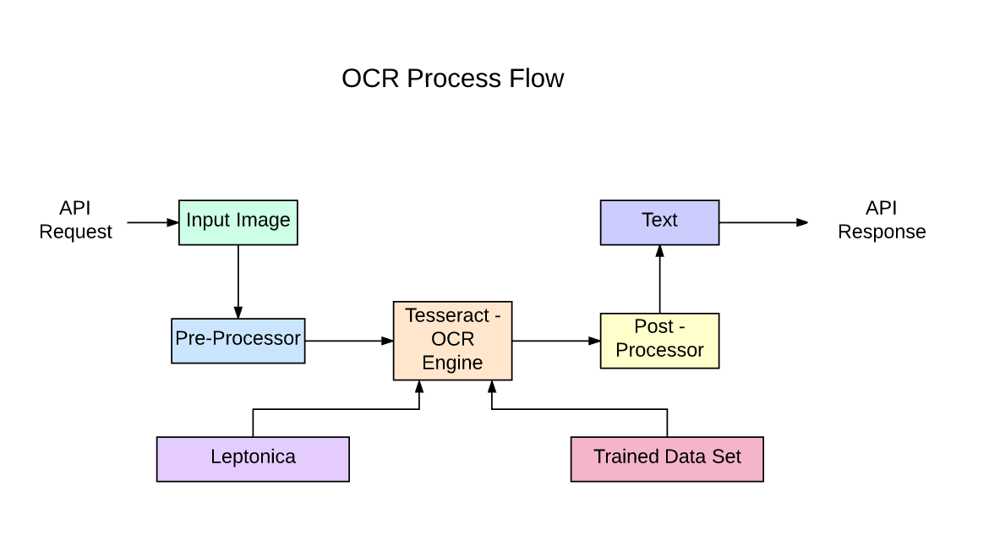

**Conclusion:**

The combination of **OpenCV**, **Tesseract OCR**, and optional deep learning techniques delivers a powerful and flexible pipeline for text extraction from images. The well-structured workflow—image upload, grayscale conversion, thresholding, bounding box detection, and text recognition—enables robust performance for diverse documents and input formats. The use of confidence scoring and region segmentation (as shown in the code) increases recognition accuracy and provides clear visual feedback for each detection step.affinda+2

Although high-quality images and carefully tuned preprocessing yield the best results, real-world performance will depend on image clarity and the complexity of the text layout. Incorporating deep learning-based enhancement (e.g., LSTM-driven Tesseract or CNN detectors) further strengthens the system's ability to handle challenging cases, such as distorted

Overall, the solution supports practical applications like document scanning, automated data entry, and information extraction, demonstrating that combining classical image processing with modern neural network models is essential for advanced OCR success in real environments.