1. What is public static void main(String args[])?
- public → accessible from anywhere (JVM can call it)
- static → runs without creating an object
- void → does not return any value
- main → method name where program starts
- String args[] → stores command-line inputs as text

2. Java.lang.object is the superclass of all the classes.
3. dir → shows files & folders
set → shows environment variables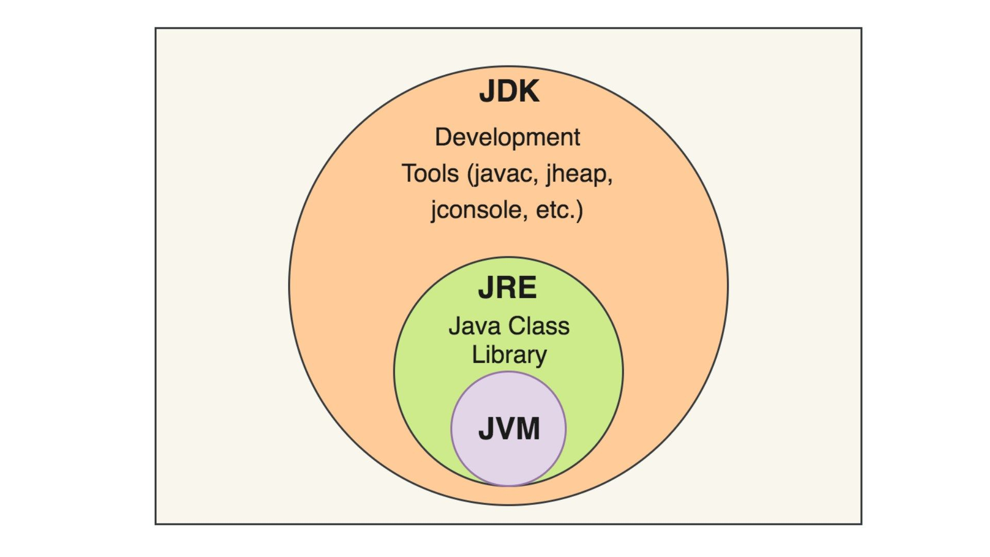
🔹 JVM (Java Virtual Machine)
👉 Runs Java programs
👉 Converts bytecode → machine code
👉 Makes Java platform independent
✅ Without JVM, Java program cannot run.

🔹 JRE (Java Runtime Environment)
👉 Provides environment to run Java programs
👉 Contains:
- JVM
- Libraries & required files
✅ Needed to run Java programs.

🔹 JDK (Java Development Kit)
👉 Used to develop Java programs
👉 Contains:
- JRE
- Compiler (javac)
- Development tools
✅ Needed to write & compile Java programs.

✅ Simple Analogy
- JDK → Kitchen (to cook food)
- JRE → Plate & table setup
- JVM → Person who eats the food
JVM executes Java bytecode, JRE provides runtime environment, and JDK provides tools to develop Java programs.

5. byte = smallest integer data type in Java (1 byte)
👉 Range: -128 to 127
👉 Saves memory
1️⃣ Cannot store values beyond range
byte num = 130; // ❌ ERROR
2️⃣ Type casting required
Arithmetic operations convert byte to int.
byte a = 10;
byte b = 20;

// byte c = a + b; ❌ error
byte c = (byte)(a + b); // ✔ correct

🔹 Where is byte used in real projects?
✔ File handling
✔ Network programming
✔ Image processing
✔ IoT & embedded systems
✔ Reading binary streams

6. What is Typescript?
7. What is Static method?
A static method in Java is a method that belongs to the class, not to objects (instances).
You can call it without creating an object.

🔹 Example Showing Static Rule
class Test {
int a = 10;
static int b = 20;

static void display() {
// System.out.println(a); ❌ ERROR
System.out.println(b); // ✅ allowed
}
}

javac
javap
javadoc

