TrainConcierge
Frontend Development and Frontend-Backend Integration Plan
AI-Powered Autonomous Train Disruption Concierge & Smart Seat Alert System

1. Instructions for the AI Coding Agent (Antigravity)
This document is the implementation brief for the TrainConcierge frontend. Read it fully before starting. The backend (Java 17, Spring Boot, Spring Security with JWT, Spring Data JPA, MySQL) is already complete across 21 phases and must be treated as the source of truth.
Work strictly one phase at a time, in order. After each phase: run the app, verify against the checklist, fix issues, and stop for review before the next phase.
Non-negotiable rules
- Inspect the existing backend code before writing any frontend code. Never invent endpoints, request fields or response fields.
- Do not modify backend business logic. If a backend change is required, report it as a gap with the smallest recommended change and wait for approval.
- React requests operations; Spring Boot decides and executes them. No booking, scoring, disruption, rebooking or seat-inventory logic in JavaScript.
- Do not use localStorage or mock data as a replacement for the database. Mock data is allowed only temporarily for visual work and must be isolated.
- All external railway, hotel, cab and payment behavior is simulated. Label it as simulated in the UI. Never claim a real IRCTC, hotel or cab integration.
- Never show a success message until the backend has confirmed success. Prevent duplicate form submissions.
- Never hardcode secrets, credentials or tokens. Frontend configuration goes in environment variables.
- Do not claim tests passed unless they were actually executed.
- The images in this document are design mockups, not screenshots of a built application. Use them as visual guidance for layout and style, but never copy their sample data. Real data comes from the backend.

2. Technology Stack
Layer | Technology
Frontend | React.js, Vite, JavaScript, Tailwind CSS, React Router, Axios, Lucide React
Optional libraries | React Hook Form, Zod, Recharts, React Hot Toast (use if they fit the project)
Backend (existing) | Java 17, Spring Boot, Spring Security + JWT, Spring Data JPA, Hibernate, MySQL
Communication | REST APIs over HTTP, JSON, Bearer JWT authentication

3. Architecture and Responsibilities
React frontend | Spring Boot backend
Display data | Authentication and authorization
Collect user input | Booking and cancellation logic
Form validation (UX) | Seat inventory management
Navigation and routing | Disruption detection
Loading and error states | Recommendation scoring
Confirmation dialogs | Rebooking transactions
Render API responses | Hotel and cab coordination, notifications, schedulers

Example: when a train is delayed, the frontend does not decide which alternative is best. It asks the backend for recommendations, displays them, and submits the user's confirmation through the appropriate API.

Repository layout
TrainConcierge/
backend/ (existing Spring Boot project; keep its current layout)
frontend/ (new React + Vite application)
FRONTEND_API_CONTRACT.md
README.md
.gitignore

If the backend already lives at the repository root, do not move it. Create frontend/ alongside it.
Environment configuration
frontend/.env -> VITE_API_BASE_URL=http://localhost:8080

The backend must allow the frontend origin (typically http://localhost:5173) through Spring Security CORS configuration. Do not commit real credentials.

4. Application Navigation Structure
Section | Items
Main menu | Dashboard, Search Trains, My Bookings, My Journeys, Smart Seat Alerts, Disruption Center, Hotel Reservations, Cab Reservations, Notifications
Account | My Profile, Settings, Logout
Admin (role restricted) | Admin Dashboard, Simulation Controls

5. Phase Overview
Phase | Title | Type
1 | Backend API Audit and API Contract | Audit
2 | React Project Setup and Architecture | Foundation
3 | Design System and Application Layout | Foundation
4 | Landing Page | Foundation
5 | Registration, Login and JWT Integration | Feature + integration
6 | Main Dashboard | Feature + integration
7 | Train Search and Schedule Browsing | Feature + integration
8 | Seat Availability and Booking | Feature + integration
9 | My Bookings | Feature + integration
10 | Journey Management and Timeline | Feature + integration
11 | Hotel and Cab Reservation UI | Feature + integration
12 | Smart Seat Alert System | Feature + integration
13 | Disruption Center and Recommendations | Feature + integration
14 | Autonomous Rebooking Workflow | Feature + integration
15 | Notification Center | Feature + integration
16 | Admin Dashboard and Simulation Controls | Polish
17 | Profile, Settings and UX Polish | Verification
18 | Full Frontend-Backend Integration Testing | Verification

6. Implementation Phases
Each phase contains an objective, the exact prompt to follow, and a verification checklist.

Phase 1: Backend API Audit and API Contract
Objective: Make the AI understand the real backend before any frontend code is written. This produces the single reference document used by every later phase.
Prompt to give Antigravity
Act as a senior full-stack developer.

I have completed the backend of my TrainConcierge project using Java 17, Spring Boot, Spring Security, JWT, Spring Data JPA and MySQL. I now want to build a React frontend and integrate it with the existing backend.

Before writing any code, thoroughly inspect the existing backend project.

Tasks:
- Identify all available REST API endpoints.
- Group endpoints by module: Authentication, User profile, Train search, Train schedules, Seat availability, Bookings, Journeys, Hotel reservations, Cab reservations, Disruption detection, Alternative train recommendations, Autonomous rebooking, Notifications, Seat alerts, Admin and simulation controls.
- For every endpoint document: HTTP method, URL, request body, response structure, authentication requirement, required user role, possible error responses.
- Identify the actual JWT format and how authentication is handled.
- Inspect the global API response wrapper and exception-handling structure.
- Identify any missing or incorrect CORS configuration.
- Verify whether the backend can support the planned frontend without modification.
- Create a document named FRONTEND_API_CONTRACT.md at the repository root.

Rules:
- Do not modify existing backend business logic.
- Do not invent API endpoints. Document only endpoints that actually exist.
- If an endpoint required by the planned UI is missing, identify it as a GAP and recommend a minimal backend change.

After the audit, present the proposed frontend architecture and implementation sequence.

Verification checklist
☐ FRONTEND_API_CONTRACT.md exists and lists real endpoints only.
☐ Gaps and required backend changes are listed separately.
☐ JWT format and error response format are documented.

Phase 2: React Project Setup and Architecture
Objective: Create the frontend project skeleton with routing, Axios, Tailwind and shared infrastructure.
Prompt to give Antigravity
Create the frontend application for TrainConcierge using React.js, Vite, JavaScript and Tailwind CSS.
Inspect the existing repository and preserve all backend files.
Create a separate directory named frontend.

Create this structure inside src/:
- assets, components (common, layout, trains, bookings, journeys, hotels, cabs, disruptions, notifications)
- pages (auth, dashboard, trains, bookings, journeys, hotels, cabs, alerts, profile, admin)
- services, hooks, context, routes, utils, constants

Requirements:
- Configure React Router.
- Install and configure Axios with a shared instance.
- Install Lucide React icons.
- Configure Tailwind CSS using the version compatible with the installed Vite setup.
- Add environment-based API configuration (VITE_API_BASE_URL=http://localhost:8080) and an .env.example.
- Create reusable loading, error, empty-state and confirmation components.
- Create a reusable page layout.
- Set up a global toast notification system.
- Add a README with installation and startup instructions.
- Keep frontend and backend independently runnable.

Do not implement all pages yet. Verify that the application starts successfully.

Verification checklist
☐ npm install and npm run dev succeed.
☐ App opens at http://localhost:5173.
☐ Backend files are untouched.

Phase 3: Design System and Application Layout
Objective: Build a consistent, professional UI foundation that looks like a real travel-tech product.
Prompt to give Antigravity
Design a modern, professional, responsive UI system for TrainConcierge (AI-Powered Autonomous Train Disruption Concierge & Smart Seat Alert System).

Design direction:
- Premium travel-tech SaaS interface.
- Clean white and light-gray surfaces; deep navy and blue as primary colors.
- Green for success, amber for warnings and delays, red for cancellations and critical disruptions.
- Consistent typography, spacing, borders, shadows and rounded corners.
- Lucide icons. Avoid excessive gradients, animations and clutter.
- Accessible and responsive.

Build reusable components: AppSidebar, TopNavbar, PageHeader, StatCard, DataTable, StatusBadge, SearchBar, FilterPanel, Modal, ConfirmationDialog, LoadingSpinner, SkeletonLoader, EmptyState, ErrorState, ToastNotifications.

Create responsive layouts for desktop, tablet and mobile.
Use sample content only for visual development, keep mock data isolated in one place, and make sure it is replaced by API data during integration.
Do not modify backend code.

Verification checklist
☐ All components render on desktop, tablet and mobile widths.
☐ StatusBadge colors map to booking, journey and disruption statuses.

Phase 4: Landing Page
Objective: Build the public entry page.
Visual reference: Figure 1 below shows the target layout and style for this screen.
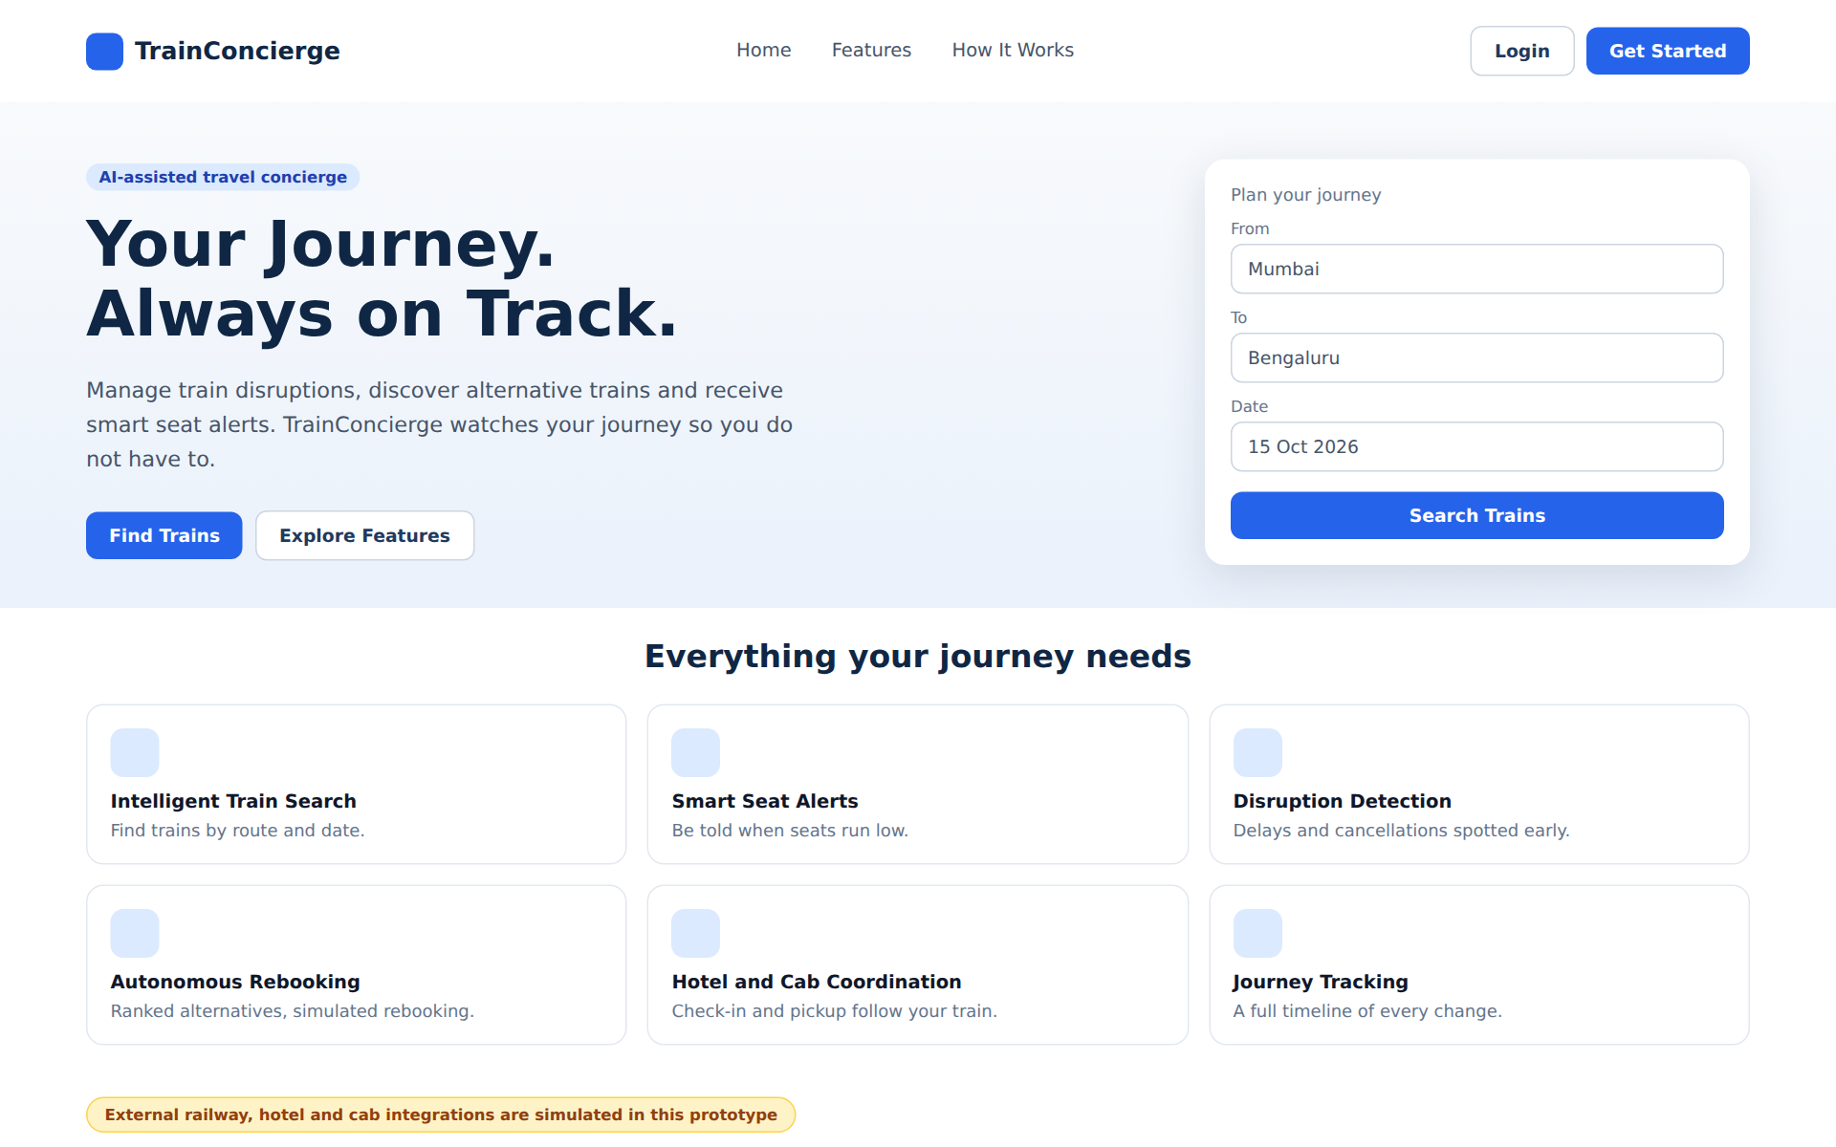
Figure 1: Landing page (design mockup with sample data)
Prompt to give Antigravity
Build the public landing page for TrainConcierge.

Sections:
- Navigation bar with logo, Home, Features, How It Works, Login / Get Started.
- Hero with headline "Your Journey. Always on Track." and supporting text about managing train disruptions, discovering alternative trains and receiving smart seat alerts. Primary CTA: Find Trains. Secondary CTA: Explore Features.
- Feature cards: Intelligent Train Search, Smart Seat Alerts, Disruption Detection, Autonomous Rebooking, Hotel and Cab Coordination, Journey Tracking.
- How It Works section.
- Trust and transparency section stating that external railway, hotel and cab integrations are simulated in this prototype.
- Footer.

Use responsive design and subtle animations. Use React Router for navigation.
Do not implement fake booking functionality. Every CTA must navigate to its intended page.

Visual reference: match the layout, spacing, colors and component style of Figure 1 in this document. The mockup is a design guide only. All data shown must come from the real backend APIs, and any element that the backend cannot support must be omitted or marked unavailable.

Verification checklist
☐ All CTAs and nav links route correctly.
☐ Simulation disclosure is visible.

Phase 5: Registration, Login and JWT Integration
Objective: First real backend integration: authentication, token handling and protected routes.
Visual reference: Figure 2 below shows the target layout and style for this screen.
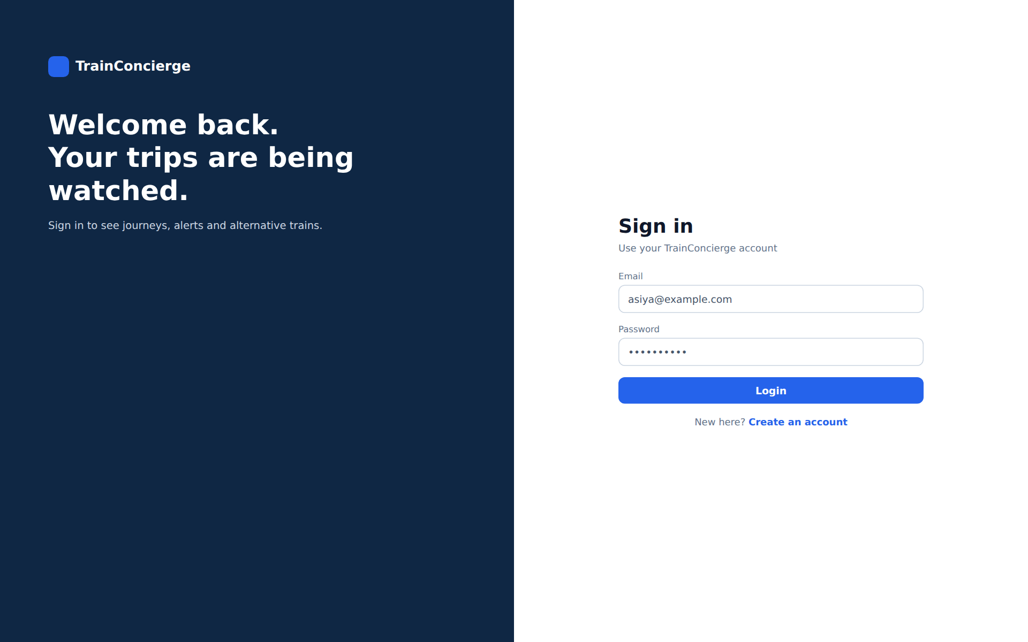
Figure 2: Login and registration (design mockup with sample data)
Prompt to give Antigravity
Implement registration and login pages for TrainConcierge and integrate them with the existing Spring Boot authentication APIs.
First read FRONTEND_API_CONTRACT.md and the actual backend authentication code.

Requirements:
- Registration form with the fields the backend supports.
- Login form using the actual backend request structure.
- Client-side validation, and clear display of backend validation errors.
- Connect forms through Axios.
- Store and manage the JWT using the safest approach compatible with the backend; document the trade-offs. Do not claim localStorage is secure against XSS. Prefer HttpOnly SameSite cookies only if the backend supports them.
- Attach the JWT through an Axios request interceptor.
- Handle expired or invalid tokens (401) with a response interceptor and redirect to login.
- Implement logout, protected routes, and role-based route access (USER / ADMIN) if the backend supports it.
- Redirect appropriately after login.
- Never hardcode credentials or tokens. Do not invent endpoints or response fields.

Test registration, login, logout, invalid credentials and protected-route behavior against the real backend.

Visual reference: match the layout, spacing, colors and component style of Figure 2 in this document. The mockup is a design guide only. All data shown must come from the real backend APIs, and any element that the backend cannot support must be omitted or marked unavailable.

Verification checklist
☐ Register, login, logout work against the real backend.
☐ Wrong password shows a clear error.
☐ Protected pages redirect when unauthenticated.
☐ GET /api/auth/me data is shown after login.

Phase 6: Main Dashboard
Objective: Authenticated home screen built only from data the backend actually provides.
Visual reference: Figure 3 below shows the target layout and style for this screen.
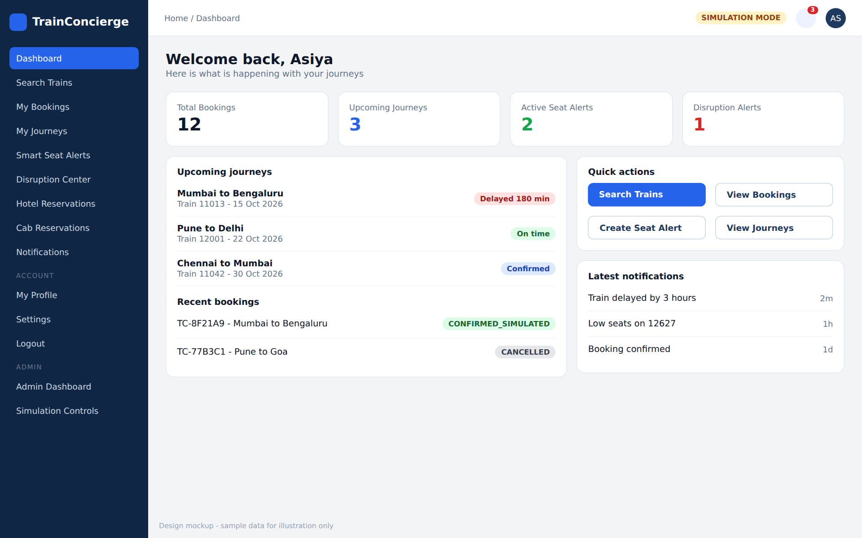
Figure 3: Main dashboard (design mockup with sample data)
Prompt to give Antigravity
Build the authenticated TrainConcierge dashboard and integrate it with the existing backend APIs.

Sections:
- Welcome message from the authenticated user's profile.
- Summary cards: Total Bookings, Upcoming Journeys, Active Seat Alerts, Disruption Alerts.
- Upcoming journey list, recent booking activity, latest notifications, journey status overview.
- Quick actions: Search Trains, View Bookings, Create Seat Alert, View Journeys.
- Disruption overview with clear status indicators.

Requirements:
- Fetch all data from the backend and use actual response fields.
- Do not calculate or fabricate metrics the backend cannot support.
- Show loading, empty and error states.
- Refresh data after relevant user actions.
- If an endpoint is missing, document the gap instead of faking data.

Visual reference: match the layout, spacing, colors and component style of Figure 3 in this document. The mockup is a design guide only. All data shown must come from the real backend APIs, and any element that the backend cannot support must be omitted or marked unavailable.

Verification checklist
☐ Every number on the dashboard traces to a real API response.
☐ Empty account shows empty states, not fake data.

Phase 7: Train Search and Schedule Browsing
Objective: Search trains end to end. Booking is NOT part of this phase.
Visual reference: Figure 4 below shows the target layout and style for this screen.
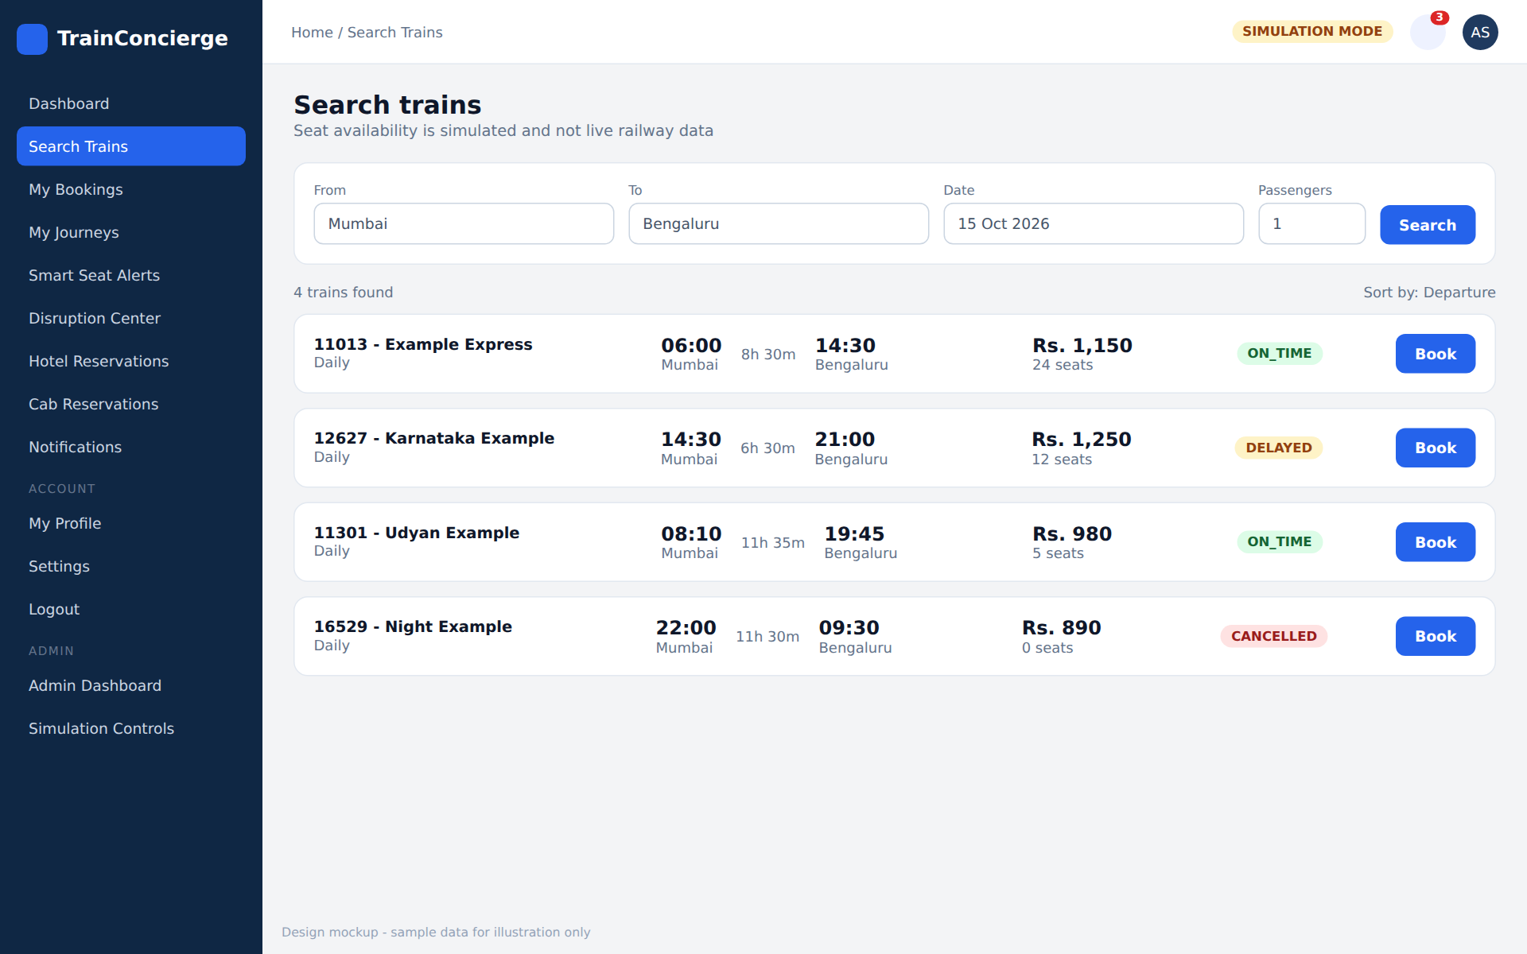
Figure 4: Train search results (design mockup with sample data)
Prompt to give Antigravity
Implement the train search module and connect it to the existing Spring Boot APIs.

Features:
- Source and destination station selection, journey date picker, search button.
- Results list: train number and name, departure and arrival time, journey duration, fare, seat availability, train status.
- Sorting, filtering and pagination based only on what the backend supports.
- Empty and error states.

Requirements:
- Use the real backend search APIs and follow the exact request and response contract.
- Prevent source and destination from being identical.
- Display dates and times in a consistent format.
- Clearly state that availability is simulated and not live railway availability.
- Make the UI responsive.

Do not implement booking in this phase.

Visual reference: match the layout, spacing, colors and component style of Figure 4 in this document. The mockup is a design guide only. All data shown must come from the real backend APIs, and any element that the backend cannot support must be omitted or marked unavailable.

Verification checklist
☐ Mumbai to Bengaluru search returns seeded data.
☐ No-result search shows an empty state.
☐ Same source and destination is blocked.

Phase 8: Seat Availability and Booking
Objective: Complete the simulated booking flow using backend inventory as the source of truth.
Visual reference: Figure 5 below shows the target layout and style for this screen.
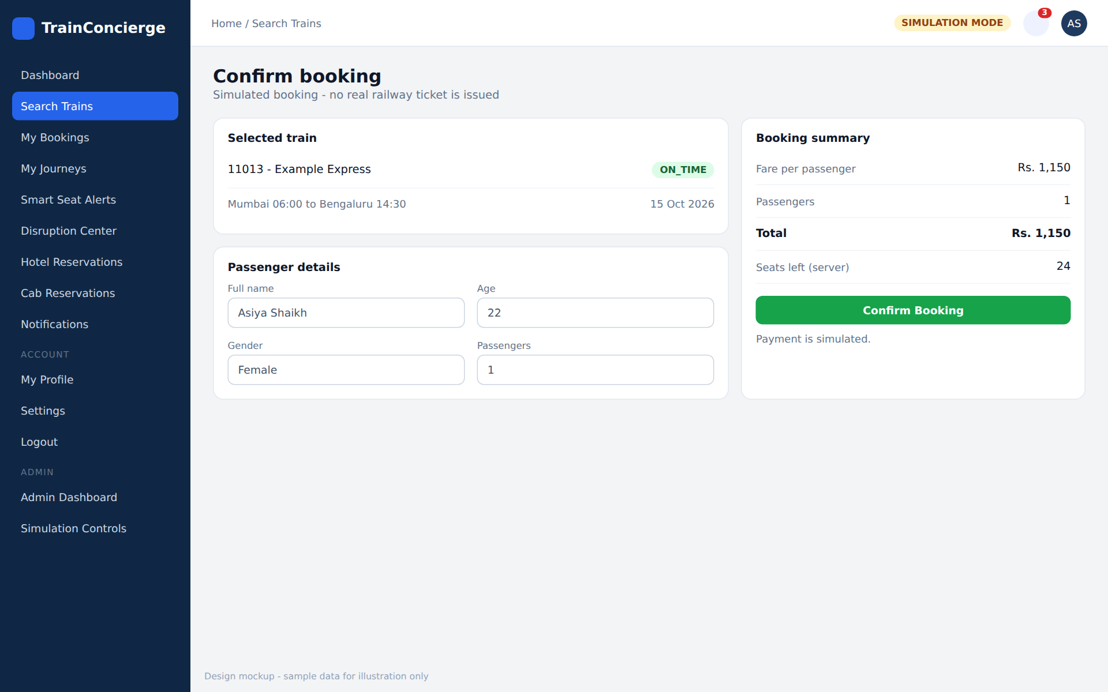
Figure 5: Booking confirmation (design mockup with sample data)
Prompt to give Antigravity
Implement train booking and seat availability using the existing backend APIs.

Workflow:
- User selects a train; frontend fetches current seat availability.
- Display available seats and fare.
- User enters the passenger details required by the backend.
- Show a booking summary, then the user confirms.
- Submit the booking request; display the confirmed booking reference and status.
- Update the booking list and dashboard.

Requirements:
- Backend inventory is the source of truth. Never decrement seat counts in frontend state as a substitute for backend transactions.
- Handle unavailable seats and concurrent-booking failures.
- Prevent duplicate form submissions (disable button while pending).
- Show clear success and failure messages and preserve the status returned by the backend.
- Do not claim a real IRCTC booking has been completed; label it as simulated.

Test the full flow against the MySQL-backed APIs.

Visual reference: match the layout, spacing, colors and component style of Figure 5 in this document. The mockup is a design guide only. All data shown must come from the real backend APIs, and any element that the backend cannot support must be omitted or marked unavailable.

Verification checklist
☐ Booking reduces seats in MySQL (check after refresh).
☐ Double-click does not create two bookings.
☐ Booking with too many passengers shows the backend error.

Phase 9: My Bookings
Objective: List, inspect and cancel the user's own bookings.
Prompt to give Antigravity
Build the My Bookings page and integrate it with the existing booking APIs.

Features:
- List the authenticated user's bookings: reference, train details, source and destination, journey date, fare, status, creation date.
- Booking detail view.
- Cancel booking (if supported) with a confirmation dialog.
- Search and filter by booking status.
- Empty and error states.

Requirements:
- Fetch data from the backend; ownership is enforced by backend authorization.
- Reflect cancellation results from the server (seat restoration happens in the backend).
- Preserve historical bookings and their statuses, including REPLACED and CANCELLED.
- Do not invent unsupported booking fields.

Verification checklist
☐ Cancelling updates status from the server response.
☐ Another user's booking ID returns an error, not data.

Phase 10: Journey Management and Timeline
Objective: Show the full story of each journey in one place.
Visual reference: Figure 6 below shows the target layout and style for this screen.
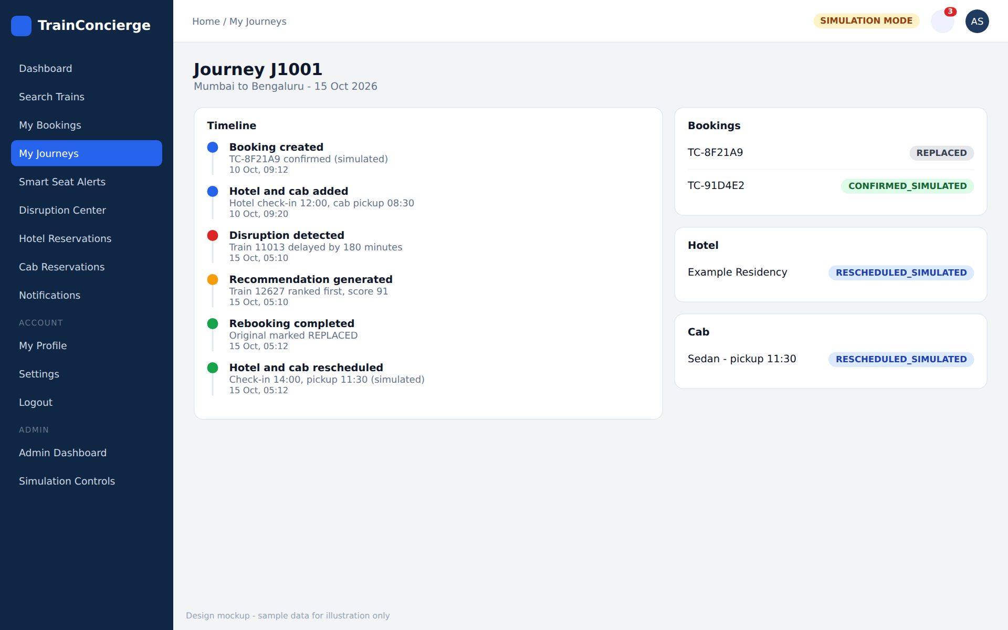
Figure 6: Journey details and timeline (design mockup with sample data)
Prompt to give Antigravity
Implement the Journey Management module.

Features:
- List user journeys and a journey detail page.
- Chronological timeline of journey events (use the existing timeline API).
- Train booking, hotel reservation and cab reservation details.
- Journey status, disruption history, rebooking history, related notifications.

Requirements:
- Integrate with the existing journey and history APIs only.
- Display events chronologically.
- Clearly distinguish completed, pending, cancelled and replaced items according to the backend enums.
- Show original and replacement booking information when available.
- Do not fabricate timeline events.
- Handle missing optional hotel or cab reservations gracefully.

Visual reference: match the layout, spacing, colors and component style of Figure 6 in this document. The mockup is a design guide only. All data shown must come from the real backend APIs, and any element that the backend cannot support must be omitted or marked unavailable.

Verification checklist
☐ Timeline order matches backend order.
☐ Journey without hotel/cab renders without errors.

Phase 11: Hotel and Cab Reservation UI
Objective: Manage simulated hotel and cab reservations linked to a journey.
Prompt to give Antigravity
Implement hotel and cab reservation interfaces for TrainConcierge.
First inspect the existing hotel and cab controllers, MockHotelService and MockCabService, and their API contracts.

Hotel features: add a reservation to a journey (hotel name, city, address, check-in, check-out), view status, reschedule.
Cab features: add a reservation (pickup location, destination, pickup time, cab type), view status, reschedule.
Offer create/cancel only if the backend supports it.

Requirements:
- Integrate with the existing backend APIs; the backend is the source of truth.
- Clearly label every result and transaction as simulated.
- Never claim a real hotel or cab provider was contacted.
- Validate check-out after check-in and handle errors.
- Show old and new values after rescheduling where the backend returns them.

Verification checklist
☐ Hotel and cab can be attached to own journey only.
☐ Simulated labels are visible.

Phase 12: Smart Seat Alert System
Objective: Subscribe to seat thresholds and view triggered alerts.
Prompt to give Antigravity
Implement the Smart Seat Alert module and connect it to the existing seat-alert APIs (POST /api/seat-alerts, GET /api/seat-alerts/my, PATCH /api/seat-alerts/{id}/deactivate, plus any others that exist).

Features:
- Create an alert for a schedule with a seat threshold.
- View active subscriptions and alert status.
- Deactivate an alert (and activate/delete only if supported).
- Show triggered alerts and alert history where available.

Requirements:
- Use actual backend APIs only.
- Explain in the UI that alerts use simulated seat availability.
- Prevent duplicate submissions and refresh state after changes.
- Handle triggered and inactive subscriptions correctly.
- Do not add frontend polling that conflicts with the backend scheduler (use a refresh on page load or a gentle manual refresh).

Verification checklist
☐ Alert triggers after seats drop to the threshold via a booking or admin change.
☐ Deactivated alert no longer triggers.

Phase 13: Disruption Center and Recommendations
Objective: Display disruptions and ranked alternatives. All scoring stays in the backend.
Visual reference: Figure 7 below shows the target layout and style for this screen.
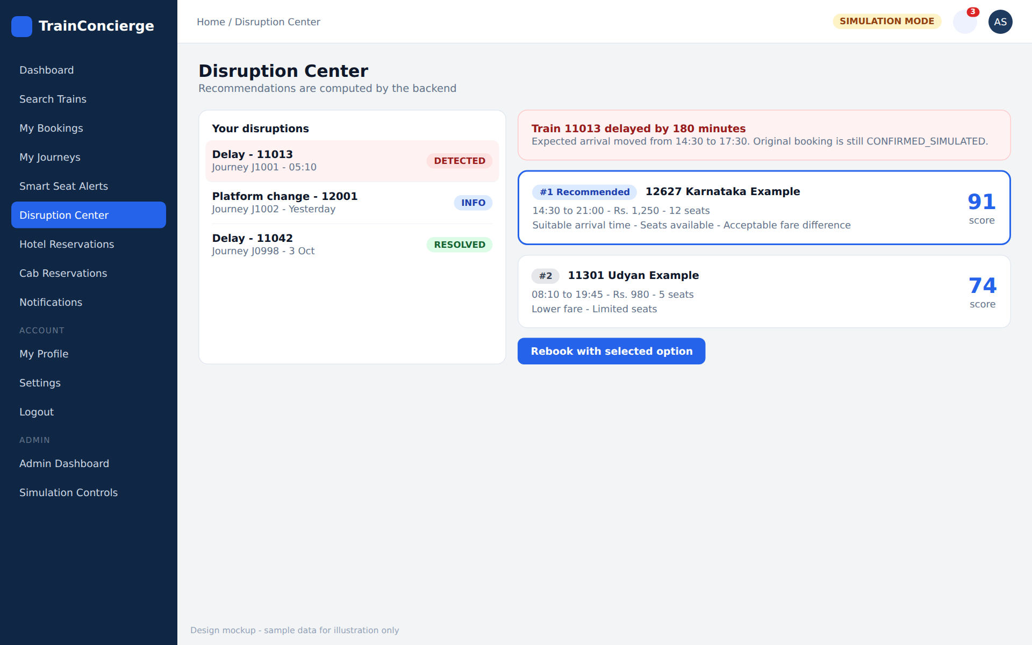
Figure 7: Disruption Center with ranked recommendations (design mockup with sample data)
Prompt to give Antigravity
Implement the Train Disruption Center and integrate it with the existing disruption and recommendation APIs (GET /api/disruptions/my, GET /api/disruptions/{id}, POST and GET /api/disruptions/{id}/recommendations).

Features:
- List disruption events with type (delay, cancellation, platform change or other backend types), severity and status, affected journey and train, detected time.
- List alternative train recommendations with score, reasons, fare, departure and arrival time, seat availability.
- Let the user inspect a recommendation.
- Offer a rebooking action only where the backend supports it.

Rules:
- Do not calculate recommendation scores in React.
- Do not make autonomous rebooking decisions in the frontend.
- Clearly distinguish a recommendation from a confirmed rebooking.
- Display the exact status returned by the server.
- Handle the no-alternative-available case with a clear message.

Visual reference: match the layout, spacing, colors and component style of Figure 7 in this document. The mockup is a design guide only. All data shown must come from the real backend APIs, and any element that the backend cannot support must be omitted or marked unavailable.

Verification checklist
☐ Scores shown match API values exactly.
☐ No-alternatives scenario shows a helpful state.

Phase 14: Autonomous Rebooking Workflow
Objective: The critical business workflow: confirm and display a simulated rebooking.
Visual reference: Figure 8 below shows the target layout and style for this screen.
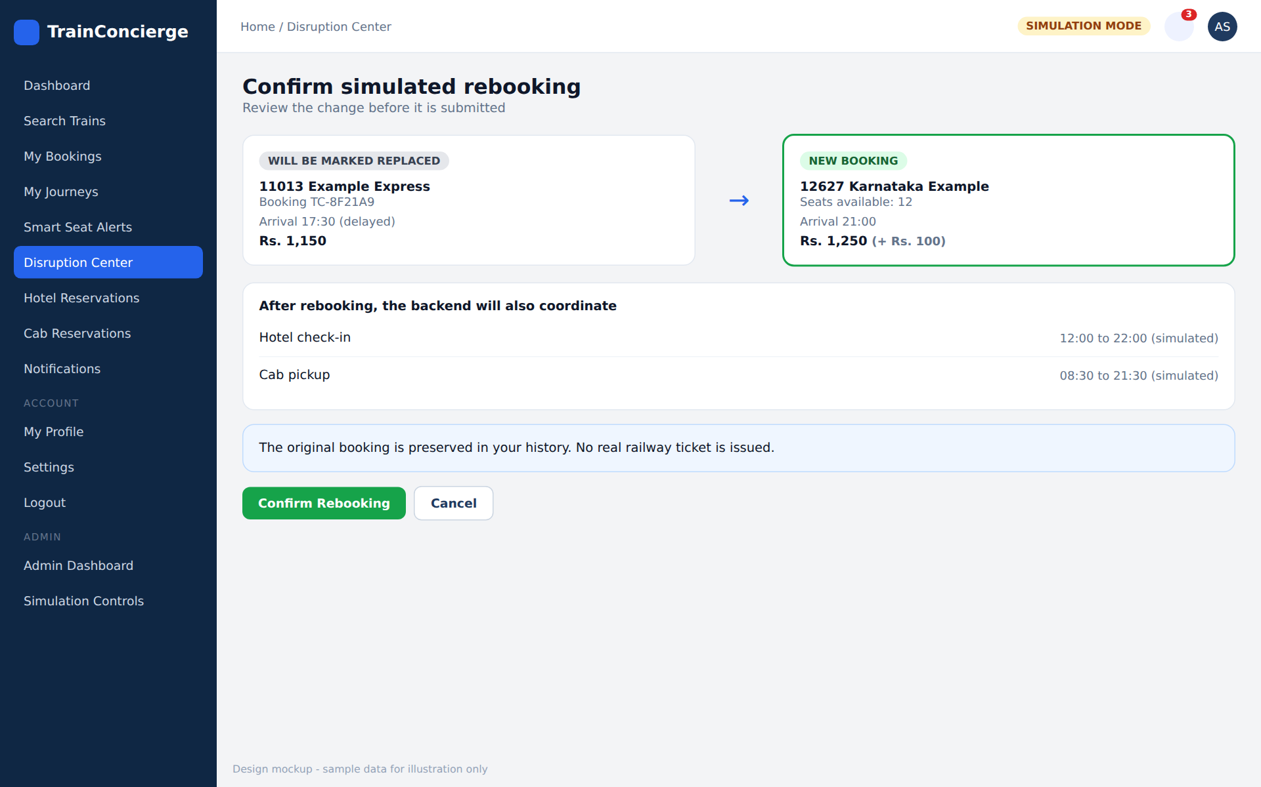
Figure 8: Rebooking confirmation (design mockup with sample data)
Prompt to give Antigravity
Implement the frontend workflow for simulated train rebooking.
Inspect the existing rebooking APIs (POST /api/disruptions/{id}/rebook, GET /api/journeys/{id}/rebooking-history) and their transaction and idempotency behavior first.

Workflow:
- Display the disruption and the original booking.
- Present recommended alternatives with reasons, fare differences and availability.
- Show a rebooking confirmation step.
- Submit the rebooking request using the backend contract.
- Display the server result and refresh booking, journey, notification and timeline data.
- Show original and replacement booking references.

Requirements:
- No rebooking business logic in React.
- Prevent duplicate rebooking submissions.
- Handle pending, successful, failed and partially completed workflows.
- Clearly show that the original booking is preserved as REPLACED.
- Show hotel and cab coordination statuses separately.
- Do not claim success until the backend confirms it.
- Use confirmation dialogs for consequential actions.
- Offer retry only where the backend supports it safely.

Visual reference: match the layout, spacing, colors and component style of Figure 8 in this document. The mockup is a design guide only. All data shown must come from the real backend APIs, and any element that the backend cannot support must be omitted or marked unavailable.

Verification checklist
☐ Rebooking twice returns a handled error, not a second booking.
☐ Hotel and cab statuses appear after rebooking.

Phase 15: Notification Center
Objective: One place for all in-app alerts.
Visual reference: Figure 9 below shows the target layout and style for this screen.
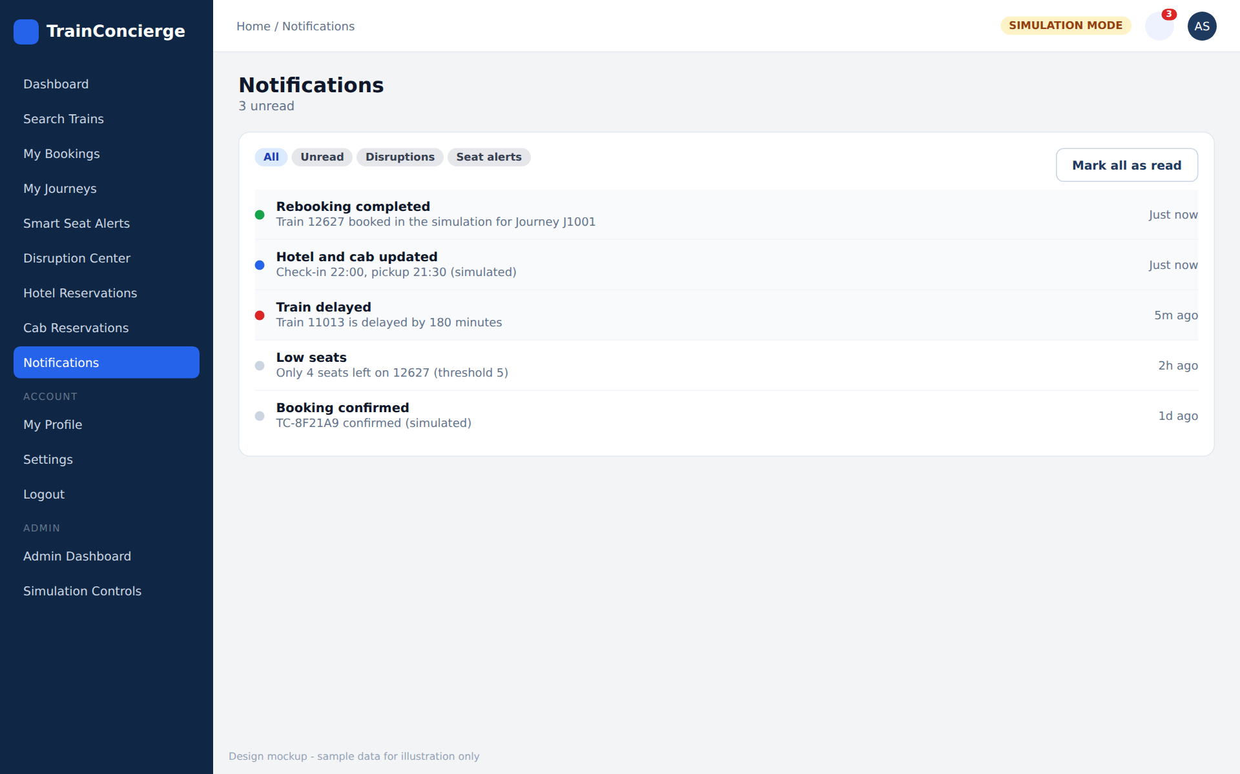
Figure 9: Notification center (design mockup with sample data)
Prompt to give Antigravity
Implement a centralized notification center for TrainConcierge using the existing APIs (GET /api/notifications/my, /unread-count, PATCH /{id}/read, PATCH /read-all).

Features:
- Notification list with pagination, newest first.
- Unread and read states, categories, timestamps.
- Mark as read and mark all as read.
- Unread count badge in the navbar.
- Link to the related journey or booking where data allows.
- Empty and error states.

Do not fabricate notification records. If a capability is not supported by the backend, document the limitation instead of faking frontend-only state.

Visual reference: match the layout, spacing, colors and component style of Figure 9 in this document. The mockup is a design guide only. All data shown must come from the real backend APIs, and any element that the backend cannot support must be omitted or marked unavailable.

Verification checklist
☐ Badge count matches unread-count API.
☐ Marking read persists after refresh.

Phase 16: Admin Dashboard and Simulation Controls
Objective: Role-restricted tools to run the demo reliably.
Visual reference: Figure 10 below shows the target layout and style for this screen.
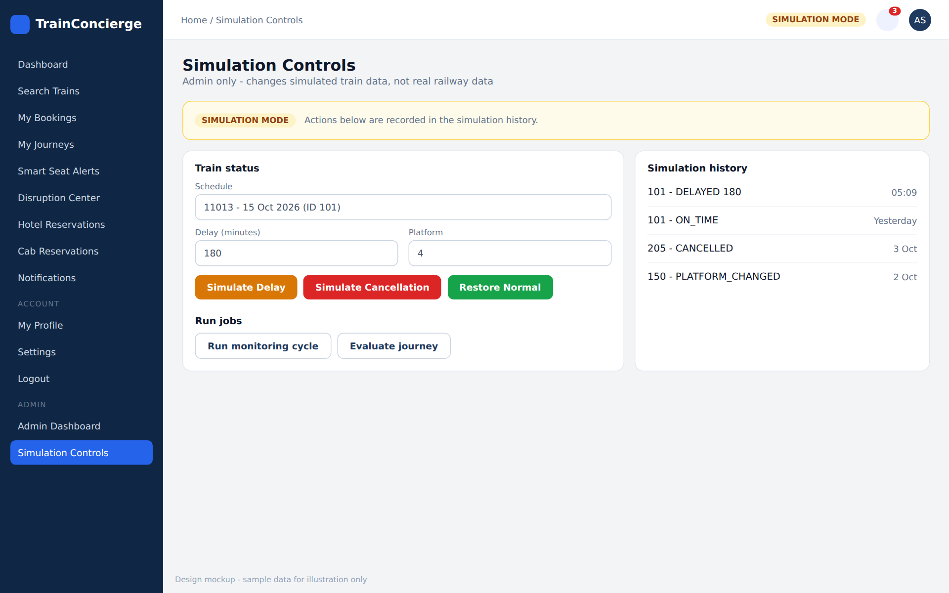
Figure 10: Admin simulation controls (design mockup with sample data)
Prompt to give Antigravity
Implement the admin dashboard using the existing backend admin and simulation APIs.

Features (according to actual backend support):
- Train, schedule and seat availability management.
- Train status simulation: delay, cancellation, platform change, restore normal.
- Manual trigger for the monitoring cycle and disruption evaluation if available.
- Disruption monitoring and simulation history.

Requirements:
- Protect admin pages with role-based routing. Backend authorization is mandatory; frontend checks are for UX only.
- Add confirmation dialogs for disruptive operations.
- Show a clear SIMULATION MODE indicator.
- Show the backend result of each operation.
- Never expose admin functionality to non-admin users.
- Do not create unsupported admin operations.

Visual reference: match the layout, spacing, colors and component style of Figure 10 in this document. The mockup is a design guide only. All data shown must come from the real backend APIs, and any element that the backend cannot support must be omitted or marked unavailable.

Verification checklist
☐ A normal user cannot open admin routes or call admin APIs.
☐ Simulating a 180-minute delay triggers the disruption workflow.

Phase 17: Profile, Settings and UX Polish
Objective: Finish the user experience.
Prompt to give Antigravity
Complete the user profile and overall application experience.

Implement:
- Profile page; update profile and change password only if the backend supports them.
- Account settings and logout.
- Responsive sidebar and navbar, consistent page titles and breadcrumbs.
- Form validation and accessible labels.
- Loading skeletons, empty states, error boundaries, toasts, confirmation dialogs.
- Consistent date, time and currency (INR) formatting.
- Mobile and tablet responsiveness.

Remove all development-only mock data from production-facing flows.
Every visible button must perform a real action or be clearly marked as unavailable.

Verification checklist
☐ No leftover mock data.
☐ Layout works at 375px, 768px and 1280px widths.

Phase 18: Full Frontend-Backend Integration Testing
Objective: Final audit across the whole application.
Prompt to give Antigravity
Perform a complete integration audit of TrainConcierge. Inspect the entire frontend and backend.

Verify these workflows:
- Registration, login and JWT authentication, protected routes.
- Train search, seat availability, booking, booking cancellation.
- Journey details, hotel and cab simulation.
- Seat alert subscription and triggering.
- Train delay simulation, disruption detection, alternative recommendations.
- Rebooking, original booking preservation, replacement booking, seat inventory consistency.
- Hotel and cab coordination, notifications, journey timeline.
- Admin authorization, logout and expired-token handling.

Also verify:
- CORS configuration and API base URL configuration.
- No hardcoded secrets, no fake success messages, no broken routes.
- No console errors, no unhandled API failures, no duplicate form submissions.
- No cross-user data exposure.
- No frontend assumptions that conflict with backend enums or response fields.

Run available frontend and backend tests.
Report: passed workflows, failed workflows, missing APIs, required backend changes, remaining limitations, and exact commands to start both applications.
Do not claim tests passed unless they were actually executed.

Verification checklist
☐ The full demo story works: search, book, simulate disruption, recommendations, rebook, check journey and notifications.

7. Working Cycle for Every Phase
- Read FRONTEND_API_CONTRACT.md and inspect the relevant backend code.
- Implement only the current phase and preserve existing work.
- Start MySQL and the Spring Boot backend, then start the frontend in a separate terminal.
- Test in the browser; check the console and the Network tab.
- Fix root causes. Do not use mock responses to hide integration failures.
- Report files changed and any remaining issues.
- Commit the verified phase to Git before starting the next.

Debugging prompt
The current frontend implementation is not working correctly with the existing backend.
Inspect the browser console, network requests, backend logs, the API contract and the relevant source files.
Identify the root cause before modifying code. Fix the issue without changing unrelated functionality.
Do not use mock responses to hide API integration failures.
After fixing: explain the root cause, list the files changed, explain the correction, verify the affected workflow, and identify remaining issues.

8. Final Demo Scenario
The finished application must complete this story end to end:
- Register a passenger and log in.
- Search trains from Mumbai to Bengaluru.
- Book the original train and add a hotel and a cab.
- As admin, simulate a 180-minute delay on the booked schedule.
- Trigger the monitoring cycle; a disruption appears in the Disruption Center.
- View ranked alternative trains with scores and reasons.
- Confirm the simulated rebooking.
- Verify the original booking shows REPLACED and the replacement booking is confirmed.
- Verify hotel and cab were rescheduled (simulated).
- Verify notifications and the journey timeline show every step.

Definition of done
☐ All 18 phases implemented and verified
☐ Authentication, protected routes and admin roles work
☐ Booking, cancellation and seat inventory stay consistent with MySQL
☐ Disruption, recommendation and rebooking workflow works through backend APIs only
☐ Hotel and cab coordination statuses display correctly
☐ Notifications and timeline are accurate
☐ No console errors, fake success messages or cross-user data exposure
☐ README documents setup and commands for both applications

