Data Validation Checks
- Quick Sanity Check
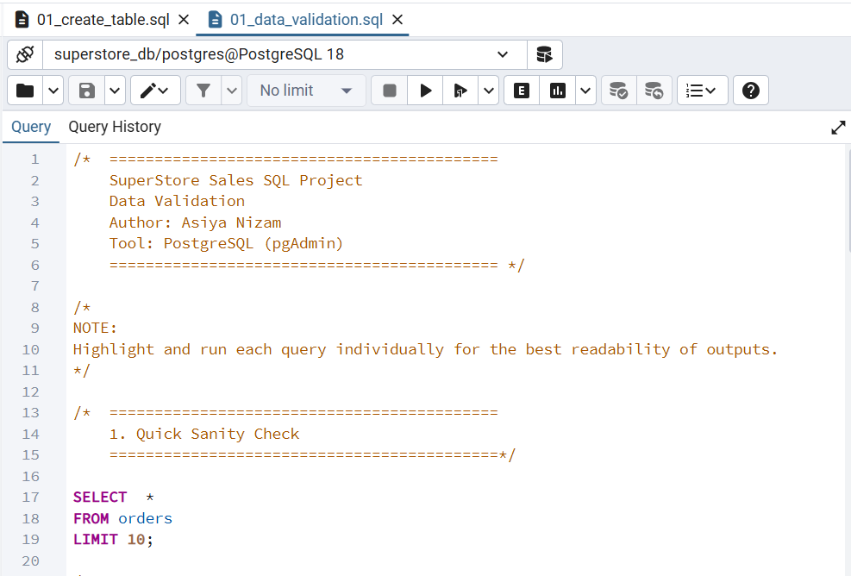
Output:
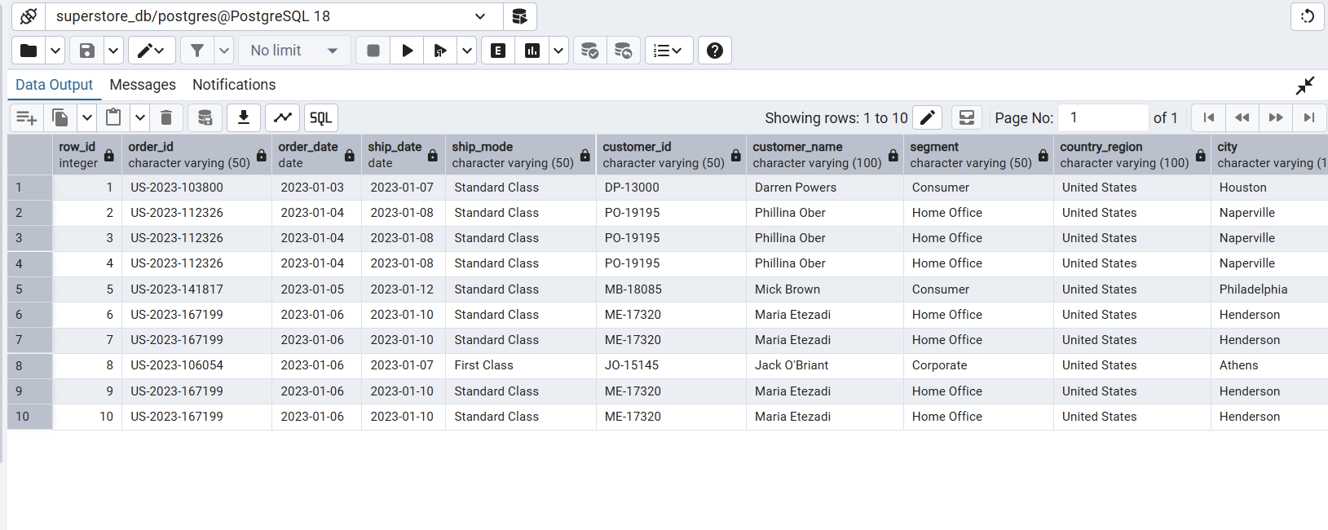

- Data Type Inspection
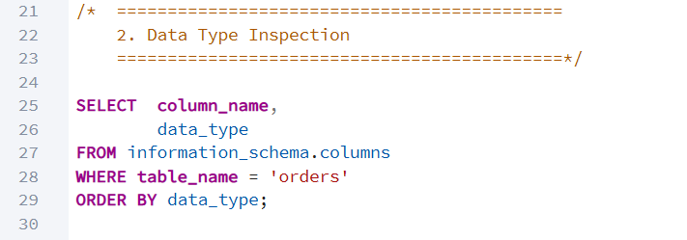
Output:
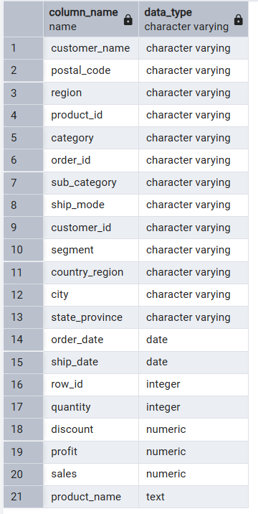
- Row Count Check
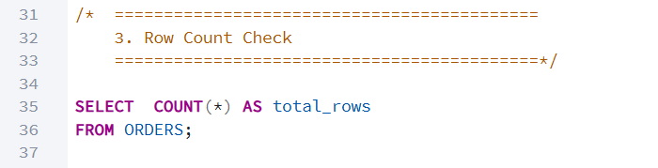
Output:
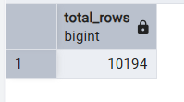
- Duplicate Check (Row Id Level)
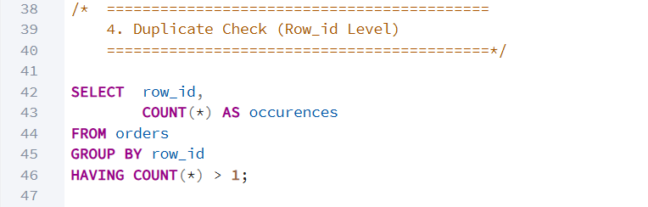
Output:
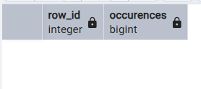
- Orders Spanning Multiple Rows
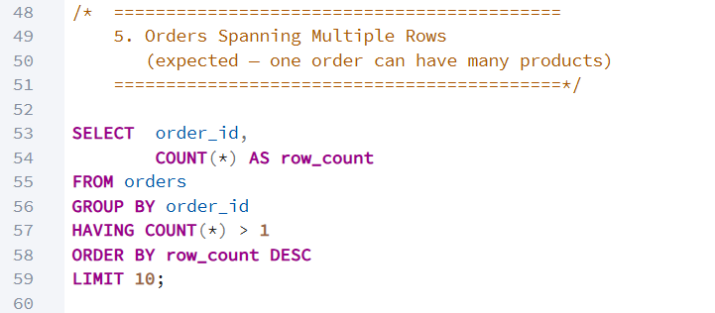
Output:
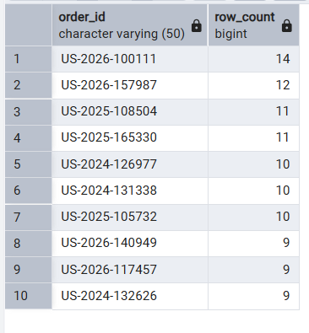
- Missing Values Check (Data Quality)
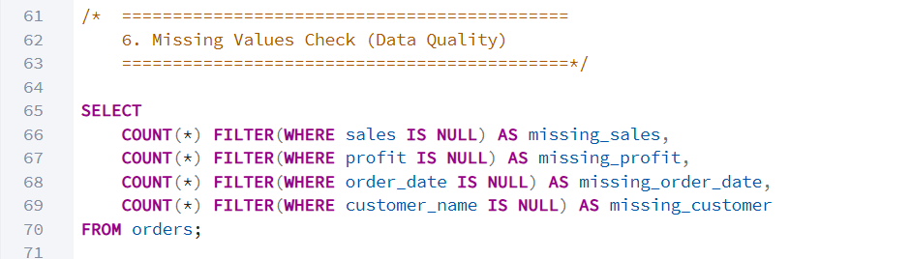

Output:
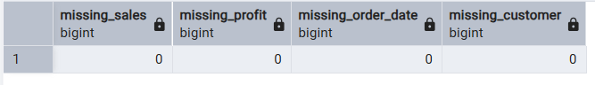
- Invalid Sales
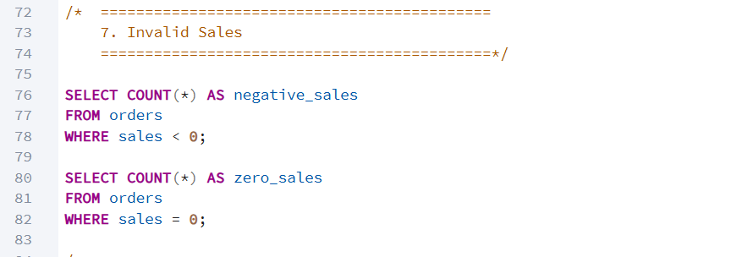
Outputs:
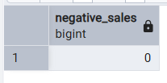
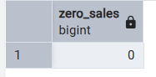
- Invalid Quantity
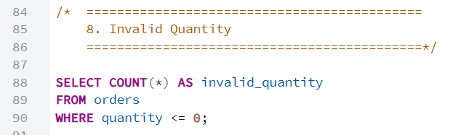

Output:
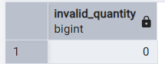
- Discount Range Check
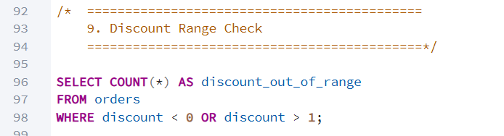

Output:
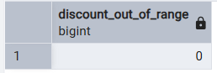
- Date Range Check
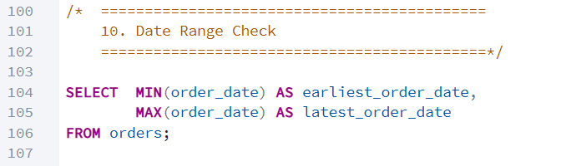
Output:
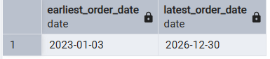
- Ship Date Before Order Date Check
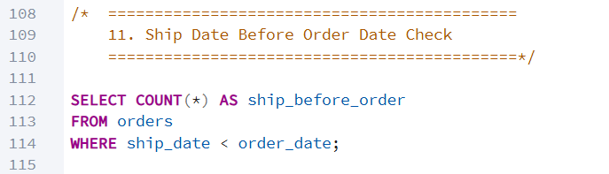

Output:
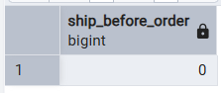
- Future Order Date Check
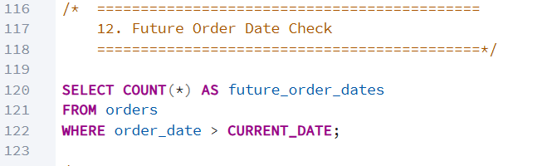
Output:
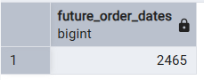
- Distinct Category Check
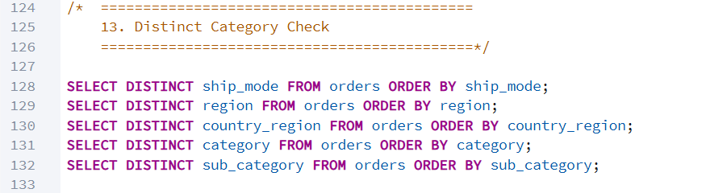

Outputs:
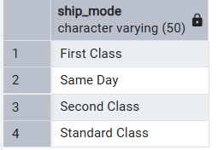

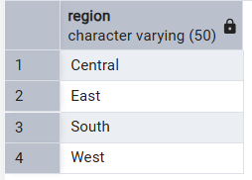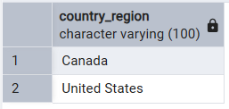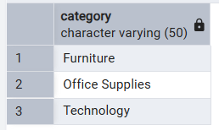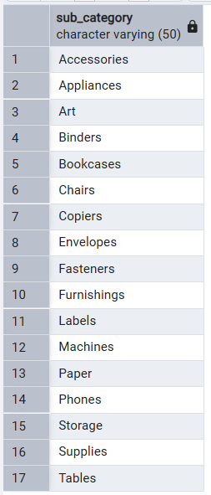
- Business KPI Sanity Check
