STATISTICAL ANALYSIS OF CHOCOLATE SALES
Applied Statistics – CIE 3

Student Name: Aryan S Jain
Student USN: 1RUA25CSE0087
Course Code: SE2041
Course Name: Applied Statistics
Professor: Prof. Varadurga Bhat
Date: 11 November 2026

Table of Contents

Introduction
The present study investigates whether there is an association between the quantity of chocolate sold and the total revenue generated from sales transactions. The research question guiding the analysis is: “Is there an association between quantity sold and revenue?” The study examines whether transactions involving larger quantities of chocolate tend to generate higher revenue.
The analysis uses the chocolate sales dataset supplied for this project. The project data are organised into transaction records and related product, customer, store, and calendar information. The transaction data provide the quantities sold and revenue values, while the supporting datasets provide descriptive information about products, customers, and stores. The analysis uses the project’s reproducible sampled dataset rather than attempting to process the full sales file directly in Excel.
Quantity is treated as the independent variable, while total revenue is treated as the dependent variable. Descriptive statistics and visualisations are used to summarise the data. Pearson’s correlation coefficient and the coefficient of determination are then used to assess the direction, strength, and explanatory power of the linear association. The results are interpreted as evidence of association rather than proof of a cause-and-effect relationship.

Methodology
The study began with the supplied raw sales data and related reference datasets. Because the complete sales file was too large for convenient direct analysis in Excel, a Simple Random Sample of 1,000 transactions was selected without replacement. A fixed random seed of 42 was used so that the sampling process could be reproduced. Product, customer, and store information was joined to the sampled transaction records using the relevant identifiers.
The variables used in the analysis and their measurement scales are summarised below. Nominal variables identify categories without a numerical order. Interval variables have meaningful differences but no absolute zero, while ratio variables have meaningful differences and a true zero.
The initial sample contained 1,000 transactions and 24 variables. During data validation, eight records were identified with unmatched product identifiers, including P0000 and P0201. These records lacked corresponding product information such as product name, brand, category, cocoa percentage, and product weight. Since these missing attributes could not be reliably recovered from the supplied product reference data, the affected transactions were excluded from the analytical dataset.
No numerical values were imputed, and no unsupported category labels were introduced. The original 1,000-record sampled dataset was retained separately for traceability. After excluding the eight unmatched records, the final cleaned dataset contained 992 transactions and 24 variables, with no missing or empty cells. This cleaned dataset was used for the subsequent frequency tables, descriptive statistics, visualisations, and correlation analysis.
The resulting workflow therefore consisted of reproducible sampling, joining the relevant reference information, validating the joined records, removing eight unmatched transactions, and using the remaining 992 complete transactions for statistical analysis. The cleaning decisions and variable definitions are documented separately in the project documentation.
Variable | Type | Measurement scale | Role / description
Quantity | Quantitative – discrete | Ratio | Independent variable; number of units sold.
Revenue | Quantitative – continuous | Ratio | Dependent variable; total transaction revenue.
Unit price | Quantitative – continuous | Ratio | Supporting variable; price per unit.
Discount | Quantitative | Ratio | Supporting variable; transaction discount.
Profit | Quantitative – continuous | Ratio | Supporting variable; transaction profit.
Age | Quantitative – discrete | Ratio | Customer age.
Order date | Temporal | Interval | Date of the transaction.
Product category | Qualitative | Nominal | Chocolate category.
Brand | Qualitative | Nominal | Product brand.
Gender | Qualitative | Nominal | Customer gender category.
Loyalty member | Qualitative | Nominal | Loyalty membership status.
Country | Qualitative | Nominal | Transaction/customer country.

Descriptive Statistical Analysis
This section presents the descriptive statistical findings for the 992 cleaned chocolate sales transactions. It examines product category and gender distributions, transaction revenue, and the central tendency and dispersion of quantity sold and revenue.

Categorical Distributions
The following figures summarise the categorical composition of the cleaned transaction dataset.
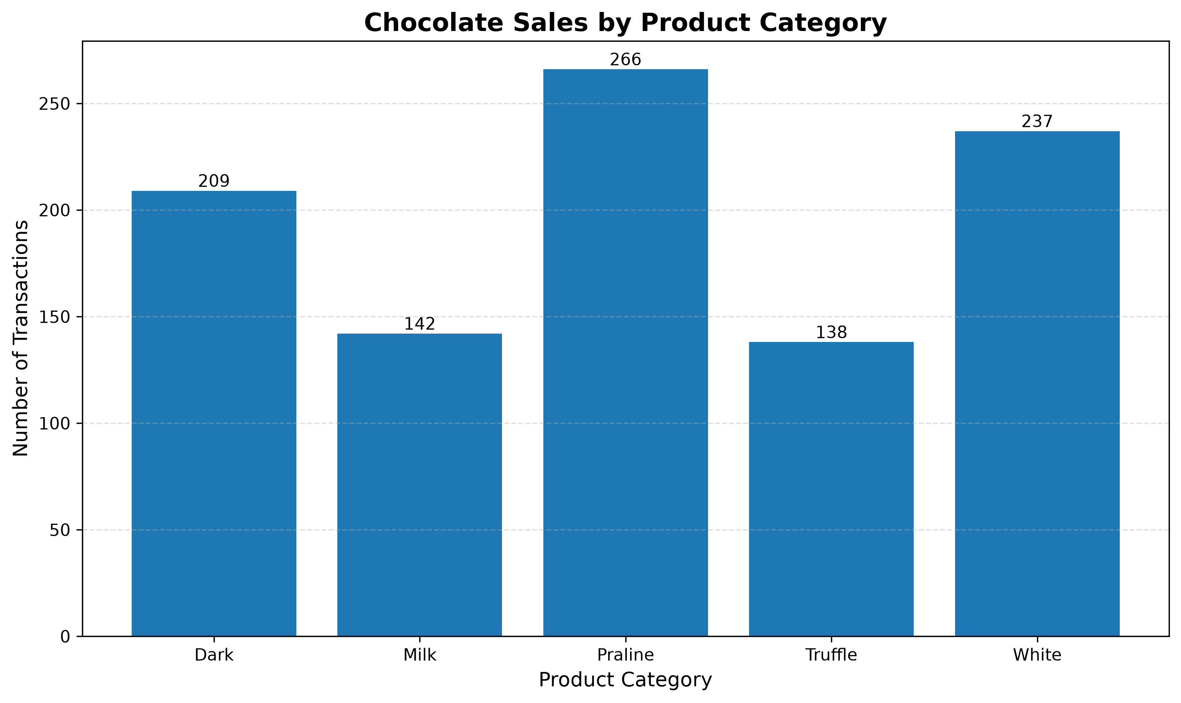
Figure 1. Frequency distribution of chocolate product categories
Praline was the most frequently recorded category, with 266 transactions, followed by White (237) and Dark (209). Truffle (138) and Milk (142) had fewer transactions. The distribution shows that transactions were not equally distributed across product categories.
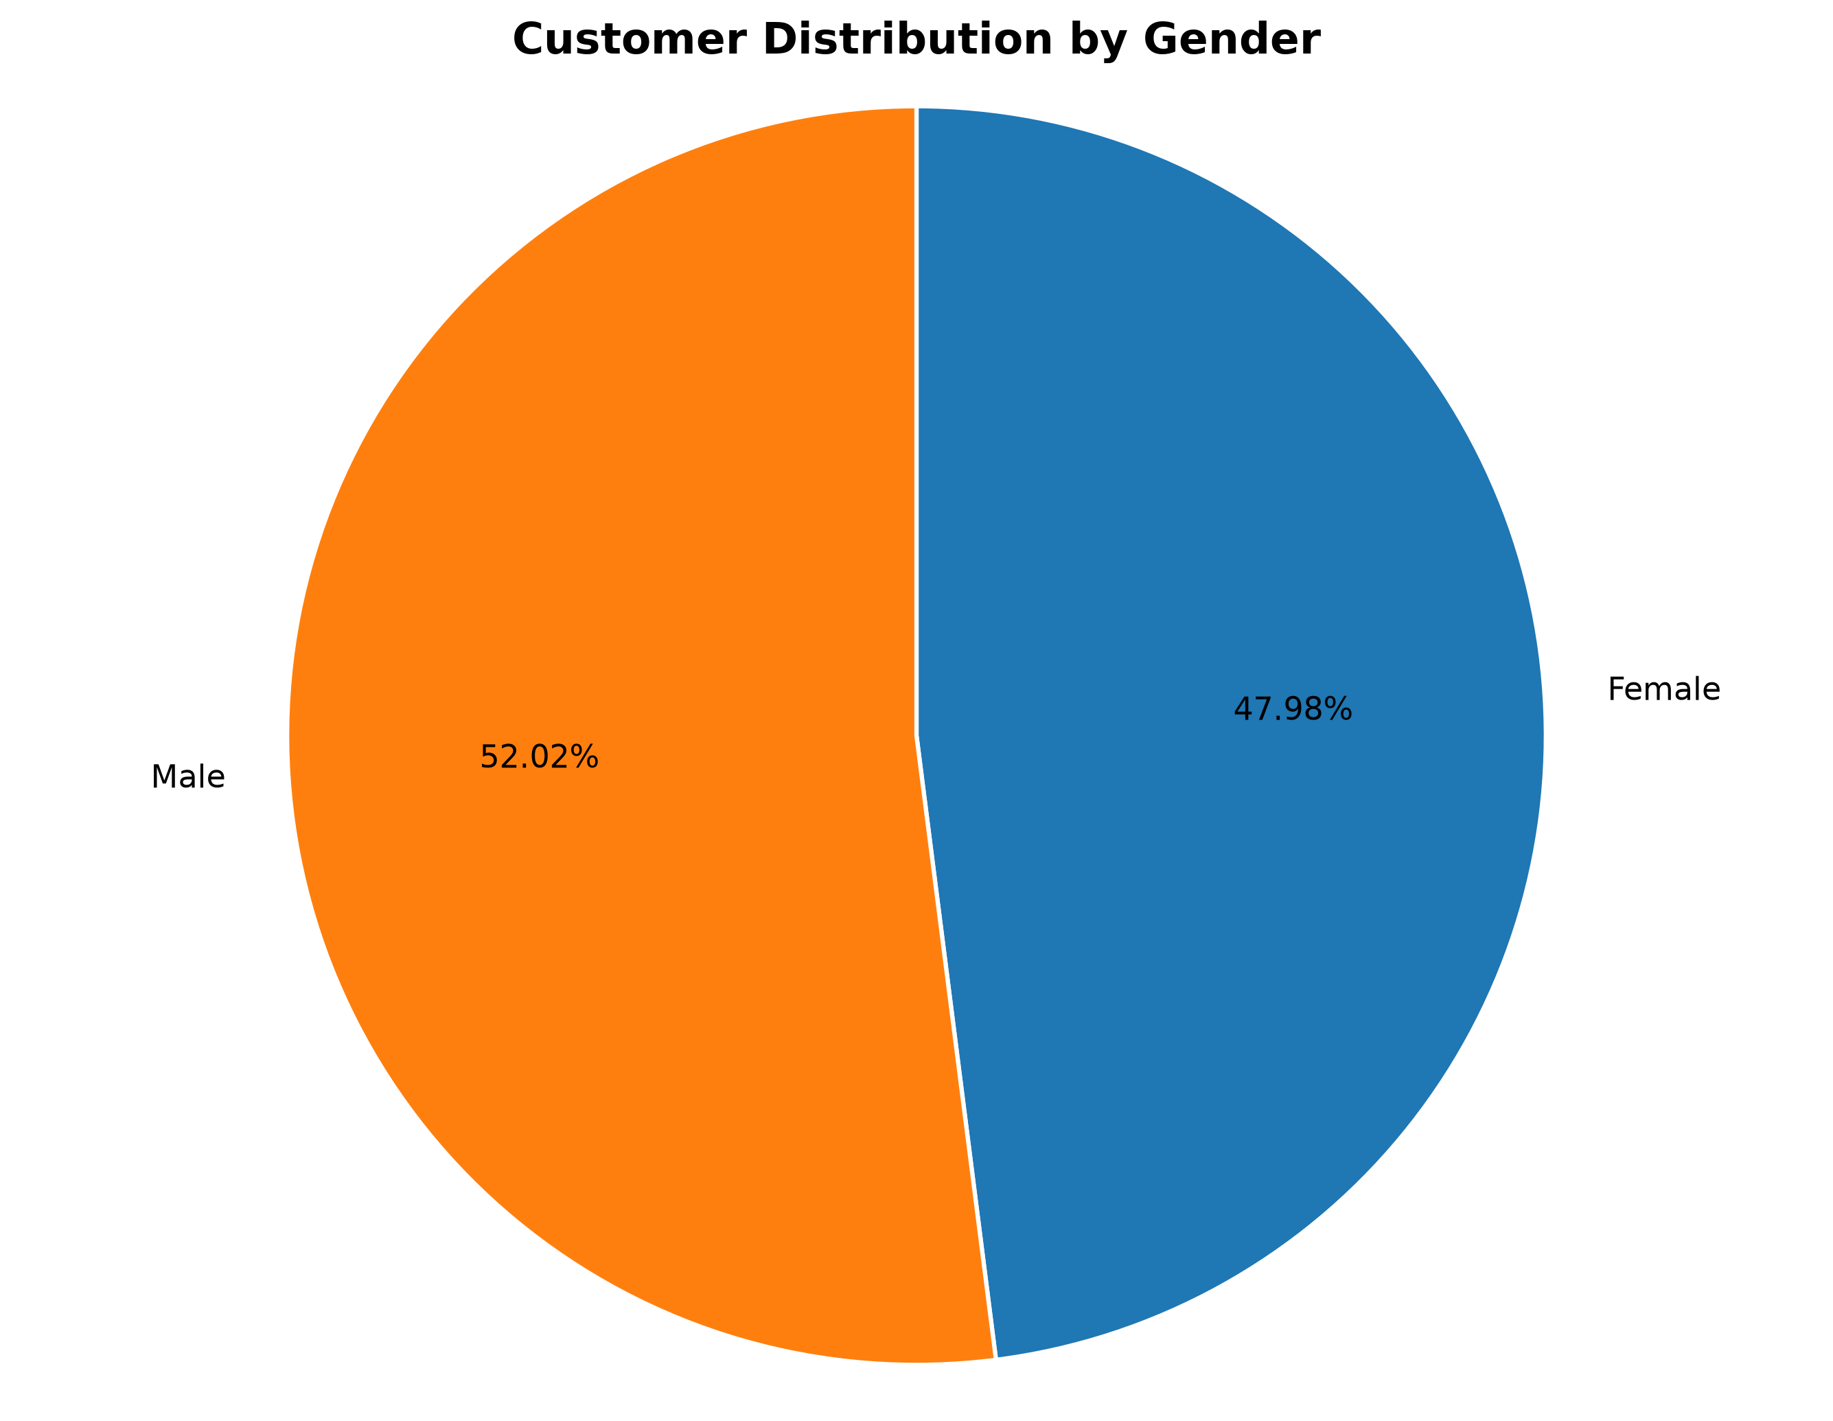
Figure 2. Distribution of transactions by customer gender
Male customers accounted for 516 transactions (52.02%), while female customers accounted for 476 transactions (47.98%). The distribution is relatively balanced. These percentages represent transactions classified by gender, not unique customers.

Revenue Distribution
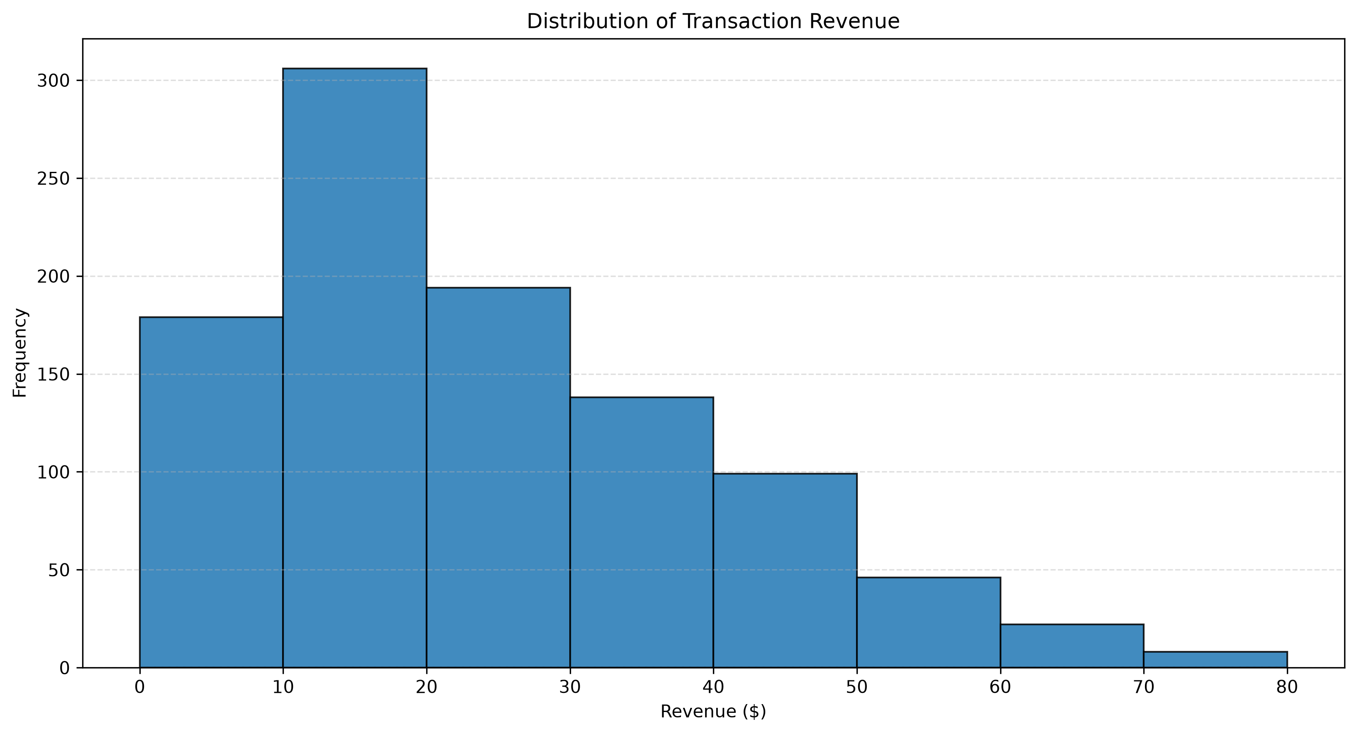
Figure 3. Frequency distribution of transaction revenue
The revenue histogram shows a concentration of transactions in the lower revenue intervals. The $10–$20 interval contains 306 transactions, the largest frequency. Frequencies generally decline across higher intervals, producing a longer right tail consistent with positive skewness.
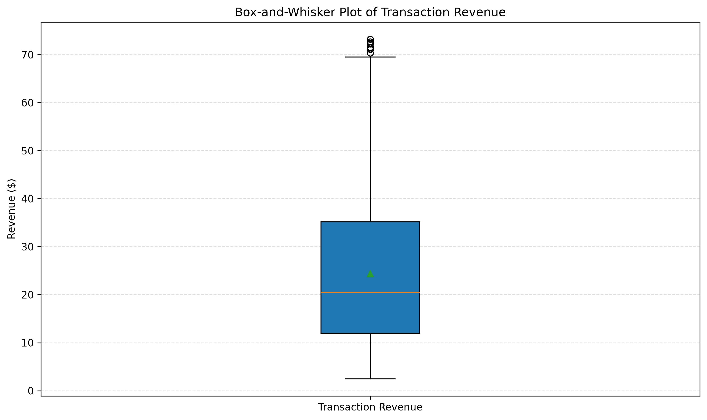
Figure 4. Box-and-whisker plot of transaction revenue
The median revenue is $20.47, and the middle 50% of transactions fall between approximately $11.94 and $35.17. The IQR is $23.23. The 1.5 × IQR rule identifies eight potential high-value outliers above the upper fence of approximately $70.02. These observations should be investigated rather than automatically removed because they may represent genuine high-revenue transactions.

Descriptive Statistics
Table 1 summarises the central tendency and dispersion of quantity sold and transaction revenue. The standard deviations are sample standard deviations.
Statistic | Quantity (units) | Revenue
Mean | 2.8901 | $24.3781
Median | 3.0000 | $20.4700
Mode | 1.0000 | $29.2000
Standard deviation | 1.3923 | $15.6019
Range | 4.0000 | $70.8100
Table 1. Descriptive statistics for quantity and revenue
For quantity sold, the mean is approximately 2.89 units and the median is 3 units. These values are close, indicating that the centre of the quantity distribution is relatively balanced. The mode is 1 unit, showing that one-unit transactions are the most frequently occurring individual quantity. The standard deviation is approximately 1.39 units, while the range is 4 units.
For revenue, the mean is approximately $24.38, which is higher than the median of $20.47. A mean greater than the median is consistent with positive (right) skewness, where relatively high-revenue transactions pull the mean upward. The mode is $29.20. Revenue also has a considerably larger standard deviation ($15.60) and range ($70.81), indicating substantial variation in transaction revenue.
The revenue box plot identifies eight potential upper outliers using the 1.5 × IQR rule. The lower quartile is approximately $11.94, the upper quartile is approximately $35.17, and the interquartile range is approximately $23.23. The upper outlier fence is approximately $70.02. No quantity observations were identified as outliers using the same rule. The potential revenue outliers were retained because statistical outlier status alone is not sufficient justification for deleting valid transactions.

Correlation Analysis
This section examines whether the quantity of chocolate sold is associated with total transaction revenue. Pearson's product-moment correlation coefficient and simple linear regression were used to describe the direction, strength and explanatory value of the relationship across the 992 cleaned transactions.
Correlation and Regression Results
The Pearson correlation coefficient was calculated as r = 0.7425. This indicates a strong positive linear association between quantity sold and total revenue. Transactions involving larger quantities generally tend to have higher revenue.
The fitted simple linear regression equation is Revenue = 8.3202 × Quantity + 0.3316. The slope indicates that an additional unit of quantity is associated with an estimated increase of approximately $8.32 in transaction revenue within this sample. The intercept is the model's estimated revenue when quantity is zero; since observed quantities range from 1 to 5, this intercept should not be interpreted as an observed transaction.
Table 2. Summary of correlation and regression results
Correlation Measure | Result
Sample size (n) | 992
Pearson correlation (r) | 0.7425
Direction and strength | Strong positive
Regression slope | 8.3202
Regression intercept | 0.3316
Regression equation | Revenue = 8.3202 × Quantity + 0.3316
Coefficient of determination (R²) | 0.5513
Explained variation | 55.13%
Unexplained variation | 44.87%
Coefficient of Determination
The coefficient of determination is R² = 0.5513, or 55.13%. This means that approximately 55.13% of the variation in transaction revenue is explained by the fitted linear relationship with quantity sold in this sample. The remaining 44.87% is not explained by this one-predictor model and may be associated with other factors, including unit price, product category, brand and discounts.
Scatterplot and Interpretation
Figure 5 presents the scatterplot of quantity sold against total revenue, together with the fitted linear regression line. The upward pattern of the observations is consistent with the positive Pearson correlation coefficient. The points do not all lie directly on the regression line, indicating that quantity alone does not fully account for differences in transaction revenue.
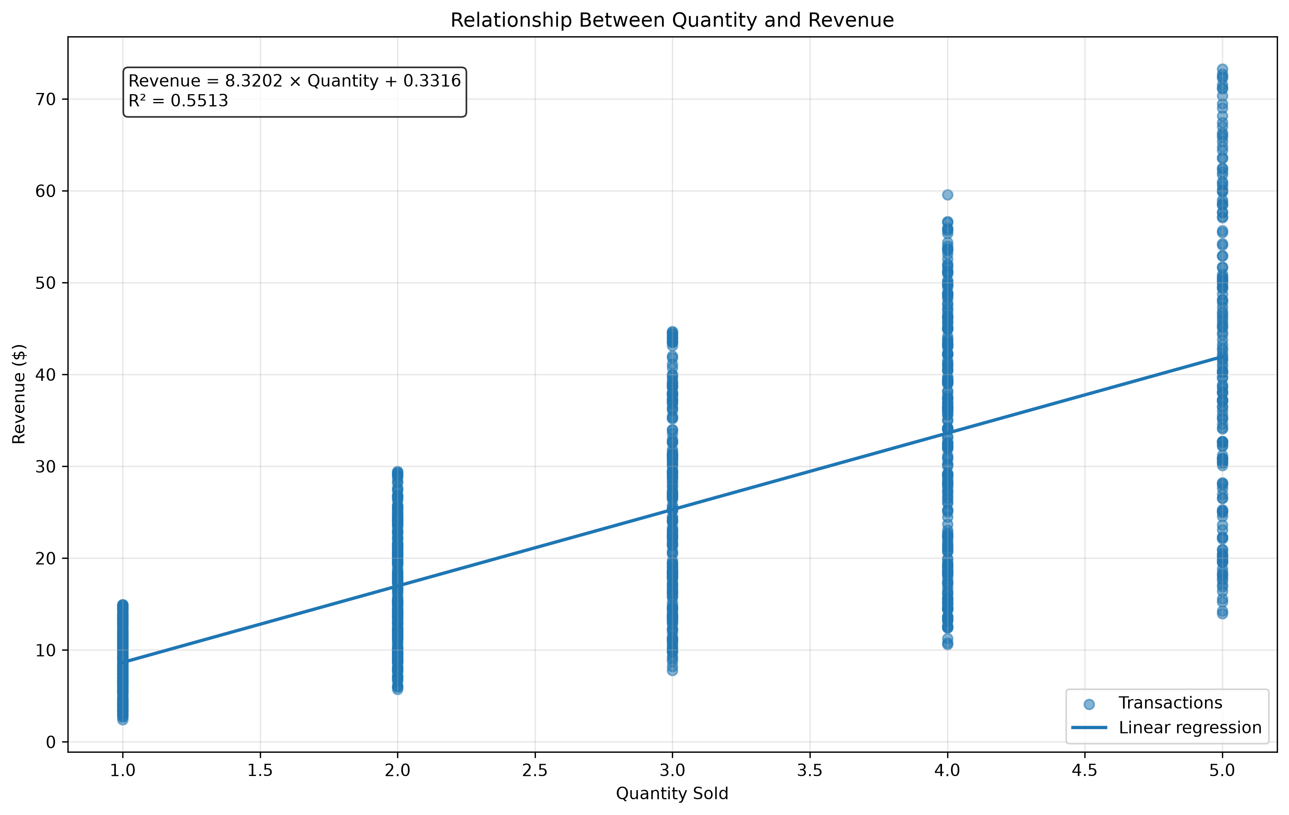
Figure 5. Relationship between quantity sold and total revenue
Limitations and Statistical Caution
The results demonstrate association, not causation. The analysis uses observational transaction data, so it cannot establish that increasing quantity by itself causes revenue to increase. Unit price and discounts can influence revenue, while product category and brand may also affect the amount paid. These variables may help explain the variation not captured by the simple regression model. The relationship should therefore be interpreted within the context of the sampled transactions and the variables included in the analysis.

Conclusion
The findings indicate a strong positive association between the quantity of chocolate sold and total transaction revenue in the analysed sample. Therefore, the research question is answered affirmatively: transactions with higher quantities generally tend to generate higher revenue. Pearson's correlation coefficient of 0.7425 supports this conclusion.
The descriptive analysis was conducted using 992 cleaned transactions. The average quantity sold was 2.8901 units, while the median was 3 units. Average transaction revenue was $24.3781, compared with a median of $20.47. The higher revenue mean relative to its median, together with the revenue histogram and boxplot, indicates a positively skewed revenue distribution. Eight potential upper outliers were identified using the 1.5 times IQR rule. These observations were retained because potential outliers should be investigated rather than automatically removed.
The simple linear regression model produced the equation Revenue = 8.3202 × Quantity + 0.3316. Its coefficient of determination was 0.5513, indicating that approximately 55.13% of the observed variation in transaction revenue is explained by its linear relationship with quantity in this sample. The remaining 44.87% is not explained by this single-predictor model.
The findings suggest that transaction quantity is a useful indicator associated with revenue. However, revenue is also influenced by unit prices, product categories, brands, discounts, promotional activities, seasonal demand, and customer or store characteristics. These factors may contribute to the variation not explained by quantity alone.
An important limitation is that this study uses observational transaction data rather than a controlled experiment. The correlation and regression results therefore describe an association and do not establish that increasing quantity causes revenue to increase. The findings are also limited to the cleaned sample of 992 transactions selected for this project.
Further research could use multiple linear regression to examine quantity alongside unit price, discount, product category, and other relevant variables. Additional analysis could also investigate differences across customer segments, stores, and time periods. Such work may provide a more comprehensive understanding of the factors associated with chocolate sales revenue.
Overall, the project demonstrates a strong positive linear association between quantity sold and total revenue. The statistical results answer the research question while highlighting the importance of considering other variables and avoiding unsupported causal conclusions.

References
[1] Project-provided chocolate sales dataset files: data/raw/sales.csv, data/raw/products.csv, data/raw/customers.csv, data/raw/stores.csv, and data/raw/calendar.csv. Original publisher and licensing information have not been independently verified.
[2] Statistical Analysis of Chocolate Sales Data. Internal project document: docs/analysis_plan.md.
[3] Statistical Analysis of Chocolate Sales Data. Internal project document: docs/data_dictionary.md.
[4] Statistical Analysis of Chocolate Sales Data. Internal project document: docs/cleaning_decisions.md.
[5] Statistical Analysis of Chocolate Sales Data. Internal project document: docs/correlation_discussion.md.
[6] Microsoft Excel. Spreadsheet software used for statistical calculations, frequency tables, and charts.
[7] Python Software Foundation. Python programming language. https://www.python.org/
[8] Openpyxl documentation. https://openpyxl.readthedocs.io/
[9] python-docx documentation. https://python-docx.readthedocs.io/
Source transparency note: The original external provenance and licensing details of the dataset remain unverified. No unverified publisher or dataset URL has been attributed.

Source: Project data dictionary and Phase 1 variable classification.

