Studio 1 FIT5032

Mohamed Arshad

31222390

TASK 1.1 Screenshot 1

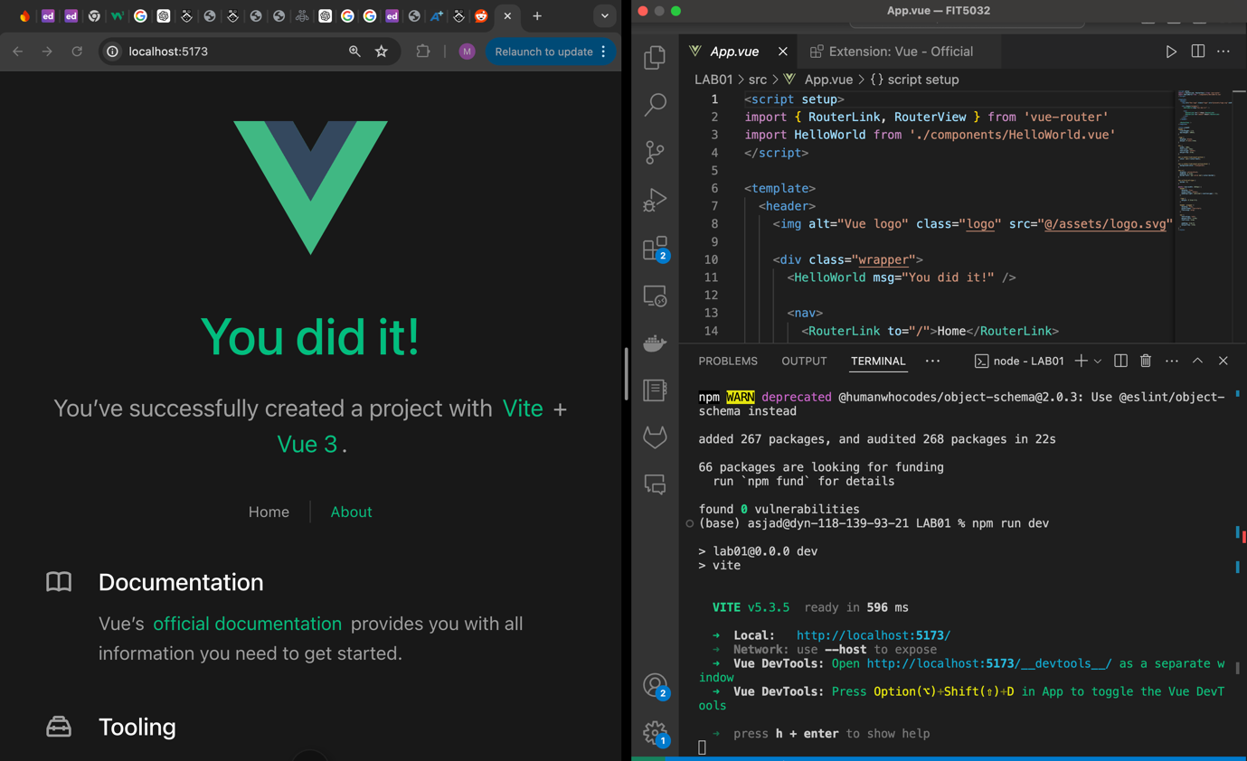

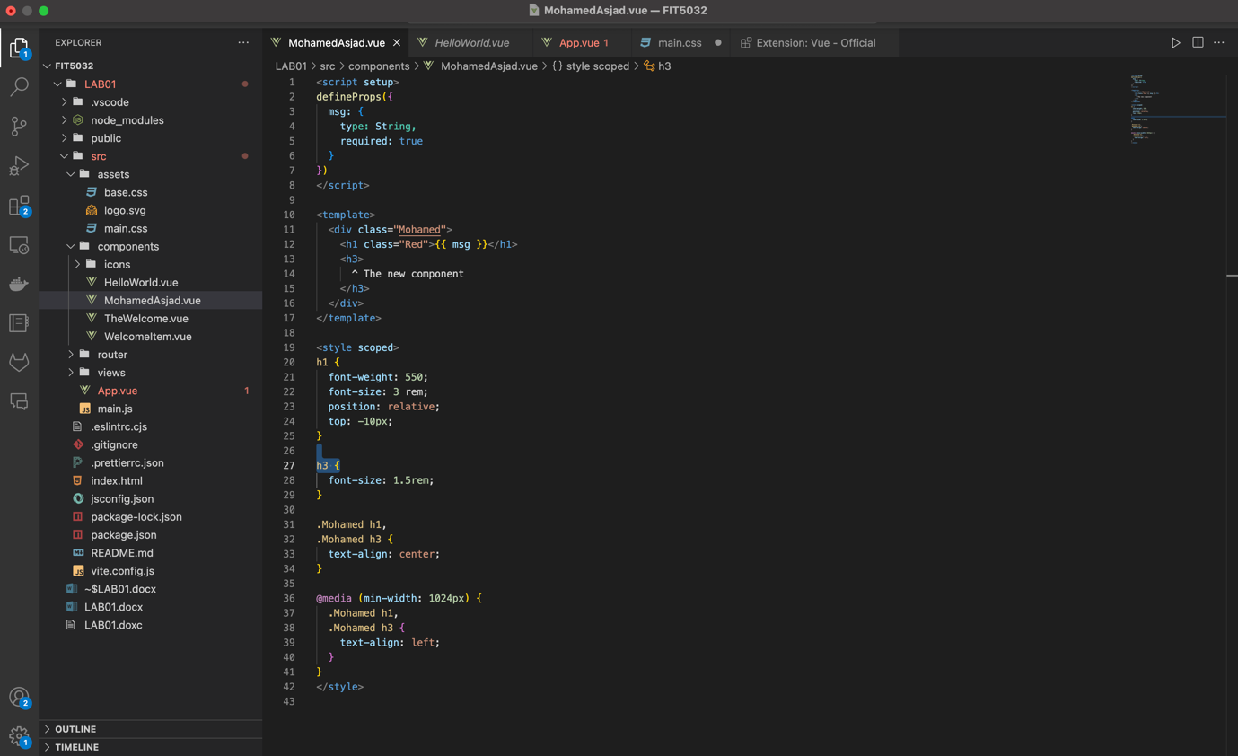TASK 1.2 Screenshot 2

Screenshot 3

GitHub link:

https://github.com/asjadarshad20/FIT5032?query=asjadarshad_20%40outlook.com