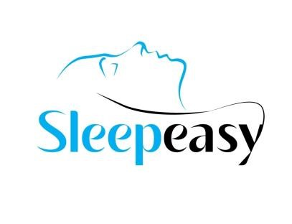

**Suite 402, Building No. 9-C,**

**Badar Commercial Area,**

**Phase V DHA – Karachi Tel: 021-37120249 www.sleepeasy.com.pk**

# POLYSOMNOGRAPHY

Name:

Nasreen Farzana

P

atient ID:

2

411

Date:

2024

Jan

18

Age:

62

years

Sex:

Female

Ref By:

Dr Salimullah Khan

Study Type:

Split

-

Night/Attnd.

Phone:

Tech:

A.

K

**HISTORY**

History of obesity, gasping, choking, snoring, morning unfreshness and excessive daytime sleepiness.

**__________________________________________________________________________________________________ PARAMETERS MONITORED**

Nasal airflow, Snoring, Thoracic movement, Body position, SpO2 and Heart Rate.

## DESCRIPTION OF FINDINGS

During the diagnostic session patient was on bed for 9 hours 50 min. Respiratory monitoring revealed total 520 abnormal events including 167 Obstructive apneas and 353 Hypopneas. This accumulated an AHI of 56.7/hour of sleep. Nocturnal oximetry was also performed. The lowest oxygen saturation during the sleep was 39% and average saturation remained 84%.

__________________________________________________________________________________________________ **TITRATION**

Bi-level titration was initiated with full face mask. All the obstructive and central events were significantly reduced at an optimal pressure of 14/6 cmH2O. Patient slept 7 hours 42 min with an AHI of 1.3/hour.

__________________________________________________________________________________________________ **CONCLUSION**

The current polysomnography is abnormal and consistent with:

1. Severe Sleep Apnea with an AHI of 56.7/hour
2. Severe desaturation to 39%
3. Bi-level therapy recommended with Full Face mask at IPAP: 14 cmH2O & EPAP: 6 cmH2O
4. Untreated obstructive sleep apnea is associated with cardiovascular complications such as hypertension and, in the long term, heart disease and cardiovascular accidents.

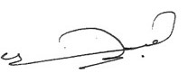

___________________

**Sleep Technician**