**Ashley R. Jamco Assignment in ICT-02**

**1-BSCS A**

I'll explain my code

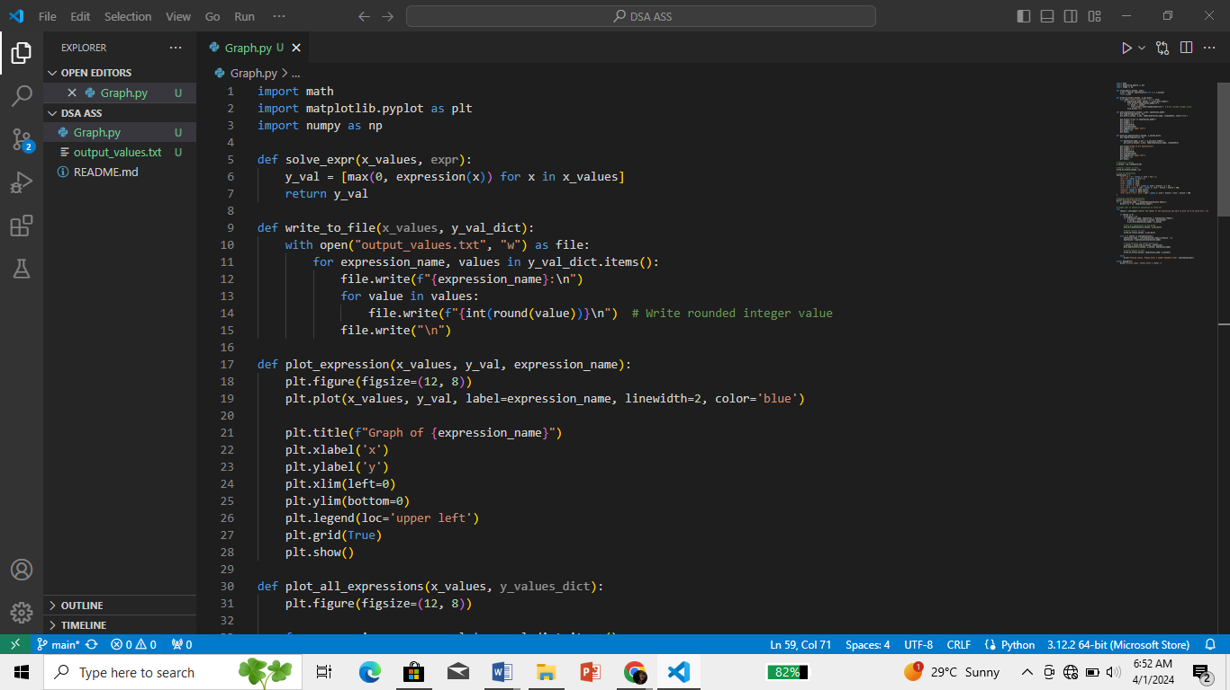

These lines import the necessary libraries: **‘math’** for mathematical functions, **‘matplotlib.pyplot’** for plotting graphs, and for numerical computations.

This function **‘solve_expr’** takes a list of x values **‘x_values’** and an expression **‘expr’** (a lambda function), and computes the corresponding y values by applying the expression to each x value. It uses a list comprehension to iterate over the x values, computing the expression value for each x, and taking the maximum between 0 and the expression value. This is done to ensure that the plotted graph doesn't go below y=0.



This function ‘**write_to_file’**takes a list of x values ‘**x_value’** and a dictionary ‘**y_val_dict’** containing expression names as keys and corresponding y values as values. It writes these values to a file named "output_values.txt". For each expression, it writes the expression name followed by its y values, rounded to the nearest integer.

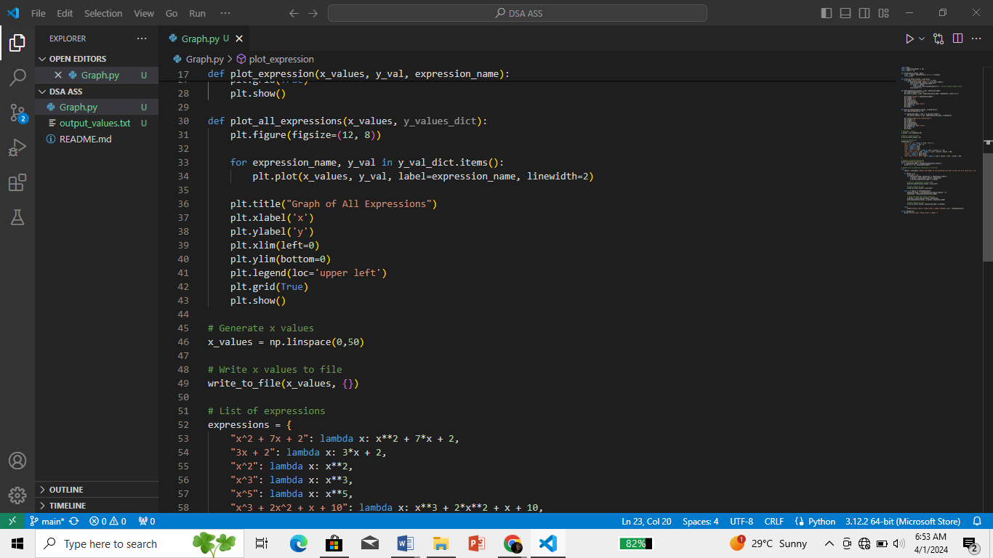

This function ‘**plot_expression’** takes a list of x values ‘**x_values’**, a list of y values ‘**y_val’**, and a string ‘**expression_name’**. It plots the graph of the given expression using Matplotlib, with the provided x and y values. It sets the title, labels for x and y axes, limits for x and y axes, legend, and grid, and then shows the plot. While ‘**plot_all_expressions’** takes a list of x values ‘**x_values’** and a dictionary ‘**y_val_dict’** containing multiple expressions' y values. It plots all the expressions in one graph using Matplotlib, with the provided x and y values. It sets the title, labels for x and y axes, limits for x and y axes, legend, and grid, and then shows the plot.

The remaining part of the code defines expressions as lambda functions, prompts the user to choose an expression to plot, and handles the user input to plot the selected expression or all expressions. It then calls the appropriate functions to plot and write the results to a file.

Screenshots of Graphs:

