Web Application Attack Detection Using Machine Learning

Name: Mohamed Aazath Asjath Ahamed
Student ID : E284304
Module: CS6P05ES
Module Leader: Ishani Gunarathne
Deadline: 19.04.2026

London Metropolitan University

Web Application Attack Detection Using Machine Learning 1
Declaration 3
Dedication 4
Acknowledgements 4
Abstract 4
Abbreviations 5
Chapter 1 Introduction 6
1.1 Goals 6
1.2 Motivation 6
1.3 Method 7
1.4 Overview of the Technical Area 7
Chapter 2 Background and Problem Statement 8
2.1 Introduction 8
2.2 Literature Review 8
2.3 Problem Statement 9
Chapter 3 Project Management 10
3.1 Approach 10
3.2 Initial Project Plan 10
3.3 Problems and Changes to the Plan 11
3.4 Final Project Record 12
Chapter 4 Feasibility Study 13
4.1 Time Feasibility 13
4.2 Cost Feasibility 13
4.3 Scope Feasibility 14
4.4 Technical Feasibility 14
4.5 Economic Feasibility 14
Chapter 5 Design 15
5.1 Proposed System 15
5.2 Hardware and Software Requirements 16
5.3 Project Structure 16
5.4 Main Script Design 17
5.5 Feature Engineering Design 17
5.6 Solution Evaluation 18
Chapter 6 Implementation 18
6.1 Data Acquisition and Master Dataset Creation 18
6.2 Model Training 20
6.3 Rule-Based Overrides 21
6.4 Prediction Threshold 21
6.5 Python WAF API 22
6.6 MVC Website Integration 22
6.7 Screenshots for Implementation Evidence 24
Chapter 7 Testing and Verification 26
7.1 Test Plan 26
7.2 How to Run the Demo 27
7.3 Test Cases 28
7.4 Browser Test URLs 29
7.5 POST Form Tests 30
7.6 Screenshot Evidence 31
7.7 How Screenshots Were Captured 36
Chapter 8 Evaluation and Conclusion 36
8.1 Evaluation Metrics 37
8.2 Confusion Matrix 38
8.3 Threshold Comparison 39
8.4 Strengths of the Project 39
8.5 Limitations 39
8.6 Conclusion 40
8.7 Future Work 40
References 41
Appendices 42
Appendix A: Project Commands 42
Appendix B: Important Output Files 43
Appendix C: Project Progress Log Sheet 44

Declaration

I declare that this report is my own work. Any sources, tools, datasets, documentation, and external materials used in the project have been acknowledged in the references section. I understand the university regulations concerning plagiarism and academic misconduct.

Signature: ____________Asjath__________
Date: _______19.04.2026_______________

Dedication

I dedicate this project to my family, lecturers, and everyone who supported my learning throughout this academic project. Their encouragement helped me continue improving the project even when technical problems occurred during model training, testing, and live integration.

Acknowledgements

I would like to thank my module leader, lecturers, classmates, friends, and family for their support during this project. I am also grateful for the availability of open-source technologies such as Apache Spark, PySpark, ASP.NET Core, and publicly available cybersecurity datasets, which made it possible to build and evaluate a practical web attack detection system.

Abstract

Web applications are frequently targeted by attacks such as SQL injection, cross-site scripting, command injection, path traversal, and server-side template injection. These attacks can exploit weak input validation and may allow attackers to access sensitive data, execute commands, or disrupt services. This project addresses the problem of detecting malicious HTTP requests before they reach a web application controller. The aim was to design and implement a Web Application Firewall prototype that combines a PySpark machine learning pipeline with rule-based security checks and integrates the result into an ASP.NET Core MVC ticket booking website.

The project used multiple HTTP request datasets containing both normal and malicious traffic. A data preparation script combined the raw files into one master dataset. A PySpark machine learning pipeline was then built using text-based features, pattern-based security features, and form-submission features. The final pipeline was trained, evaluated, saved, and exposed through a local Python WAF API. The ASP.NET Core MVC website was copied into the project folder and protected using custom middleware. For each incoming request, the middleware sends the request details to the WAF API. The API returns a decision, including whether the request should be allowed or blocked, the reason for the decision, and the malicious probability score.

The final model achieved an accuracy of approximately 98.34 percent on the test data, with a weighted F1 score of approximately 98.34 percent. The live demonstration showed that normal requests such as event searches were allowed, while malicious payloads such as XSS, SQL injection, command injection, and path traversal were blocked before reaching the MVC controller. The project successfully demonstrates a practical security pipeline, although it should not be considered a perfect or production-ready WAF. Future improvements could include more modern datasets, deployment behind a real reverse proxy, additional attack categories, and continuous retraining.

Abbreviations

Abbreviation | Meaning
API | Application Programming Interface
CSV | Comma-Separated Values
F1 | Harmonic mean of precision and recall
FN | False Negative
FP | False Positive
HTTP | Hypertext Transfer Protocol
ID | Identifier
ML | Machine Learning
MVC | Model-View-Controller
PR | Precision-Recall
ROC | Receiver Operating Characteristic
SQLi | SQL Injection
SSTI | Server-Side Template Injection
WAF | Web Application Firewall
XSS | Cross-Site Scripting

Chapter 1 Introduction

This chapter introduces the project, explains the goals and motivation, and summarises the technical approach. The project focuses on building a practical Web Application Firewall prototype using PySpark machine learning and rule-based request inspection. The final system is integrated with an ASP.NET Core MVC ticket booking website to demonstrate how malicious requests can be blocked before they reach application controllers.

1.1 Goals

The main goal of the project was to build a working WAF detection pipeline that can identify malicious HTTP requests and protect a web application during a live demonstration. The system was designed to:

- Combine public and custom HTTP request datasets into one master dataset.
- Train a PySpark machine learning pipeline to classify requests as normal or malicious.
- Detect common web attacks including SQL injection, XSS, command injection, path traversal, and SSTI.
- Reduce false positives for legitimate form submissions such as login and event searching.
- Save the trained model and evaluation outputs.
- Expose the WAF model through a local Python API.
- Integrate the WAF API with an ASP.NET Core MVC ticket booking system.
- Display visible proof when requests are allowed or blocked.

1.2 Motivation

Web applications are commonly exposed to user input through URLs, query strings, forms, and request bodies. If this input is not handled safely, attackers can attempt to inject SQL statements, JavaScript, operating system commands, file paths, or template expressions. OWASP identifies web application security risks as a major concern for developers and security teams [1]. A WAF is useful because it can inspect incoming requests before they reach sensitive application logic.

The motivation for this project was not only to train a model, but to demonstrate how a data science pipeline can be connected to a real web application. This makes the project more practical than a standalone notebook because the final system can show live request blocking inside a website.

1.3 Method

The project was carried out using a structured pipeline:

- Raw HTTP request datasets were collected and stored in the `data_raw` folder.
- A PySpark processing script converts different dataset formats into a common schema.
- The cleaned data was saved as a master dataset.
- A PySpark ML pipeline was trained using engineered request features and text features.
- The model was evaluated using accuracy, precision, recall, F1 score, ROC area, PR area, false positives, and false negatives.
- A local Python API was created to expose the WAF decision logic.
- The ASP.NET Core MVC website was copied into the project and protected using middleware.
- Live tests were performed with normal and malicious payloads.

1.4 Overview of the Technical Area

The project combines three technical areas. The first area is web application security, where attacks are identified from suspicious HTTP request content. The second area is machine learning, where a trained model learns patterns from labelled examples. The third area is web application integration, where middleware intercepts requests before controllers handle them. Apache Spark ML pipelines support scalable machine learning workflows by chaining feature extraction, transformation, and model training stages. ASP.NET Core middleware provides a suitable integration point because middleware can inspect requests before they reach MVC controller actions.

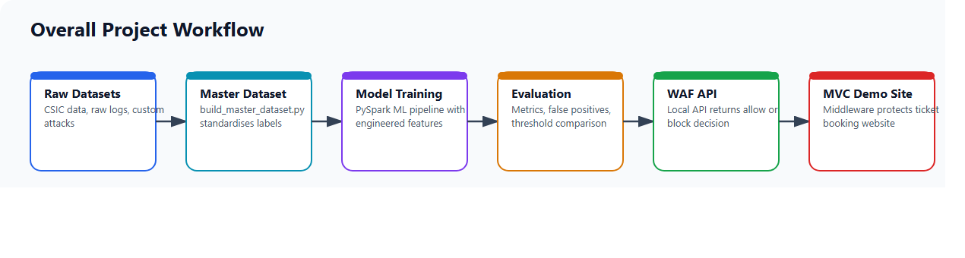

Chapter 2 Background and Problem Statement

This chapter describes the background of web attack detection, reviews related security and machine learning concepts, and states the problem that this project attempts to solve.

2.1 Introduction

A web application receives requests from browsers, APIs, and automated clients. Each request can contain input in the URL path, query string, headers, or body. Normal users use these inputs to search, log in, register, contact support, and complete bookings. Attackers may use the same input fields to submit malicious payloads. This creates a classification problem: the system must distinguish between normal traffic and malicious traffic.

Traditional WAF systems often use rule-based detection, where known suspicious patterns are blocked. Machine learning systems can learn request patterns from data, but they may create false positives when normal traffic looks unusual. This project combines both methods. Rule-based checks are used for high-confidence attacks and safe normal patterns, while a PySpark model supports broader classification.

2.2 Literature Review

OWASP provides awareness material about major web application security risks, including injection-related risks and other categories that affect modern applications [1]. These risks show why input inspection is important in web systems.

The CSIC 2010 HTTP dataset is a commonly used public dataset for web attack detection research. It contains normal and anomalous HTTP traffic targeted at an e-commerce application, including attacks such as SQL injection, XSS, file disclosure, and parameter tampering [4]. Although the dataset is older and does not fully represent modern production traffic, it is useful for educational and experimental WAF projects because it contains labelled request examples.

Apache Spark ML pipelines provide a structured method for machine learning. A pipeline can chain multiple stages such as tokenisation, feature extraction, vector assembly, and classification [2]. This is suitable for the project because HTTP request classification requires several transformation steps before prediction.

ASP.NET Core middleware is designed to process HTTP requests through a pipeline before they reach endpoint logic [3]. This makes it appropriate for WAF integration because a custom middleware component can call an external WAF API and decide whether to allow or block the request.

2.3 Problem Statement

The problem addressed in this project is:

How can a PySpark-based machine learning pipeline be used with rule-based security checks to detect malicious HTTP requests and protect an ASP.NET Core MVC web application during live request handling?

The project specifically focuses on common web attack payloads such as:

- SQL injection, for example `' OR '1'='1` and `UNION SELECT`.
- XSS, for example `<script>alert(1)</script>`.
- Command injection, for example `;whoami`.
- Path traversal, for example `../../../../etc/passwd`.
- SSTI, for example `{{7*7}}`.

The project also addresses a practical challenge: normal POST requests such as login and contact forms can be incorrectly classified as malicious. Therefore, the model and runtime logic include features and safe rules for common form submissions.

Chapter 3 Project Management

This chapter explains how the project was planned, what changed during development, and how the final project record differs from the original plan.

3.1 Approach

The project followed an iterative development approach. The first stage focused on data preparation and model training. The second stage focused on evaluation and reducing false positives. The third stage focused on live integration with the MVC website. This approach was chosen because machine learning projects often require repeated testing and improvement. It was also important to get a working model before connecting it to the website.

3.2 Initial Project Plan

Week | Planned Task | Description
Week 1 | Project setup | Create folder structure, virtual environment, and install PySpark.
Week 2 | Dataset collection | Add public and custom datasets to `data_raw`.
Week 3 | Data processing | Build master dataset from different raw formats.
Week 4 | Feature engineering | Create request features for attack detection and normal traffic.
Week 5 | Model training | Train PySpark ML pipeline and save the model.
Week 6 | Evaluation | Measure accuracy, precision, recall, F1, false positives, and false negatives.
Week 7 | Website integration | Connect WAF API to MVC ticket booking website.
Week 8 | Testing and report | Capture screenshots, write report, and prepare live demo.

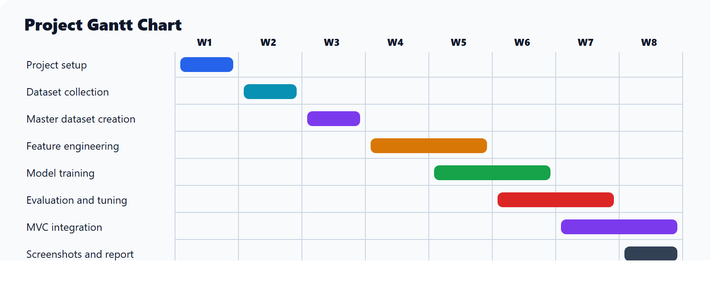

3.3 Problems and Changes to the Plan

Several issues were encountered during the project:

- The first model produced too many false positives for normal POST requests.
- The custom dataset initially contained mostly malicious examples, which created imbalance.
- The system needed additional normal traffic features to distinguish clean form submissions from attacks.
- PySpark startup was slow during live API testing.
- The MVC website initially showed `API UNAVAILABLE` because the WAF API was not running or was still starting.
- The MVC-to-Python JSON handoff initially sent default request values, so the API inspected `GET / HTTP/1.1` instead of the real request.

The plan changed to include:

- More focus on class imbalance and false positive reduction.
- Additional safe form features.
- A configurable prediction threshold.
- Saved false positive and false negative examples.
- A local API with fast rule checks and lazy Spark loading for demo stability.
- Visible proof banners and block pages inside the MVC website.

3.4 Final Project Record

Stage | Actual Work Completed
Data preparation | Multiple raw datasets were combined into one processed master dataset.
Model training | A PySpark ML pipeline was trained and saved.
Evaluation | Metrics and misclassified examples were saved in `reports/evaluation`.
False positive improvement | Safe form and endpoint-aware features were added.
Website integration | A copied ASP.NET Core MVC website was protected using WAF middleware.
Live demo | Normal traffic was allowed and attack payloads were blocked with visible proof.

Figure 2: Final project workflow.

Chapter 4 Feasibility Study

This chapter evaluates whether the project was realistic in terms of time, cost, scope, technical resources, and economic value.

4.1 Time Feasibility

The project was feasible within the available academic timeframe because it was divided into clear phases: data processing, training, evaluation, integration, and testing. The most time-consuming parts were dataset cleaning, false positive reduction, and live website integration. The final project remained feasible because the scope was controlled: the system was built as a local prototype rather than a production cloud WAF.

4.2 Cost Feasibility

The project had low cost because it used open-source and already available tools:

- Python and PySpark.
- Apache Spark.
- ASP.NET Core MVC.
- Local Windows development environment.
- Public and custom CSV datasets.
- Local browser testing with Microsoft Edge.

No paid cloud service or paid security product was required.

4.3 Scope Feasibility

The project scope was feasible because it focused on detecting common HTTP request attacks rather than solving every possible web security problem. The system does not replace secure coding practices, authentication, authorisation, input validation, or database security. Instead, it demonstrates a WAF-style detection layer for selected attack categories.

4.4 Technical Feasibility

The technical implementation was feasible because PySpark supports scalable data processing and ML pipelines, while ASP.NET Core supports middleware-based request inspection. The final system used a Python API as the bridge between the PySpark WAF logic and the MVC website. A technical challenge was Spark startup time; this was solved by lazy loading Spark and using fast rules for obvious live-demo traffic.

4.5 Economic Feasibility

From an economic perspective, this project is useful because it demonstrates how open-source tools can be used to prototype a web attack detection system without purchasing a commercial WAF. In a real organisation, a system like this could support early-stage security monitoring, research, or educational demonstrations. However, production deployment would require further testing, monitoring, logging, model updates, and secure infrastructure.

Chapter 5 Design

This chapter describes the proposed system design, hardware and software requirements, and evaluation of the solution.

5.1 Proposed System

The proposed system is a hybrid WAF that combines:

- PySpark ML classification.
- Rule-based attack overrides.
- Safe-form rules for normal web traffic.
- ASP.NET Core MVC middleware integration.
- A local Python API for prediction.

The system architecture is:

User Browser
|
v
ASP.NET Core MVC Website
|
v
WAF Inspection Middleware
|
v
Python WAF API
|
+--> Fast rule checks
|
+--> PySpark ML fallback
|
v
Decision: allow or block

Figure 3: MVC and WAF API integration architecture.
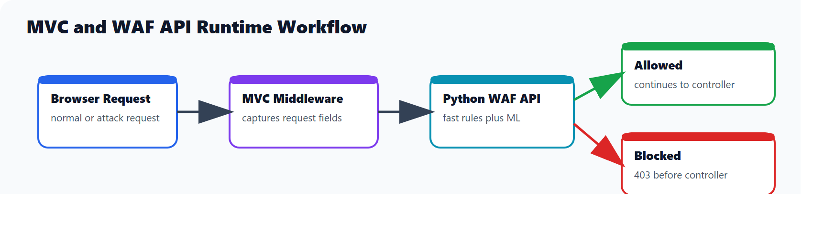

5.2 Hardware and Software Requirements

Category | Requirement
Operating system | Windows development machine
Programming languages | Python, C#
Data processing | PySpark
ML framework | `pyspark.ml`
Web framework | ASP.NET Core MVC
IDE | Visual Studio Code
Browser | Microsoft Edge or Chrome
Runtime | Python virtual environment and .NET SDK
Storage | Local project folders for raw data, processed data, model, reports, and screenshots

5.3 Project Structure

Folder | Purpose
`data_raw` | Original raw datasets.
`data_processed` | Combined master dataset.
`src` | Python scripts for data processing, training, evaluation, prediction, and API.
`model` | Saved PySpark WAF model.
`reports/evaluation` | Metrics, threshold comparison, false positives, false negatives, and misclassified examples.
`demo_website` | Copied ASP.NET Core MVC website with WAF integration.
`demo_files/screenshots` | Screenshots used as proof for report and presentation.

5.4 Main Script Design

Script | Responsibility
`build_master_dataset.py` | Reads raw datasets, standardises request and label columns, and saves the master dataset.
`train_pipeline.py` | Builds features, trains the PySpark ML pipeline, applies rule-based logic, and saves the model.
`evaluate_pipeline.py` | Loads the model and test data, evaluates metrics, and saves analysis files.
`predict_unseen.py` | Runs predictions on unseen log files.
`run_prediction.py` | Supports batch prediction for demo log files.
`waf_api.py` | Runs a local API used by the MVC website to classify incoming requests.

5.5 Feature Engineering Design

The model uses several feature groups:

- Basic request features such as request length, number of special characters, and query-string indicators.
- Attack pattern features for SQL injection, XSS, command injection, path traversal, and SSTI.
- HTTP method features such as GET and POST.
- Body features such as form key-value pair count.
- Benign parameter features such as username, password, email, name, message, product_id, quantity, address, phone, city, page, and id.
- Safe form features for normal endpoints such as login, register, contact, checkout, profile, support, account login, bookings, inquiries, reviews, members, and events.

This design was chosen because relying only on suspicious characters can cause false positives. For example, a normal form body contains `=` and `&`, but this does not mean it is an attack. The final design therefore includes both attack indicators and normal traffic indicators.

5.6 Solution Evaluation

The selected solution is appropriate because it demonstrates both data science and web security. A purely rule-based system would be easier to implement but less flexible. A purely ML-based system could produce false positives and would be harder to explain during a live demo. The hybrid solution is stronger because obvious attacks can be blocked with clear reasons, while ML remains available for broader classification.

Chapter 6 Implementation

This chapter explains how the system was implemented, including data processing, model training, evaluation, API creation, and MVC website integration.

6.1 Data Acquisition and Master Dataset Creation

The project used the following raw datasets:
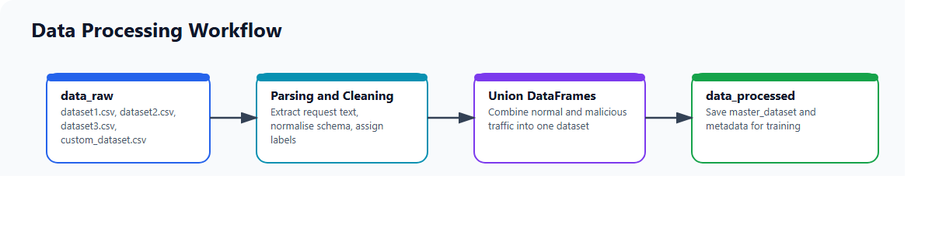
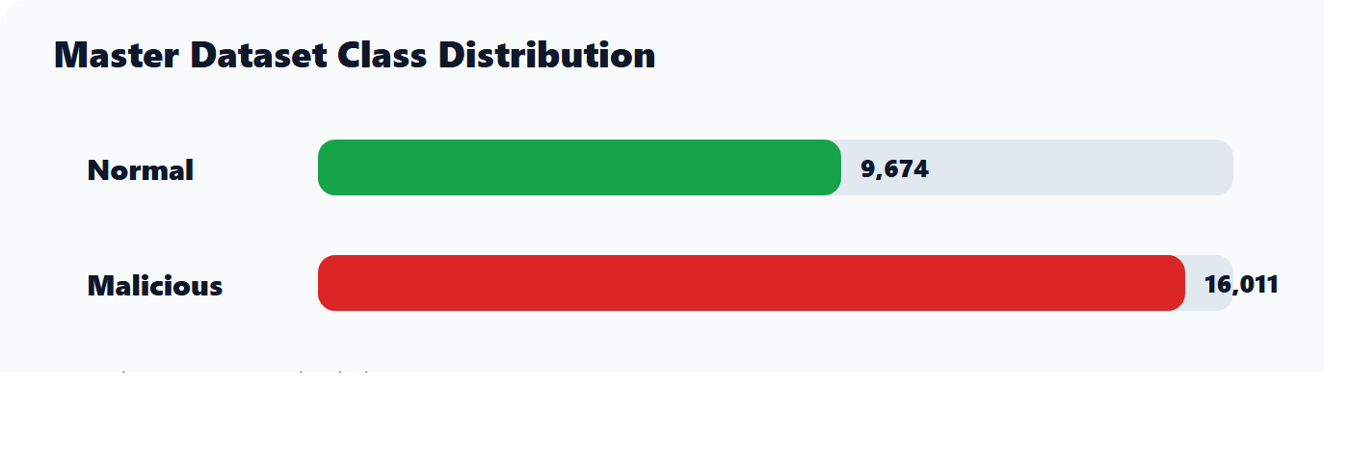
Dataset | Location | Description
`dataset1.csv` | `data_raw` | Public dataset containing normal and malicious HTTP request fields.
`dataset2.csv` | `data_raw` | Raw HTTP request lines from public attack traffic.
`dataset3.csv` | `data_raw` | Raw malicious request examples.
`custom_dataset.csv` | `data_raw` | Custom malicious payload dataset containing attack examples.

The script `build_master_dataset.py` standardises the input data into a common structure. The master dataset is saved in:

C:\Users\Asjath\Desktop\Pyspark_WAF_Project\data_processed\master_dataset

The final label distribution was:

Label | Meaning | Count
0 | Normal | 9,674
1 | Malicious | 16,011

The imbalance ratio of malicious to normal traffic was approximately 1.66. Class weights were used during training to reduce the effect of imbalance:

Class | Weight
Normal | 1.3275
Malicious | 0.8021

6.2 Model Training

The model was trained using:

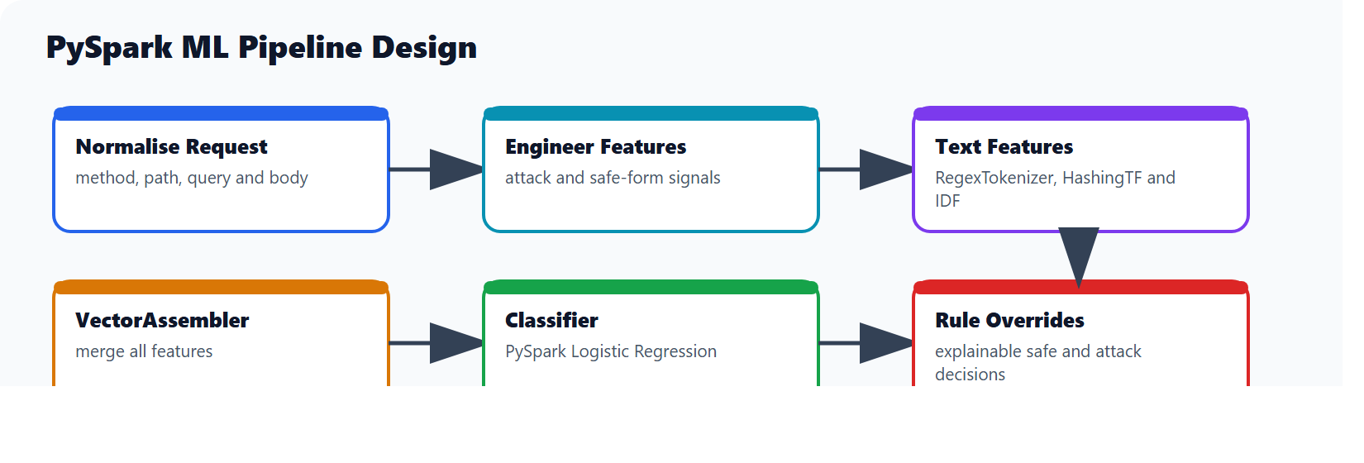

The PySpark pipeline includes:

- Request normalisation.
- SQL-based feature transformation.
- Tokenisation using `RegexTokenizer`.
- Text vectorisation using `HashingTF`.
- Inverse document frequency using `IDF`.
- Feature assembly using `VectorAssembler`.
- Classification using PySpark Logistic Regression.
- Rule-based post-processing for safe and malicious overrides.

The trained model was saved in:

C:\Users\Asjath\Desktop\Pyspark_WAF_Project\model\waf_detection_pipeline

6.3 Rule-Based Overrides

The runtime prediction logic includes rule-based overrides. These rules are important because they provide explainable decisions for obvious attacks. For example:

- `obvious_sql_injection`
- `obvious_xss`
- `obvious_command_injection`
- `obvious_path_traversal`
- `obvious_ssti`
- `safe_clean_get`
- `safe_smartevent_form`

Safe overrides only apply when no attack indicators are present. This is important because a normal-looking endpoint can still contain a malicious payload.

6.4 Prediction Threshold

The project uses a configurable prediction threshold. The selected threshold was:

0.70

This threshold was selected to reduce false positives while maintaining strong attack detection. Evaluation was also performed for thresholds 0.60, 0.65, 0.70, and 0.75.

6.5 Python WAF API

The WAF API is implemented in:

C:\Users\Asjath\Desktop\Pyspark_WAF_Project\src\waf_api.py

Run command:

cd C:\Users\Asjath\Desktop\Pyspark_WAF_Project
.\.venv\Scripts\python.exe .\src\waf_api.py

The API provides:

Endpoint | Purpose
`GET /health` | Checks whether the WAF API is running.
`POST /check` | Receives a request and returns allow or block decision.

The API uses lazy Spark loading. This means the API starts quickly and only loads Spark when the ML fallback is required. This improved live demo reliability because obvious normal and malicious requests can be handled quickly by fast rules.

6.6 MVC Website Integration

The original website was not modified. A copied version was placed in:

C:\Users\Asjath\Desktop\Pyspark_WAF_Project\demo_website\SmartEventMVC_WAF_Demo

Middleware\WafInspectionMiddleware.cs

The middleware:

- Captures incoming GET and POST requests.
- Builds a request object containing method, path, query string, body, and threshold.
- Sends the request to the Python WAF API.
- Allows normal traffic to continue to the MVC controller.
- Blocks malicious traffic and returns a WAF block page.
- Stores decision details in session so the layout can show visible proof.

The MVC WAF configuration is in:

appsettings.json

Important values:

{
"Waf": {
"Enabled": true,
"ApiUrl": "http://127.0.0.1:8765/check",
"FailOpen": true,
"InspectGet": true,
"InspectPost": true,
"PredictionThreshold": 0.70,
"RequestTimeoutSeconds": 45
}
}

6.7 Screenshots for Implementation Evidence

Insert the following screenshots in Chapter 6:

Figure 4: Normal request allowed by WAF.

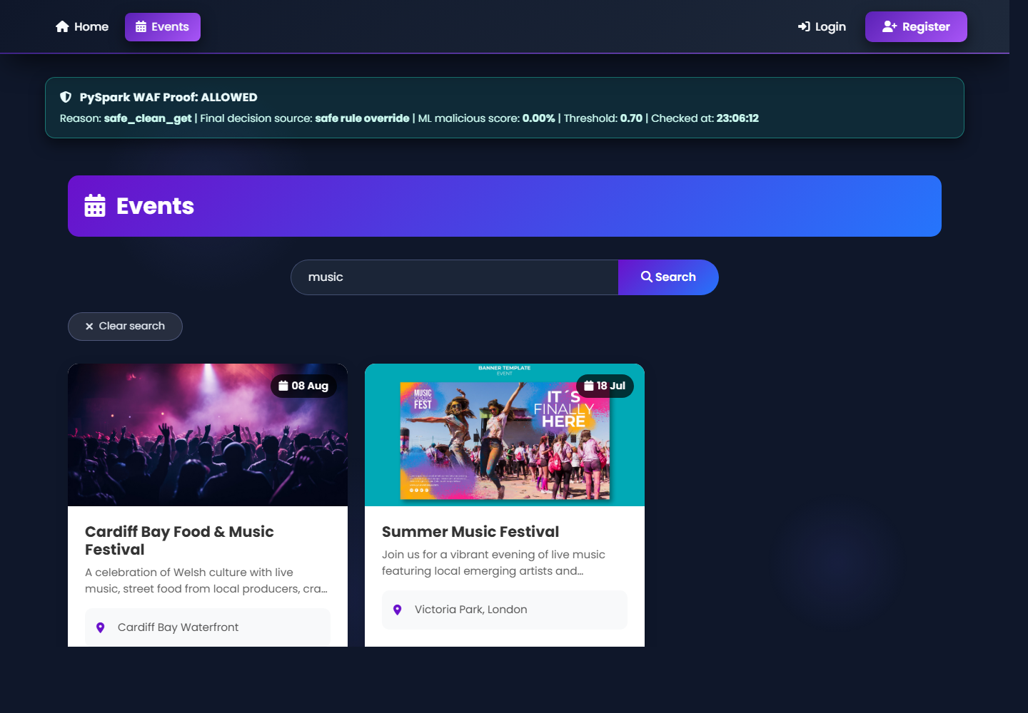
Figure 4: Normal request allowed by WAF

Figure 5: XSS request blocked by WAF.

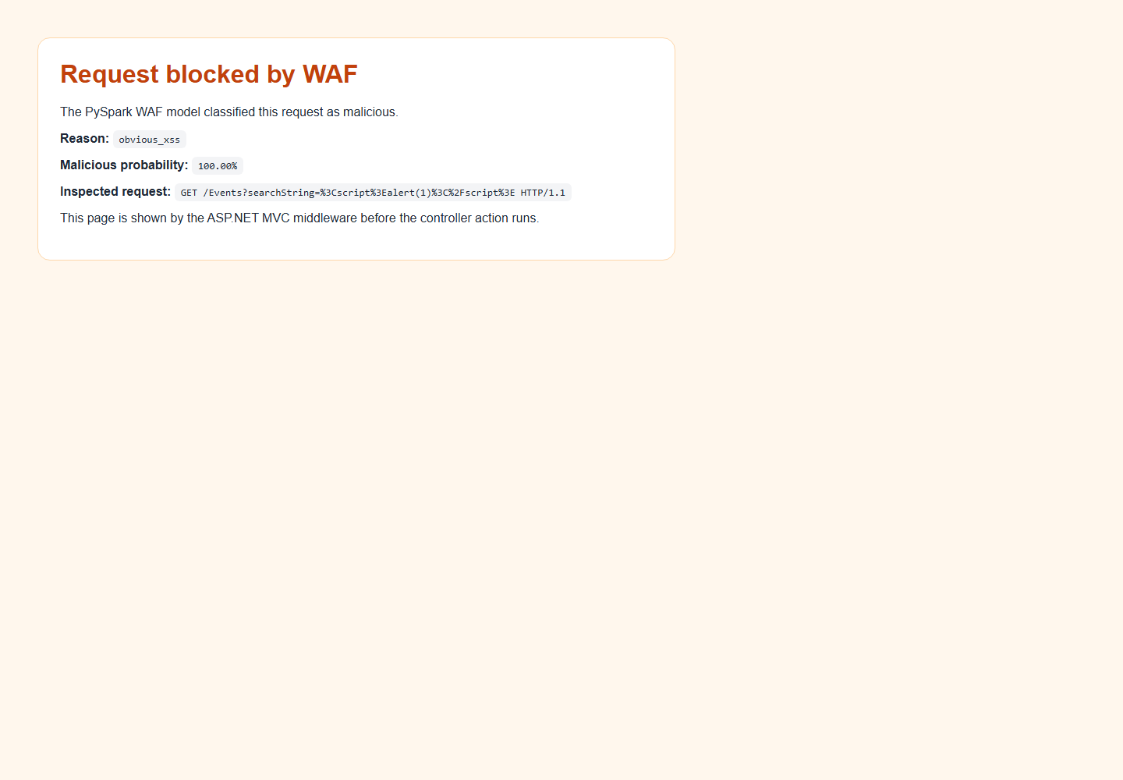
Figure 5: XSS request blocked by WAF

Chapter 7 Testing and Verification

This chapter presents the test plan, test cases, expected results, actual results, and proof collection method.

7.1 Test Plan

The testing strategy included:

- Unit-level script checks.
- Dataset processing checks.
- Model evaluation checks.
- API endpoint testing.
- MVC website integration testing.
- Live browser payload testing.

The main aim was to verify that:

- Normal requests are allowed.
- Malicious requests are blocked.
- The WAF decision is visible on the website.
- The API terminal prints proof of allow and block decisions.
- Evaluation files are saved for analysis.

7.2 How to Run the Demo

Step 1: Start the WAF API.

cd C:\Users\Asjath\Desktop\Pyspark_WAF_Project
.\.venv\Scripts\python.exe .\src\waf_api.py

Expected output:

WAF API ready
Health check: http://127.0.0.1:8765/health
Prediction endpoint: http://127.0.0.1:8765/check
Spark model loading: lazy, only when ML fallback is needed

Step 2: Start the MVC website.

cd C:\Users\Asjath\Desktop\Pyspark_WAF_Project\demo_website\SmartEventMVC_WAF_Demo\SmartEventMVC
dotnet run

Step 3: Open the website.

http://localhost:5284

7.3 Test Cases

Test ID | Test Input | Expected Result | Actual Result
TC01 | `/Events?searchString=music` | Request allowed | Passed
TC02 | `/Events?searchString=drama` | Request allowed | Passed
TC03 | `/Events?searchString=%3Cscript%3Ealert(1)%3C%2Fscript%3E` | Request blocked as XSS | Passed
TC04 | `/Events?searchString=%27%20OR%20%271%27%3D%271` | Request blocked as SQL injection | Passed
TC05 | `/Events?searchString=1%20UNION%20SELECT%20username,password%20FROM%20users` | Request blocked as SQL injection | Passed
TC06 | `/Events?searchString=%3Bwhoami` | Request blocked as command injection | Passed
TC07 | `/Events?file=..%2F..%2F..%2F..%2Fetc%2Fpasswd` | Request blocked as path traversal | Passed
TC08 | `/Events?searchString=%7B%7B7*7%7D%7D` | Request blocked as SSTI | Passed

7.4 Browser Test URLs

Normal request:

http://localhost:5284/Events?searchString=music

Expected proof:

PySpark WAF Proof: ALLOWED
Reason: safe_clean_get

XSS attack:

http://localhost:5284/Events?searchString=%3Cscript%3Ealert(1)%3C%2Fscript%3E

Expected proof:

Request blocked by WAF
Reason: obvious_xss

SQL injection:

http://localhost:5284/Events?searchString=%27%20OR%20%271%27%3D%271

Expected proof:

Request blocked by WAF
Reason: obvious_sql_injection

Command injection:

http://localhost:5284/Events?searchString=%3Bwhoami

Expected proof:

Request blocked by WAF
Reason: obvious_command_injection

Path traversal:

http://localhost:5284/Events?file=..%2F..%2F..%2F..%2Fetc%2Fpasswd

Expected proof:

Request blocked by WAF
Reason: obvious_path_traversal

7.5 POST Form Tests

Normal login form:

curl.exe -i -X POST "http://localhost:5284/Account/Login" -H "Content-Type: application/x-www-form-urlencoded" --data "mobile=0712345678&password=123"

Expected result:

Allow

Malicious login form:

curl.exe -i -X POST "http://localhost:5284/Account/Login" -H "Content-Type: application/x-www-form-urlencoded" --data "mobile=0712345678&password=' OR '1'='1"

Expected result:

Block
Reason: obvious_sql_injection

7.6 Screenshot Evidence

Insert these screenshots in Chapter 7:

Figure 6: Normal event search allowed.

Figure 7: XSS request blocked.

Figure 8: SQL injection request blocked.
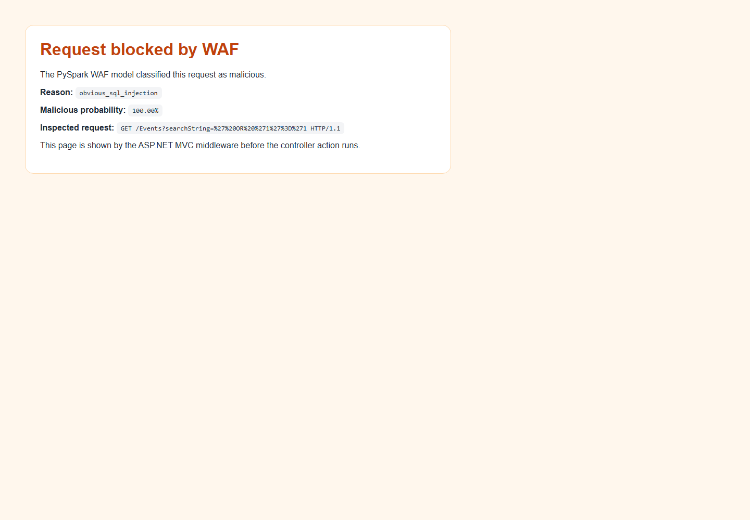

Figure 9: Command injection request blocked.
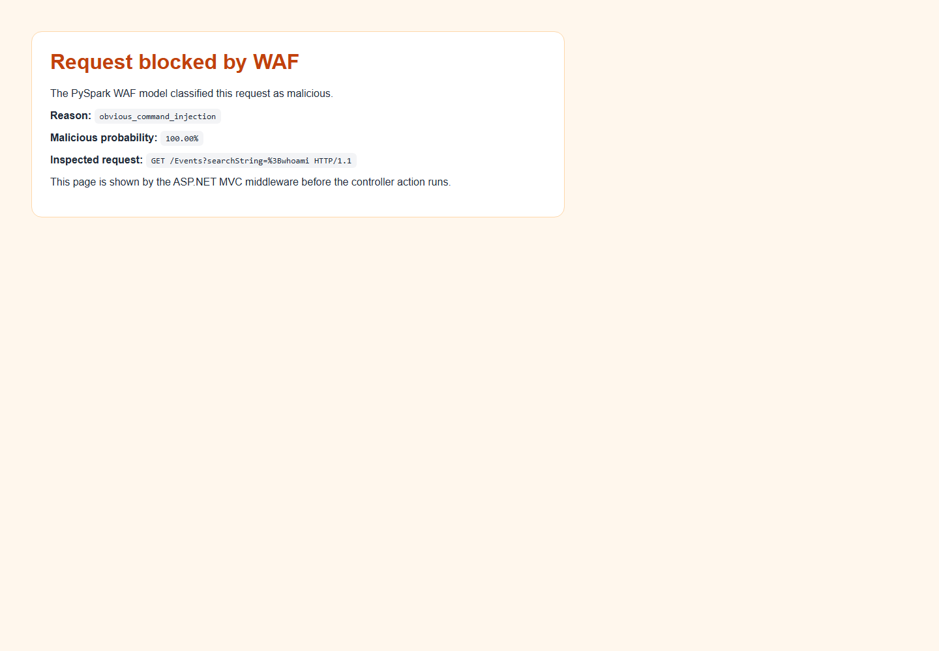

Figure 10: Path traversal request blocked.
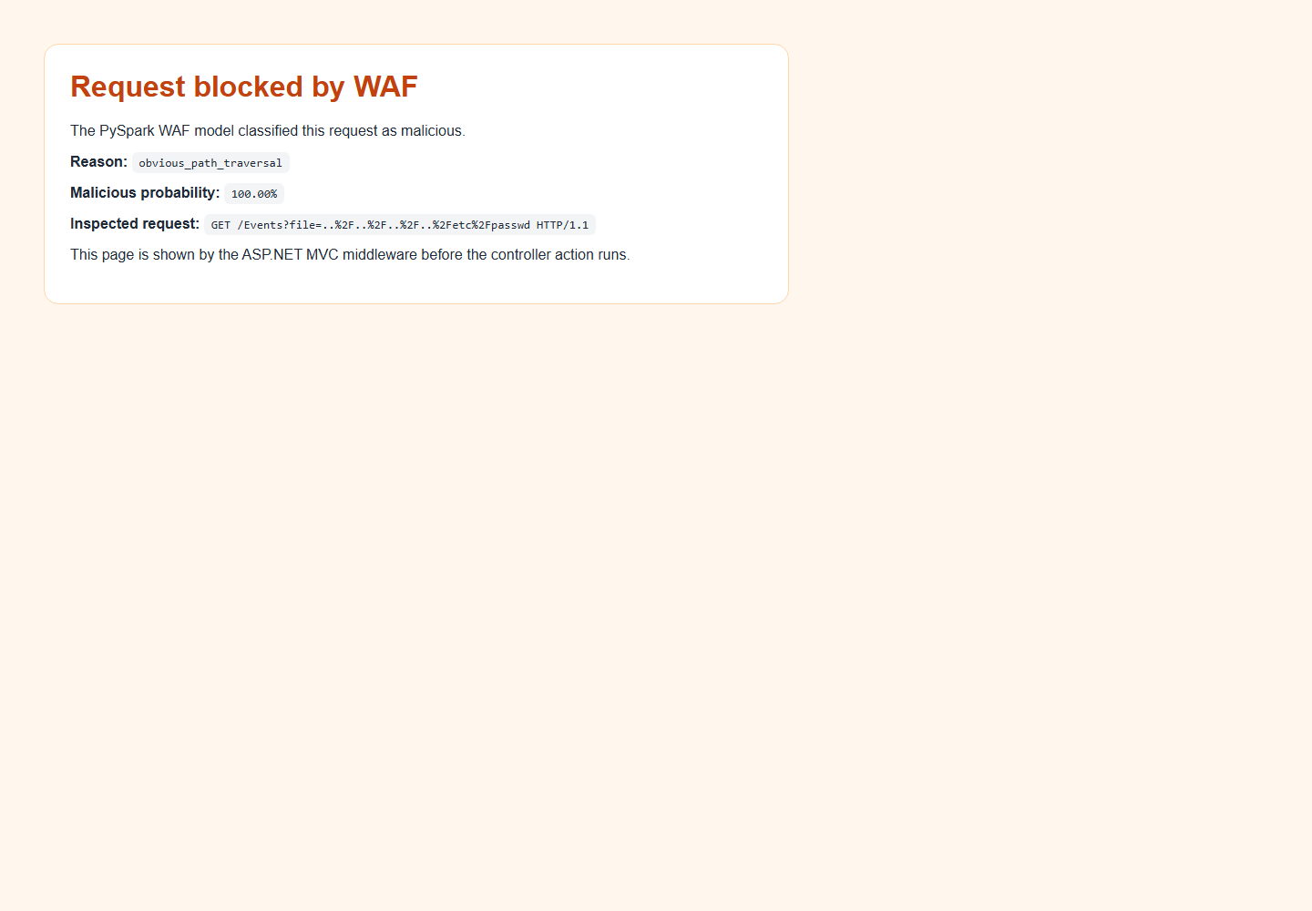

7.7 How Screenshots Were Captured

The screenshots were captured from the live MVC website while the WAF API was running. The allowed screenshot shows the event search page with a WAF proof banner. The blocked screenshots show the WAF block page returned by middleware before the controller action runs. This confirms that detection happens before the MVC request is processed by the application controller.

Chapter 8 Evaluation and Conclusion

This chapter evaluates the final model, discusses strengths and weaknesses, and concludes the project.

8.1 Evaluation Metrics

The final evaluation results were saved in:

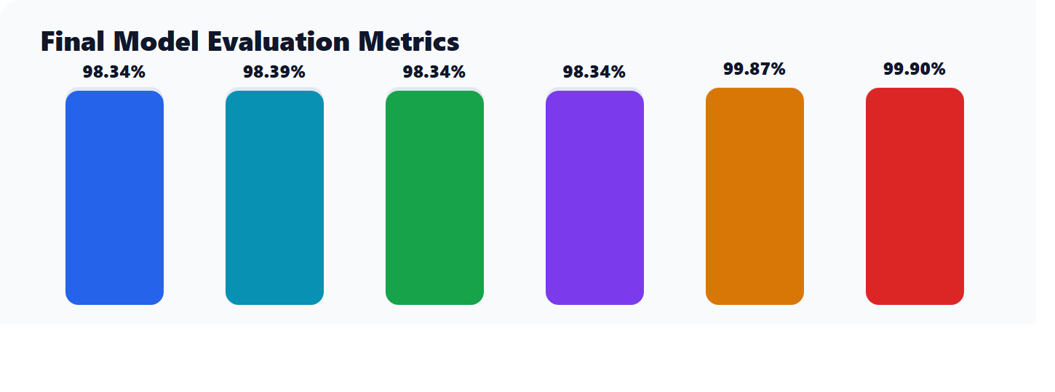
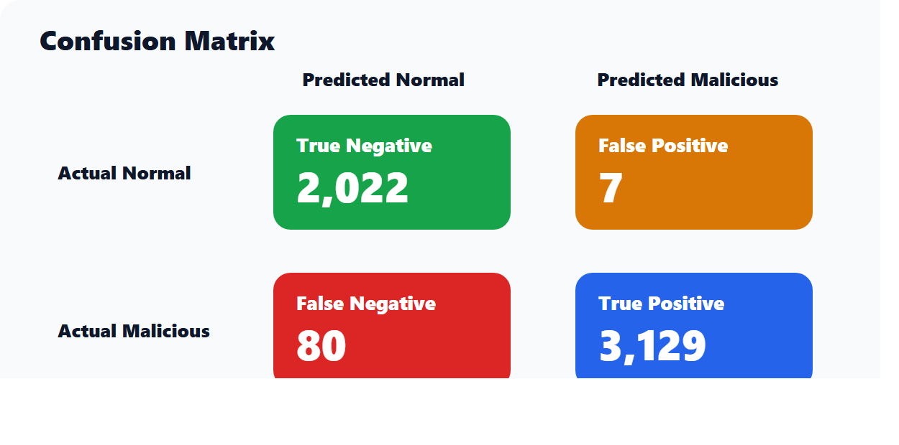
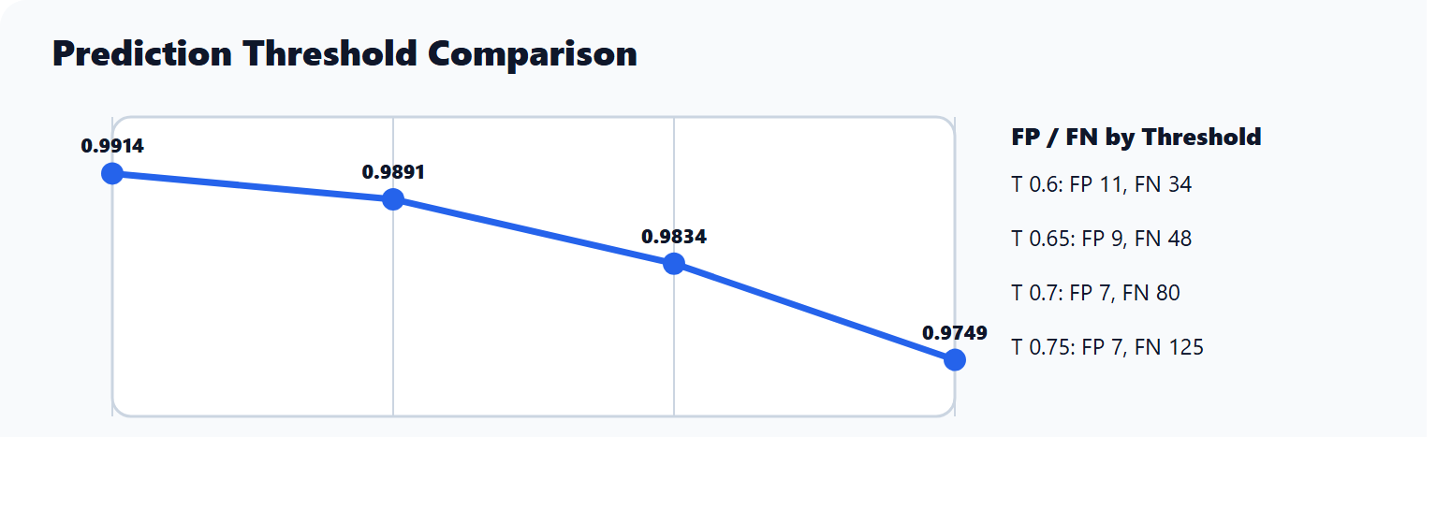

The final evaluation metrics were:

Metric | Value
Accuracy | 0.9834
Weighted precision | 0.9839
Weighted recall | 0.9834
F1 score | 0.9834
Area under ROC | 0.9987
Area under PR | 0.9990
Test rows | 4,977
Prediction threshold | 0.70

The accuracy can be reported as approximately:

98.34 percent

8.2 Confusion Matrix

Actual Label | Predicted Label | Count | Meaning
0 | 0 | 2,022 | True negatives
0 | 1 | 7 | False positives
1 | 0 | 80 | False negatives
1 | 1 | 3,129 | True positives

The false positive rate was approximately 0.345 percent. The false negative rate was approximately 2.493 percent.

8.3 Threshold Comparison

Threshold | Accuracy | F1 | False Positives | False Negatives
0.60 | 0.9914 | 0.9914 | 11 | 34
0.65 | 0.9891 | 0.9891 | 9 | 48
0.70 | 0.9834 | 0.9834 | 7 | 80
0.75 | 0.9748 | 0.9749 | 7 | 125

Threshold 0.70 was selected because it reduced false positives while keeping strong overall detection. This is suitable for the project goal because false positives were a major issue during development, especially for normal POST form requests.

8.4 Strengths of the Project

The project has several strengths:

- It uses PySpark rather than only a small local Python classifier.
- It combines multiple datasets into a master dataset.
- It includes feature engineering for both attack indicators and normal form traffic.
- It saves evaluation outputs, misclassified examples, and threshold comparisons.
- It integrates the WAF with a real ASP.NET Core MVC website.
- It provides visible proof on the website and terminal.
- It avoids claiming unrealistic 100 percent accuracy.

8.5 Limitations

The system has limitations:

- The public CSIC dataset is older and may not fully represent modern production web traffic.
- The custom dataset contains many malicious examples, so more normal traffic could improve generalisation.
- The live demo uses a local API rather than a production reverse proxy.
- The WAF focuses on selected attack types and does not cover every possible web threat.
- Rule-based detection can miss unknown payload variations.
- Machine learning models can still produce false positives and false negatives.
- The system is a prototype and would need more testing before production use.

8.6 Conclusion

The project successfully produced a working PySpark-based WAF prototype. It processes raw HTTP request datasets, trains a machine learning pipeline, evaluates the final model, exposes prediction through a local API, and integrates the WAF with an ASP.NET Core MVC ticket booking website. During testing, normal requests were allowed and malicious requests were blocked before reaching the MVC controller.

The final model achieved approximately 98.34 percent accuracy and a weighted F1 score of approximately 98.34 percent on the test data. The live demo confirmed that obvious XSS, SQL injection, command injection, path traversal, and SSTI payloads can be blocked with visible proof. The project should be presented as a practical hybrid WAF prototype rather than a perfect production security product.

8.7 Future Work

Future improvements could include:

- Collecting more normal traffic from the MVC ticket booking website.
- Adding more modern attack datasets.
- Testing with real reverse proxy deployment.
- Adding request logging and a security dashboard.
- Adding authentication and role-based admin monitoring.
- Improving ML fallback latency.
- Testing against more encoded and obfuscated payloads.
- Adding continuous retraining and model versioning.

References

[1]
OWASP Foundation (n.d.) OWASP Top Ten Web Application Security Risks. Available at: https://owasp.org/www-project-top-ten/ (Accessed: 22 April 2026).
[2]
Apache Spark (n.d.) ML Pipelines – Spark Documentation. Available at: https://spark.apache.org/docs/latest/ml-pipeline.html (Accessed: 22 April 2026).
[3]
Microsoft (n.d.) ASP.NET Core Middleware. Available at: https://learn.microsoft.com/en-us/aspnet/core/fundamentals/middleware (Accessed: 22 April 2026).
[4]
Spangler, I. (n.d.) CSIC 2010 Web Application Attacks. Kaggle Dataset. Available at: https://www.kaggle.com/datasets/ispangler/csic-2010-web-application-attacks (Accessed: 22 April 2026).
[5]
Apache Spark (n.d.) PySpark Documentation. Available at: https://spark.apache.org/docs/latest/api/python/ (Accessed: 22 April 2026).
[6]
Microsoft (n.d.) ASP.NET Core MVC Overview. Available at: https://learn.microsoft.com/en-us/aspnet/core/mvc/overview (Accessed: 22 April 2026).

Appendices

Appendix A: Project Commands

Build master dataset:

cd C:\Users\Asjath\Desktop\Pyspark_WAF_Project
python .\src\build_master_dataset.py

Train model:

python .\src\train_pipeline.py

Evaluate model:

python .\src\evaluate_pipeline.py

Start WAF API:

.\.venv\Scripts\python.exe .\src\waf_api.py

Start MVC website:

cd C:\Users\Asjath\Desktop\Pyspark_WAF_Project\demo_website\SmartEventMVC_WAF_Demo\SmartEventMVC
dotnet run

Appendix B: Important Output Files

File | Purpose
`model\waf_detection_pipeline` | Final saved PySpark model.
`reports\evaluation\waf_detection_pipeline_metrics.json` | Main model metrics.
`reports\evaluation\threshold_comparison.csv` | Threshold comparison.
`reports\evaluation\false_positives.csv` | False positive examples.
`reports\evaluation\false_negatives.csv` | False negative examples.
`reports\evaluation\misclassified_examples.csv` | All saved misclassified examples.
`demo_files\screenshots` | Screenshots for report and presentation.

Appendix C: Project Progress Log Sheet
