Database System Lab

**Task Name: Asjid Ahmed**

**Roll No: P17-6124**

**Assignment: 1**

**Instructor: Muhammad Usman.**

# **Question # 1**

Part 1

Find all the employees that contains at least one vowel in their last name.

select * from employees

WHERE last_name LIKE '%u%'

or last_name LIKE '%a%'

or last_name LIKE '%o%'

or last_name LIKE '%i%'

or last_name LIKE '%e%'

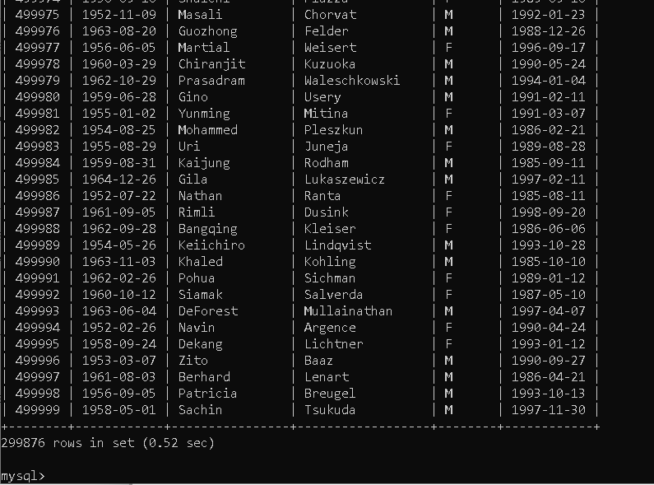

Part 2

Write a Query to display the number of Male (M) and Female employees in the employee

database.

[SELECT](http://localhost/phpmyadmin/url.php?url=https://dev.mysql.com/doc/refman/5.5/en/select.html) ([SELECT](http://localhost/phpmyadmin/url.php?url=https://dev.mysql.com/doc/refman/5.5/en/select.html) [COUNT](http://localhost/phpmyadmin/url.php?url=https://dev.mysql.com/doc/refman/5.5/en/group-by-functions.html#function_count)(*) FROM employees WHERE gender='F') AS FEMALE,([SELECT](http://localhost/phpmyadmin/url.php?url=https://dev.mysql.com/doc/refman/5.5/en/select.html) [COUNT](http://localhost/phpmyadmin/url.php?url=https://dev.mysql.com/doc/refman/5.5/en/group-by-functions.html#function_count)(*) FROM employees WHERE gender='M') AS MALE FROM employees GROUP BY FEMALE;

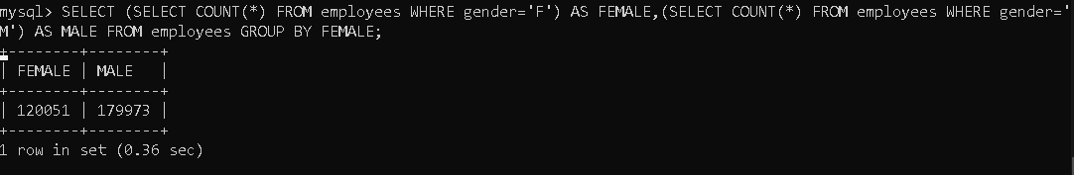

Part 3

Display the TOTAL SALARY drawn by employees having emp number

(10001,401829).

[SELECT](http://localhost/phpmyadmin/url.php?url=https://dev.mysql.com/doc/refman/5.5/en/select.html) ([SELECT](http://localhost/phpmyadmin/url.php?url=https://dev.mysql.com/doc/refman/5.5/en/select.html) [SUM](http://localhost/phpmyadmin/url.php?url=https://dev.mysql.com/doc/refman/5.5/en/group-by-functions.html#function_sum)(salary) from salaries where emp_no=10001 [or](http://localhost/phpmyadmin/url.php?url=https://dev.mysql.com/doc/refman/5.5/en/logical-operators.html#operator_or) emp_no=401829) AS "Total Salary" FROM employees GROUP BY "Total Salary";

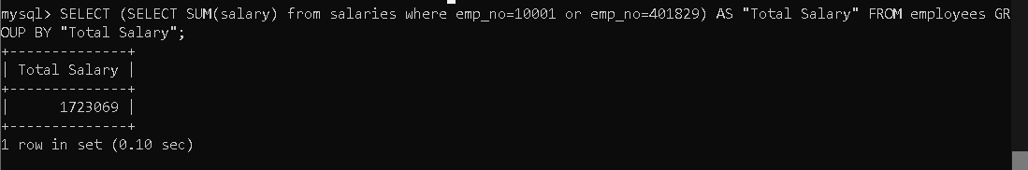

Part 4

Display the employee number, first name, last name, and salary of the lowest payed

employee.

SELECT employees.emp_no, employees.first_name, employees.last_name, salaries.salary

FROM employees JOIN salaries

ON employees.emp_no=salaries.emp_no

HAVING MIN(salaries.salary);

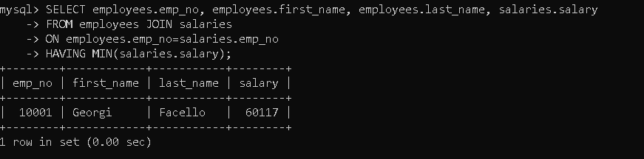

Part 5

Write a Query to find all the employees that have worked in at least 2 departments. Show

their emp number, first name, last name and the number of departments they work in.

Select employees.emp_no, employees.first_name, employees.last_name,dept_emp.dept_no

From employees JOIN dept_emp ON employees.emp_no=dept_emp.emp_no

HAVING COUNT(*)>=2;

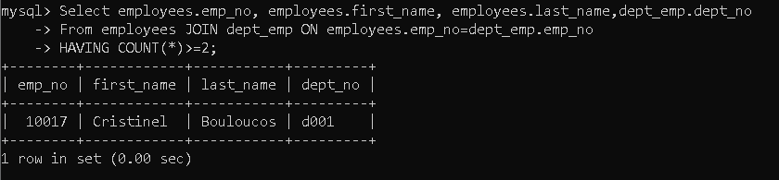

Part 6

Display the employee number, first name, last name, and salary of the second and third

highest payed employee.

[SELECT](http://localhost/phpmyadmin/url.php?url=https://dev.mysql.com/doc/refman/5.5/en/select.html) employees.emp_no,employees.first_name,employees.last_name,salaries.salary FROM employees JOIN salaries ON employees.emp_no=salaries.emp_no WHERE salaries.salary [IN](http://localhost/phpmyadmin/url.php?url=https://dev.mysql.com/doc/refman/5.5/en/comparison-operators.html#function_in) ([SELECT](http://localhost/phpmyadmin/url.php?url=https://dev.mysql.com/doc/refman/5.5/en/select.html) [MAX](http://localhost/phpmyadmin/url.php?url=https://dev.mysql.com/doc/refman/5.5/en/group-by-functions.html#function_max)(salary) FROM salaries WHERE salary [NOT](http://localhost/phpmyadmin/url.php?url=https://dev.mysql.com/doc/refman/5.5/en/logical-operators.html#operator_not) [IN](http://localhost/phpmyadmin/url.php?url=https://dev.mysql.com/doc/refman/5.5/en/comparison-operators.html#function_in) ([SELECT](http://localhost/phpmyadmin/url.php?url=https://dev.mysql.com/doc/refman/5.5/en/select.html) [MAX](http://localhost/phpmyadmin/url.php?url=https://dev.mysql.com/doc/refman/5.5/en/group-by-functions.html#function_max)(salary) from salaries)) ORDER BY salary DESC LIMIT 1 OFFSET 2;



Part 7

Write a Query to display employee first name, last name and the department in which

he/she worked.

SELECT employees.first_name,employees.last_name,dept_emp.dept_no

FROM employees JOIN dept_emp

ON employees.emp_no=dept_emp.emp_no

ORDER BY employees.emp_no;

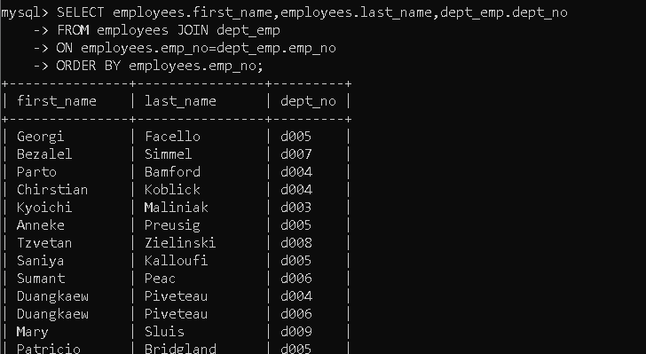

Part 8

Display the employee number, first name, last name, and salary of the third highest payed

employee.

SELECT employees.emp_no,employees.first_name,employees.last_name,salaries.salary

FROM employees JOIN salaries

ON employees.emp_no=salaries.emp_no

WHERE salaries.salary IN (SELECT MAX(salary) from salaries

WHERE salary NOT IN (SELECT MAX(salary)

FROM salaries))

ORDER BY salaries.emp_no;

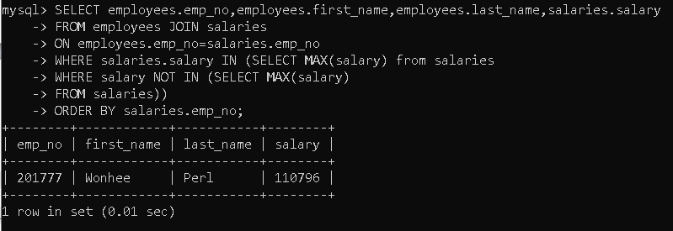

Part 9

Have you noticed an optional clause (ON DELETE CASCADE) in the script

employee.sql for Foreign key declaration. Elaborate this clause with example.

It means if a primary key value is changed in a table then all the other tables that uses that primary as a foreign key will be updated on performing delete operation.

Example

Delete student id from student table

The student id in marks table will be deleted too.

Part 10

Delete every employee who was hired after 31st December 1999.

DELETE FROM employees

WHERE hire_date > ('1999-12-31');

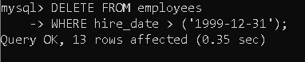

Part 11

Update the employee number (10004) title to Project Manager.

UPDATE titles

SET title="Project Manager"

WHERE emp_no = 10004;

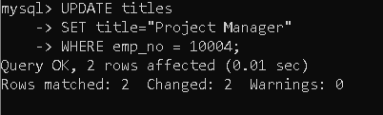

Part 12

Modify the column dept_name characteristics in the department table by changing the

string characteristics from varchar(40) to varchar(60).

ALTER TABLE departments

MODIFY COLUMN dept_name varchar(60);

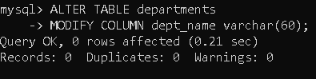

Part 13

Rename the salary attribute to payslip in the salary table.

ALTER TABLE salaries

CHANGE salary payslip int(15);

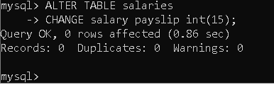

Part 14

Rename the table titles to job_description.

ALTER TABLE titles

RENAME TO job_description;

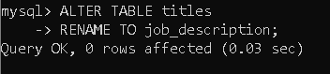

Part 15

Rename database employee to employee_v2 and then delete the database.

Create database employees_v2;

Rename table employees.departments to employees_v2.departments;

Rename table employees.dept_emp to employees_v2. dept_emp;

Rename table employees.dept_manager to employees_v2. dept_manager;

Rename table employees.employees to employees_v2. employees;

Rename table employees.job_description to employees_v2. job_description;

Rename table employees.job_salaries to employees_v2. salaries;

Drop database employees;

