Database System Lab

**Task Name: Asjid Ahmed**

**Roll No: P17-6124**

**DB LAB Assignment: 2**

**Instructor: Muhammad Usman.**

# **Q.NO.1**

CREATE TABLE Courses

(

COURSE_CODE varchar(10) NOT NULL,

COURSE_NAME varchar(20) DEFAULT NULL,

CREDIT_HOURS varchar(20) DEFAULT NULL,

ROLL_NO varchar(10) NOT NULL,

PRIMARY KEY (COURSE_CODE),

FOREIGN KEY (ROLL_NO) REFERENCES student(ROLL_NO) ON DELETE CASCADE

);

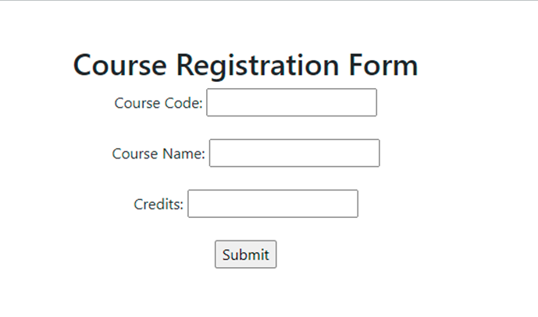

# **Q.No.2**

Attached file with name ‘Q2.sql’