Lab Task #06

# Exercises

# E6.1

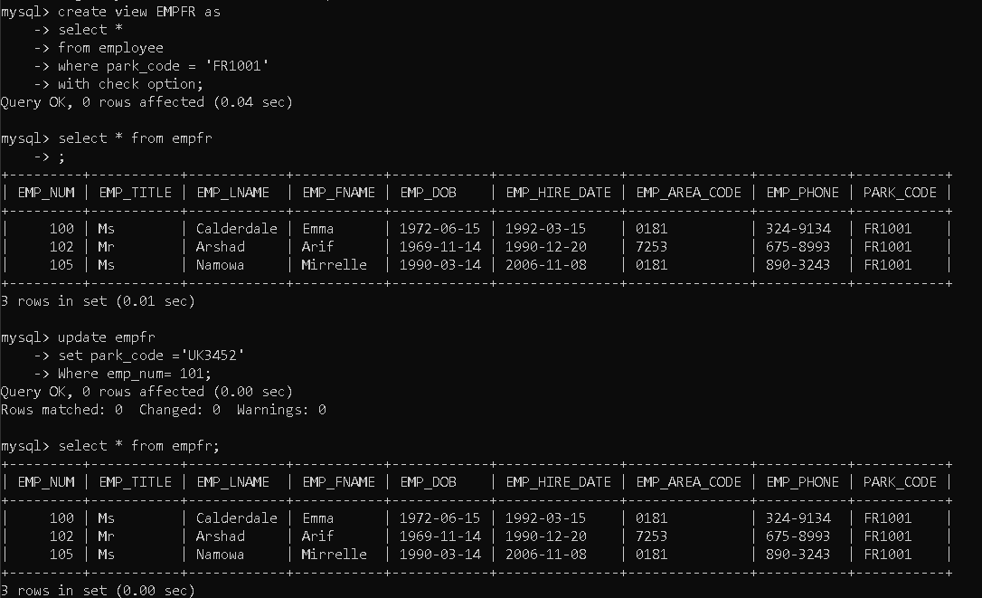

# E6.2

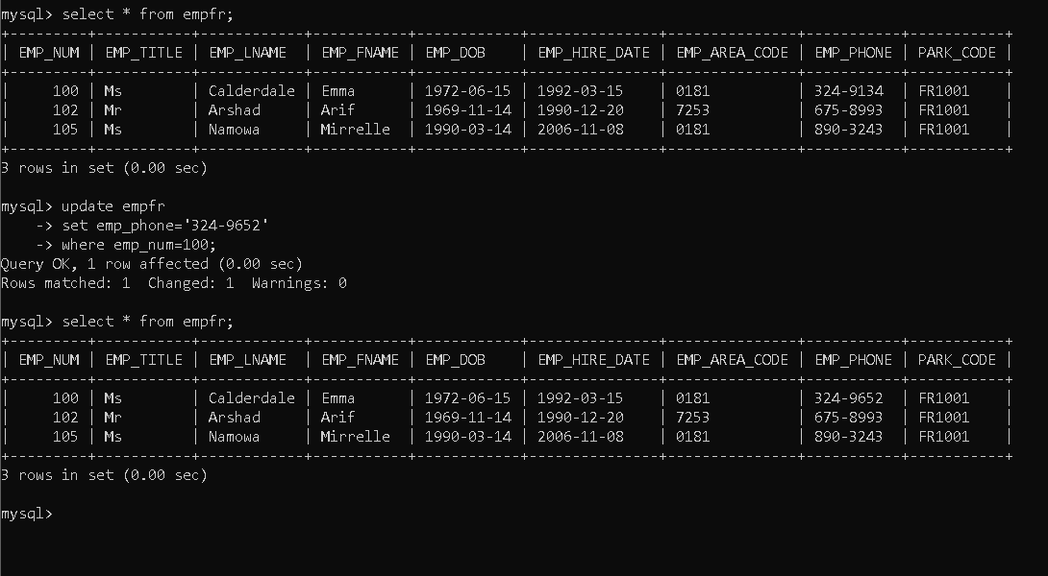

# E6.3

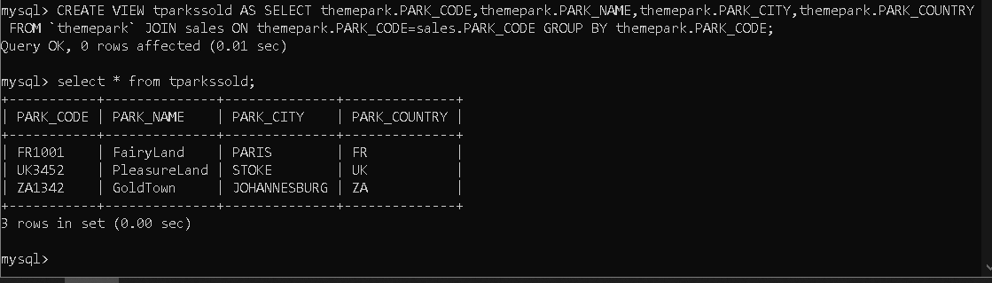

# E6.4

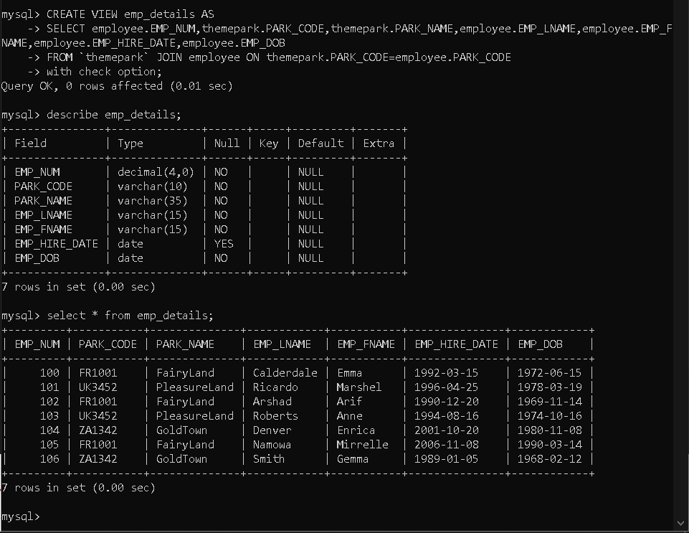

# E6.5

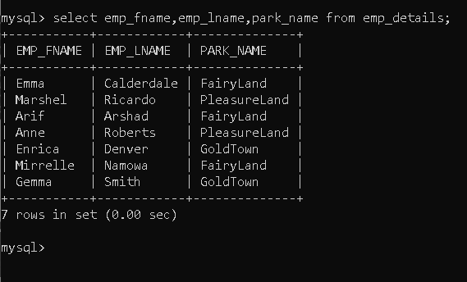

# E6.6

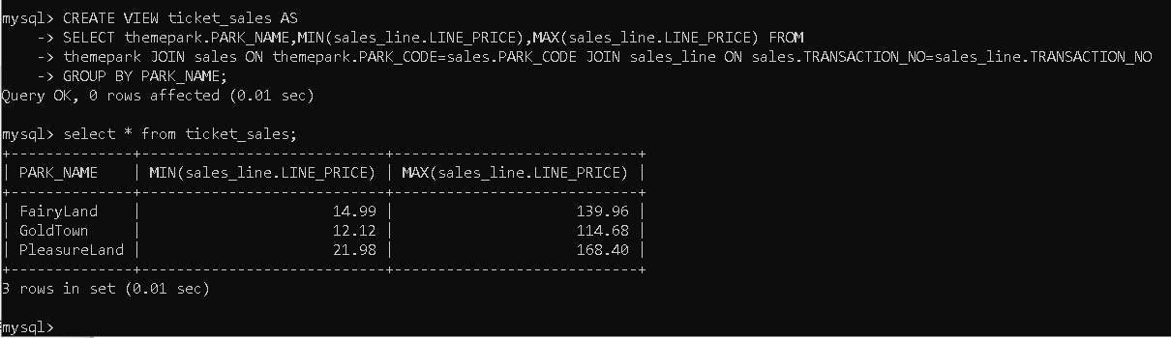

# E6.7

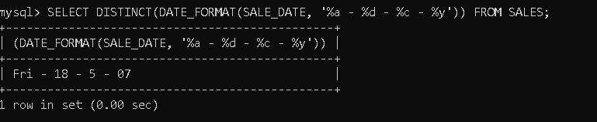

# E6.8

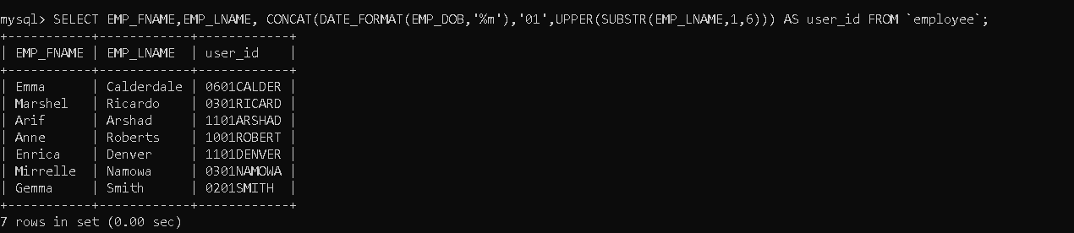

# E6.9

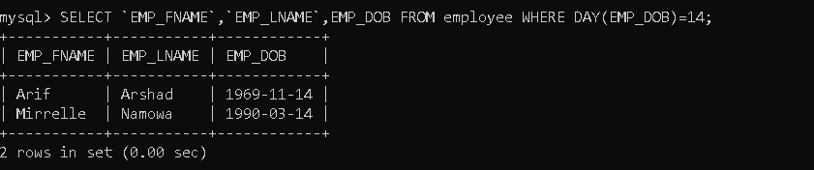

# E6.10

