**Name:** Asjid Tahir

**Roll no:** 19p-0085

**Section:** B

**Lab no:** 01

**Computer Networks Lab**

**Basic Commands:**

* **For ipconfig:**

Shows basics information of adaptors.

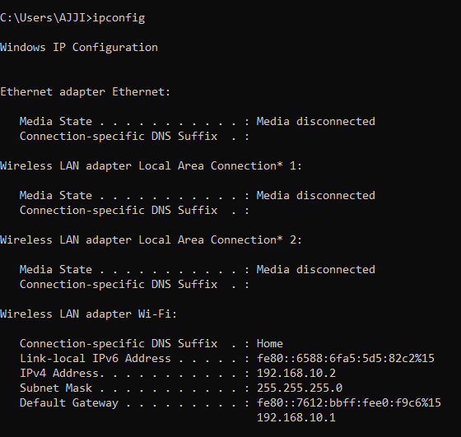

* **For config-all:**

Show detail information of network adaptors i.e Internet protocol routing, proxies etc.

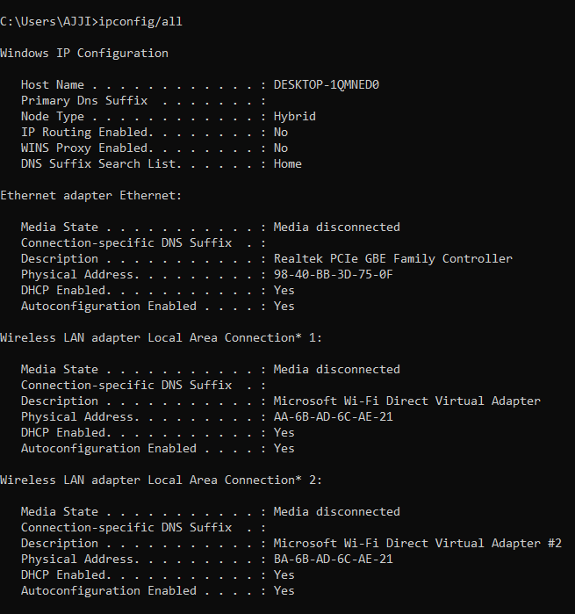

* For v4:



* For physical address:

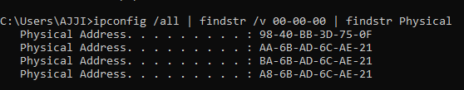

* 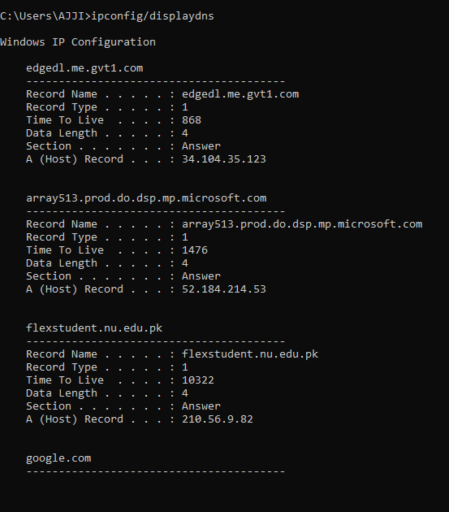For DNS:
* 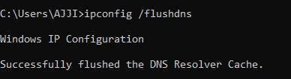For flush DNS:
* **For ip-config-help:**

Internet protocol rules that how to communicate and configure with the other ips.

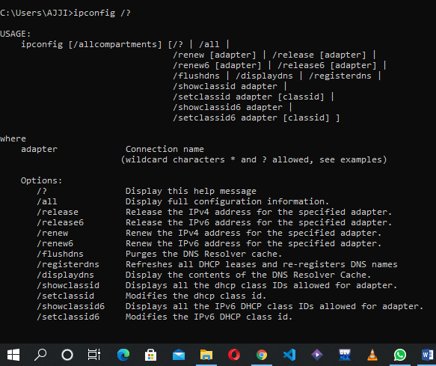

* For ip-output-to-result-text-file:

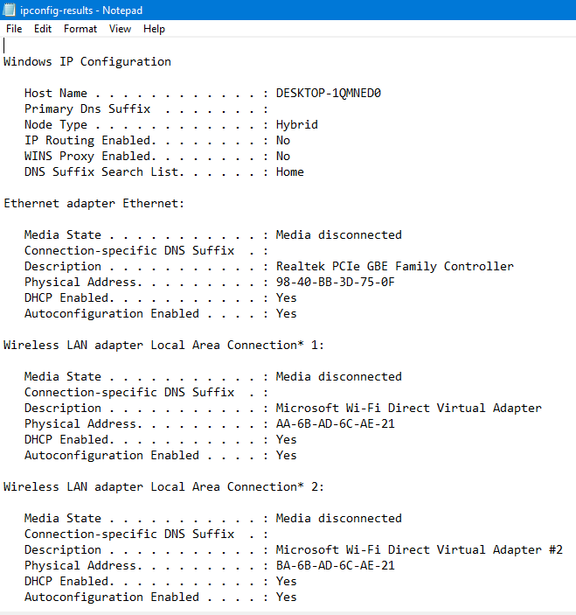

* 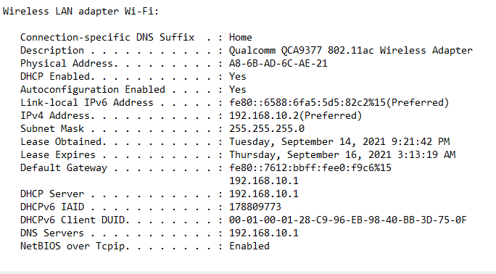**For nslookup:**

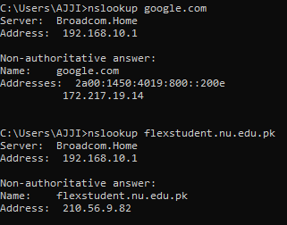Nslookup (stands for “Name Server Lookup”) is a useful command for getting information from

DNS server. It is used for finding domain name or internet protocol mapping.