ASJID TAHIR
P19-0085
OPERATING SYSTEM LAB

LAB TASK # 05:

CODE:
Q no 01:

#include <stdio.h>
#include <sys/types.h>
#include <unistd.h>

int main(){

fork();
fork();
fork();
fork();
fork();
fork();
fork();
fork();

printf("Hello");

return 0;
}

PROCESSES = 256
HELLO PRINTS =256

TREE HIERARCHY:
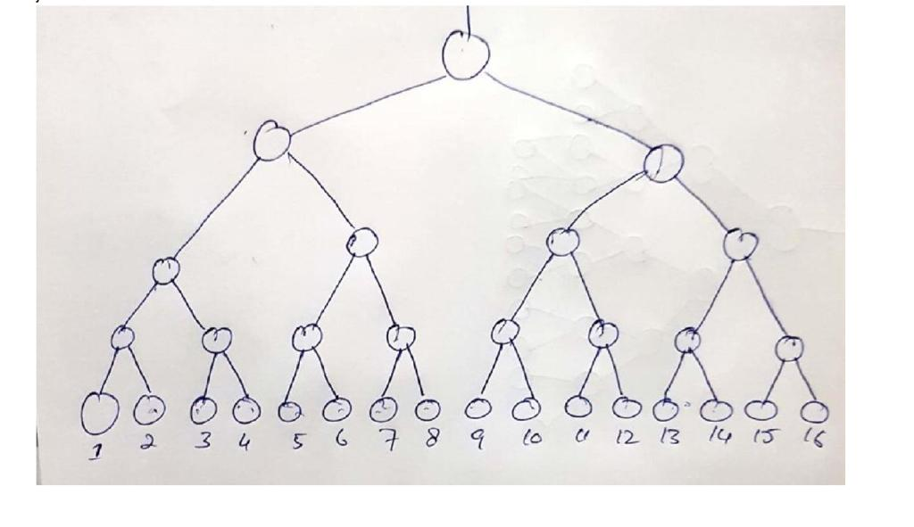

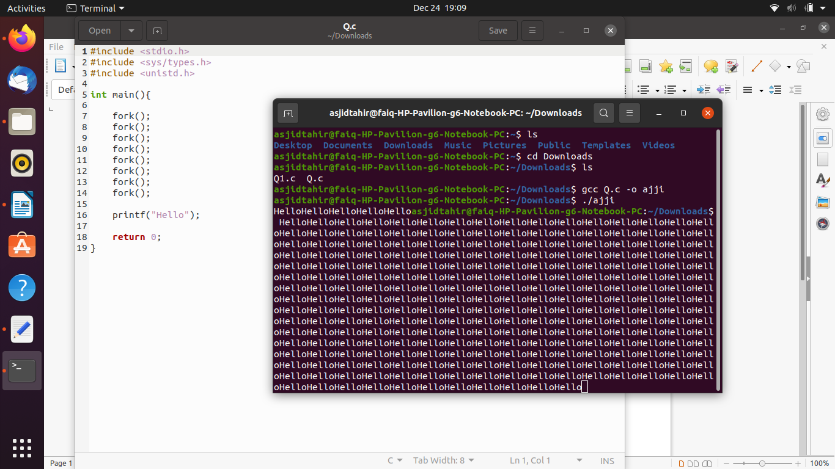

Q no 02:

#include <stdio.h>
#include <sys/types.h>
#include <unistd.h>
int main()
{
int pid = fork();

if ( pid == 0){
fork();
fork();
printf("Hello \n");
}
else
{
fork();
printf("Hello \n");
}
return 0;
}
PROCESSES = 6
HELLO PRINTS =6
TREE:
