2. Sift feature extraction

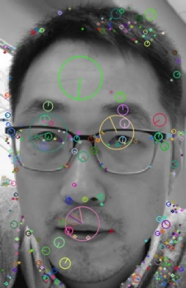

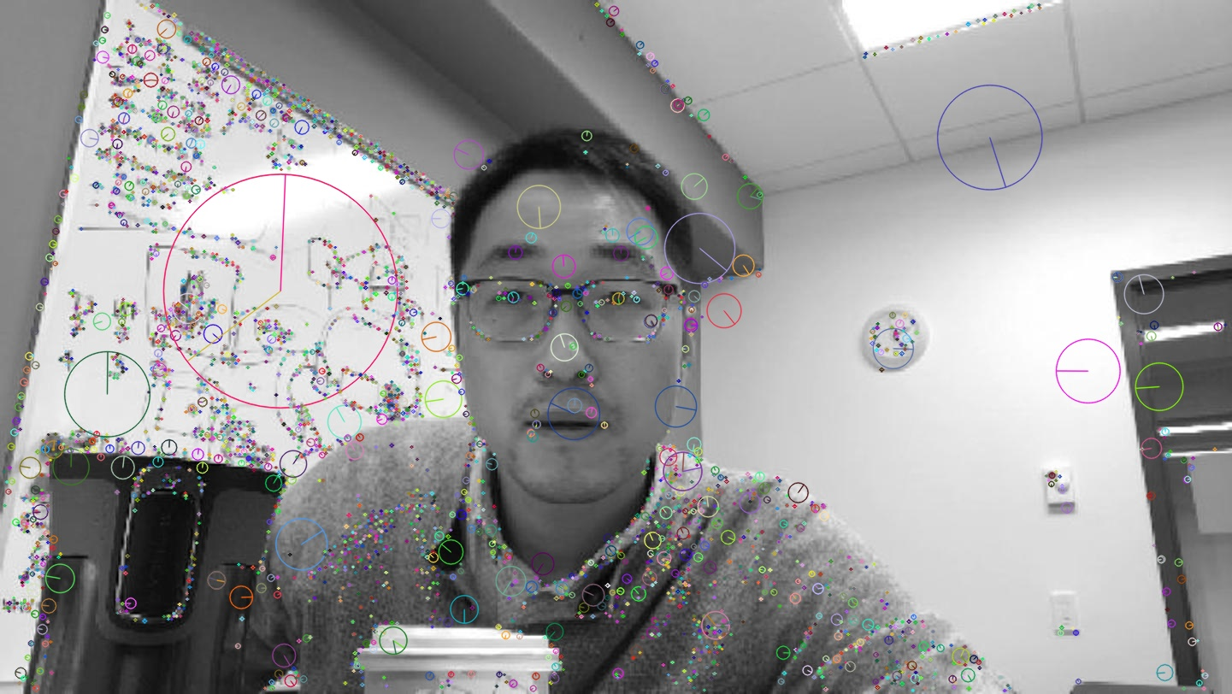

3. SIFT Feature matching (find_match)

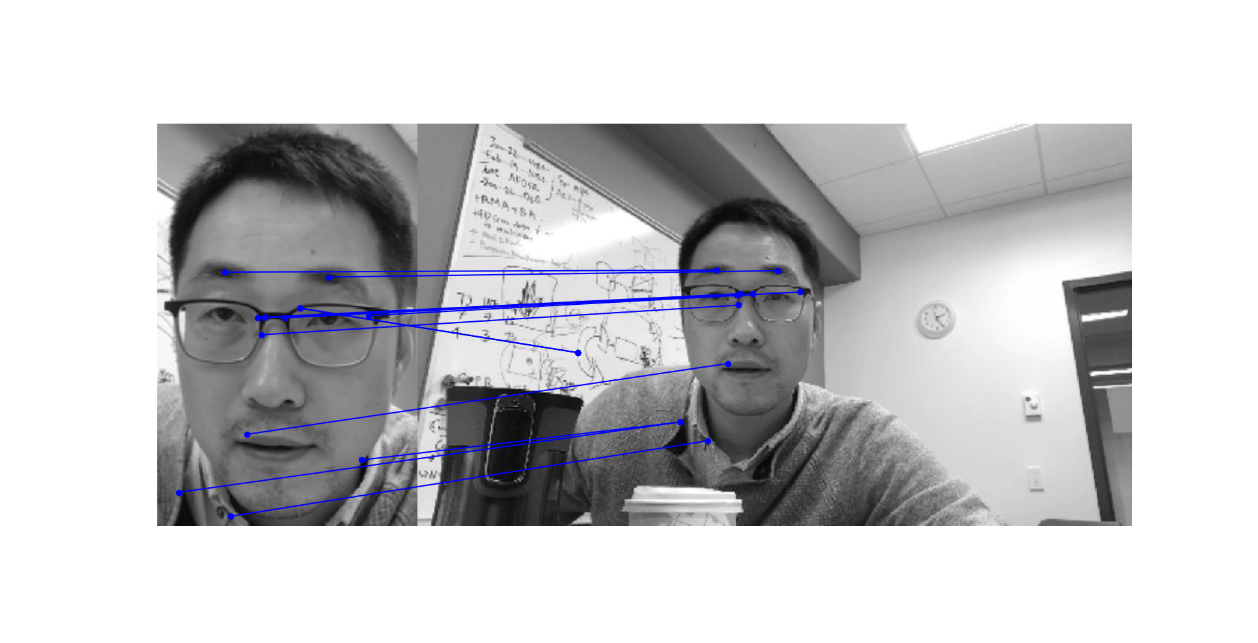

4. Feature-based image alignment (align_image_using_feature)  
Number of inliners are 5, for this. If we change threshold and number of iterations then we will get different number of inliners. Initial warped image is as follows.

5. Image warping (warp_image)  
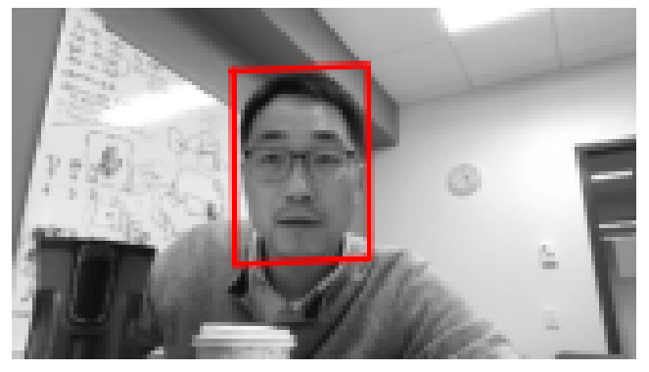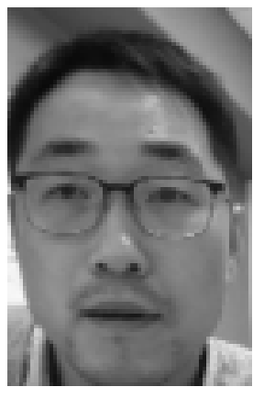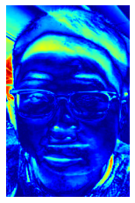

6. Inverse compositional image alignment (align_image)  
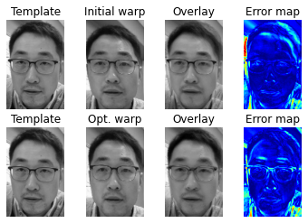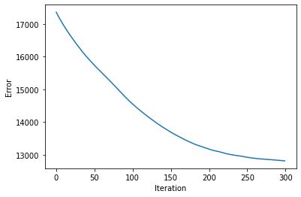

7. Putting things together: multiframe tracking (track_multi_frames)  
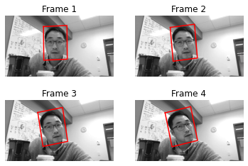  
Errors for frame 1, Frame 2, frame 3, frame 4  
