All figures and stereo.mat files are submitted in the folder.

3. SIFT feature matching

Find_match function was written. Mostly code was similar to HW2. It take two images and finds bidirectional matching between two images using sift module.

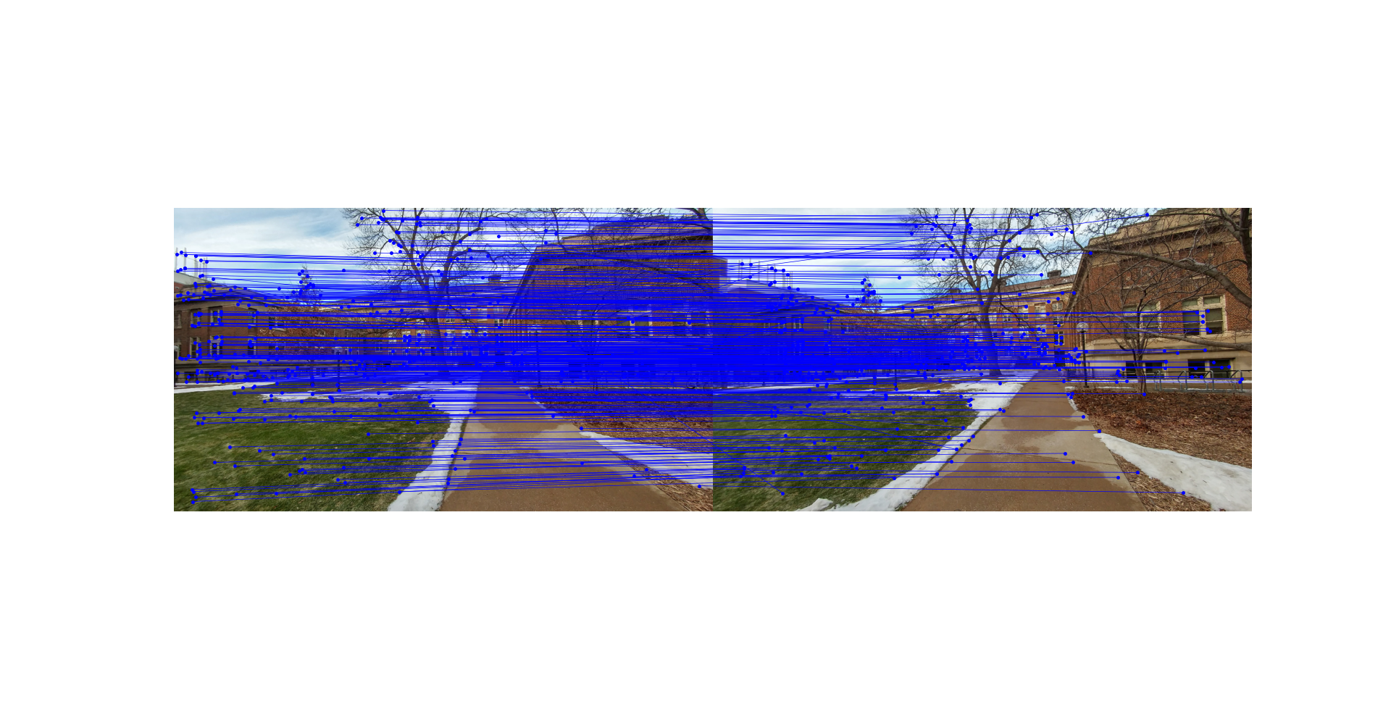

4. Fundamental matrix computation

Compute_F was written. This function takes points received from previous function and calculates F (Fundamental matrix based on that. Total iteration used were 10000, threshold was 0.01. In the end results I got are as following.

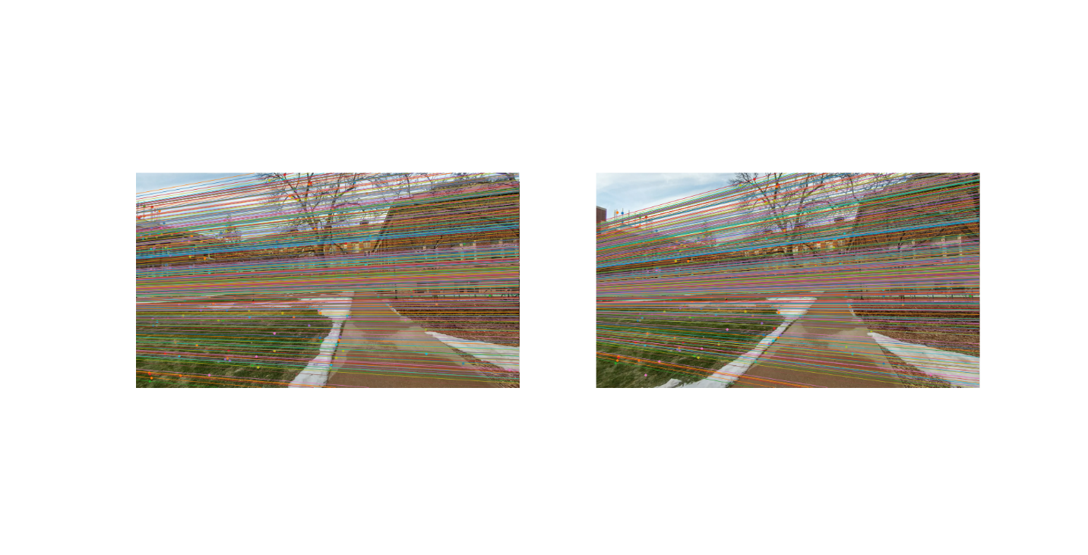

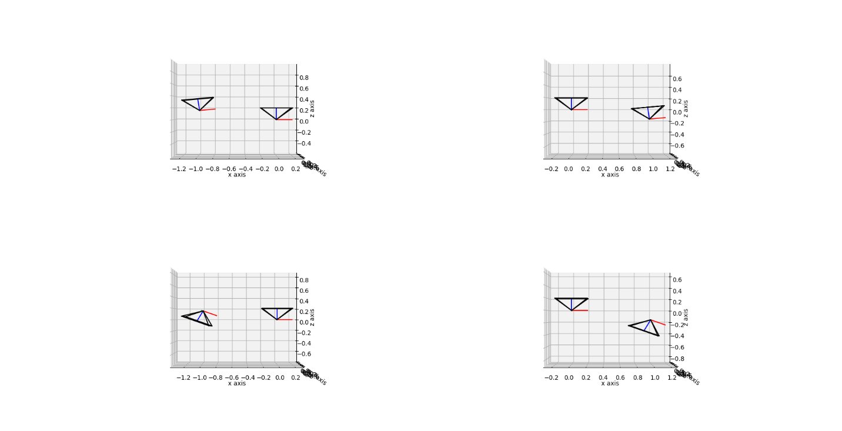

5. Triangulation

Triangulation function was written to do so. It take point and p1, p2 as input and give 3D reconstructed points as output.

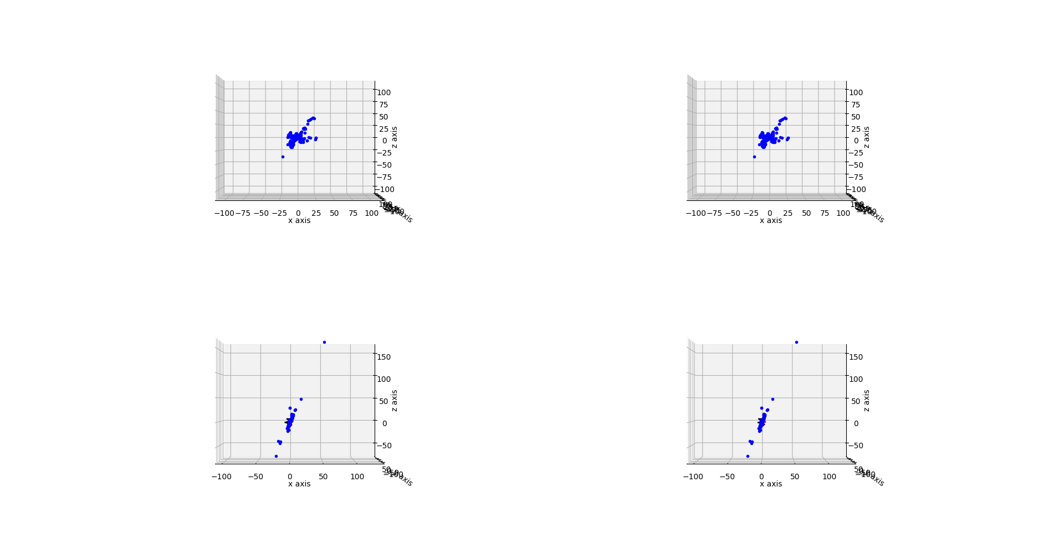

6. Pose Disambiguation

Disambiguate_pose function was written. It takes rotation matrix, camera centers and 3D reconstructed points as an input and gives best camera rotation center and 3D reconstructed points as output.

7. Stereo

Compute_rectification and dense_match were written. Camera pose and intrinsic parameters as input and gives homographies for left and right images.

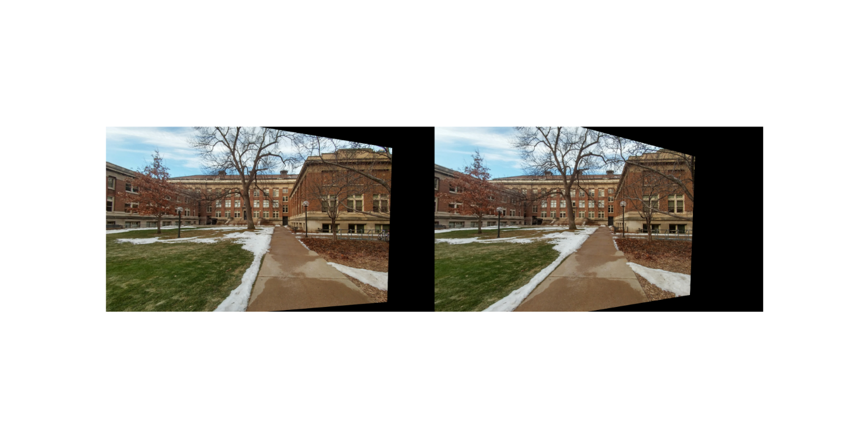

And second function take two images as input and gives disparity between two. Results are shown here.

