COURSE CODE : EE 171
ENERGY HARVESTER USING RF SIGNALS
MOTTO - To Support IoT Devices

ENERGY HARVESTER:
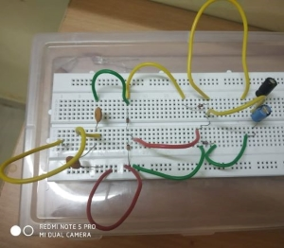

MOTIVATION
Abstract— Electromagnetic energy harvesting holds a promising future for powering up low power electronic devices in wireless technology circuits. Most of the Internet of things(IoT Applications) require sensor nodes to operate for a large period of a time.These sensor nodes are generally deployed in harsh and inaccessible environments. For these reasons, sensor nodes are supposed to operate over long time periods without human intervention.Therefore, an accurate energy consumption model of the sensor node is essential to estimate the sensor lifetime. This energy model allows optimizing the power consumption of the sensor node.This project presents an RF energy harvesting system that can harvest energy from the ambient surroundings at the Wireless Radio frequency that lie in the range ranging from around 3 kHz-300 GHz band. The harvesting system aimed to provide a new generation an alternative source of energy for powering up low power devices, specifically IoT Devices. In this project, we will harness the freely available emitted radio frequency signals from different existing frequency bands used by telecommunication companies and utilize it by converting it into a usable DC power using circular antenna and a converter circuit in the form of radiant energy collector for the purpose of optimization and conservation of energy through the concept of reuse and recycle. It aims to create a device that maximizes the freely available radio frequency signals by using a low cost rectenna design and convert it directly to electrical energy and reduce the demand of electricity especially in areas with abundance of ambient RF signals. The research involves design, experiments, assembling and optimization of the circuit. The study is slightly slanted towards research in which the regulation of the output voltage leads to the utilization of the energy in powering up low-powered sensors located in the facilities such as telecom room to lessen the operational expenses (OPEX).The goal of this work is to propose an energy consumption model for sensor nodes.

INTRODUCTION :
There is an active research area investigating a number of alternative ways to extract energy from the environment and convert it into electrical energy for energizing low power electronic circuits directly or store it for later use. Complementing the low power sources used for energizing the low power electronic devices, as an application to green technology. RF energy harvesting from ambient sources have great potential to impact on the cellular phones and portable electronic devices. ABI Research and iSupply estimate the number of mobile phone subscriptions has recently surpassed 5 billion, and the ITU estimates there are over 1 billion subscriptions for mobile broadband. Mobile phones are huge source from which to harvest RF energy to provide power for many portable and close range-sensing applications. There is also a big consideration to the wide range number of Wi-Fi routers and wireless end-user devices such as computers. Maintaining the RF to DC conversion efficiency of the harvester will also determine the output.

CIRCUIT ELEMENTS :
- CIRCULAR ANTENNA
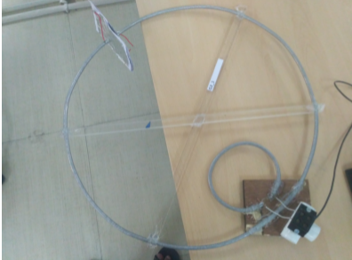
2. 0.22 uF 100V CERAMIC CAPACITORS (2)
3. 100uF 25V ELECTROLYTIC CAPACITORS (2)
4. IN34 GERMANIUM DIODE (4)
In crafting the device, the following factors were considered :-
Antenna -
A loop antenna is a type of a radio antenna, which consists of a loop (circular electrical conductor) usually fed by a balanced source or feeding a balanced load.The large self resonant loop antenna has a circumference close to one wavelength of the operating frequency and so is resonant at that frequency . This category also includes smaller loops 5% to 30% of a wavelength in circumference, which use a capacitor to make them resonant.This antenna is used for receiving radio signals in surrounding and converting them into electrical signals.

Capacitors -
The capacitors used are electrolytic and ceramic , with 100uF for the electrolytic and 0.22uF for the ceramic, and both must be 50V rating for the calculated safety values. Ceramic capacitors were used in the input side it is a unpolarized capacitor to capture the full RF signal. Electrolytic capacitors were used in the output side as a filter to smoothen the DC output rectified by the germanium diodes.

Diodes -
Germanium diodes (IN34) were used in the study because of its significant characteristic of being a low voltage drop diode perfect for the harvesting and conversion of energy purposes.

CIRCUIT DESIGN AND WORKING :
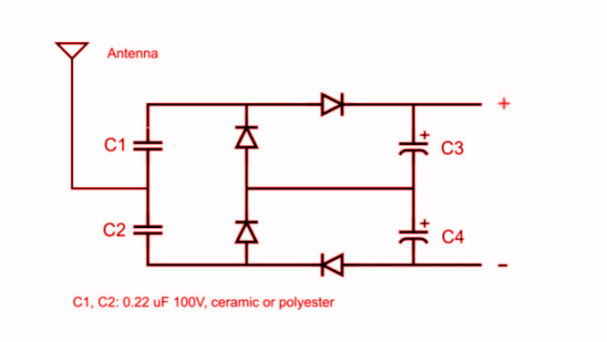
Working of circuit -
In the positive half cycle of the input AC signal that is obtained from the antenna the capacitors C3 and C4 will be charged and in the negative half cycle capacitors C1 and C2 will be charged. They are charged in order to provide more amount of current to the external capacitors.

GRAPHS FROM OSCILLOSCOPE:
The Data below describes the details of the the study of the voltage profile and current profile measured via digital oscilloscope. The setup was made and tested in EE lab of IIT Bhilai.
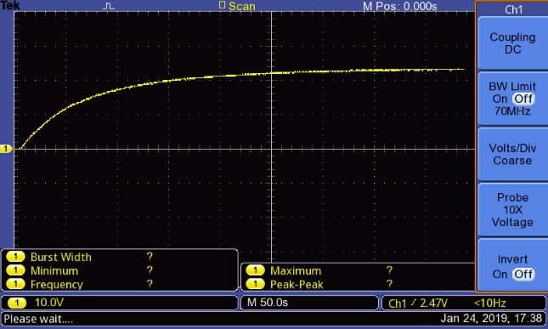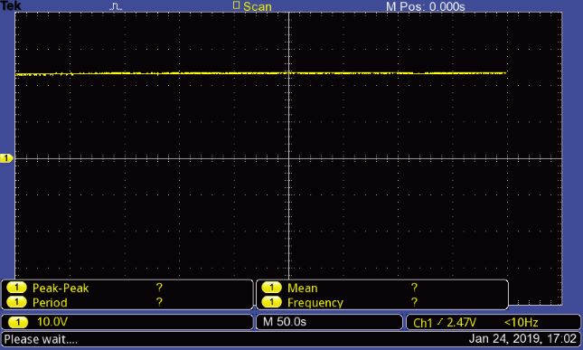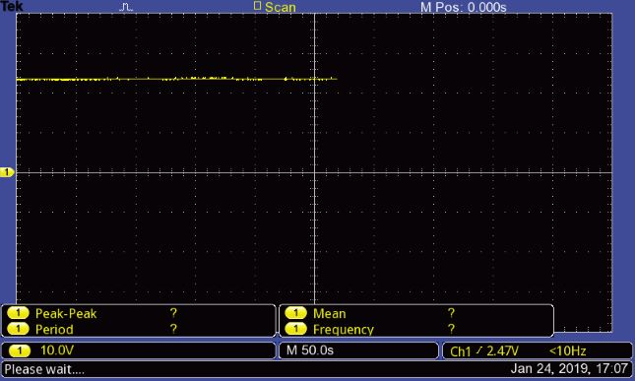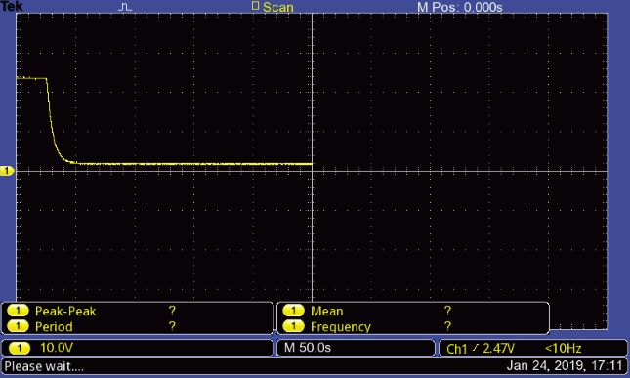
Images of voltage profile during both charging and discharging of the capacitors using oscilloscope.

Graphs drawn manually:
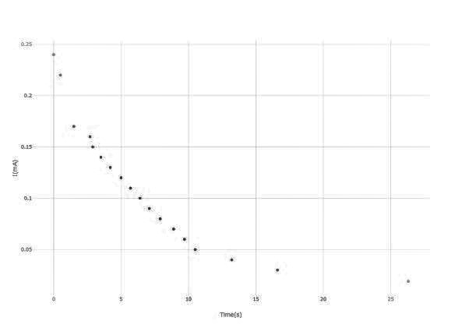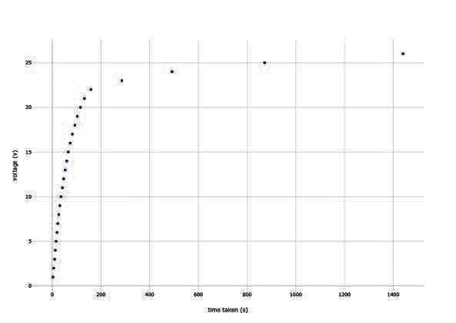Current time plot while Discharging Voltage time plot Charging
The tables for the following graphs and the scaled graphs are in the following links -
1.https://plot.ly/~MadhukarKolli/3/#data
2.https://plot.ly/~MadhukarKolli/1/#data

ENGINEERING AND DIMENSIONING THE SYSTEM

SENSOR WORKING SCENARIO -
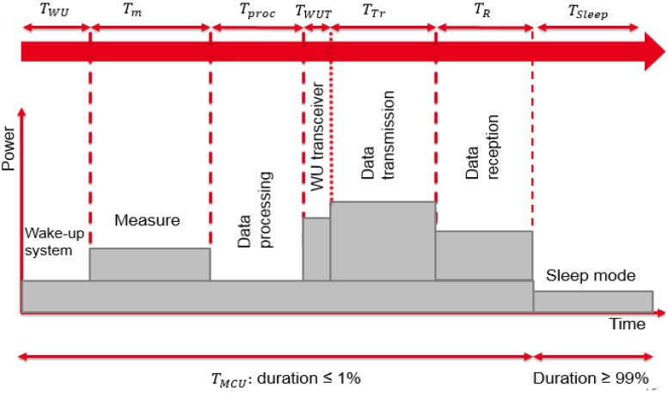

A first approach consists in considering all elements active during a fixed time duration and inactive for the rest of the time cycle. Most of the time, the wireless sensor is in sleep mode. The consumed energy in this mode could impact the power consumption amount of the sensor.It is for every 100 sec of time duration it can be charged 99 sec using an external source which it uses in 1 sec.
The total consumed energy ETotal used by the communicating sensor for one cycle is given by Equation:
E Total = E Sleep + E Active,

where E Sleep and E Active are the dissipated energy by the node in the sleep mode and the total energy consumption during the active mode of the microcontroller, respectively. ESleep is expressed as:
E Sleep = P Sleep * T Sleep
where PSleep and TSleep are the power consumption and the time duration in the sleep mode, respectively.
The total energy consumption EActive is calculated as the sum of the energy consumption of each part of the sensor node. It is given by the following equation:
EActive = EWU + Edm + Eproc + EWUT + ETr + ER
where EWU, Edm, Eproc, EWUT, ETr and ER are, respectively, the consumed energies in the system wake-up, the data measurement, the microcontroller processing, the wake-up of the transceiver ,data transmission ,data reception .
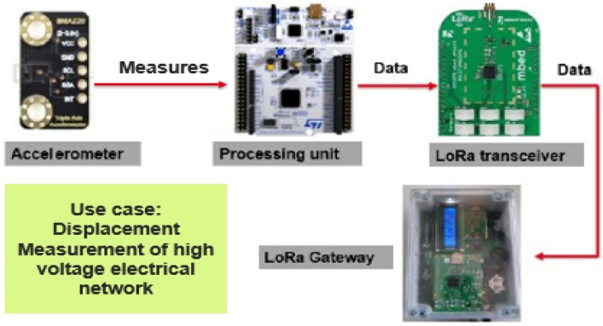

Total power that is generated by the energy harvester when it is connected to an external resistance of 100k ohm then the current generated was 0.24mA and it took 24 min in order to generate this amount of current thus the power that is generated is nearly 0.96mAh.
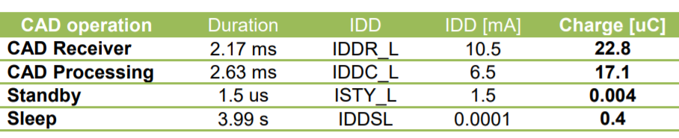

According to this data regarding the cad operation of a lora device the total amount of charge that is required is 40.304μC and this to be generated in a time span of 4 sec.In the same time interval of time the model that we made generates a charge of , let the effective capacitance across be k=c/2 and the voltage across it in 4sec 1.5 V.

Q = effective capacitance * v
= k * v
= c*v/2
= 50μF *1.5 v
Q = 75μC

As the required charge was only 40.304μC thus the harvester we have made is thoroughly sufficient to support the LoRA Device under consideration. Similarly for any other devices we should change the number of capacitors used

FUTURE SCOPE OF WORK :
1.This harvester can be used to charge up Iot (Internet of things devices and other sensors.

REFERENCE :
1.Energy Consumption Model for Sensor Nodes Based on LoRa and LoRaWAN
Taoufik Bouguera,1,2,* Jean-François Diouris,1 Jean-Jacques Chaillout,2 Randa Jaouadi,3 andGuillaume Andrieux1
2. BMA220, STM32L073 and SX1272 datasheets [29,32,33].
3. Wireless RF Energy Harvesting: RF-to-DC Conversion and a Look at Powercast Hardware
August 03, 2018 by Mark Hughes

REPORT BY,
A.S.K.KAUSHEEK(11840120)
M.ALEKHYA (11840720)
G.SAI RISHITHA (11840540)
K.MADHUKAR (11840670)

