**Empirical Study on STM Transmission System of Gazi Networks**

**Limited (ICX)**

By

Pijush Sarkar

ID: 152-19-1792

This Internship Report is presented in partial fulfillment of the requirements of the Degree of Bachelor of Science in Electronics and Telecommunication Engineering.

Supervised By

**Engr. Md. Zahirul Islam**

Assistant Professor

Department of ETE

Daffodil International University



DAFFODIL INTERNATIONAL UNIVERSITY

DHAKA-1207, BANGLADESH

May, 2018

**APPROVAL**

This Internship Report Titled “**Empirical Study on STM Transmission System of Gazi Network Ltd**” is submitted by Pijush Sarkar to the Department of Electronics & Telecommunication Engineering, Daffodil International University, has been accepted as fit for the partial fulfillment of the condition for the Degree of B.Sc. (Hon’s) in Electronics & Telecommunication Engineering & ap-proved as to its style and guts. The Presentation will be held on October, 2018.

**BOARD OF EXAMINERS**

**Md. Taslim Arefin**

Associate Professor & Head Chairman

Department of ETE

Daffodil International University

**Dr. Engr. Quamruzzaman**

Professor Internal Examiner

Department of ETE

Daffodil International University

**Ms. Shahina Haque**

Assistant Professor Internal Examiner

Department of ETE

Daffodil International University

**Dr. Subrata Kumar Aditya**

Professor External Examiner

Department of EEE

University of Dhaka

**DECLARATION**

I hereby declare that this Internship Report has been done by me under the supervision of Engr. Md. Zahirul Islam, Assistant Professor, Department of ETE, Daffodil International University & Gazi Network Ltd. I also declare that neither this report nor any part of it has been submitted away for award of any degree or diploma.

Supervised by

**Engr. Md. Zahirul Islam**

Assistant Professor

Department of ETE

Daffodil International University

Submitted by

**Pijush Sarkar**

ID:152-19-1792

Department of ETE

Daffodil International University

**ACKNOWLEDGMENTS**

At First, I am like to convey my gratitude to the Almighty for charitable me the right path while trying the duty.

The real sprit of achieving a goal is finished the way of quality and austere castigation. I would have never thrived in effecting my task without the teamwork, help and support provided to me by many personalities.

This internship report would not consume been possible without the provision and direction of **Engr.Md. Zahirul Islam, Assistant Professor,** Department of Electronics and Telecommunication Engineering, Daffodil International University, Dhaka, under whose direction I chose this topic.

I would like to rapid my heartiest gratitude to **Md. TaslimArefin, Associate Professorand Head,** Department of Electronics and Telecommunication Engineering, for his kindhelp to surface our thesis and also to other faculty participants, the staffs of the ETE Department of Daffodil International University.

I must grant with due esteem the perpetual support and endurance of my family members for final this internship.

**Pijush Sarkar**

**Abstract**

It was a great occasion to work under **GAZI Networks Ltd**. The main resolve of the program was to see the real life state. The moot knowledge is not well plenty to compete with real domain. This internship package was helpful to face the real waged atmosphere. In **GAZI Networks Ltd.** I have paid a good time in erudition and was satisfied for my best sweats, learnt to deal with different states, had experience of communal working location which affects an employee act and attitude towards labor, had good time in knowledge and performance. I have also collected experience about the turmoil of the trouble times while standard was going through one of its foremost transition phase. Poise, on time decision making, steadiness, hard work, team graft, seeking victory out of dark, origination, creativity, organizational persistence are the key scholarship’s out of my work and I would like to say that it resolve be one of my top skill that would remain per mean help me in upcoming which will offer many tasks. I would like to acme this, that my skill with GAZI Networks Ltd was very striking and full of cultures, where I found a lot of helpful changes in my arrogance, learning and performance

**Table of Contents**

**Chapter** **Page**

**Chapter 1: Introduction** 07-09

1.1: Introduction 07

1.2: About Gazi Network Ltd 07

1.3 Company Profile 08

1.4 Objective the Report 08

1.5 Summary of the Report 09

**Chapter 2: Telecommunications network architecture** 12-25

2.1 Abstract 12

2.2 What is OSS and BSS architecture 13

2.3 How do Telecom Systems work 13

2.4 What are the types of Telecommunication Networks 14

2.5 Is the internet a telecommunication network 14

2.6 What is OSS in Telecom 14

2.7 What is BSS in Telecom 15

2.8 What is BSC in Telecom 15

2.9 What is CRM in Telecom 15

2.10 What is a call flow 17

2.11 What is call flow in Telecom 17

2.12 GSM call flow 17

2.13 What is LTE call flow 19

2.14 What is SIP call flow 19

2.15 What is IMS call flow 19

2.16 What is 3G call flow 20

2.17 What is ISUP in GSM 20

2.18 Inbound call flow 20

2.19 Outbound call flow 25

**Chapter 3: GSM (Global System for Mobile Communications** 27-41

3.1 GSM Network structure 28

3.2 Introduction to SDH 29

3.3 Synchronization of Digitals Signals 29

3.4 Overview 30

3.5 Graphical SDH Multiplexer Structure 32

3.6 What is PDH 33

3.7 What is SDH signals 34

3.8 SDH Frame Structure 37

3.9 SDH overhead 38

3.10 SDH error performance monitoring 41

**Chapter 4: Core Device** 42-45

4.1 What is the media gateway (MGW) 42

4.2 MGW architecture 44

4.3 What is MGC Network 45

4.4 What is MGCP 45

**Chapter 5: Alarms in NOC (Network Operation Center)** 48-57

**Chapter 6: Conclusion**  58-59

**References** 60

**List of Figures**

**Figure Name**  **Page**

Fig. 2.2: OSS and BSS architecture 13

Fig. 2.3: Telecom systems Work 13

Fig. 2.7: Business Support Systems (BSS) 15

Fig. 2.8: Telecommunication Network Architecture 16

Fig. 2.12: GSM call flow 17

Fig. 2.13: CDMA call flow 18

Fig.2.16: IS originating and IMS terminating Call 20

Fig. 3.1: GSM Network Architecture 28

Fig. 3.5: PDG Multiplexing by steps 31

Fig. 3.9: Virtual container 32

Fig. 3.13: Graphical SDH Multiplexing Structure 41

Fig. 4.1:MGW architecture 43

Fig. 4.2: Media gateway control protocol 45

Fig. 4.3: Core device 46

Fig. 5.2: Basic Alarms of Gazi Networks 50

**Chapter 1**

**Introduction**

**1.1 Introduction**

Telecom officials blatant an ICX (Interconnection Exchange) based interconnection tenet in 2007 and with that proceeding a new era of interconnection in Bangladesh. The ICX has no subscriber and is not also conventional connected with any external operator. So the movement of IGW’s (International Gateway) and ANS’s (Access Network Services) is also the traffic of ICX’s. With the open data from BTRC and BTTB, it is observed that the total worldwide traffic (both incoming & outgoing) choices from 35 to 45 million paid minutes per day and the entomb operator traffic is about 45 million per day. There is still specific dormant international movement extending from 3 to 4 million which is careful as proscribed movement. With the synchronized effort among the law applying supports, the new IGW and ICXmachinists under the guide ranks of BTRC, a considerable volume of barred movement can be moved back to the legal channel. It can be understood that international call will rise much every year due to the subjects like growing numbers of Bangladeshi exiles outside the country. This will also help to improve the domestic tile-density and rise the business actions

**1.2 About Gazi Network Ltd**

GAZI Networks Limited is the interconnection exchange (ICX) operator licensed by Bangladesh Telecommunications Regulatory Commission (BTRC) for the routing of domestic and international voice traffic to and from ANS & IGW. Gazi Networks Limited will commercially launch in 12-04-2012, now the company is one of the leading ICX operations in Bangladesh. The company has highly skilled, hardworking, professional and talented manpower. The management team has also extensive experience in the telecom sector. GAZI Networks Limited has three exchange. They are located in Dhaka, Khulna, and Bogra .

**1.3 Company Profile**

|  |  |
| --- | --- |
| Name: | **Gazi Networks Ltd** |
| Address: | Head Office |
|  | 25, SegunBagicha |
|  | (1st Floor) Dhaka-1000, Bangladesh |
| Telephone: | +88-01966604567 |
| Email: | [**info@gazinetworks.com**](mailto:info@gazinetworks.com) |
| Website: | [http://www.gazinetworks.com](http://www.gazinetworks.com/) |
| **1.4 Objective of the Report** |  |

The main objectives of this report are as follows:

1. To Identify Network Architecture Gazi Net Ltd.
2. To Observe the SDH Network Which is Used In Telecom Mostly.
3. To Identify Network Architecture

Working And Monitoring Alarms In Tejas NMS System

**1.5 Summary of the Report**

The objective of this Internship is to improve an effective knowledge in Network Architecture of Gazi Networks Limited (ICX). In ***The First chapter,*** I have termed the Details & objective an overall view that I am going to instrument during these internship work and I would describe the background of GaziNetwork ***The Second Chapter,*** mainly discuss about Telecom Architecture. The***The Third chapter*** is describing, of Network Architecture of GSM here details of definition, SDH Network,PDH Network,Graphical SDH Multiplexer Structure. At least style of transmission of IGW and ICX ***The Fourth Chapter*** is Core device of ICX network.The last one is Chapter ***Five*** that is Alarms and ***Chapter six*** Conclusion.

**Chapter 2**

**Telecommunications network architecture**

**2.1 Abstract**

An abstract generic system model and methodology that form the Telecommunications Network Architecture (TNA) are described. The model represents controls and communication functions required for the transfer of information within a node or a network of nodes providing any service (message, packet, or voice).

As part of the development of their proposed integrated services network, Network 2000, ITT have produced the 1240 digital exchange for voice and data. Hardware has been designed for a range of exchange sizes. LSI and commercially-available microprocessors are used. A distributed control structure provides the size range, and a modular approach allows the attachment of new or customized modules.

Software has been designed to cover the full traffic range and telecommunications needs that will include voice, data, rural, local transit and toll applications. The system is intended to allow the simple implementation of design changes for technology and for the offering of new services.

The UK Meteorological Office requires the rapid transmission of weather bulletins in a format suitable for direct insertion into the main message-switching computer of the British Meteorological Communication Network. Computer-assisted message preparation equipment is to be used that will provide store-and-forward switching, automatic formatting and automatic time-controlled release to line.

System requirements are outlined and the control modules described. Examples of use of the system are given.

**2.2 What is OSS and BSS architecture?**

They support management functions such as network inventory, service provisioning, network configuration and fault management. Together with business support systems (BSS), they are used to support various end-to-end telecommunication services. BSS and OSS have their own data and service responsibilities.

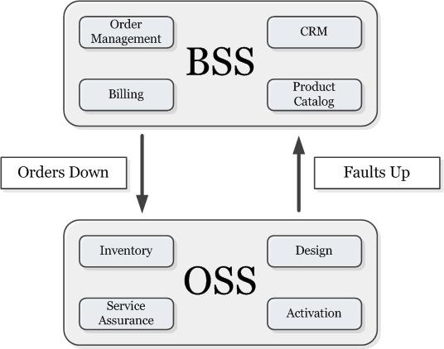

**Figure 2.2** Super simple relationship between OSS and BSS

**2.3 How do telecom systems work?**

Telecommunication networks. A communications network is a collection of transmitters, receivers, and comm.unications channels that send messages to one another. Some digital communications networks contain one or more routers thatwork together to transmit information to the correct user.

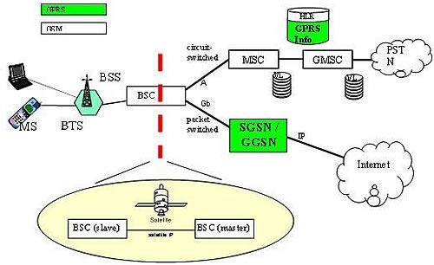

**Figure 2.3**Telecom systems work

**2.4 What are the types of telecommunication networks?**

Types of telecommunication networks

* Computer networks. ARPANET. Ethernet. Internet. Wireless networks.
* Public switched telephone networks (PSTN)
* Packet switched networks.
* Radio networks.
* Television networks.

**2.5 Is the Internet a telecommunications network?**

A telecommunications network is a collection of terminal nodes, links are connected so as to enable telecommunication between the terminals .computer networks the Internet the telephone network.

**2.6 What is OSS in telecom?**

OSS/BSS, in telecommunications, stands for operations support system/business support system. The two systems, operated together by telecommunications service providers, are used to support a range of telecommunication services.

**2.7 What is BSS in Telecom?**

Business support systems (BSS) are the components that a telecommunications service provider (or telco) uses to run its business operations towards customers. Together with operations support systems (OSS), they are used to support various end-to-end telecommunication services (e.g., telephone services).

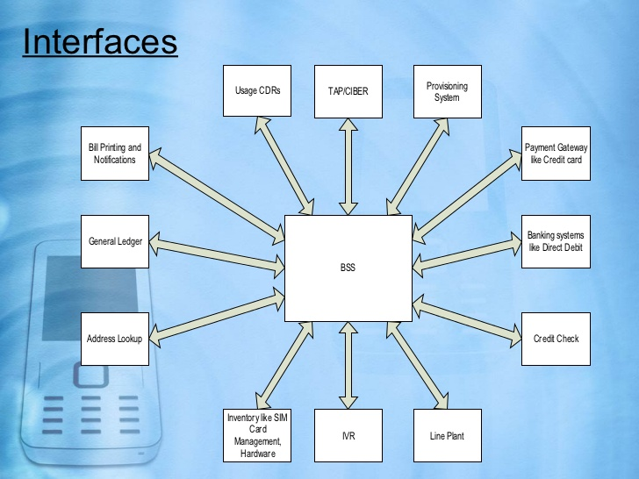

**Figure 2.7**Business support systems (BSS)

**2.8 What is BSC in telecom?**

BSC. The Base Station Controller (BSC) is in control of and supervises a number of Base Transceiver Stations (BTS). The BSC is responsible for the allocation of radio resources to a mobile call and for the handovers that are made between base stations under his control.

**2.9 What is CRM in telecom?**

Customer relationship management (CRM) is a term that refers to practices, strategies and technologies that companies use to manage and analyze customer interactions and data throughout the customer lifecycle, with the goal of improving customer service relationships and assisting in customer retention and driving

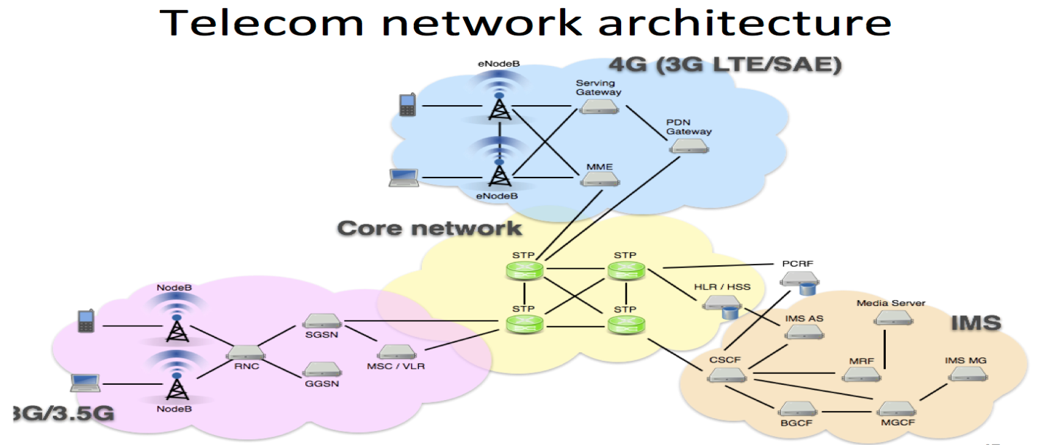

**Figure 2.8** Telecommunication network architecture

.

**2.10 What is a call flow?**

A call flow is a road map to how calls will be handled from the moment they enter the phone system to the end of the call. Call flows can be used to handle even the most complex call scenarios and enable great customer care

**2.11 What is call flow in Telecom?**

Call flow describes the process by which a network routes a call to a mobile device. ... 3G call flow is different in a GSM network than in a CDMA network.

**2.12GSM Call Flow.**

A GSM mobile phone uses aAccidental Access Channel (RACH) to application a keen channel from the base station. The base station responds with a Radio Resource Assignment on the Access Grant Channel (AGCH).Then the device sends a service request to the base station on the Stand Alone Dedicated Control Channel. But the base station will not grant service until the device authenticates itself, so it sends an authentication request to the user’s SIM card in the form of a random 128-bit number (RAND). The mobile device uses the RAND to generate a 32-bit number, called the Signed Response. Once the base station gets this response, the user is authenticated.Then the device sends to the base station the ISDN (integrated service digital network) number of the phone that it is trying to call, and the base station assigns a traffic channel. The base station then sends the call to the mobile switching center (MSC) via the base station controller (BSC).

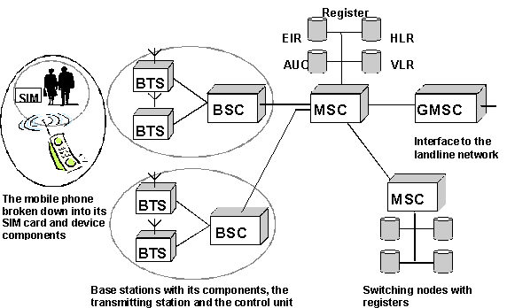

**Figure 2.12** GSM Call flow

The mobile switching center (MSC) sends an initial address message to the network via the GSMC (Global System for Telecommunication), and the call is routed to the correct switching center, often via the landline network. The network generates an address complete message (ACM) when the correct switching center is found. When the MSC receives this message it alerts the base station, which in turn alerts the mobile phone of the caller to generate a ringing sound in the earpiece. If the called party answers, the MSC alerts the caller’s mobile device to transmit voice on the assigned traffic channel.

**2.14 What is LTE call flow?**

With Long Term Evolution (LTE) comes a myriad of new and exciting attributes. One of these is the LTE call flow itself. In fact, call flow and signaling is unique for LTE, and is driven by 3GPP standards. Call flow is how signaling and sessions are created across an LTE network.

**2.15 What is SIP call flow?**

Abstract This document gives examples of Session Initiation Protocol (SIP) call flows. Elements in these call flows include SIP User Agents and Clients, SIP Proxy and Redirect Servers. Scenarios include SIP Registration and SIP session establishment.

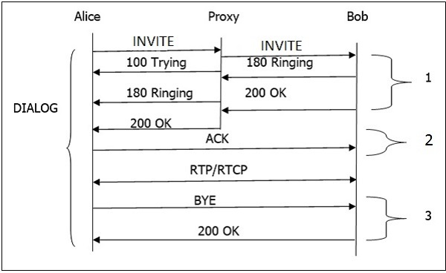

Fig . 2.15[SIP Basic Call Flow](https://www.google.com/url?sa=i&rct=j&q=&esrc=s&source=imgres&cd=&ved=2ahUKEwj19_G9lcPdAhWYaCsKHWd7D6sQjhx6BAgBEAM&url=https%3A%2F%2Fwww.tutorialspoint.com%2Fsession_initiation_protocol%2Fsession_initiation_protocol_basic_call_flow.htm&psig=AOvVaw0ISFnkzfAH5Z70bhfMkVra&ust=1537312501029014)

**2.16 What is IMS call flow?**

IP Multimedia Subsystem (IMS) Call Flows. IP Multimedia Subsystem (IMS) is the next generation platform for IP based multimedia services. Detailed IMS call flowdiagrams for the following scenarios are covered here: ... PSTN (ISUP) to IMSInterworking Call Flow. IMS to PSTN (ISUP) Interworking Call Flow.

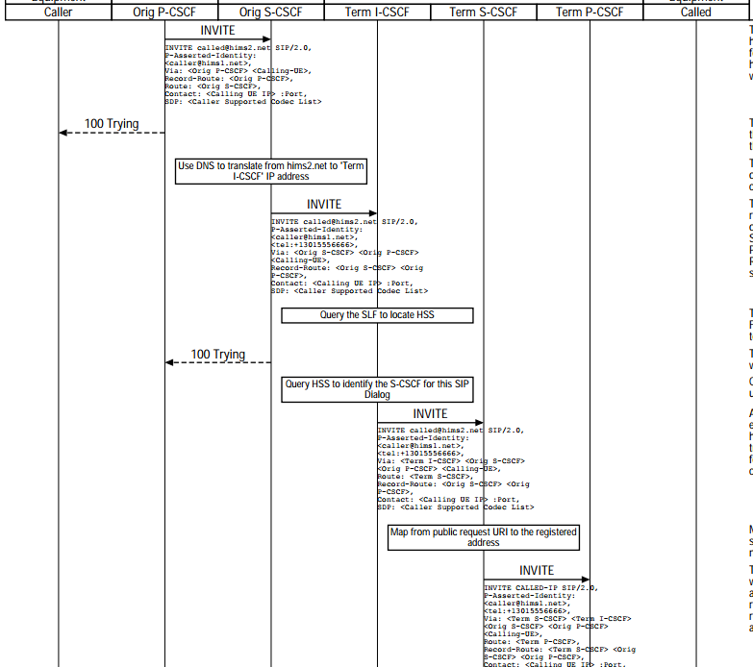

Fig . 2.16 IMS originating and IMS terminating call

**2.17 What is 3g call flow?**

3G UMTS originating call flow. A 3G UMTS originating voice call call setup involves complex signaling to setup and release the call. RRC (Radio Resource Control) signaling between the UE and RAN sets up the radio link.

**2.18 What is ISUP in GSM?**

ISUP is the protocol used to support the signaling necessary to provide voice and non-voice services in telephone communications. It is an extension of SS7, used as the interface protocol for voice and data within, and for ingression or egression to/from the Public Switched Telephone Network (PSTN.)

**2.19 Inbound Call Flow**

* [Abandoned call](https://support.talkdesk.com/hc/en-us/articles/204587275-What-is-an-Abandoned-call-) timer: begins immediately when an inbound call is connected.
* [Waiting time](https://support.talkdesk.com/hc/en-us/articles/201241145-Average-Waiting-Time-a-k-a-Average-Speed-of-Answer-ASA-) and [Service level](https://support.talkdesk.com/hc/en-us/articles/200880965-Service-Level-Metrics) timers: begin when the customer enters the waiting queue.
* [Short abandoned threshold](https://support.talkdesk.com/hc/en-us/articles/206581085-Short-Abandons): optionally set by the account admin.
* [Speed to answer](https://support.talkdesk.com/hc/en-us/articles/201241145-Average-Waiting-Time-a-k-a-Average-Speed-of-Answer-ASA-) timer: begins when the call is presented to one or multiple agents
* [Call duration](https://support.talkdesk.com/hc/en-us/articles/200881025-Calls) timer: begins once the customer is connected to an agent.

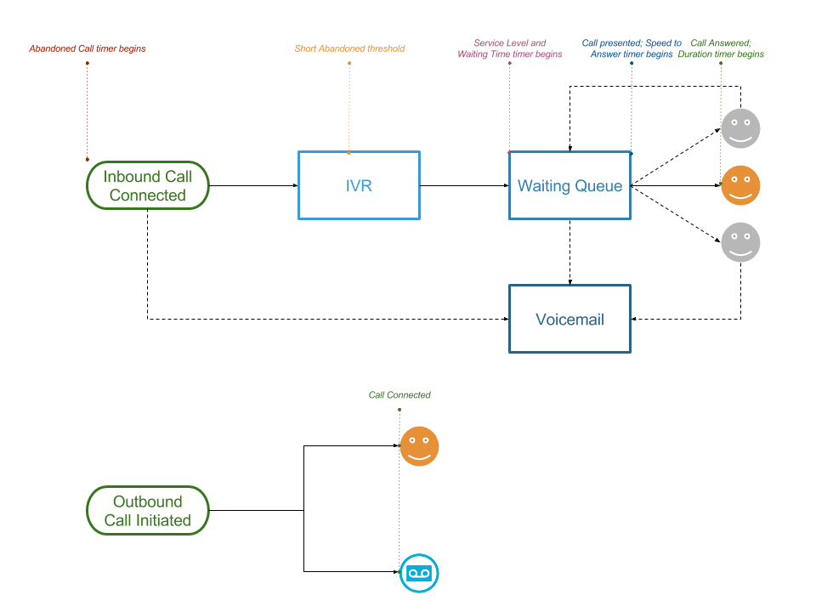

Hang up calls prior to the short abandoned threshold (ie. in the IVR), are considered [Short Abandoned calls](https://support.talkdesk.com/hc/en-us/articles/206581085-Short-Abandons) and are not counted against your call center’s abandon call metrics:

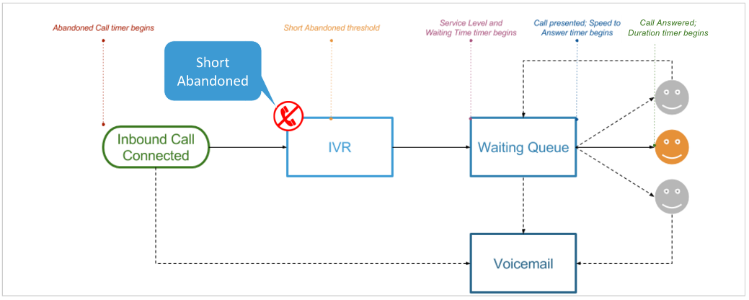

Once the short abandon threshold has been passed however, any calls that hang up within the IVR will be considered true **Abandoned** calls:

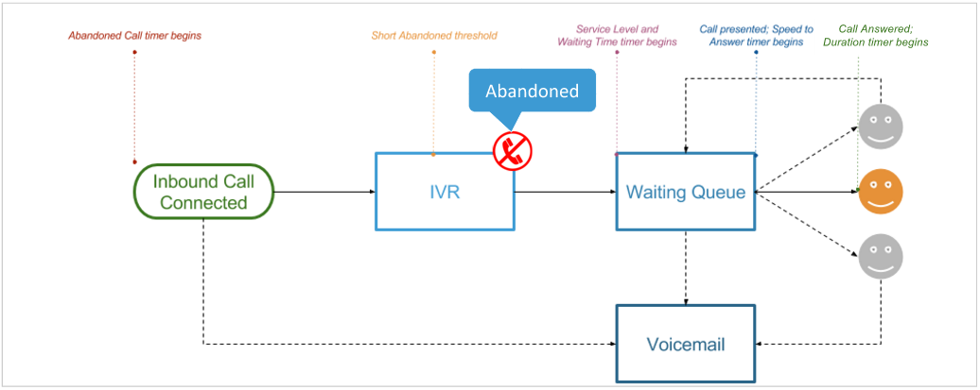

Similarly, assuming the short abandon threshold has been passed, calls that hang up in the waiting queue without having been connected to an agent, will also be considered **Abandoned** calls:

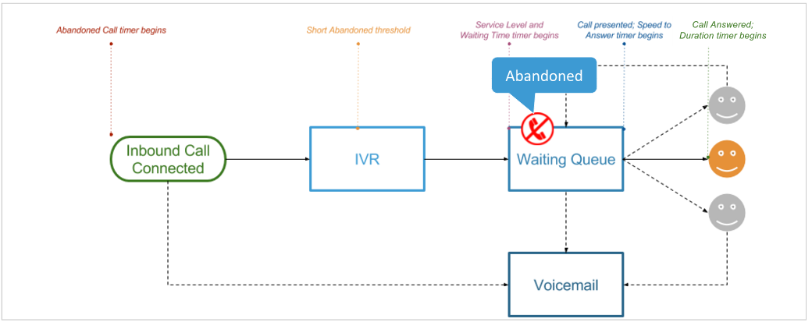

If a caller is routed to voicemail from the waiting queue without being presented to an agent (via voicemail IVR option), and the hang up occurs before the caller leaves a voicemail, the call will again be considered **Abandoned**:

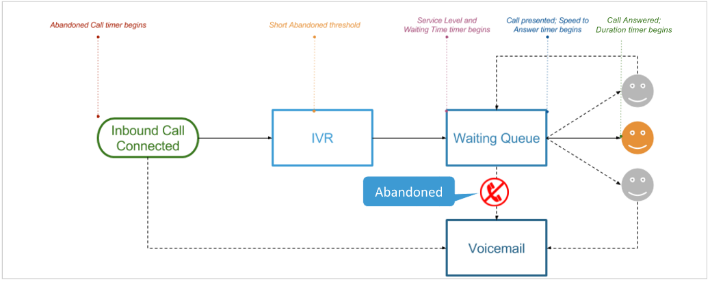

Once the call has been presented to one or multiple agents, if the caller hangs up at any point during agent ringing, the call will be considered **Missed**:

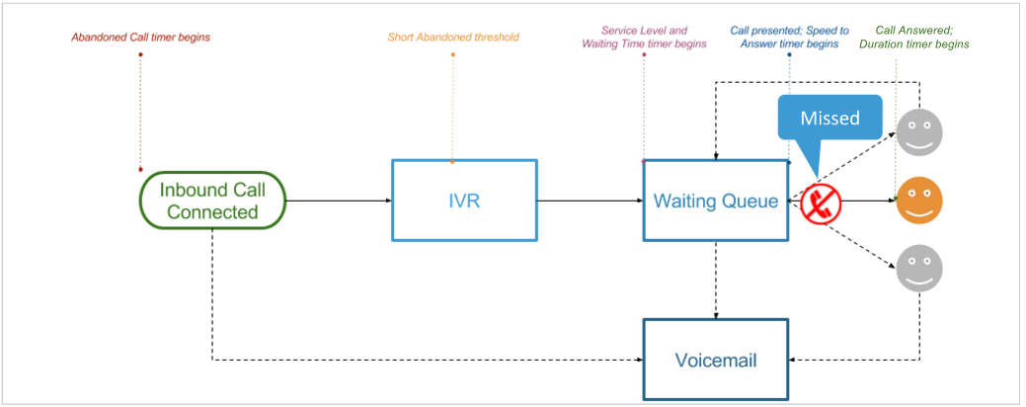

For the "happy path" scenario, where inbound calls are hung up after connecting with an agent, talkdesk will report these call outcomes as **Inbound** calls:

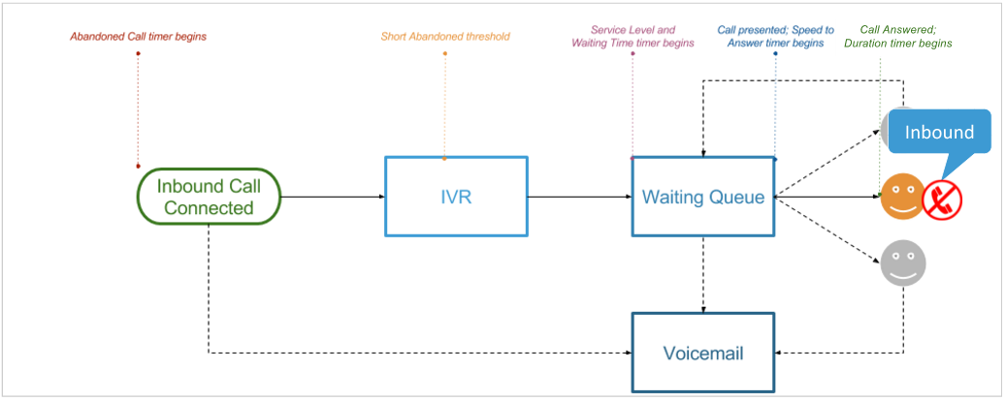

Any hang-ups that occur after a call is placed back into the waiting queue as a result of agents not answering for any reason is considered as **Abandoned**:



However, if a customer has been placed back in the waiting queue after being connected to an agent (such as during transfers), any hang ups that occur in the waiting queue at this point are considered as **Missed** – not abandoned.

After connecting with an agent, a call cannot be considered abandoned at any point, as talkdesk considers the transfer to be **Missed** at this point:

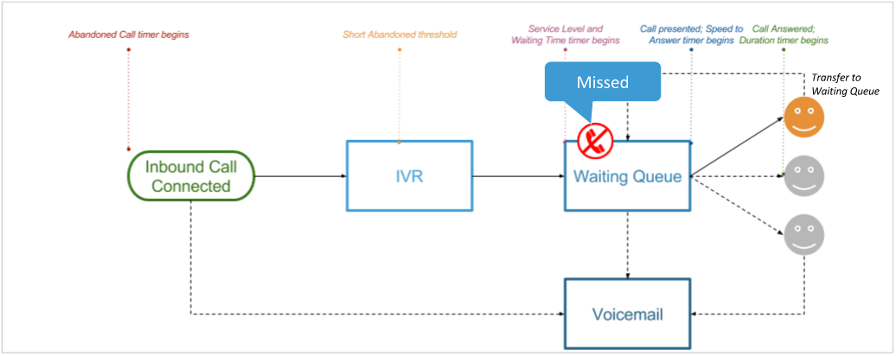

Additionally, if calls are routed to voicemail as a result of a no answer and the hang up occurs en route to voicemail, the call will also be considered **Missed**:

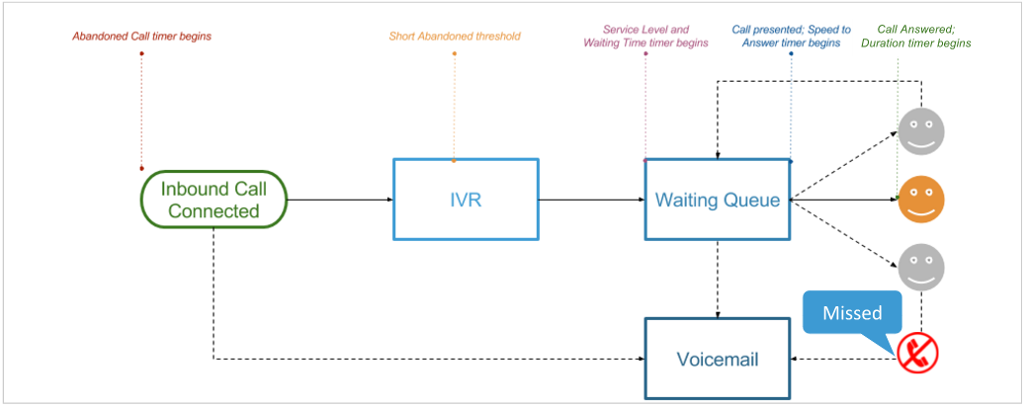

Finally, if calls are routed to voicemail directly (for example, outside of business hours) and the hang up occurs before a voicemail is left, the call will also be considered as **Missed**:

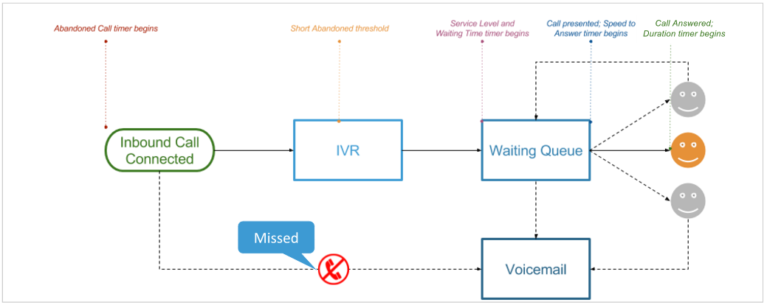

If the caller ultimately hangs up after the voicemail prompt/beep, in effect leaving a voicemail, the call will be classified as **Voicemail**:

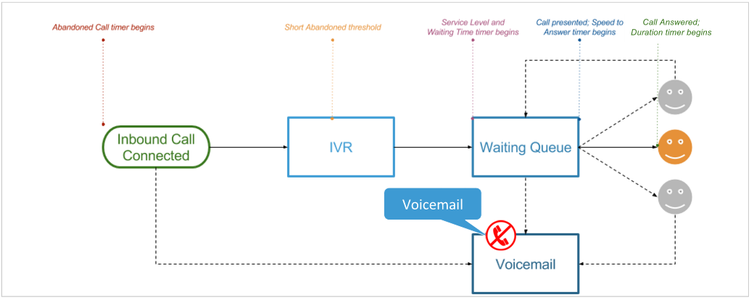

  Figure 2.19 Inbound Call Flow

**2.20 Outbound Call Flow**

The outbound call flow is much simpler in Talkdesk, but similar principles apply: once the outbound call is connected with either the customer or the customer’s voicemail, the call duration timer begins:

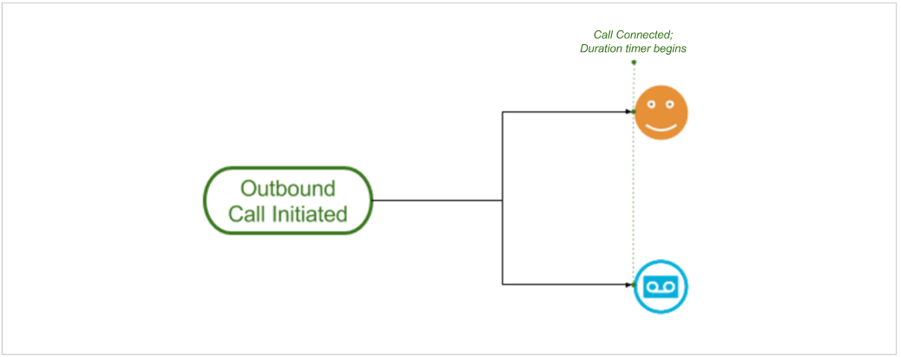

If the hangup by the agent occurs on an outbound call and before the call is connected to voicemail or the customer, the call will be classified as **Outbound Missed**:

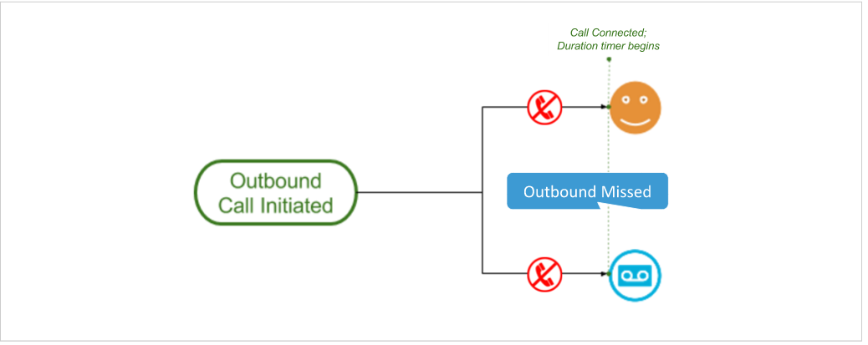

If the agent places an outbound call and hangs up after being connected, the call will simply be classified as **Outbound**. Currently, Talkdesk does not discriminate between voicemails or live customers on the receiving end of an outbound call; we simply know that it was connected:

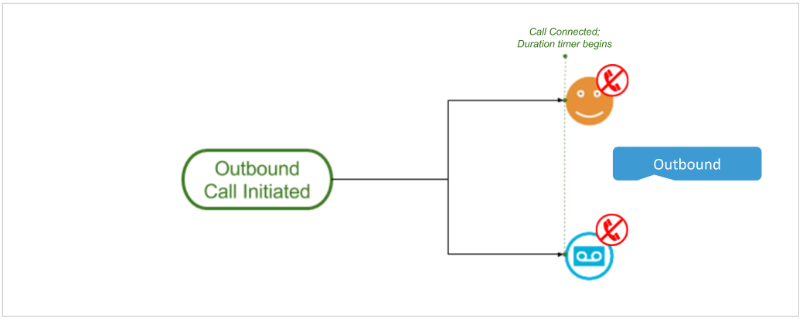

Figure 2.20 Outbound Call Flow

**Chapter 3**

GSM

# 3.0 GSM (Global System for Mobile communication)

GSM (Global System for Mobile communication) is a [digital](https://whatis.techtarget.com/definition/digital) mobile telephony system that is widely used in Europe and other parts of the world. GSM uses a variation of time division multiple access ([TDMA](https://searchnetworking.techtarget.com/definition/TDMA)) and is the most widely used of the three digital [wireless](https://searchmobilecomputing.techtarget.com/definition/wireless) telephony technologies (TDMA, GSM, and [CDMA](https://searchtelecom.techtarget.com/definition/CDMA)). GSM digitizes and compresses data, then sends it down a channel with two other streams of user data, each in its own time slot. It operates at either the 900 [MHz](https://searchnetworking.techtarget.com/definition/MHz) or 1800 MHz frequency band.

Mobile services based on GSM technology were first launched in Finland in 1991. Today, more than 690 mobile networks provide GSM services across 213 countries and GSM represents 82.4% of all global mobile connections. According to GSM World, there are now more than 2 billion GSM [mobile phone](https://searchmobilecomputing.techtarget.com/definition/cellular-telephone) users worldwide. GSM World references China as "the largest single GSM market, with more than 370 million users, followed by Russia with 145 million, India with 83 million and the USA with 78 million users."

Since many GSM network operators have roaming agreements with foreign operators, users can often continue to use their mobile phones when they travel to other countries. [SIM card](https://searchmobilecomputing.techtarget.com/definition/SIM-card)s (Subscriber Identity Module) holding home network access configurations may be switched to those will metered local access, significantly reducing [roaming](https://searchmobilecomputing.techtarget.com/definition/roaming-service) costs while experiencing no reductions in service.

GSM, together with other technologies, is part of the evolution of wireless mobile telemmunications that includes High-Speed Circuit-Switched Data ([HSCSD](https://searchnetworking.techtarget.com/definition/High-Speed-Circuit-Switched-Data)), General Packet Radio System ([GPRS](https://searchmobilecomputing.techtarget.com/definition/GPRS)), Enhanced Data GSM Environment ([EDGE](https://searchmobilecomputing.techtarget.com/definition/EDGE)), and Universal Mobile Telecommunications Service ([UMTS](https://searchmobilecomputing.techtarget.com/definition/UMTS)).

**3.1 GSM Network Structure**

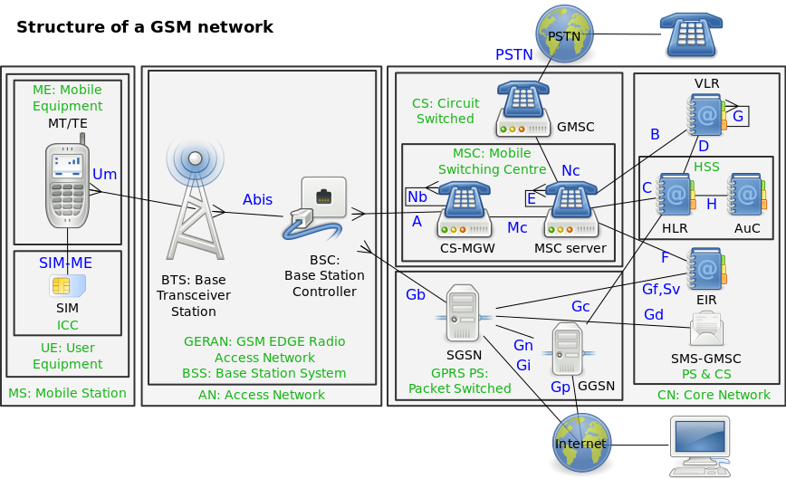

**Figure: 3.1** Global System for Mobile communication (GSM ) Structure

**SDH Network**

# 3.2What is SDH (Synchronous Digital Hierarchy)

This document is intended as an introductory guide to the Synchronous Digital Hierarchy (SDH) multiplexing standard.Standards in the telecommunications field are always evolving. Information in this SDH primer is based on the latest information available from the ITU-T standardisationorganization.Use this primer as an introduction to the technology of SDH. Consult the actual material from ITU-T, paying particular attention to the latest revision, if more detailed information is required.For help in understanding the language of SDH telecommunications, a comprehensive Glossary appears at the end of this document.

**3.2.1 Introduction To SDH**

SDH (Synchronous Digital Hierarchy) is a standard for telecommunications transport formulated by the International Telecommunication Union (ITU), previously called the International Telegraph and Telephone Consultative Committee (CCITT).SDH was first introduced into the telecommunications network in 1992 and has been deployed at rapid rates since then. It’s deployed at all levels of the network infrastructure, including the access network and the long-distance trunk network. It’s based on overlaying a synchronous multiplexed signal onto a light stream transmitted over fiber-optic cable. SDH is also defined for use on radio relay links, satellite links, and at electrical interfaces between equipment.The comprehensive SDH standard is expected to provide the transport infrastructure for worldwide telecommunications for at least the next two or three decades.The increased configuration flexibility and bandwidth availability of SDH provides significant advantages over the older telecommunications sys-tem. These advantages include:

* A reduction in the amount of equipment and an increase in network reliability.
* The provision of overhead and payload bytes – the overhead bytes permitting management of the payload bytes on an individual basis and facilitating centralized fault sectionalisation.
* The definition of a synchronous multiplexing format for carrying lower-level digital signals (such as 2 Mbit/s, 34 Mbit/s, 140 Mbit/s) which greatly simplifies the interface to digital switches, digital cross-connects, and add-drop multiplexers.
* The availability of a set of generic standards, which enable multi-vendor interoperability.
* The definition of a flexible architecture capable of accommodating future applications, with a variety of transmission rates.

In brief, SDH defines synchronous transport modules (STMs) for the fiber optic based transmission hierarchy.

**3.3 Synchronization of Digital Signals**

To correctly understand the concepts and details of SDH, it’s important to be clear about the meaning of Synchronous, Pole Synchronous, and Asynchronous.In a set of Synchronous signals, the digital transitions in the signals occur at exactly the same rate. There may however be a phase difference between the transitions of the two signals, and this would lie within specified limits. These phase differences may be due to propagation time delays, or low-frequency wander introduced in the transmission network. In a synchronous network, all the clocks are traceable to one Stratum 1 Primary Reference Clock (PRC). The accuracy of the PRC is better than ±1 in 1011 and is derived from a cesium atomic standard.If two digital signals are Pole Synchronous, their transitions occur at “almost” the same rate, with any variation being constrained within tight limits. These limits are set down in ITU-T recommendation G.811. For example, if two networks need to interwork, their clocks may be derived from two different PRCs. Although these clocks are extremely accurate, there’s a small frequency difference between one clock and the other. This is known as aPole Synchronous difference.In the case of Asynchronous signals, the transitions of the signals don’t necessarily occur at the same nominal rate. Asynchronous, in this case, means that the difference between two clocks is much greater than a Pole Synchronous difference. For example, if two clocks are derived from free-running quartz oscillators, they could be described as asynchronous.

**3.4 SDH Advantages**

The primary reason for the creation of SDH was to provide a long-term solution for an optical mid-span meet between operators; that is, to allow equipment from different vendors to communicate with each other. This ability is referred to as multi-vendor interworking and allows one SDH-compatible network element to communicate with another, and to replace several network elements, which may have previously existed solely for interface purposes.The second major advantage of SDH is the fact that it’s synchronous. Currently, most fiber and multiplex systems are plesiochronous. This means that the timing may vary from equipment to equipment because they are synchronized from different network clocks. In order to multiplex this type of signal, a process known as bit-stuffing is used. Bit-stuffing adds extra bits to bring all input signals up to some common bit-rate, thereby requiring multi-stage multiplexing and demultiplexing.Because SDH is synchronous, it allows single-stage multiplexing and demultiplexing. This single-stage multiplexing eliminates hardware complexity, thus decreasing the cost of equipment while improving signal quality.Inplesiochronous networks, an entire signal had to be demultiplexed in order to access a particular channel; then the non-accessed channels had to be re-multiplexed back together in order to be sent further along the network to their proper destination. In SDH format, only those channels that are required at a particular point are demultiplexing, thereby eliminating the need for back-to-back multiplexing. In other words, SDH makes individual channels “visible” and they can easily be added and dropped.

**3.5 Plesiochronous Digital Hierarchy (PDH)**

Traditionally, digital transmission systems and hierarchies have been based on multiplexing signals which are plesiochronous (running at almost the same speed). Also, various parts of the world use different hierarchies which lead to problems of international interworking; for example, between those countries using 1.544 Mbit/s systems (U.S.A. and Japan) and those using the 2.048 Mbit/s system.To recover a 64 kbit/s channel from a 140 Mbit/s PDH signal, it’s necessary to DE-multiplex the signal all the way down to the 2 Mbit/s level before the location of the 64 kbit/s channel can be identified. PDH requires “steps” (140-34, 34-8, 8-2 DE-multiplex; 2-8, 8-34, 34-140 multiplex) to drop out or add an individual speech or data channel (see Figure 1). This is due to the bit-stuffing used at each level.

Limitations of PDH Network

The main limitations of PDH are:

* Inability to identify individual channels in a higher-order bit stream.
* Insufficient capacity for network management;
* Most PDH network management is proprietary.
* There’s no standardized definition of PDH bit rates greater than 140 Mbit/s.
* There are different hierarchies in use around the world. Specialized interface equipment is required to interwork the two hierarchies.

|  |  |  |  |  |  |  |  |  |  |  |  |  |  |
| --- | --- | --- | --- | --- | --- | --- | --- | --- | --- | --- | --- | --- | --- |
| 140 Mbit/s | | |  |  |  |  |  |  |  |  |  | 140 Mbit/s | |
|  |  |  | 140-34 | | DEMUX |  |  | 34-140 MUX | | | |  |  |
|  |  |  |  |  |  |  |  |  |  |  |  |  |  |
|  |  |  |  |  | 34 Mbit/s | | 34 Mbit/s | |  |  |  |  |  |
|  |  |  |  |  |  |
|  |  |  |  |  |  |  |  |  |  |  |  |  |  |
|  |  |  |  | 34-8 | DEMUX |  |  | 8-34 MUX | | |  |  |  |
|  |  |  |  |  |  |  |  |  |  |  |  |  |  |
|  |  |  |  |  | 8 Mbit/s | | 8 Mbit/s | | | | | | |
|  |  |  |  |  |  |  |  |  |  |  |  |  |  |

8-2 DEMUX  2-8 MUX

2mbit/s

Drop & Add

***Figure 1: 3.5****PDH multiplexing by steps, showing add/drop function*

**3.6 Basic SDH Signal**

The basic format of an SDH signal allows it to carry many different services in its Virtual Container (VC) because it is bandwidth-flexible. This capability allows for such things as the transmission of high-speed packet-switched services, ATM, contribution video, and distribution video. However, SDH still permits transport and networking at the 2 Mbit/s, 34 Mbit/s, and 140 Mbit/s levels, accommodating the existing digital hierarchy signals. In addition, SDH supports the transport of signals based on the 1.5 Mbit/s hierarchy.

**Table 1. Non-Synchronous, PDH Hierarchy**

|  |  |  |
| --- | --- | --- |
| Signal | Digital Bit Rate | Channels |
|  |  |  |
| E0 | 64 kbit/s | One 64 kbit/s |
| E1 | 2.048 Mbit/s | 32 E0 |
| E2 | 8.448 Mbit/s | 128 E0 |
| E3 | 34.368 Mbit/s | 16 E1 |
| E4 | 139.264 Mbit/s | 64 E1 |

**Table 2. SDH Hierarchy**

|  |  |  |  |  |
| --- | --- | --- | --- | --- |
| Bit Rate | Abbreviated | SDH | SDH Capacity | |
|  |  |  |  |  |
| 51.84 Mbit/s | 51 Mbit/s | STM-0 |  | 21 E1 |
| 155.52 Mbit/s | 155 Mbit/s | STM-1 | 63 E1 or 1 E4 | |
| 622.08 Mbit/s | 622 Mbit/s | STM-4 | 252 | E1 or 4 E4 |
| 2488.32 Mbit/s | 2.4 Gbit/s | STM-16 | 1008 | E1 or 16 E4 |
| 9953.28 Mbit/s | 10 Gbit/s | STM-64 | 4032 | E1 or 64 E4 |
| 39813.12 Mbit/s | 40 Gbit/s | STM-256 | 16128 | E1 or 256 E4 |

STM = Synchronous Transport Module

**3.7 Transmission Hierarchies**

Following ANSI’s development of the SONET standard, the ITU-T under-took to define a standard that would address interworking between the 2048 kbit/s and 1554 kbit/s transmission hierarchies. That effort culminated in 1989 with ITU-T’s publication of the Synchronous Digital Hierarchy (SDH) standards.Tables 1 and 2 compare the Non-synchronous and Synchronous transmission hierarchies.

**3.8 SDH Frame Structure**

The STM-1 frame is the basic transmission format for SDH. The frame lasts for 125 microseconds, therefore, there are 8000 frames per second.The STM-1 frame consists of overhead plus a virtual container capacity (see Figure 2). The first nine columns of each frame make up the Section Overhead, and the last 261 columns make up the Virtual Container (VC) capacity. The VC plus the pointers (H1, H2, H3 bytes) is called the AU (Administrative Unit).Carried within the VC capacity, which has its own frame structure of nine rows and 261 columns, is the Path Overhead and the Container (see Figure 3). The first column is for Path Overhead; it’s followed by the payload container, which can itself carry other containers.Virtual Containers can have any phase alignment within the Administrative Unit, and this alignment is indicated by the Pointer in row four, as described later in the Pointers section. Within the Section Overhead, the first three rows are used for the Regenerator Section Overhead, and the last five rows are used for the Multiplex Section Overhead.The STM frame is transmitted in a byte-serial fashion, row-by-row, and is scrambled immediately prior to transmission to ensure adequate clock timing content for downstream regenerators.

**3.9 Virtual Container**

SDH supports a concept called virtual containers (VC). Through the use of pointers and offset values, VCs can be carried in the SDH payload as independent data packages. VCs are used to transport lower-speed trib-utary signals. Figure 3 illustrates the location of a VC-4 within the STM-1 frame. Note that it can start (indicated by the J1 path overhead byte) at any point within the STM-1 frame. The start location of the J1 byte is indicated by the pointer byte values.Virtual containers can also be concatenated to provide more capacity in a flexible fashion.Table 3 lists the names and some of the parameters of the virtual containers.

**Table 3. Virtual Containers (VC)**

|  |  |  |
| --- | --- | --- |
| SDH | Digital Bit Rate | Size of VC |
|  |  |  |
| VC-11 | 1.728 Mbit/s | 9 rows, 3 columns |
| VC-12 | 2.304 Mbit/s | 9 rows, 4 columns |
| VC-2 | 6.912 Mbit/s | 9 rows, 12 columns |
| VC-3 | 48.960 Mbit/s | 9 rows, 85 columns |
| VC-4 | 150.336 Mbit/s | 9 rows, 261 columns |

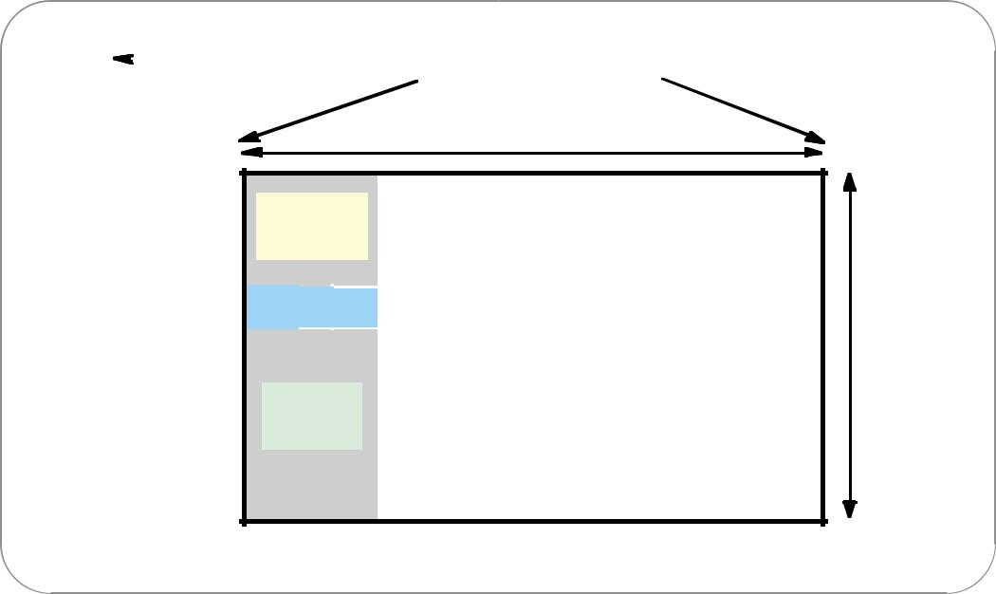

|  |  |  |  |  |  |  |  |
| --- | --- | --- | --- | --- | --- | --- | --- |
|  |  |  | **Frame = 125**  **s** |  | **Frame = 125**  **s** | **Frame = 125**  **s** | |
|  |  |  |  |  |  |  |  |

**1 byte = One 64 kbit/s channel**

**STM-1 = 270 Columns (2430 bytes)**

**1**

**Regenerator**

1. **Section**

|  |  |  |  |  |  |  |
| --- | --- | --- | --- | --- | --- | --- |
|  | **Overhead** | | | | **Administrative Unit** |  |
| **3** |  |  |  |  |  |
|  |  |  |  |  |  |  |
| **P o i n t e r s 4** | **H1** |  | **H2** | **H3** | **Capacity of the** |  |
|  | **H1H1H1** |  | **H2H2H2** | **H3H3H3** | **9 Rows** |
| **5** |  |  |  |  | **Virtual Container** |
|  |  |  |  |  |

1. **Multiplex**

**Section**

1. **Overhead**

**8**

**9**

**Overhead width = 9 columns**

**Figure 2. STM-1 frame structure.**

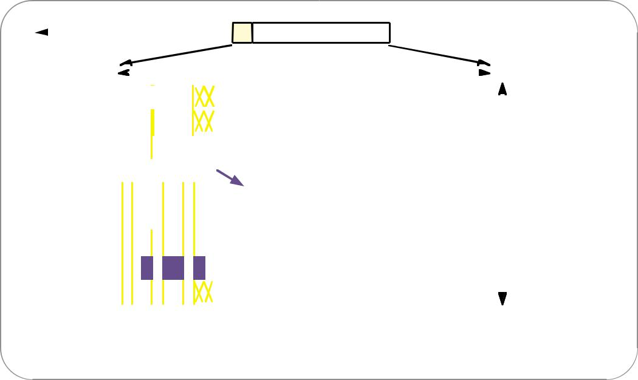

|  |  |  |  |  |  |  |  |  |  |  |  |  |  |  |  |  |
| --- | --- | --- | --- | --- | --- | --- | --- | --- | --- | --- | --- | --- | --- | --- | --- | --- |
|  |  |  |  | **Frame = 125**  **s** | | | | |  | **Frame = 125**  **s** | **Frame = 125**  **s** | | | | |  |
|  |  |  |  |  |  |
|  |  |  |  |  |  |  |  |  |  | **STM-1 = 270 Columns** |  |  |  |  |  |  |
|  |  |  |  |  |  |  |  |  |  |  |  |  |  |  |  |  |
|  |  |  |  |  |  |  |  |  |  |  |  |  |  |  |  |  |

**Regenerator 1 Section 2**

**Overhead** **3**

**Pointers** **4**

**5**

**Multiplex 6 Section 7**

**Overhead 8**

**9**

|  |  |  |  |  |  |  |  |  |  |  |  |  |  |  |  |  |
| --- | --- | --- | --- | --- | --- | --- | --- | --- | --- | --- | --- | --- | --- | --- | --- | --- |
|  |  |  |  |  |  |  |  |  |  |  |  |  |  |  |  |  |
| **A1** |  | **A1** | **A1A2** | | **A2** | **A2** | **J 0** |  |  |  |  |  |  |  |  |  |
|  |  |  |  |  |  |  | **Z 0** |  |  |  |  |  |  |  |  |  |
| **B1** |  |  |  | **E1** |  |  | **F 1** |  |  |  |  |  |  |  |  |  |
| **D1** |  |  |  | **D2** |  |  | **D3** |  |  |  |  |  |  |  |  | **9 Rows** |
|  |  |  |  |  |  |  |  |  |  |  |  |  |  |
|  |  | |  |  |  |  |  |  |  |  |  |  |  |  |  |  |
| **H1** | **B2** | | **B2** | **H2** | **H2** | **H2** | **H3** | **H3** | **H3** |  | **Path Overhead** | |  |  |  |  |
|  |  |  |  |  |  |  |  |  |  |  |  | |  |  |
| **B2** |  |  |  | **K1** |  |  | **K2** |  |  |  | **J 1** |  |  |  |  |  |
|  |  |  |  |  |  |  |  |  |  |  |  |  |  |  |  |
| **D4** |  |  |  | **D5** |  |  | **D6** |  |  |  | **B3** |  |  |  |  |  |
|  |  |  |  |  |  |  |  |  |  |  | **C2** | **Bounded by 261 columns** |  |  |  |  |
| **D7** |  |  |  | **D8** |  |  | **D9** |  |  |  | **G1** |  |  |  |  |  |
|  |  |  |  |  |  |  |  |  |  |  |  |  |  |  |  |
| **D 1** | **0** |  | **D 1 1** | |  |  | **D 1 2** |  |  |  | **F2** | **Wrap-around within SDH payload** |  |  |  |  |
| **S1** |  |  |  |  |  | **M 1** | **E2** |  |  |  | **H4** |  |  |  |  |  |
|  |  |  |  |  |  |  |  |  |  |  | **F3** |  |  |  |  |  |
|  |  |  |  |  |  |  |  |  |  |  | **K3** |  |  |  |  |  |
|  |  |  |  |  |  |  |  |  |  |  | **N1** |  |  |  |  |  |
|  |  |  |  |  |  |  |  |  |  |  |  |  |  |  |  |  |

***Figure 3.*** *Virtual container structure showing VC*

**3.10 SDH Overhead**

The SDH standard was developed using a client/server layer approach (see Figure 4). The overhead and transport functions are divided into layers. They are:

Regenerator Section



Multiplex Section



Path



The layers have a hierarchical relationship, with each layer building on the services provided by all the lower layers.This section details the different SDH overhead

information, specifically:

* Regenerator Section Overhead
* Multiplex Overhead
* Path Overhead

**Regenerator Section Overhead**

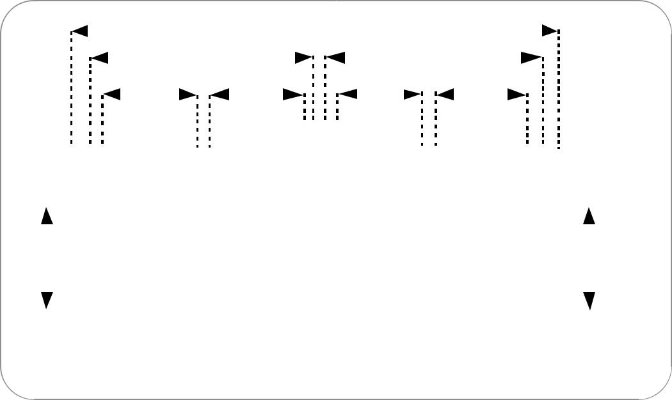The Regenerator Section Overhead contains only the information required for the elements located at both ends of a section. This might be two regenerators, a piece of line terminating equipment and a regen-erator, or two pieces of line terminating equipment.The Regenerator Section Overhead is found in the first three rows of Columns 1 through 9 of the STM-1 frame (see Figure 5). Byte by byte, the Regenerator Section Overhead is shown in Table 4.

|  |  |  |  |  |  |  |  |  |  |  |  |  |  |  |  |  |  |  |  |  |  |  |  |  |  |  |  |  |  |  |  |  |  |  |  |  |
| --- | --- | --- | --- | --- | --- | --- | --- | --- | --- | --- | --- | --- | --- | --- | --- | --- | --- | --- | --- | --- | --- | --- | --- | --- | --- | --- | --- | --- | --- | --- | --- | --- | --- | --- | --- | --- |
| This section details the different SDH overhead | | | | | | | | |  |  |  |  |  |  |  |  | | **Path** | | |  |  |  |  |  |  |  |  |  |  |  |  |  |  |  |  |
| information, specifically: | | | |  |  |  |  |  |  |  |  |  |  |  |  |  | |  |  |  |  |  |  |  |  |  |  |  |  |  |  |  |  |
|  |  | **Multiplex Section** | | | | | | | | | | | | |  |  |  | **Multiplex Section** | | | | | | | | |  | |  |  |  |  |
| Regenerator Section Overhead | | | | |  |  |  |  |  |  |
|  | **Regenerator Section** | | | | | | | | | | | | | | | **Regenerator Section** | | | | | | | | | | | |  |  |  |  |
| Multiplex Overhead | | | | | |  |  |  |  |
|  | | |  |  |  |  |  |  |  |  | |  |  |  |  |  |  |  |  |  |  |  |  |  |  |  |  |  |  |  |
| Path Overhead |  |  |  |  |  |  |  |  |  |  |  |  |  |  |  |  | |  |  |  |  |  |  |  |  |  |  |  |  |  |  |  |  |  |  |  |
|  |  |  |  |  |  |  |  |  |  |  |  |  |  |  |  | |  |  |  |  |  |  |  |  |  |  |  |  |  |  |  |  |  |  |  |
|  |  |  |  |  |  |  |  |  |  |  |  |  |  |  |  |  | |  |  |  |  |  |  |  |  |  |  |  |  |  |  |  |  |  |  |  |
|  |  |  | **PTE** | | | |  |  |  | **REG** | |  |  |  |  | **ADM** | | | | |  |  |  | **REG** | |  |  |  |  | **PTE** | | |  |  |  |  |
|  |  |  |  |  |  |  |  |  |  |  |  |  | |  |  |  |  |  |  |  |  |  |  |  |  |  |  |  |  |
|  |  |  |  |  |  |  |  |  |  |  |  |  |  |  |  |  | |  |  |  |  |  |  |  |  |  |  |  |  |  |  |  |  |  |  |  |
|  |  |  |  |  |  |  |  |  | **Section** | | | |  |  |  |  | |  |  |  |  |  |  | **Section** | | |  |  |  |  |  |  |  |  |  |  |
|  |  |  | **Path** | | | | |  | **Termination** | | | |  |  |  |  | |  |  |  |  |  | **Termination** | | | |  |  | **Path** | | | |  |  |  |  |
|  |  |  | **Termination** | | | | | |  |  |  |  | **Multiplex Section** | | | | | | | | | | | | | | **Termination** | | | | | | |  |  | |
|  |  |  |  |  |  |  |  |  |  |  |  |  |  | **Termination** | | | | | | | | | | | | |  |  |  |  |  |  |  |  |  |  |
|  |  |  |  |  |  |  |  |  |  |  |  |  |  | **Legend:** | | | | | | |  |  |  |  |  |  |  |  |  |  |  |  |  |  |  |  |
|  | **Service (2 Mbit/s, 140 Mbit/s...)** | | | | | | | | | | | | | **PTE = Path Terminating Element** | | | | | | | | | | | | | | | | | | | **Service** | | | |
|  | **REG = Regenerator** | | | | | | | | | | | | |  |  |  |  |  |  |
|  | **Mapping** | | | | | | | |  |  |  |  |  |  |  |  |  |  |  | **Mapping** | | | |
|  |  |  |  |  |  | **ADM = Add/Drop Multiplexer** | | | | | | | | | | | | | | | | | | |
|  | **Demapping** | | | | | | | |  |  |  |  |  | **Demapping** | | | |
|  |  |  |  |  |  |  |  |  |  | |  |  |  |  |  |  |  |  |  |  |  |  |  |  |
|  |  |  |  |  |  |  |  |  |  |  |  |  |  |  |  |  |  | |  |  |  |  |  |  |  |  |  |  |  |  |  |  |  |  |  |  |

***Figure 3.10*** *SDH network layers.*

|  |  |  |  |  |  |  |  |  |  |  |  |
| --- | --- | --- | --- | --- | --- | --- | --- | --- | --- | --- | --- |
| **Regenerator** | |  |  |  |  | **STM-1** |  |  |  |  |  |
| **Section** | |  |  |  |  |  |  |  |  |  |
|  |  |  |  |  |  |  |  |  |  |
|  |  |  |  |  |  |  |  |  |  |  |  |
|  |  |  |  |  |  |  |  |  |  |  |  |
|  | **1** | **A1** | **A1** | **A1** | **A2** | **A2** | **A2** | **J0** |  |  |  |
|  | **2** | **B1** | ∆ | ∆ | **E1** | ∆ |  | **F1** |  |  |  |
|  | **3** | **D1** | ∆ | ∆ | **D2** | ∆ |  | **D3** |  |  |  |
| **4** | | **H1** | **H1** | **H1** | **H2** | **H2** | **H2** | **H3** | **H3** | **H3** |  |
| **5** | | **B2** | **B2** | **B2** | **K1** |  |  | **K2** |  |  |  |
| **6** | | **D4** |  |  | **D5** |  |  | **D6** |  |  |  |
| **7** | | **D6** |  |  | **D8** |  |  | **D9** |  |  |  |
| **8** | | **D10** |  |  | **D11** |  |  | **D12** |  |  |  |
| **9** | | **S1** |  |  |  |  | **M1** | **E2** |  |  |  |
|  |  |  |  |  |  |  |  |  |  |  |  |

**∆= Media-dependent bytes**

***Figure 5.*** *STM-1 Regenerator section overhead.*

**Multiplex Section Overhead**

The Multiplex Section Overhead contains the information required between the multiplex section termination equipment at each end of the Multiplex section (that is, between consecutive network elements excluding the regenerators).The Multiplex Section Overhead is found in Rows 5 to 9 of Columns 1 through 9 of the STM-1 frame (see Figure 6). Byte by byte, the Multiplex Section Overhead is shown in Table 5.

Table 4. Regenerator Section Overhead

|  |  |
| --- | --- |
| Byte | Description |
|  |  |
| A1 and A2 | Framing bytes – These two bytes indicate the beginning of the STM-N frame. The A1, A2 bytes are unscrambled. A1 has the binary value 11110110, |
|  | and A2 has the binary value 00101000. The frame alignment word of an STM-N frame is composed of (3 x N) A1 bytes followed by (3 x N) A2 bytes. |
| J0 | Regenerator Section (RS) Trace message – It’s used to transmit a Section Access Point Identifier so that a section receiver can verify its continued |
|  | connection to the intended transmitter. The coding of the J0 byte is the same as for J1 and J2 bytes. This byte is defined only for STM-1 number 1 |
|  | of an STM-N signal. |
| Z0 | These bytes, which are located at positions S[1,6N+2] to S[1,7N] of an STM-N signal (N > 1), are reserved for future international standardisation. |
| B1 | RS bit interleaved parity code (BIP-8) byte – This is a parity code (even parity), used to check for transmission errors over a regenerator section. |
|  | Its value is calculated over all bits of the previous STM-N frame after scrambling, then placed in the B1 byte of STM-1 before scrambling. Therefore, |
|  | this byte is defined only for STM-1 number 1 of an STM-N signal. |
| E1 | RS orderwire byte – This byte is allocated to be used as a local orderwire channel for voice communication between regenerators. |
| F1 | RS user channel byte – This byte is set aside for the user’s purposes; it can be read and/or written to at each section terminating equipment |
|  | in that line. |
| D1, D2, D3 | RS Data Communications Channel (DCC) bytes – These three bytes form a 192 kbit/s message channel providing a message-based channel for |
|  | Operations, Administration and Maintenance (OAM) between pieces of section terminating equipment. The channel can be used from a central location |
|  | for control, monitoring, administration, and other communication needs. |

**STM-1**

|  |  |  |  |  |  |  |  |  |  |  |
| --- | --- | --- | --- | --- | --- | --- | --- | --- | --- | --- |
| **1** | **A1** | **A1** | **A1** | **A2** | **A2** | **A2** | **J0** |  |  |  |
| **2** | **B1** | ∆ |  | **E1** | ∆ |  | **F1** |  |  |  |
| **3** | **D1** | ∆ |  | **D2** | ∆ |  | **D3** |  |  |  |
| **4** | **H1** | **H1** | **H1** | **H2** | **H2** | **H2** | **H3** | **H3** | **H3** |  |
| **5** | **B2** | **B2** | **B2** | **K1** |  |  | **K2** |  |  |  |
| **6** | **D4** |  |  | **D5** |  |  | **D6** |  |  |  |
| **7** | **D6** |  |  | **D8** |  |  | **D9** |  |  |  |
| **8** | **D10** |  |  | **D11** |  |  | **D12** |  |  |  |
| **9** | **S1** |  |  |  |  | **M1** | **E2** |  |  |  |
|  |  |  |  |  |  |  |  |  |  |  |

**Multiplex Section**

 ***Figure 6.*** *STM-1 Multiplex section overhead.*

**

**3.11 SDH Anomalies, Defects, Failures, and Alarms**

The SDH frame structure has been designed to contain a large amount of overhead information. The overhead information provides for a variety of management and other functions such as:

Alarm Indication Signals (AIS)



Error Performance Monitoring using BIP-N



Pointer Adjustment Information



Path Status



Path Trace



Section Trace



Remote Defect, Error, and Failure Indications



Signal Labels



New Data Flag Indications



Data Communications Channels (DCC)



Automatic Protection Switching (APS) Control



Orderwire



Synchronisation Status Message



Much of this overhead information is involved with alarm and in-service monitoring of the particular SDH sections. Table 8 and Figure 9, that fol-low the definitions, list the criteria for errors and the performance moni-toring for errors.

**Definitions**

Alarm – The maintenance signal used in the digital network to alert down-stream equipment that a defect or equipment failure has been detected

Anomaly – The smallest discrepancy which can be observed between the actual and desired characteristics of an item. The occurrence of a single anomaly does not constitute an interruption in the ability to per-form a required function. Examples of SDH anomalies are:

B1 BIP



B2 BIP



Path B3 BIP



REI



Pattern Bit (OOS test)



Defect – The density of anomalies has reached a level where the ability to perform a required function has been interrupted. Defects are used as input for performance monitoring, the control of consequent actions, and the determination of fault cause. Examples of SDH Defects are:

OOF



AIS



RDI



LOF



LOP



LOM



Failure – The inability of a function to perform a required action which has persisted beyond a maximum time allocated.

**3.12 SDH Error Performance Monitoring**

Error performance monitoring in the SDH is based on Bit-Interleaved-Parity (BIP) checks calculated on a frame-by-frame basis. These BIPchecks are inserted in the Regenerator Section Overhead, Multiplex Section Overhead, and Path Overheads. In addition, Higher-Order Path Terminating Equipment (HO PTE) and Lower-Order Path Terminating Equipment (LO PTE) produce Remote Error Indications (REI) based on errors detected in the HO Path and LO Path BIP respectively. The REI signals are sent back to the equipment at the origi-nating end of a path. All defects listed in Figure 8 are described in Table 8.

*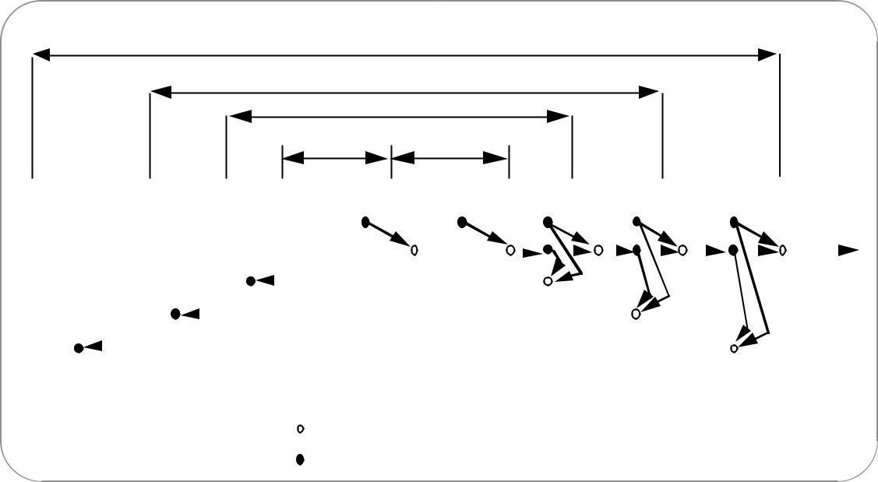***Lower Order Path**

**Higher Order Path**

**Multiplex Section (MSOH)**

**Regenerator Section (RSOH)**

|  |  |  |  |  |  |  |  |  |  |  |  |  |  |  |  |  |  |  |  |  |  |  |  |  |  |  |  |  |  |  |  |  |  |  |
| --- | --- | --- | --- | --- | --- | --- | --- | --- | --- | --- | --- | --- | --- | --- | --- | --- | --- | --- | --- | --- | --- | --- | --- | --- | --- | --- | --- | --- | --- | --- | --- | --- | --- | --- |
| **LO PTE** |  |  | **HO PTE** |  |  | **MSTE** |  |  | **RSTE** |  | **RSTE** |  |  | **RSTE** |  |  |  | **MSTE** | |  |  |  |  | **HO PTE** | |  |  |  |  | **LO PTE** | |  |  |  |
|  |  |  |  |  |  |  |  |  |  | **L O S** |  |  | **L O S** |  | **L O S** | | |  |  |  |  |  |  |  |  |  |  |  |  |  |  |  | **Tributary** | |
|  |  |  |  |  |  |  |  |  |  | **LOF** |  |  | **LOF** |  | **LOF** | | |  |  |  | **L O P** | | |  |  |  | **L O P** | | |  |  |  |
|  |  |  |  |  |  |  |  |  |  |  |  |  |  |  |  |  |  |  |  |  |  | **A I S** | |
|  |  |  |  |  |  |  |  |  |  |  |  |  |  |  |  |  |  |  |  |  |  |  |  |  |  |  |  |  |  |  |  |  |
|  |  |  |  |  |  |  |  |  |  |  |  |  |  |  |  |  |  |  |  |  |  |  |  |  |  |  |  |  |  |  |  |  |  |  |
|  |  |  |  |  |  |  |  |  |  |  |  |  |  |  |  |  |  |  |  |  |  |  |  |  |  |  |  |  |  |  |  |  |  |  |
|  |  |  |  |  |  | **R D I** |  |  |  |  |  |  | **M S** |  | **M S** | | |  |  | **AU-AIS** | | | |  |  |  | **TU-AIS** | | |  |  |  |  |  |
|  |  |  |  |  |  | **( K 2 )** |  |  |  |  |  |  | **A I S** |  | **A I S** | |  |  |  | **( H1,H2)** | | | |  |  |  | **(V1,V2)** | | |  |  |  |  |  |
|  |  |  |  |  |  |  |  |  |  |  |  |  |  |  |  |  |  | **R D I** | |  |  |  |  |  |  |  |  |  |  |  |  |  |  |  |
|  |  |  |  |  |  |  |  |  |  |  |  |  |  |  |  |  |  | **( K 2 )** | |  |  |  |  |  |  |  |  |  |  |  |  |  |  |  |
|  |  |  | **R D I** |  |  |  |  |  |  |  |  |  |  |  |  |  |  |  |  |  |  |  |  | **R D I** | |  |  |  |  |  |  |  |  |  |
|  |  |  | **( G 1 )** |  |  |  |  |  |  |  |  |  |  |  |  |  |  |  |  |  |  |  |  |  |  |  |  |  |  |  |  |  |
| **R D I** |  |  |  |  |  |  |  |  |  |  |  |  |  |  |  |  |  |  |  |  |  |  | **( G 1 )** | |  |  |  |  |  |  |  |  |  |
|  |  |  |  |  |  |  |  |  |  |  |  |  |  |  |  |  |  |  |  |  |  |  |  |  |  |  |  |  |  |  |  |
|  |  |  |  |  |  |  |  |  |  |  |  |  |  |  |  |  |  |  |  |  |  |  |  |  |  |  |  |  |  |  |  |  |  |
| **( V 5 )** |  |  |  |  |  |  |  |  |  |  |  |  |  |  |  |  |  |  |  |  |  |  |  |  |  |  |  |  |  | **R D I** | |  |  |  |
|  |  |  |  |  |  |  |  |  |  |  |  |  |  |  |  |  |  |  |  |  |  |  |  |  |  |  |  |  |  | **( V 5 )** | |  |  |  |
|  |  |  |  |  |  |  |  |  |  |  |  |  |  |  |  |  |  |  |  |  |  |  |  |  |  |  |  |  |  |  |  |  |  |  |

**Alarm Transmission**

**Alarm Detection**

Figure 8. Interaction between defects in forward and backward directions, according to the different SDH levels.

**Table 8. Anomalies, Defects, Failures, Alarms**

|  |  |  |
| --- | --- | --- |
| Abbreviation | Description | Criteria |
|  |  |  |
| LOS | Loss of Signal | LOS is raised when the synchronous signal (STM-N) level drops below the threshold at which a BER of 1 in 103 is |
|  |  | predicted. It could be due to a cut cable, excessive attenuation of the signal, or equipment fault. |
|  |  | The LOS state will clear when two consecutive framing patterns are received and no new LOS condition is detected. |
| OOF | Out of Frame Alignment | OOF state occurs when several consecutive SDH frames are received with invalid (errored) framing patterns (A1 and |
|  |  | A2 bytes). The maximum time to detect OOF is 625 microseconds. OOF state clears within 250 microseconds when two |
|  |  | consecutive SDH frames are received with valid framing patterns. |
| LOF | Loss of Frame | LOF state occurs when the OOF state exists for a specified time in microseconds. The LOF state clears when |
|  | Alignment | an in-frame condition exists continuously for a specified time in microseconds. The time for detection and clearance |
|  |  | is normally 3 milliseconds. |
| LOP | Loss of Pointer | LOP state occurs when N consecutive invalid pointers are received or N consecutive New Data Flags (NDF) are received |
|  |  | (other than in a concatenation indicator), where N = 8, 9, or 10. LOP state is cleared when three equal valid pointers |
|  |  | or three consecutive AIS indications are received. |
|  |  | LOP can be identified as: |
|  |  | • AU-LOP (Administrative Unit Loss of Pointer) |
|  |  | • TU-LOP (Tributary Unit Loss of Pointer) |
| AIS | Alarm Indication | AIS is an all-ONES characteristic or adapted information signal. It’s generated to replace the normal traffic signal when it |
|  | Signal | contains a defect condition in order to prevent consequential downstream failures being declared or alarms being raised. |
|  |  | AIS can be identified as: |
|  |  | • MS-AIS (Multiplex Section Alarm Indication Signal) |
|  |  | • AU-AIS (Administrative Unit Alarm Indication Signal) |
|  |  | • TU-AIS (Tributary Unit Alarm Indication Signal) |
| REI | Remote Error | An indication returned to a transmitting node (source) that an errored block has been detected at the receiving node (sink). |
|  | Indication | This indication was previously known as FEBE (Far End Block Error). |
|  |  | REI can be identified as: |
|  |  | • MS-REI (Multiplex Section Remote Error Indication) |
|  |  | • HP-REI (Higher-order Path Remote Error Indication) |
|  |  | • LP-REI (Lower-order Path Remote Error Indication) |
| RDI | Remote Defect | A signal returned to the transmitting Terminating Equipment upon detecting a Loss of Signal, Loss of Frame, or AIS defect. |
|  | Indication | RDI was previously known as FERF (Far End Receiver Failure). |
|  |  | RDI can be identified as: |
|  |  | • MS-RDI (Multiplex Section Remote Defect Indication) |
|  |  | • HP-RDI (Higher-order Path Remote Defect Indication) |
|  |  | • LP-RDI (Lower-order Path Remote Defect Indication) |
| RFI | Remote Failure | A failure is a defect that persists beyond the maximum time allocated to the transmission system protection mechanisms. |
|  | Indication | When this situation occurs, an RFI is sent to the far end and will initiate a path protection switch if this function has |
|  |  | been provisioned. |
|  |  | RFI can be identified as: |
|  |  | • LP-RFI (Lower-order Path Remote Failure Indication) |
| B1 error | B1 error | Parity errors evaluated by byte B1 (BIP-8) of an STM-N shall be monitored. If any of the eight parity checks fail, |
|  |  | the corresponding block is assumed to be in error. |
| B2 error | B2 error | Parity errors evaluated by byte B2 (BIP-24 x N) of an STM-N shall be monitored. If any of the N x 24 parity checks fail, |
|  |  | the corresponding block is assumed to be in error. |
| B3 error | B3 error | Parity errors evaluated by byte B3 (BIP-8) of a VC-N (N = 3,4) shall be monitored. If any of the eight parity checks fail, |
|  |  | the corresponding block is assumed to be in error. |
| BIP-2 error | BIP-2 error | Parity errors contained in bits 1 and 2 (BIP-2) of byte V5 of a VC-m (m=11,12,2) shall be monitored. If any of the two |
|  |  | parity checks fail, the corresponding block is assumed to be in error. |
| LSS | Loss of Sequence | Out-of-service bit error measurements using pseudo-random sequences can only be performed if the reference sequence |
|  | Synchronisation | produced on the receiving side of the test set-up is correctly synchronised to the sequence coming from the object |
|  |  | under test. In order to achieve compatible measurement results, it’s necessary that the sequence synchronisation |
|  |  | characteristics are specified. The following requirement is applicable to all ITU-T O.150 Recommendations dealing |
|  |  | with error performance measurements using pseudo-random sequences. |
|  |  | Sequence synchronisation shall be considered to be lost and re-synchronisation shall be started if: |
|  |  | • The bit error ratio is ≥ 0.20 during an integration interval of 1 second; or |
|  |  | • It can be unambiguously identified that the test sequence and the reference sequence are out of phase. |

**3.13 Graphical SDH Multiplexing Structure**

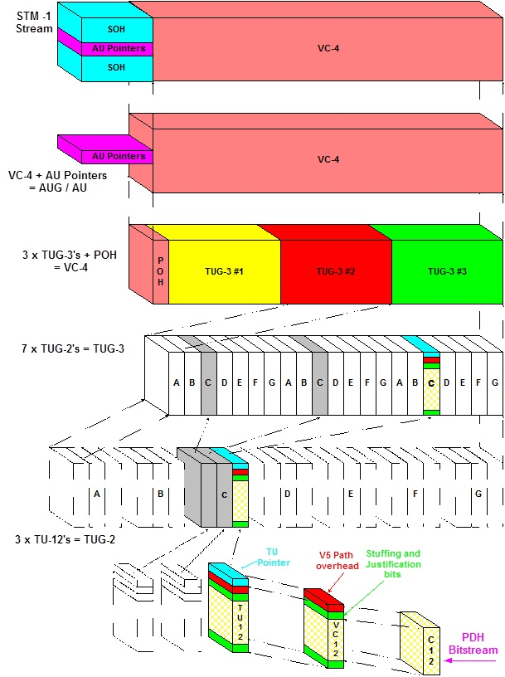

**Chapter 4**

**Core Device**

**4.0 MGW**

**4.1 What is the media gateway?**

A media gateway is a translation device or service that converts media streams between disparate telecommunications technologiessuch as [POTS](https://en.wikipedia.org/wiki/Plain_old_telephone_service), [SS7](https://en.wikipedia.org/wiki/Signaling_System_7), [Next Generation Networks](https://en.wikipedia.org/wiki/Next_Generation_Networks) ([2G](https://en.wikipedia.org/wiki/2G), [2.5G](https://en.wikipedia.org/wiki/2.5G) and [3G](https://en.wikipedia.org/wiki/3G) radio access networks) or [private branch exchange](https://en.wikipedia.org/wiki/Private_branch_exchange) (PBX) systems. Media gateways enable [multimedia](https://en.wikipedia.org/wiki/Multimedia) communications across packet networks using transport protocols such as [Asynchronous Transfer Mode](https://en.wikipedia.org/wiki/Asynchronous_Transfer_Mode) (ATM) and [Internet Protocol](https://en.wikipedia.org/wiki/Internet_Protocol) (IP).

Because the media gateway connects different types of networks, one of its main functions is to convert between different transmission and coding techniques. Media streaming functions such as [echo cancellation](https://en.wikipedia.org/wiki/Echo_cancellation), [DTMF](https://en.wikipedia.org/wiki/DTMF), and tone sender are also located in the media gateway.

Media gateways are often controlled by a separate [Media Gateway Controller](https://en.wikipedia.org/wiki/Media_Gateway_Controller) which provides the call control and signaling functionality. Communication between media gateways and Call Agents is achieved by means of protocols such as [MGCP](https://en.wikipedia.org/wiki/Media_Gateway_Control_Protocol) or [Megaco](https://en.wikipedia.org/wiki/Megaco) (H.248) or [Session Initiation Protocol](https://en.wikipedia.org/wiki/Session_Initiation_Protocol) (SIP). Modern media gateways used with SIP are often stand-alone units with their own call and signaling control integrated and can function as independent, intelligent SIP end-points.

[Voice over Internet Protocol](https://en.wikipedia.org/wiki/Voice_over_Internet_Protocol) (VoIP) media gateways perform the conversion between [Time-division multiplexing](https://en.wikipedia.org/wiki/Time-division_multiplexing) (TDM) voice to a media streaming protocol, such as the [Real-time Transport Protocol](https://en.wikipedia.org/wiki/Real-time_Transport_Protocol), (RTP), as well as a signaling protocol used in the VoIP system.

Mobile access media gateways connect the radio access networks of a public land mobile network [PLMN](https://en.wikipedia.org/wiki/PLMN) to a next-generation [core network](https://en.wikipedia.org/wiki/Core_network). [3GPP](https://en.wikipedia.org/wiki/3GPP) standards define the functionality of [CS-MGW](https://en.wikipedia.org/w/index.php?title=CS-MGW&action=edit&redlink=1) and [IMS-MGW](https://en.wikipedia.org/w/index.php?title=IMS-MGW&action=edit&redlink=1) for [UTRAN](https://en.wikipedia.org/wiki/UTRAN) and [GERAN](https://en.wikipedia.org/wiki/GERAN) based [PLMNs](https://en.wikipedia.org/wiki/PLMN).

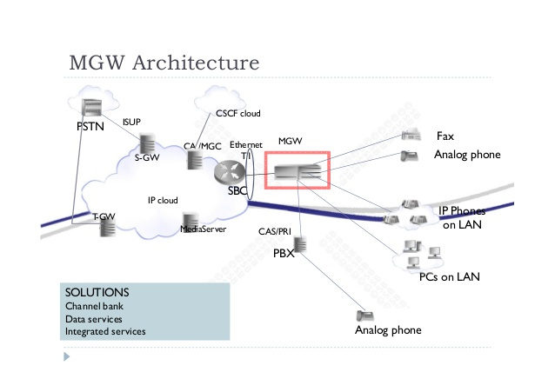

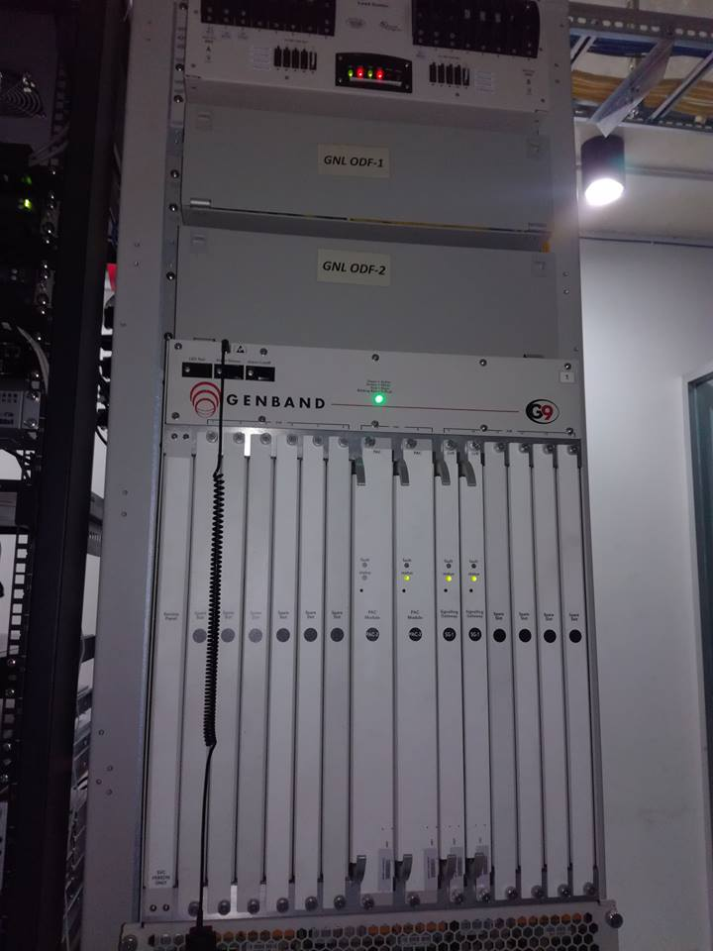

Figure : 4.1 Core device in Gazi Networks

**4.2 MGC**

**4.2.1 what is MGC network?**

A Media Gateway Controller (MGC), also known as a *call agent*, controls the media gateways. It monitors the gateways for events, such as an off-hook state when a user intends to initiate a telephone call, and issues requests to the gateway to initiate or complete sessions, to alert the called party, or to terminate a call. The protocols used for this interaction between the gateway and its controller have evolved through various types and versions. The Simple Gateway Controller protocol (SGCP) and the Internet Protocol Device (IPDC) have been replaced by the Media Gateway Controller Protocol(MGCP) and Megaco, which is also known as H.248.

Some MGCs interface with other signaling protocols, such as [Signalling System No. 7](https://en.wikipedia.org/wiki/Signalling_System_No._7) (SS7), for interconnection with the traditional telephone system, [H.323](https://en.wikipedia.org/wiki/H.323), and the Session Initiation Protocol(SIP).

4.2.2 The **Media Gateway Control Protocol** (**MGCP**)

The **Media Gateway Control Protocol** (**MGCP**) is a signaling and call control Communication Protocols used in **Voice Over IP** (VoIP) telecommunication systems. It implements the [media gateway control protocol architecture](https://en.wikipedia.org/wiki/Media_gateway_control_protocol_architecture) for controlling media gateways on **Internet Protocol** (IP) networks connected to the **Public Switched Telephone Network** (PSTN). The protocol is a successor to the**Simple Gateway Control Protocol**(SGCP), which was developed by Bell core and Cisco. and the **Internet Protocol Device Controller**(IPDC).

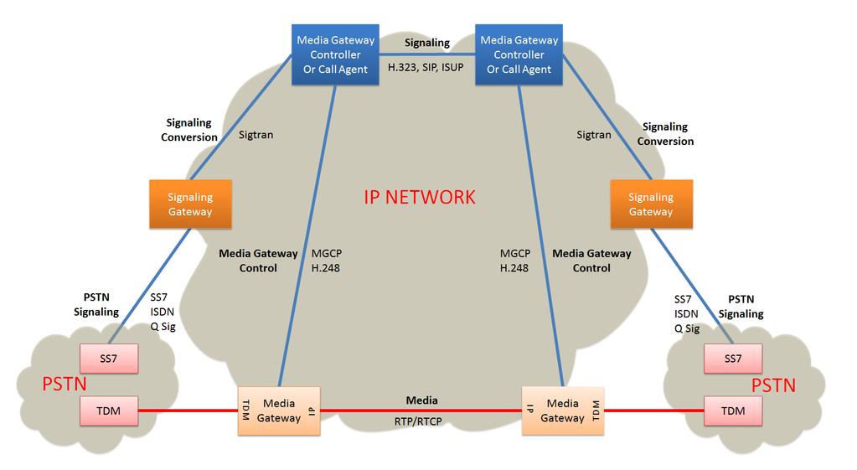

Fig. 4.2.1 Gateway Control Protocol Relationship

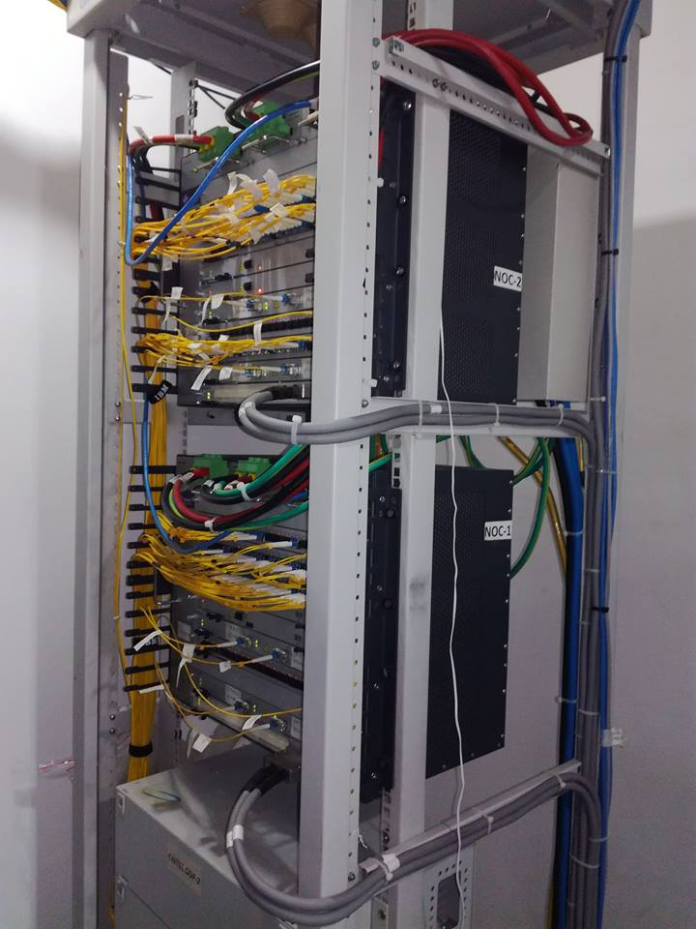

Figure: 4.2.2 Mask of Gazi Networks

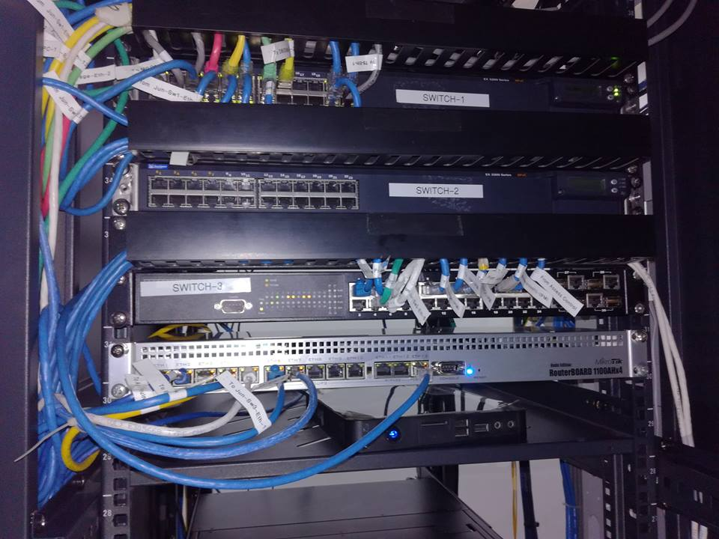

Figure:4.2.3 Switch in Gazi Networks

**Chapter 5**

**Alarms in NOC**

**5.0 Alarm**

However working in NOC (Network Operation Center) section, there are getting some following types of common alarms in the physical transmission-

**5.1 Basic Alarms of Gazi Networks**

**R_LOS**

**Description**

The R_LOS is an alarm indicating loss of signals on the receive side of the line.

**Attribute**

|  |  |
| --- | --- |
| **Alarm Severity** | **Alarm Type** |
|  |  |
| Critical | Communication alarm |
|  |  |
| **Possible Causes** |  |

The possible causes of the R_LOS alarm are as follows:

**Optical InterfaceBoard**

Cause 1: The local optical interface is not in use (in the case of the optical interface board).

Cause 2: The opposite laser is shut down, and therefore no optical signals are accessed (in the case of the optical edge board).

**Electrical Interface Board**

Cause 3: A fiber cut occurs or the act of the line declines.

**IF Board**

* Cause 4: The signal modes of both ends are different (in the case of the STM-1 electrical interface board).

**Common Cause**

* Cause 5: Other alarms trigger the R_LOS alarm (in the case of the IF board).
* Cause 6: The receive board at the local station is faulty, and therefore the signal fails to be received on the line.
* Cause 7: The transmit board (including the cross-connect and timing board) at the opposite

station is faulty, and therefore the signal fails to be transmitted on the

**R_LOF**

**Description**

The R_LOF is an alarm indicating loss of frames on the receive side of the line. When the correct A1 and A2 bytes are not contained in five consecutive frames received at the receive optical interface of the local station, the R_LOF alarm is reported.

**Attribute**

|  |  |
| --- | --- |
| **Alarm Severity** | **Alarm Type** |
|  |  |
| Critical | Communication alarm |
|  |  |
| **Possible Causes** |  |

The possible causes of the R_LOF alarm are as follows:

* Cause 1: Two boards at different rates are interconnected (in the case of the optical interface board).
* Cause 2: The transmit cable is faulty, and the fiber connector is loose or contaminated (in the case of the optical interface board).
* Cause 3: Other alarms elicit the R_LOF alarm (in the item of the IF meal).
* Cause 4: The receive board at the local station is broken, and thus the frame structure is lost.
* Cause 5: The transmit board (including the cross-connect board) at the opposite station is faulty, and thus the frame structure is lost.

**5.2 AU_AIS**

**Description**

The AU_AIS is an alarm indication of the administrative unit (AU). This alarm occurs when the optical interface on the local NE receives the AU pointer of all 1s.

**Attribute**

|  |  |
| --- | --- |
| **Alarm Severity** | **Alarm Type** |
|  |  |
| Major | Communication alarm |
|  |  |
| **Possible Causes** |  |

The possible causes of the AU_AIS alarm are as follows:

Cause 1: The local NE insets the AIS alarm to the lower level track.

Cause 2: The upstream NE inserts the AIS alarm to the downstream NE.

Cause 3: The cross-connect structure of the service type is indecent

Cause 4: The transmit boards (comprising the cross-connect and skill board) on the upstream NE are damaged.

Cause 5: The receive boards on the local NE are faulty.

**5.3 HP_RDI**

**Description**

The HP_RDI is an alarm indicating a remote defect in the higher order path.

**Attribute**

|  |  |
| --- | --- |
| **Alarm Severity** | **Alarm Type** |
|  |  |
| Minor | Communication alarm |
|  |  |
| **Possible Causes** |  |

The possible causes of the HP_RDI alarm are as follows:

* Cause 1: The service receive end (opposite end) terminates the HPOH, the section-level or higher order alarm exists.
* Cause 2: The receive end (opposite end) is configured with lower order services, and the HP_SLM, HP_TIM, HP_LOM alarms are reported.
* Cause 3: The service receive end (opposite end) terminates the HPOH, and the alarms that insert the AIS signal exist.

**5.4 IN_PWR_LOW**

**Description**

The IN_PWR_LOW is an alarm indicating that the input optical power is very low. This alarm occurs when a board detects that the actual input optical power is lower than the lower threshold of the input power reference value.

**Attribute**

|  |  |
| --- | --- |
| **Alarm Severity** | **Alarm Type** |
|  |  |
| Critical | Equipment alarm |
|  |  |

**Possible Causes**

The possible causes of the IN_PWR_LOW alarm are as follows:

* Cause 1: The threshold of the optical power is not set properly.
* Cause 2: The fiber connector is loose or dirty.
* Cause 3: The transmit power of the opposite station is very low.
* Cause 4: The model of the selected ophthalmic module is incorrect.

**5.5**

**20003: SYS_CARD_TYPE_REPORT**

**EVENT ID**

20003

**CATEGORY**

PLAT

**DEFAULT SEVERITY**

INFO

**DESCRIPTION**

The Media Gateway is reporting the card type stored in EEPROM.

**CAUSE**

The Media Gateway successfully acquired the card type from EEPROM data after its insertion.

**REPAIR ACTION**

No action is required.

**AFFECTED COMPONENT**

trapNodeInstance+msfTrapObjSlotId+msfTrapObjCardId

**PARAMETERS**

mscTrapObjCardType: cardType

**TRAP TYPE**

EVENT

**MANUAL CLEAR**

NO

**CLEARED BY**

NA

**SERVICE AFFECTING**

NO

**SEND TO NOC**

NO

**5.6**

**20004: SYS_BUFPOOL_LOW**

**EVENT ID**

20004

**CATEGORY**

RESRC

G9 Events and Alarms Guide **45**

630-00469-01 Rev 15.04 4/11/12

**DEFAULT SEVERITY**

MAJOR

**DESCRIPTION**

The Media Gateway is reporting that memory buffer pool is empty. The pool remains in the empty or low

condition until the SYS BUFPOOL LOW CLEARevent occurs. There are several buffer pools in a

memory system and one memory system per CPU. Typically, if this event occurs on consecutive buffer

pools of the same CPU, the system may be headed for memory depletion condition. When one pool is

empty, the CPU will borrow memory from the next largest pool.

**CAUSE**

The Media Gateway CPU is heavily using units of the memory pool. The event occurs from either a

memory draining software defect, or insufficient configuration for extreme case memory needs.

**REPAIR ACTION**

If problem persists, contact customer support.

**AFFECTED COMPONENT**

NA

**PARAMETERS**

mscTrapObjSysPoolId: sysPoolId

mscTrapObjSlotId: slotId

mscTrapObjCpuId: cpuId (0-based)

**TRAP TYPE**

EVENT

**MANUAL CLEAR**

NO

**CLEARED BY**

NA

**SERVICE AFFECTING**

NO

**SEND TO NOC**

NO

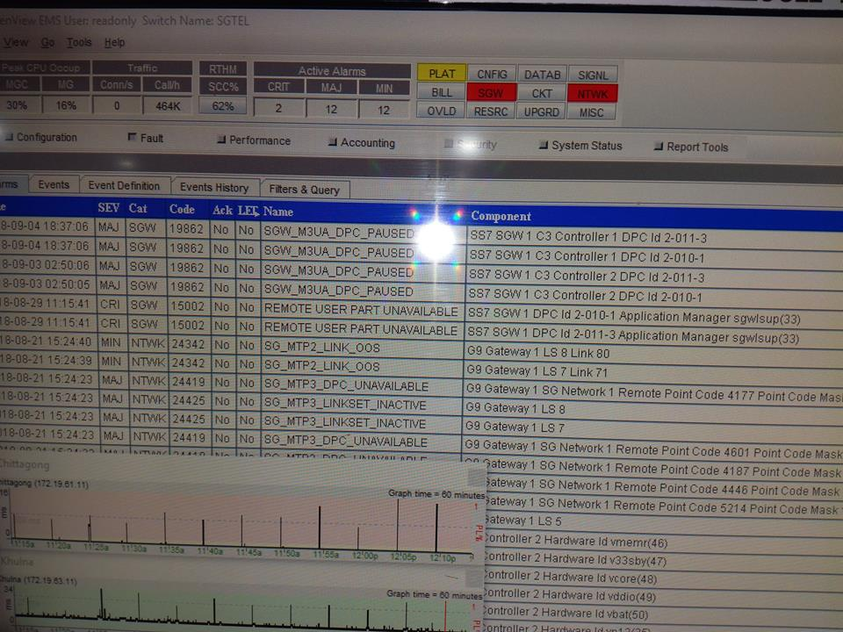

Fig.5.1: Alarm Monitoring

**5.7**

**20020: SYS_CPU_APP_VERSION_MISMATCH**

**EVENT ID**

20020

**CATEGORY**

CNFIG

G9 Events and Alarms Guide **57**

630-00469-01 Rev 15.04 4/11/12

**DEFAULT SEVERITY**

MINOR

**DESCRIPTION**

The CPU application doesn't have current software loaded.

**CAUSE**

Most likely it is by the software control file has the multiple bin file names on this CPU.

**REPAIR ACTION**

Contact customer support to remove the unused bin file name from the software control file if the problem

persists, then reset CM/PAC card.

**AFFECTED COMPONENT**

trapNodeInstance+msfTrapObjSlotId+msfTrapObjCpuId

**PARAMETERS**

mscTrapObjApplicationVersion: applicationVersion

**TRAP TYPE**

ALARM ON

**MANUAL CLEAR**

NO

**CLEARED BY**

20021

**SERVICE AFFECTING**

NO

**SEND TO NOC**

NO

**5.8**

**20070: CAS_Analog_Line_Term_LINE_UNIT_TEMP_UNAVAILABLE**

**EVENT ID**

20070

**CATEGORY**

CKT

**DEFAULT SEVERITY**

MINOR

**DESCRIPTION**

Please ignore it because MSF has no longer used it.

**CAUSE**

Testing, maintenance activities, line is taken out of service by the operator or link down, not provisioned,

trunk signaling failure or facility out of service, etc.

**REPAIR ACTION**

No action is required.

**AFFECTED COMPONENT**

trapNodeInstance+msfTrapObjGr303NeId+msfTrapObjGr303AltId

**PARAMETERS**

NA

**TRAP TYPE**

EVENT

**MANUAL CLEAR**

NO

**CLEARED BY**

NA

**SERVICE AFFECTING**

NO

**SEND TO NOC**

NO

**20078: CAS_TEMPORARY_FAILURE**

**EVENT ID**

20078

**CATEGORY**

SIGNL

**DEFAULT SEVERITY**

MAJOR

G9 Events and Alarms Guide **99**

630-00469-01 Rev 15.04 4/11/12

**DESCRIPTION**

The Media Gateway has encountered signaling processing error.

**CAUSE**

The possible causes are:

1. Timer expiration.

2. Message buffers (memory) depletion, In the case of memory depletion, SYS_BUFFER_ALLOC_FAILED

event will be raised first.

**REPAIR ACTION**

Contact customer support if the problem persists.

**AFFECTED COMPONENT**

NA

**PARAMETERS**

NA

**TRAP TYPE**

EVENT

**MANUAL CLEAR**

NO

**CLEARED BY**

NA

**SERVICE AFFECTING**

NO

**SEND TO NOC**

NO

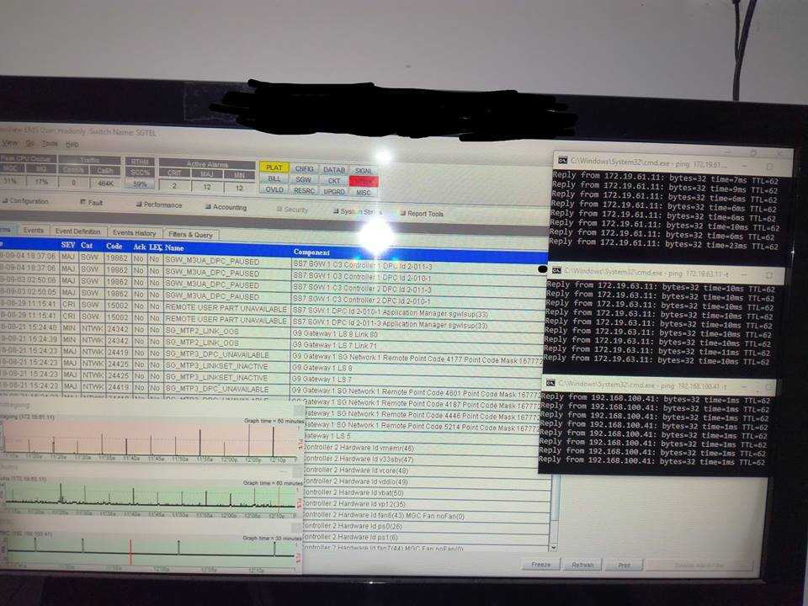

Fig. Alarm Monitoring

**5.9**

**20100: SLC96_DATA_LINK_FAILURE**

**EVENT ID**

20100

**CATEGORY**

NTWK

**DEFAULT SEVERITY**

MAJOR

**DESCRIPTION**

The Media Gateway has detected a failure on data links connected to SLC96 Remote Terminal (RT).

**CAUSE**

The specified span has experienced an AIS, LOF or LOS.

**REPAIR ACTION**

1. Check equipment on both sides.

2. Check data links provisioning.

3. Call custom support.

**AFFECTED COMPONENT**

trapNodeInstance+msfTrapObjSlc96RtId

**PARAMETERS**

mscTrapObjSlc96RtShelfSpanIfIndex: The ifIndex of span associated with the SLC96 Remote Terminal

Shelf.

**TRAP TYPE**

ALARM ON

**MANUAL CLEAR**

NO

**106** G9 Events and Alarms Guide

630-00469-01 Rev 15.04 4/11/12

**CLEARED BY**

20101

**SERVICE AFFECTING**

NO

**SEND TO NOC**

NO

**5.10**

**20489: ATM_BILL_DATA_WRITE_ERROR**

**EVENT ID**

20489

**CATEGORY**

BILL

**DEFAULT SEVERITY**

CRITICAL

**DESCRIPTION**

The billing task on the ATM switch fabric CPU or ATM control CPU is not able to write CDRs to CM/PAC

(Control Module/Packet And Control) disk.(Note: This feature has been disabled.) This alarm has been

deprecated since 7.1.x.

**CAUSE**

Either the IPC connection between the ATM switch fabric CPU or the ATM control CPU and CM/PAC

Master CPU is down, or the hard drive partition for billing is full.

**REPAIR ACTION**

Contact customer support.

**AFFECTED COMPONENT**

TrapNodeInstance+msfTrapObjSingletonId

**PARAMETERS**

mscTrapObjSlotId: slotId

mscTrapObjFileMsgErrCode: Mg Message Utilities error code.

mscTrapObjFileName: fileName

**198** G9 Events and Alarms Guide

630-00469-01 Rev 15.04 4/11/12

**TRAP TYPE**

ALARM ON

**MANUAL CLEAR**

NO

**CLEARED BY**

20491

**SERVICE AFFECTING**

NO

**SEND TO NOC**

NO

**5.10**

**21320: IP_PING_TEST_FAILED**

**EVENT ID**

21320

**CATEGORY**

SWLOG

**DEFAULT SEVERITY**

INFO

**DESCRIPTION**

PING test indicates failure to reach the destination.

**CAUSE**

The PING test indicates failure to reach the final destination. Possible connectivity or configuration issues

in the IP network.

**REPAIR ACTION**

No action is required

G9 Events and Alarms Guide **373**

630-00469-01 Rev 15.04 4/11/12

**AFFECTED COMPONENT**

trapNodeInstance+msfTrapObjOwnerIndex+msfTrapObjTestName

**PARAMETERS**

mscTrapObjMgrSessionId: mgrSessionId

mscTrapObjTargetInetAddressType: The type of target address.

mscTrapObjTargetInetAddress: Target IP address.

mscTrapObjPingErrorCode: Ping failure error code.

**TRAP TYPE**

EVENT

**MANUAL CLEAR**

NO

**CLEARED BY**

NA

**SERVICE AFFECTING**

NO

**SEND TO NOC**

NO

**5.11**

**21527: CMC_PROVISIONED_FROM_ESA**

**EVENT ID**

21527

**CATEGORY**

SWLOG

**DEFAULT SEVERITY**

INFO

**DESCRIPTION**

Media Gateway CM/PAC (Control Module/Packet And Control) has received provision data from ESA

(Emergency StandAlone).

**CAUSE**

The connection between remote MG and core MGC was down while CM/PAC card was booting.

**REPAIR ACTION**

Check the connection between remote MG and core MGC. After connection restored, reset the alarmed

CM/PAC.

**AFFECTED COMPONENT**

trapNodeInstance+msfTrapObjSlotId+msfTrapObjCardId

**PARAMETERS**

mscTrapObjCmDbSource: The CM/PAC database sources.

**TRAP TYPE**

ALARM ON

**MANUAL CLEAR**

NO

**CLEARED BY**

21528

**SERVICE AFFECTING**

NO

**SEND TO NOC**

NO

**5.12**

**23003: GEN_MO_CREATE_FAILURE**

**EVENT ID**

23003

**CATEGORY**

DATAB

**DEFAULT SEVERITY**

MAJOR

**DESCRIPTION**

A Media Gateway application has encountered an error during an add transaction.

**CAUSE**

The possible reasons are:

1. The application specified has overloaded or did not start.

2. Error in provision data.

**REPAIR ACTION**

1. If application is not running, contact customer support.

2. Verify data in add transaction.

**660** G9 Events and Alarms Guide

630-00469-01 Rev 15.04 4/11/12

**AFFECTED COMPONENT**

trapNodeInstance+msfTrapObjTargetObject+msfTrapObjTargetObjectInstance

**PARAMETERS**

mscTrapObjEmnpErrCode: emnpErrCode. Error code for the MO related operation.

mscTrapObjDstAppId: Destination application ID.

mscTrapObjDstAppInstance: event destination application Instance

**TRAP TYPE**

EVENT

**MANUAL CLEAR**

NO

**CLEARED BY**

NA

**SERVICE AFFECTING**

NO

**SEND TO NOC**

NO



Fig.: Alarm Monitoring

Chapter 6

Conclusion

**Conclusion**

Gazi Networks Ltd. an ICX worker was chosen as an case to show the initialization course of ICX worker. The connectivity of Gazi Networks Ltd. in Dhaka and other two telecom zones in Bangladesh is alike to other ICX operators. So, the group size, initialization cost, yearly costs and fees to BTRC etc. have comparisons. Studying provided services, CAPEX, OPEX and Organogram of Gazi Networks Ltd. can give us an total view. Gazi Networks Ltd. was recognized in 2012 with government’s view to lessen the complexity of interconnection and be a part of the total telecom scheme in order to intersect workers and monitor the process. Gazi Networks Ltd. is related with Grameenphone, Robi, Airtel, Telltale, Bangla link and City cell in Dhaka zone. The Firm is connected with all the 29 IGWs done the 7 IOSs, 6 Mobile operators, 2 IPTSP workers and BTRC.

In Dhaka zone Gazi Networks Ltd. is proficient enough to grip all domestic calls as well as global incoming and outward calls. It is linked with the ANSs in Khulna and Bogra zone to handle regional local calls. Despite Bangladesh taking an vastly promising telecom souk – it seemed to be repeatedly waiting to happen till this time. The BTTB (Bangladesh Wire and Telephone Board), the innovator in the telecom sector in the nation with land phone, PSTN (Public Swapped Telecom Network) was the lone worker. The BTTB was shaped in 1972. The inherited &age old equivalent system of telephone exchange sustained for many years. Most region towns had access to another system for urgent infrastructures, in the form of a UHF or VHF radio scheme or radio relay network. With the overview of satellite networks in the post-independence decade, done facilities at Petunia and Aliabad earth-satellite places were mile-stones in the segment. Bangladesh planned to recoverits telecommunications thru the Third Five-year plan (1985-90) by the fitting of a digital radioconvey network, mechanization of telephone connections and installation of a mobile phonenetwork in Dhaka and there after slow induction of digital connections across the republic, thegeneral and global telecom services ongoing to recover.

Before 2012 there were only 3 ICX operators in Bangladesh. But since then the call rates stood receiving cheaper more and more people of the nation involved themselves inside the telecom network of Bangladesh. As a outcome the number of calls was cumulative very quickly. The weight was too high for the current 3 ICX operators to transmit so many calls near the Mobile workers which had been resultant technical difficulties very frequently. To resolve the problematic and create more service and better monitoring BTRC decided to present more ICX workers. Then in 2012 BTRC gave license to 23 more ICX workers in the telecom segment and Gazi Networks Ltd. became one of the foremost ICX operator within year.

**References**

1.https://en.wikipedia.org/wiki/GSM

2.https://en.wikipedia.org/wiki/Media_gateway

3.https://en.wikipedia.org/wiki/Media_gateway_control_protocol_architecture

4.https://en.wikipedia.org/wiki/Network_packet

5.<http://whatis.techtarget.com/definition/time-division-multiplexing-TDM>

6.<https://en.wikipedia.org/wiki/Power_transmission>

7.<http://pluto.ksi.edu/~cyh/cis370/ebook/ch05b.htm>

8.<https://www.techopedia.com/definition/21314/plesiochronous-digital->[hierarchy- pdh](https://www.techopedia.com/definition/21314/plesiochronous-digital-hierarchy-pdh)

9.<http://searchnetworking.techtarget.com/definition/SDH>

10.<http://whatismyipaddress.com/vpn>

11.<https://en.wikipedia.org/wiki/Multiprotocol_Label_Switching>

12.<https://en.wikipedia.org/wiki/Virtual_Private_LAN_Service>